

Participation, activities and outcomes in the Home Interaction Program for Parents and Youngsters (HIPPY): A descriptive analysis
April 2026
Patrick Rehill, Vera Newman, Ramethaa Pirathiban and Harry Greenwell
© Commonwealth of Australia 2026
ISBN: 978-1-923278-65-3
This publication is available for your use under a Creative Commons Attribution 4.0 International licence, with the exception of the Commonwealth Coat of Arms, the Australian Centre for Evaluation logo, photographs, images, third party materials, materials protected by a trademark, signatures and where otherwise stated. The full licence terms are available from https://creativecommons.org/licenses/by/4.0/legalcode.

Use of Australian Government material under a Creative Commons Attribution 4.0 International licence requires you to attribute the work (but not in any way that suggests that the Australian Government endorses you or your use of the work).
Australian Government material used ‘as supplied’
Provided you have not modified or transformed Australian Government material in any way including, for example, by changing the Australian Government text; calculating percentage changes; graphing or charting data; or deriving new statistics from published Australian Government statistics – then the Australian Government prefers the following attribution:
Source: Rehill P, Newman V, Pirathiban R and Greenwell H (2026) Participation, activities and outcomes in the Home Interaction Program for Parents and Youngsters (HIPPY): A descriptive analysis, the Australian Centre for Evaluation, the Australian Treasury.
Derivative material
If you have modified or transformed Treasury material, or derived new material from those of the Treasury in any way, then Treasury prefers the following attribution:
Based on The Commonwealth of Australia data.
Use of the Coat of Arms
The terms under which the Coat of Arms can be used are set out on the Department of the Prime Minister and Cabinet website (see www.pmc.gov.au/government/commonwealth-coat-arms).
Other uses
Enquiries regarding this licence and any other use of this document are welcome at:
Manager
Media Unit
The Treasury
Langton Crescent
Parkes ACT 2600
Email: media@treasury.gov.au
In the spirit of reconciliation, the Treasury acknowledges the Traditional Custodians of country throughout Australia and their connections to land, sea and community. We pay our respect to their Elders past and present and extend that respect to all Aboriginal and Torres Strait Islander peoples.

Disclaimer
The results of the observational study in this report are based, in part, on data supplied to the Australian Bureau of Statistics (ABS) under the Taxation Administration Act 1953, A New Tax System (Australian Business Number) Act 1999, Australian Border Force Act 2015, Social Security (Administration) Act 1999, A New Tax System (Family Assistance) (Administration) Act 1999, Paid Parental Leave Act 2010 and/or the Student Assistance Act 1973. Such data may only be used for the purpose of administering the Census and Statistics Act 1905 or performance of functions of the ABS as set out in Section 6 of the Australian Bureau of Statistics Act 1975. No individual information collected under the Census and Statistics Act 1905 is provided back to custodians for administrative or regulatory purposes. Any discussion of data limitations or weaknesses is in the context of using the data for statistical purposes and is not related to the ability of the data to support the Australian Taxation Office, Australian Business Register, Department of Social Services and/or Department of Home Affairs’ core operational requirements.
Legislative requirements to ensure privacy and secrecy of these data have been followed. For access to PLIDA and/or BLADE data under Section 16A of the ABS Act 1975 or enabled by Section 15 of the Census and Statistics (Information Release and Access) Determination 2018, source data are de-identified and so data about specific individuals has not been viewed in conducting this analysis. In accordance with the Census and Statistics Act 1905, results have been treated where necessary to ensure that they are not likely to enable identification of a particular person or organisation.

Contents
Executive Summary 1
Introduction 2
Data sources 2
Limitations 3
Section 1: Who used HIPPY? 4
Sample, data and limitations 4
HIPPY served ‘priority’ groups 5
Number of priority classifications 8
Change in priority categories over time 10
Section 2: What activities did HIPPY participants take part in? 12
Difference in activities by completion status 15
Section 3: DSS SCORE ratings of HIPPY 16
Section 4: What other DSS programs did HIPPY participants take part in? 17
Section 5: HIPPY tutors 19
Demographic characteristics 19
Employment and training 21
Appendix A – Data used and limitations 25
Appendix B – HIPPY activities: excerpts from DEX program-specific guidance 27

Executive Summary
This report covers descriptive analysis of the Home Interaction Program for Parents and Youngsters (HIPPY) program. It uses administrative data to answer 5 questions:
- Who is taking part in HIPPY?
- What activities are HIPPY participants taking part in?
- How do DSS’ Standard Client/Community Outcomes Reporting (SCORE) assessments (which rate client circumstances, goals and satisfaction) change during the program?
- What other DSS programs are HIPPY participants accessing?
- What are the characteristics of HIPPY tutors?
Who is taking part in HIPPY? HIPPY is meeting its goal of serving priority groups. HIPPY is designed to primarily serve children in one of 9 ’priority categories’. Children in HIPPY were more likely to fall into each of the priority categories and were significantly more likely to have several priority characteristics. Around 80% of children in HIPPY belong to at least one of the priority categories that have been identified for the program. This compares to 61% of children in the same age cohorts who lived in an area where HIPPY was offered but did not take part in the program.
What activities are HIPPY participants taking part in? Around 61% of children in the 2020 and 2021 cohorts who started HIPPY completed the program. These children completed an average of 39 family capacity building sessions and both children and adults completed a range of other activities, including referral to other services and advice sessions on parenting and employment pathways.
How do DSS SCORE assessments change during the program? Assessments data from the Data Exchange (DEX) showed a high level of satisfaction with HIPPY. It also showed capabilities for both children and adults being assessed as higher on average after completing the program. However, assessments data in DEX were collected according to DSS program-specific guidance, which changed throughout the period of time studied here. This made interpreting the data difficult. These challenges are detailed in the report where relevant.
What other DSS programs are HIPPY participants accessing? Participants in HIPPY accessed a range of other DSS services – primarily emergency relief and other programs to support young children.
Who are HIPPY tutors and what are their education and work outcomes? In addition to its potential benefits for parents and children, HIPPY may also contribute to employment outcomes for people from diverse backgrounds, through its recruitment of HIPPY tutors. In particular, many tutors are former HIPPY parents. Tutors came from a very diverse range of backgrounds reflecting the diversity of HIPPY participants. Many tutors were studying or working other jobs during the program. 39 per cent of those who found a job after HIPPY were working within HIPPY provider organisations either directly on HIPPY or in other functions.

Introduction
The Home Interaction Program for Parents and Youngsters (HIPPY) is a 2-year, structured, early childhood and parent engagement program delivered in the home. It supports parents to be their child’s first teacher by developing their skills, confidence and capacity to create a positive home-learning environment.
HIPPY is delivered nationally through 100 sites by local not-for-profit organisations under a sub-licence from the Brotherhood of St Laurence (BSL), which holds the sole licence for HIPPY in Australia. When HIPPY commenced in Australia, the 2-year program was offered to children aged 4–‍5 years. Since 2023, all sites have been delivering the new HIPPY Age 3 program, which is offered to children aged 3–‍4 years.
The Department of Social Services (DSS) commissioned the Australian Centre for Evaluation (ACE) to conduct an impact evaluation of HIPPY. ACE’s evaluation assessed whether HIPPY improves outcomes for children and parents. This report is a supplement to ACE’s evaluation and provides a description of HIPPY participants and HIPPY tutors, to better understand who HIPPY is serving and how the program is being implemented. Accordingly, the focus of this report is on who used the program and how they used it (as opposed to the effect of the program, which is addressed in a separate report). It is divided into 5 sections.
- Section 1 describes demographic characteristics of participants.
- Section 2 outlines what activities participants took part in.
- Section 3 focuses on the DSS ‘SCORE ratings’ for HIPPY participants. (SCORE ratings are a standardised rating of client goals, circumstances and satisfaction with a program. These ratings can be made by a practitioner, client, or a support person).
- Section 4 sets out what other DSS services HIPPY participants used.
- Section 5 discusses the characteristics of HIPPY tutors and their study and work activities during and after HIPPY.

Data sources
The analysis for Sections 1–4 used the Australian Bureau of Statistics’ (ABS) Person Level Integrated Data Asset (PLIDA), which links together a number of population-level administrative datasets from the Australian Government and other data custodians. The core of this analysis was the DSS Data Exchange (DEX) dataset which holds data on participation in DSS programs, including HIPPY. Overall, the analysis covers HIPPY participants between 2017 and 2023. The specific reference period varies for each section, as noted below.
Information on participant characteristics in Section 1 was primarily sourced from DEX, 2021 Census of population and housing, Income Tax Return (ITR), the Australian Early Childhood Development Census (AEDC), and Data Over Multiple Individual Occurrences (DOMINO) within PLIDA.
Analyses of program activities, SCORE assessments, and access to other DSS services (Sections 2–‍4) used data from the DEX only within PLIDA. Activity counts were analysed for the period 2020 to 2023, with completion analyses restricted to the 2020 and 2021 cohorts, who had sufficient time to complete the program. SCORE data coverage varied substantially by measure and time point, reflecting program guidance changes and differential take‑up of assessments. Information on engagement with other DSS programs was drawn from DEX service‑use records between 2017 and 2023, noting that coverage reflects recorded service use rather than the full eligible population.
The characteristics of HIPPY tutors, presented in Section 5, used separate de-identified BSL program data for 2018–2025, which was shared with ACE under a data sharing agreement.
Further details of the data source used, reference period and sample size are provided in each section and summarised in Appendix A.

Limitations
Overall, HIPPY participants included in this analysis were limited to records with a PLIDA ‘spine linkage ID’. The ABS’s aim is that the PLIDA spine covers all people who were resident in Australia during a given reference period (currently January 2006 to June 2023). This spine can then be used to link across administrative datasets. Restricting the analysis to participants with a spine linkage ID therefore removed duplicate records and ensured that each participant was counted uniquely.
For Section 1, records without a spine linkage ID were removed because they could not be linked to other datasets in PLIDA. The sample was further restricted to records that were successfully linked to the 2021 census in order to obtain information on priority groups. As a result, the data in this section represent a sample of HIPPY participants rather than the whole HIPPY population.
For Sections 2–4, after duplicates were removed using the spine linkage ID, records without a spine linkage ID were retained in the analysis. This decision was made to ensure that participants who could not be linked within PLIDA – typically due to missing or incomplete linkage information – were still included in analyses based solely on DEX data. While including records without a spine linkage ID may reintroduce the possibility of duplicate records, it allows for more complete coverage of HIPPY cohorts and improves representativeness for analyses that do not rely on linkage to external datasets.
The only exception is the analysis of HIPPY completion rates by priority groups in Section 3, where the sample was again restricted to records successfully linked to the 2021 census to obtain priority group information. As with Section 1, these results therefore represent a subset of HIPPY participants rather than the full population.
To safeguard the data held in PLIDA, the ABS has rules around privacy that prevent some types of analysis from being publicly released from the secure environment. This includes a rule that statistics based on small counts cannot be cleared to be used publicly. This affected the analysis in this report in several small ways. For example, it is not possible to give counts for the number of children with 6 or more priority characteristics or report the number of HIPPY participants who also took part in some other small DSS programs.
Like any data, the data available in PLIDA has limitations. In particular, data in the DEX dataset was sometimes incomplete or changed over time. These limitations are discussed at relevant points throughout this report.

Section 1: Who used HIPPY?
This section discusses the demographic characteristics of HIPPY users. HIPPY is designed to serve certain priority groups. Children who fall into these categories are given priority entry into the program. Children who do not meet any of these criteria are often ‘waitlisted’ by sites and then enrolled into a HIPPY cohort if there are still spots available at the start of a cohort (which, in most situations, there tends to be).
The priority categories are:
- the family holds a Health Care Card
- the HIPPY child is Aboriginal and/or Torres Strait Islander
- the HIPPY child resides in out-of-home care
- the household has no income, or receives a government support payment as their primary source of income
- the family is a single-parent family
- the child resides with a carer (not a parent)
- the main language spoken at home is not English
- child has a developmental delay or disability
- parent or carer lives with a disability or long-term health condition.

Sample, data and limitations
While the overall analysis is limited to children with a PLIDA spine linkage ID, this section further restricts the sample to those records successfully linked to the 2021 census. As such this section reports on the cohort of 10,673 children who took part in HIPPY between 2017 and 2023, had a PLIDA ‘linkage spine ID’, and could be joined to the 2021 census with that key.
Of 15,207 children in the DEX data who started HIPPY during the years covered in this analysis, there are 4,534 individual records in the DEX data that are missing from the analysis either because it was not possible to link their DEX data to the PLIDA spine, or it was not possible to then link those individuals with any record in the census data. This may mean that the sample used in this section is not fully representative of the HIPPY cohort for the intended period. For example, families that have newly immigrated to Australia are unlikely to be present in the census.
The characteristics of the children in the sample were compared to a cohort of children of the same age and living in the same areas who did not take part in HIPPY. This comparison group includes children in the 104 regions where residents were eligible for HIPPY in the period covered in this analysis, who were born in 2014 or later and who were included in the 2021 census. There were 750,787 children in this cohort.
The linked administrative data used in this section is not the data that was used by HIPPY providers to assess eligibility and determine enrolment into the program. Enrolment decisions were based on information provided by parents during discussions with site coordinators. Some of this data is available in DEX but a large amount was missing and so was not used in this report. (For more details on the linked administrative data, see Appendix A.)
While this analysis is indicative of the kind of people using HIPPY, it is not necessarily a perfect picture of which people HIPPY sites judged to meet one or more of the ‘priority access’ criteria. This means that some people who were identified as meeting one of the priority criteria by service providers may not appear as such in this data. For example, many individuals who get most of their income from government benefits would have incomes so low that they are not required to file a tax return, so this priority status is not captured when just looking at administrative data. In some cases, it was not possible to perfectly capture a priority criterion in administrative data, or it was not possible to separately measure 2 different categories (for example, separating out-of-home care from living with a carer). These categories then do not line up exactly with the priority criteria but can give a broad picture of how HIPPY is serving its priority groups.
In addition, some of the administrative data used in this section might not reflect the characteristics of a child at the time they joined HIPPY. For example, many of these categories use data from the 2021 census to determine different characteristics about a child and their family. Children could have joined HIPPY before or after census night 2021 and their characteristics and those of their family may have changed between when they entered the program and when the census was taken.
For several of the priority characteristics it was necessary to measure a variable at the point in time a child started HIPPY (for example family income in that year). The comparison sample of course does not have a date they started HIPPY. To allow for comparison, a realistic possible start date was created for each comparison child by randomly sampling a start date from one HIPPY child with the same birth year. This sampling was done ‘with replacement’ which means the same HIPPY child’s start date can be used as a reference date by several comparison children. The 3 characteristics that required sampling a reference date were: that a family’s income is mostly government benefits, that a family has no income, and that a child is covered by a healthcare card.

HIPPY served ‘priority’ groups
Broadly speaking, HIPPY met its goal of serving priority groups during the period studied (2017 to 2023). HIPPY children were more likely to be in each priority group than children in the comparison sample (Figure 1). HIPPY children were also likely to have a greater number of priority characteristics than the comparison sample.
Figure 1: Percentage of HIPPY participants by HIPPY priority characteristic, 2017–‍2023
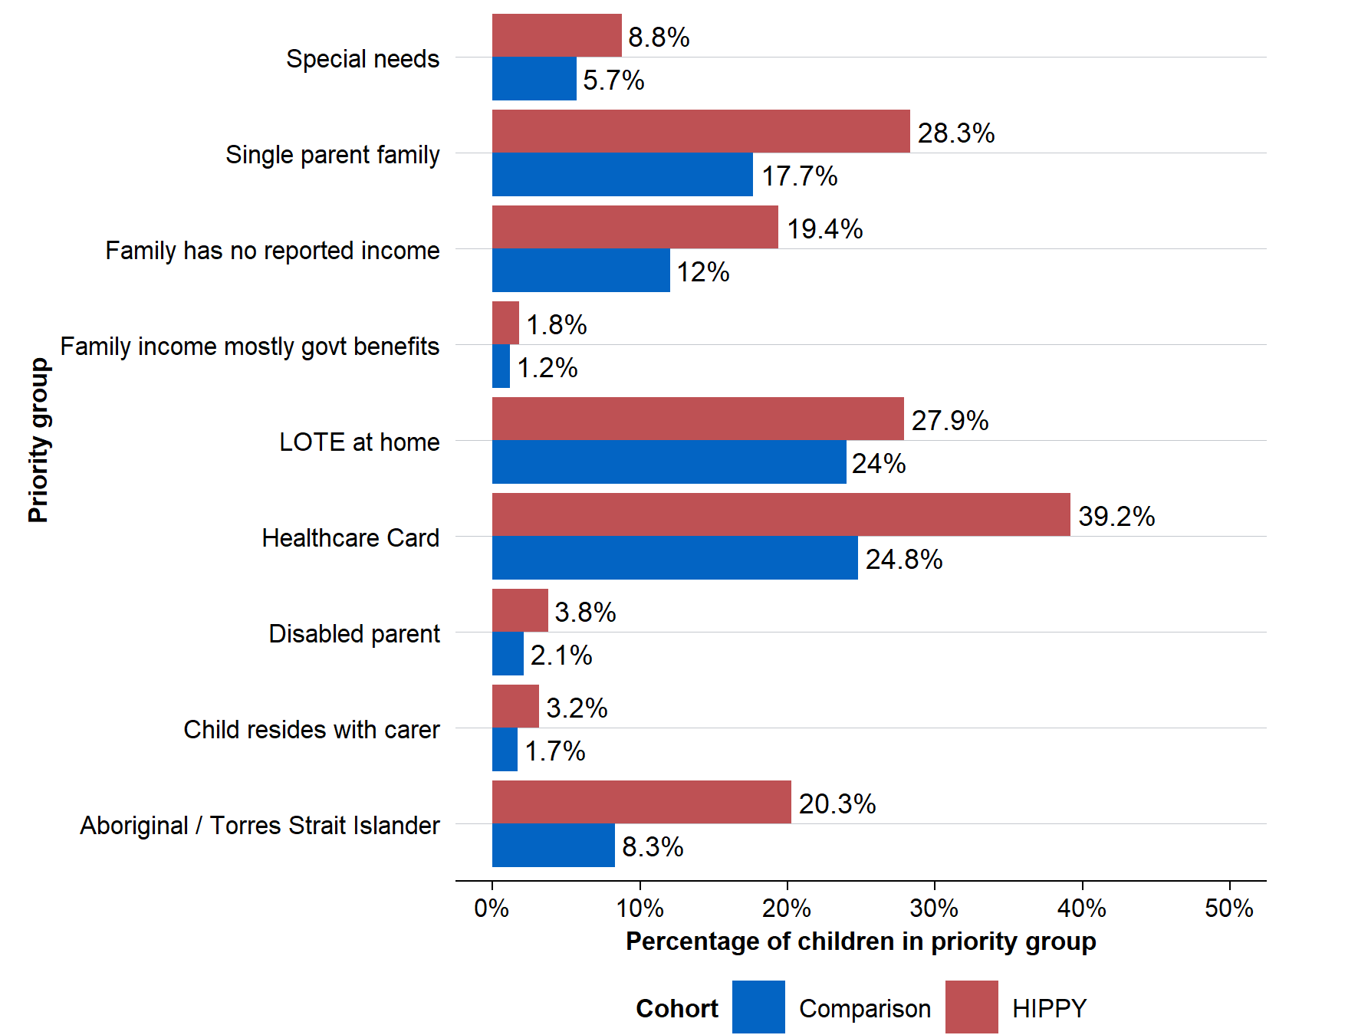
Source: PLIDA data across census, AEDC, tax returns, DOMINO, and DEX. See Appendix A for more details.
Notes: The ‘HIPPY cohort’ relates to children who commenced HIPPY between 2017 and 2023, had a PLIDA ‘linkage spine ID’, and could be joined to the 2021 census with that key. The number of observations varies by statistic: see Appendix A for a full list.

Aboriginal and/or Torres Strait Islander
A substantial percentage of HIPPY participants were Aboriginal and/or Torres Strait Islander. Around 20% of children participating were Aboriginal and/or Torres Strait Islander, compared to 8% of the children in the comparison sample. This reflects the fact that several HIPPY sites are specifically targeted at helping parents of Aboriginal and Torres Strait Islander children, including being based in areas with high Indigenous populations and whose providers are Indigenous organisations.

Main language used at home is not English
The percentage of participants who speak a language other than English (LOTE) at home was somewhat greater for the HIPPY cohort than the comparison cohort – 28% to 24%. This is calculated as the percentage who said they use a language other than English at home on the 2021 census.

Child is in a single-parent family
A much higher portion of children in HIPPY were in single-parent families compared to their peers in the comparison group – 28% compared to 18%. This is based on whether the child was living in a single-parent family at the time of the 2021 census, which may not necessarily reflect family arrangements at the time of enrolment into HIPPY. However, this caveat applies equally to the HIPPY group and the comparison group.

Child has special needs
HIPPY was accessed by some children with special needs. Children in HIPPY were somewhat more likely to have special needs (9%) than those in the comparison sample (6%).
Children with special needs were identified in the AEDC, which is collected every 3 years for children in their first year of school. For this study, the data was confined to children who started school (and for whom the AEDC was completed) in 2021. Because of this, the number of children for which there is data is quite small relative to other categories – there are just 1,632 HIPPY children for whom there is valid AEDC data.
Note that while it might be that HIPPY children were more likely to have special needs, it may also be the case that children who went through HIPPY were more likely to have their special needs identified by the time they started school due to the program. The AEDC data was collected after a child started school – and therefore after they were enrolled into HIPPY – so did not necessarily reflect a pre-HIPPY difference in having identified special needs.

Parent has a disability
HIPPY children were twice as likely to have a parent with a disability – 4% compared to 2%. This was measured by whether a parent in a family required assistance with daily activities in the 2021 census.

Child resides with a carer or in out-of-home care
About 3% of HIPPY children were not living with a parent compared to 2% in the comparison sample. This provides an indication of the proportion of children who were living in out-of-home care or with a carer.

Family income is mostly government benefits
It is challenging to determine what percentage of families drew most of their income from government benefits because full income data is only available in PLIDA for those who filed tax returns. Individuals with incomes below the tax-free threshold are, for the most part, not required to lodge a tax return. Because individuals who are reliant on government benefits for most of their income are likely to have low incomes, an estimate using individual tax return data will likely be an underestimate.
Under that caveat, 2% of HIPPY participants had family incomes that were mostly made up of government benefits (and at least one member of the family filing a tax return) compared to 1% of the comparison sample. This calculation was based on the income tax returns for the financial year when the child began HIPPY. The child’s family was taken from the family unit identified in the 2021 census.

Family has no income
A higher proportion of HIPPY participants came from a family with no reported income (19%) compared with comparison children (12%). As with the previous category, this is based on tax returns in the financial year that a child started HIPPY. Any person in a family was counted as having zero income if they did not file a tax return. If everyone in the family reported zero income or did not file a return, the family was considered to have no income. This means that this category may be an overestimate as it is not possible to distinguish those with zero income from those with low incomes where no one in the family filed a tax return for other reasons.

Child is covered by a healthcare card
Around 39% of HIPPY children were covered by a healthcare card compared to 25% of the comparison cohort. This is based on whether there was a healthcare card covering the child at the time of their first HIPPY activity. (This was identified through the DOMINO dataset.) Generally, a child will fall under a parent’s healthcare card but in rare cases a child might have their own healthcare card (for example if a child is in out-of-home care).

Number of priority classifications
In addition to looking at each category individually, it is worth asking if individuals fell into multiple categories or no categories. A larger share of children in HIPPY belong to at least one priority category (80%) compared to 61% of children in the SA3s where HIPPY is offered (Figure 2). This suggests that the program primarily served priority groups though there was still some capacity in HIPPY to serve other children.
The HIPPY cohort was also more likely to have multiple overlapping priority characteristics than the comparison cohort. HIPPY children were more than twice as likely to have 3 priority characteristics and roughly 4 times as likely to have 4 or 5 characteristics.
Figure 2: Number of priority categories a child meets by cohort, 2017–‍2023
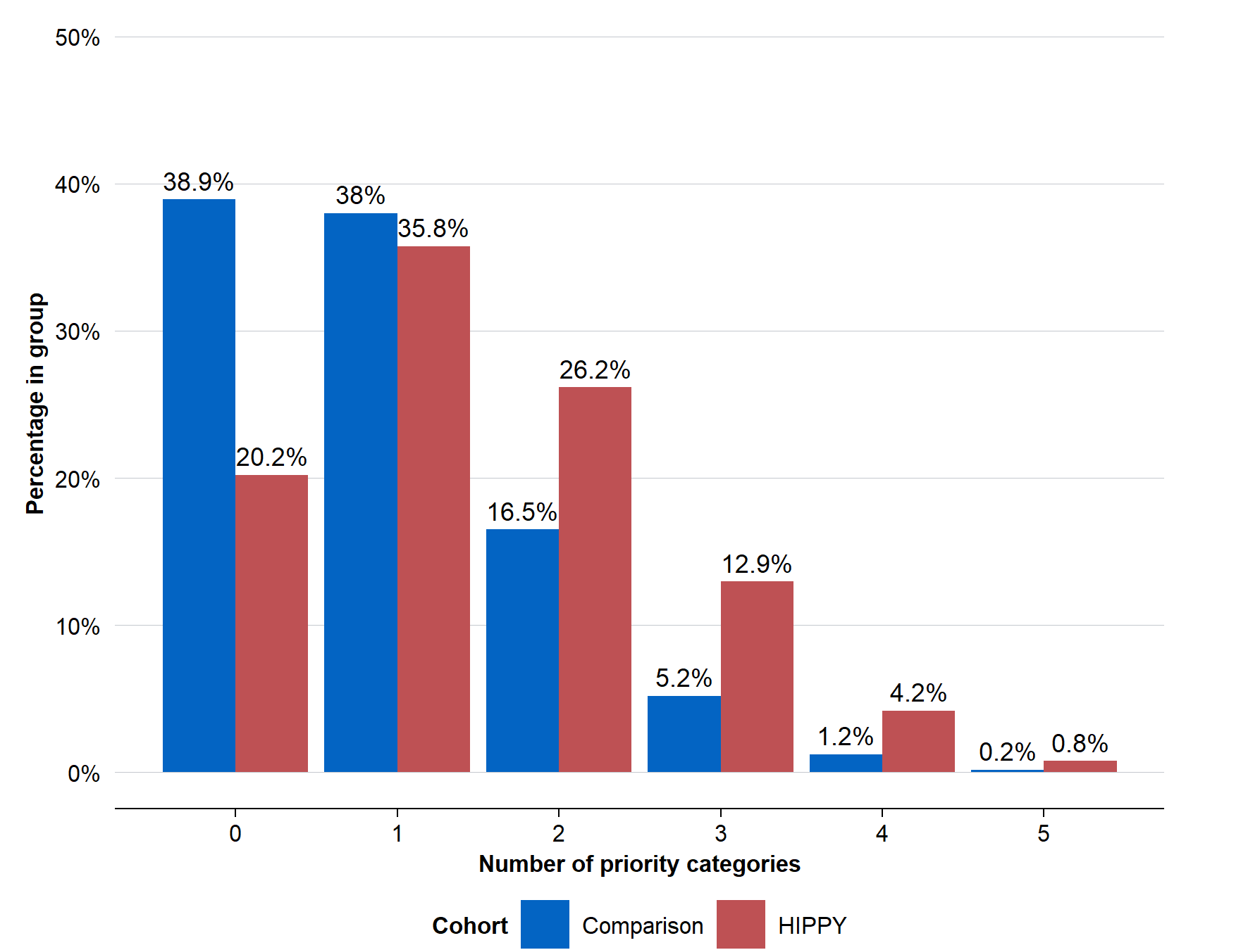
Source: PLIDA data across census, AEDC, tax returns, DOMINO, and DEX. See Appendix A for more details.
Notes: The ‘HIPPY cohort’ relates to children who commenced HIPPY between 2017 and 2023, had a PLIDA ‘linkage spine ID’, and could be joined to the 2021 census with that key. There are some children with more priority categories, however, there are very few and so these statistics have been suppressed in line with ABS PLIDA clearance rules. This analysis includes both children who have a valid measure for special needs (those who started school in 2021 and so were part of the AEDC 2021 cohort) and those that do not. This means that this analysis will have a slight undercount of the actual number of priority categories. However, a similar percentage of the 2 cohorts have a valid measure of special needs, so this is an accurate picture of the relative number of priority categories each cohort meets.

Change in priority categories over time
The percentage of children in each priority group largely remained stable over time (Figure 3). There were small changes (though from a small baseline value) in the percentage of children not living with a parent, and an increase in the percentage of individuals whose incomes were mostly benefits. In addition, there was a fall in the number of participants whose families had no reported income and those from a single parent family.
There could be several explanations for these changes over time. It might be that different kinds of people were taking part in HIPPY, or it could be that overall societal conditions have changed over time. For example, it is likely that both ‘mostly government benefits’ and ‘no reported income’ have changed over time due to the expansion of government transfer payments in the 2019–‍20 and 2020–‍21 financial years. A lot of Australians receiving benefits got a coronavirus supplement and more people who would not have otherwise been on transfer payments received them either due to job losses or relaxed requirements.
Figure 3: Change in priority characteristic prevalence by year
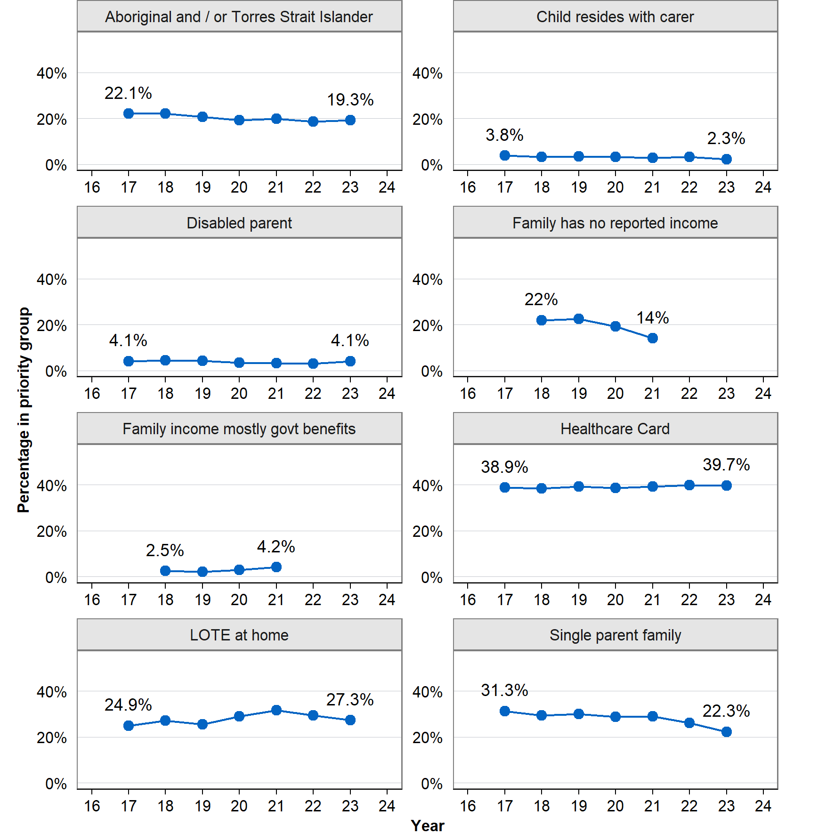
Source: PLIDA data across census, AEDC, tax returns, DOMINO, and DEX. See Appendix A for more details.
Notes: Years abbreviated to just the last 2 digits. Not all data is available in all years. A ‘child having special needs’ is excluded here as only one year of data was available. The ‘HIPPY cohort’ relates to children who commenced HIPPY between 2017 and 2023, had a PLIDA ‘linkage spine ID’, and could be joined to the 2021 census with that key. The number of observations varies by statistic: see Appendix A for a full list.

Section 2: What activities did HIPPY participants take part in?
This section examines activity participation by HIPPY participants and provides a general picture of the services provided under the program based solely on DEX data. The sample for this analysis comprised 5,175 adults and 4,403 children. The total activities analysis (Figure 4 and Figure 5) was based on activities recorded between 2020 and 2023. Analysis by completion status (Figure 6) was restricted to the 2020 and 2021 cohorts, as these groups had sufficient time to complete the program within the period for which data were available.
In this analysis, the activities are described in general terms, and the exact meanings of some of these activities are unclear. In addition, program-specific guidance on reporting of activities changed significantly over time. This resulted in changes to the definitions of different categories or service types, and changes in who was recorded as participating in those activities (the parent, the child or both). In addition, some activities were only reported in some years. For example, ‘child-focused activities’ was a new category in 2023. It was therefore very uncommon for the cohort covered in this section (who had mostly finished the program by then), but much more common in children who started later.
Definitions of these activities are provided by DSS in their DEX program specific guidance. The relevant table is excerpted in Appendix B. However, this is not a perfect guide because some of the terms are defined quite broadly. For example, ‘education and skills training’ might be training for tutors or for standard participants. There were also many changes in the definition of each activity over time though most of the period where this data is relevant (2020 to 2023) will be covered by the May 2020 guidance in Appendix B.
The total number of times participants have undertaken different activities is shown in Figure 4.
Figure 4: Total number of times participants have taken part in different types of activity, 2020–‍2023
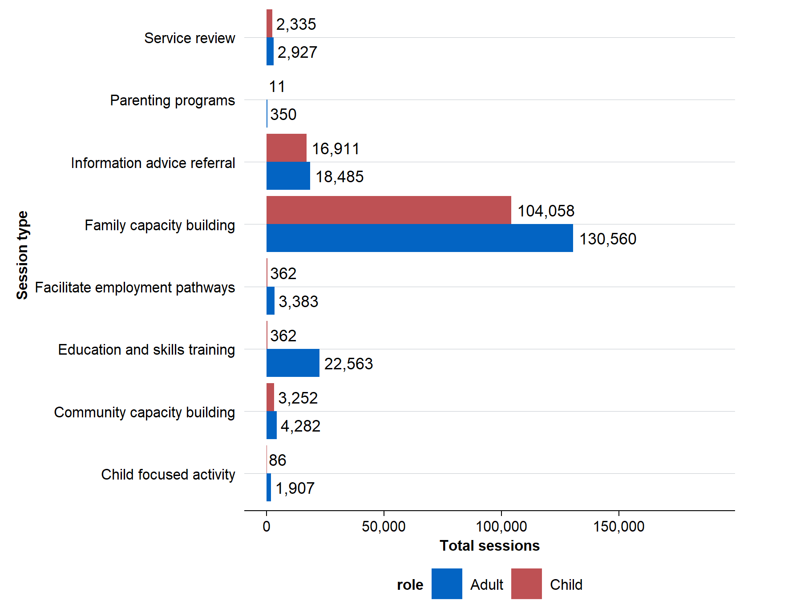
Source: DEX data.
Note: This analysis covers HIPPY participants who took part in activities from 2020 to 2023. Some activities like ‘intake and assessment’, ‘core component completed’ and ‘tutor training completed’ were excluded from this table. The former two are used to define whether an individual completed the program or not. The latter did not provide a reliable count of tutors when compared to the BSL program data used in Section 5.
Figure 5 shows the percentage of adult participants who took part in a certain activity at some point during HIPPY and the average number of sessions for those who took part. ‘Family capacity building’ appears to cover the core activities of HIPPY. Based on program-specific guidance, this activity likely mostly refers to the home visits themselves though other activities might fall under this label as well.
Figure 5: Percentage of adult HIPPY participants taking part in a particular activity and average number of sessions for those who took part in that activity, 2020–‍2023
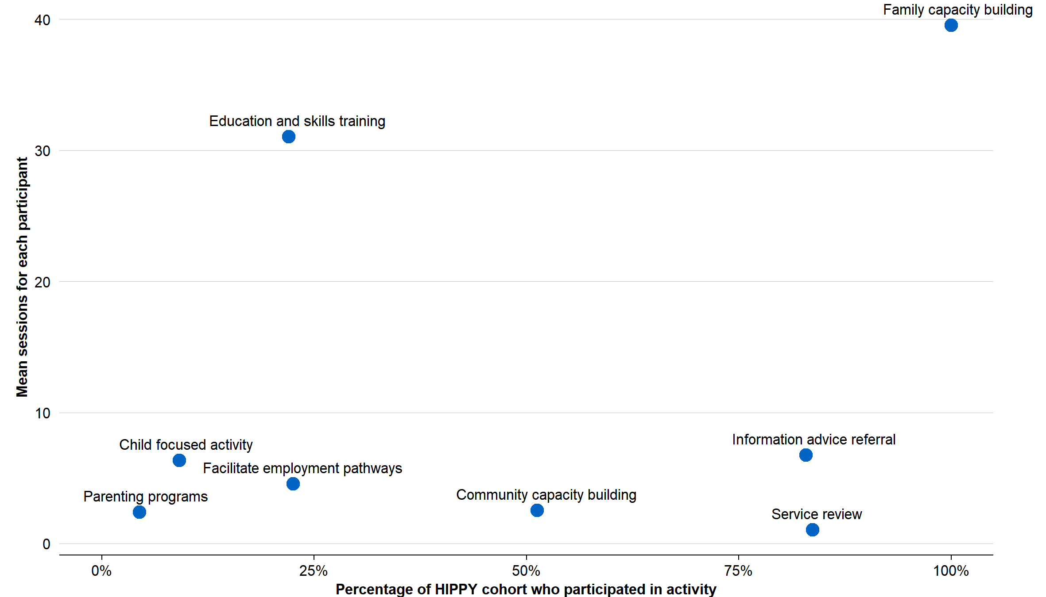
Source: DEX data.
Notes: The cohort for this figure is confined to parents or carers who attended HIPPY sessions from 2020 to 2023. The number of observations varies by statistic: see Appendix A for a full list.
The activity ‘education and skills training’, as provided to adults, is not particularly well defined in the program specific guidance. Earlier versions of the guidance suggest it could refer to either tutor training or group meetings for regular participants. However, the most recent guidance appears to narrow this definition specifically to tutor training. Around 22% of adults in HIPPY are accessing this, but each person accessing this service attends on average 31 sessions.
HIPPY appears to have been a useful source of advice and other referrals with a large percentage of participants having at least one time they were given advice or a referral (as shown under the ‘information advice referral’ activity). HIPPY appears to have been an important source of employment pathways guidance too as 23% of adults enrolled in HIPPY accessed this and averaged 5 sessions each.
The data for children was reasonably similar to that of the adults, however for children it is unclear what it means that a child was provided some of these services. For example, roughly 10% of children received ‘facilitate employment pathways’. This is likely because the child was either present while their parent or guardian received that service or because a service was entered into the data for a child when it was provided to their parent or guardian.
Some of the activity entries within the data are unusual. For example, the activities dataset lists roughly 20 tutors having completed tutor training each year the data is available (see Section 5 for more discussion of tutors), yet there were approximately ten times this number present in the BSL program data. There are also several activities here that were somewhat implausible for children (for example employment pathways support). Future consideration of the quality of reporting may be necessary.

Difference in activities by completion status
There are a few key differences by completion status. Around 61% of children who started HIPPY completed the program (Figure 6). Those who completed HIPPY completed on average 39 sessions of family capacity building, mostly comprised of the core HIPPY home visits and group meetings.
Those that did not complete the program averaged 18 of these activities, suggesting that even those who did not complete the program were in the program for a reasonable amount of time. That said, most who did not graduate from HIPPY appear to have dropped out of the program before their one-year assessment – 72% of those who did not complete the program did not make it to a one-year service review. This means that 28% of those who did not complete the program did receive a service review which is expected at one year.
There were some small differences in completion rates across priority category classifications. Generally, children in priority categories were less likely to finish the program than children who were not. The exception here is in families that spoke a LOTE at home, who had a higher completion rate than those who just spoke English.
Figure 6: HIPPY completion rates by priority group, 2020–‍2023
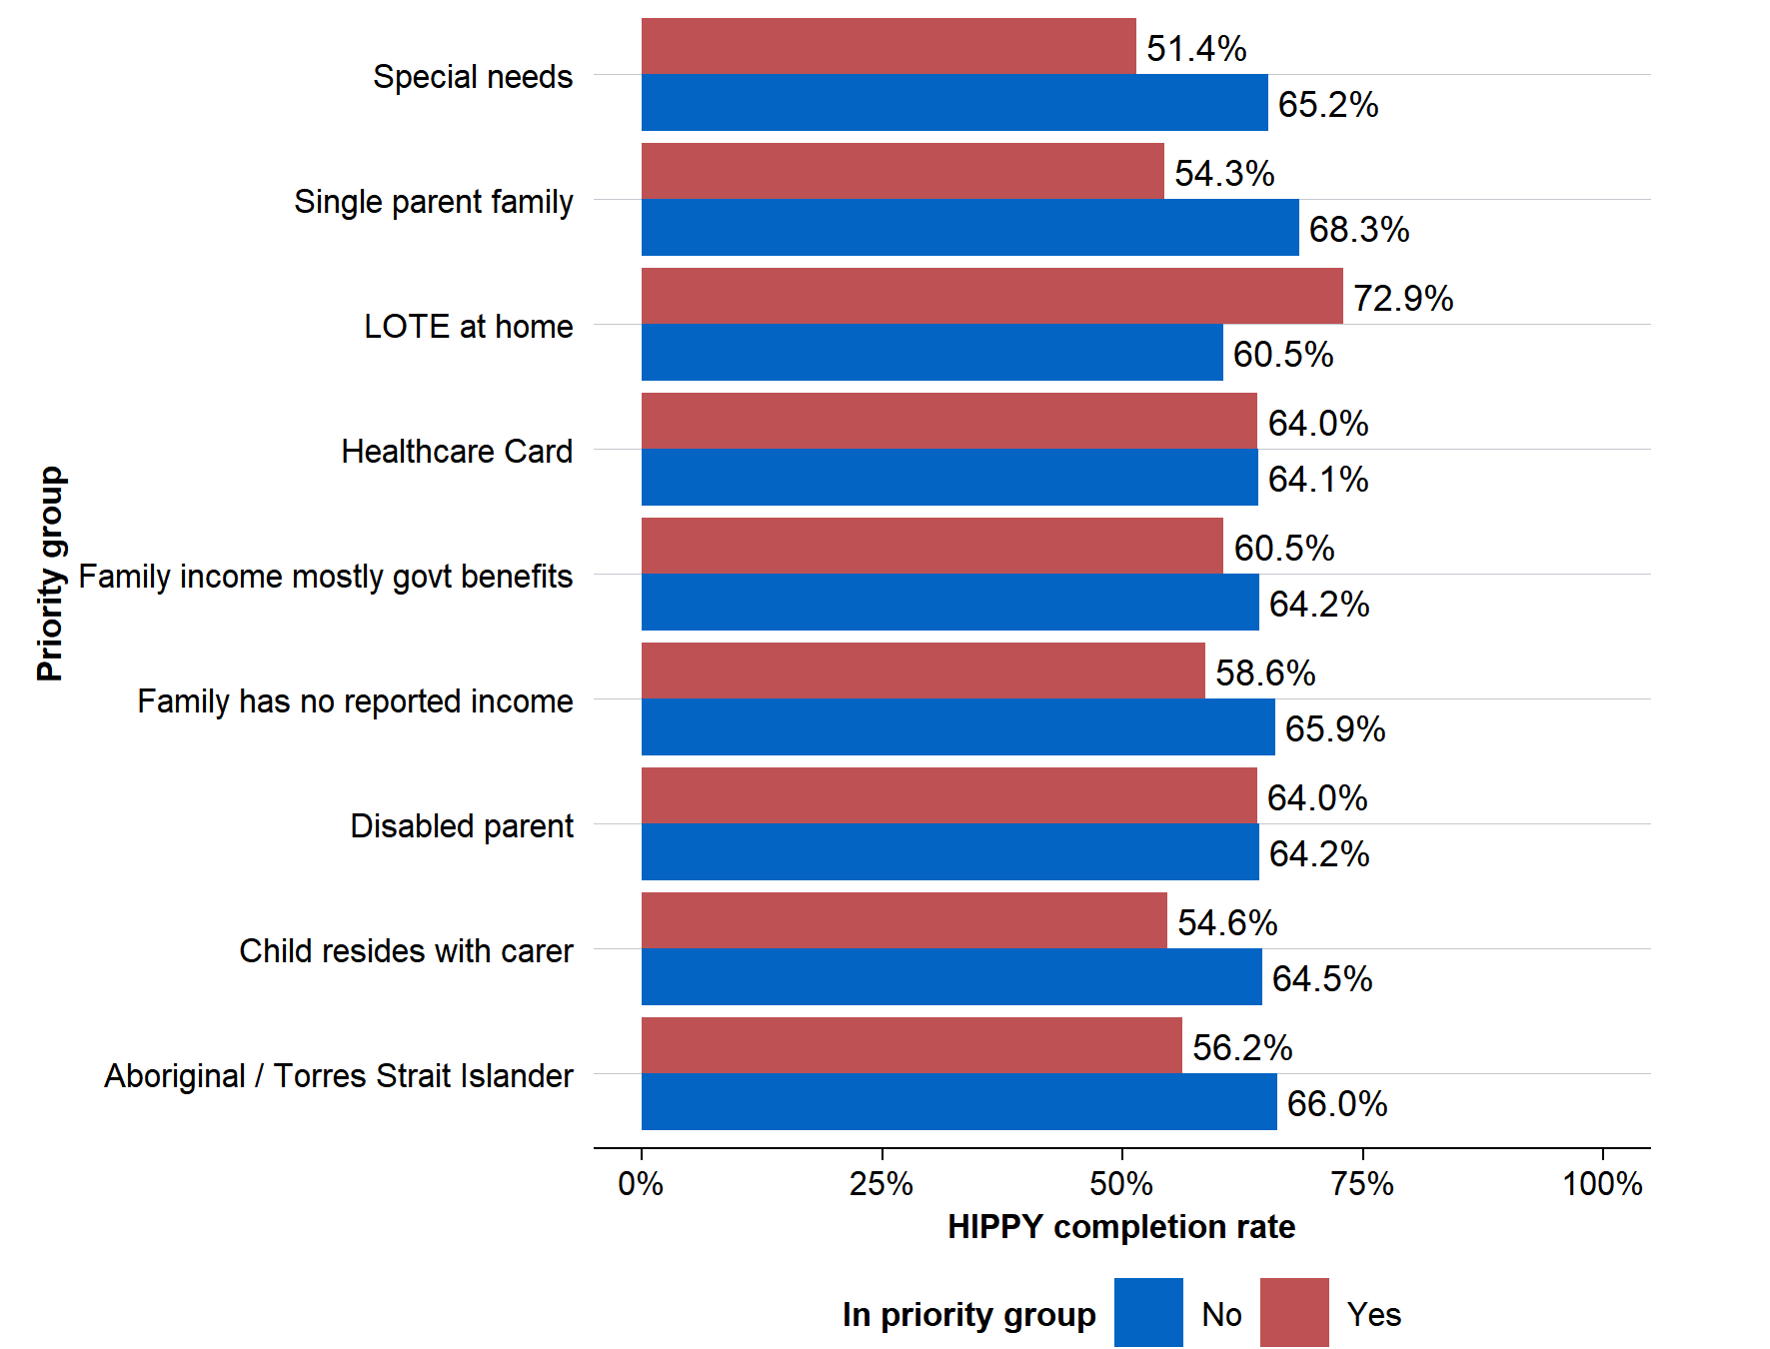
Source: PLIDA data across census, AEDC, tax returns, DOMINO, and DEX. See Appendix A for more details.
Notes: This analysis applies to those in the 2020 and 2021 HIPPY cohorts who had a PLIDA ‘linkage spine ID’ and could be joined to the 2021 census with that key. The number of observations varies by statistic: see Appendix A for a full list.

Section 3: DSS SCORE ratings of HIPPY
This section concerns ratings of HIPPY using DSS’ standard outcome reporting framework– the Standard Client/Community Outcomes Reporting (SCORE) – based on DEX data covering the period from 2020 to 2023. SCORE ratings are a standardised rating of client goals, circumstances and satisfaction with a program. SCORE collects data from program monitoring and evaluation activities and reports these outcomes on a 1–‍5 scale. SCORE data covers both individual-level and community-level outcomes and can be collected in different ways. For example, SCORE outcomes can be assessed by the individual participant themselves, service workers, or a support person.
In addition, the way data is recorded in DEX is quite complex – various domains have been assessed for different kinds of participants over time and there are some details that are not clear from the program-specific guidance. This section presents data as it is, but this is likely not a perfect picture of participant outcomes.
An important caveat is that any changes in SCORE should not be taken as causal. These are not clear before-and-after ratings and, even if they were, that would not necessarily convey the program’s effect on these outcomes. Evidence on the impact of the program is presented in the separate impact evaluation report.
Figure 7: SCORE assessments before and after completing HIPPY, 2020–‍2023
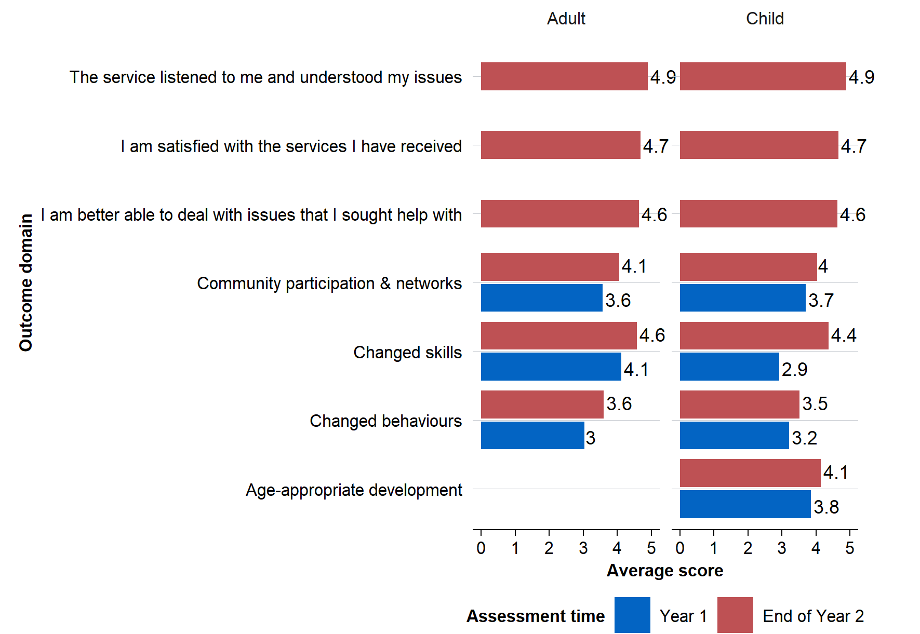
Source: DEX SCORE data.
Notes: The ‘HIPPY cohort’ relates to children who commenced HIPPY between 2020 and 2023. The number of observations varies by statistic: see Appendix A for a full list.
Generally, assessments across time seem to have shown an improvement for both adults and children, at least when the Year 1 SCOREs were not already very high (Figure 7). However, as noted above, it is unclear whether these improvements are attributable to the effects of HIPPY, to changes in data collection, or to changes that would have occurred anyway.

Section 4: What other DSS programs did HIPPY participants take part in?
This section looks at other services used by HIPPY participants based on the DEX data covering the period from 2017 to 2023. DEX only captures data on certain programs funded by DSS which are required to report into DEX. Many similar programs might be funded by other agencies, levels of government, or organisations. Therefore, the other services discussed in this section do not constitute an exhaustive list of all the support services that families might access.
The most used service was ‘financial crisis and material aid – emergency relief’ (Figure 8). This was followed by ‘Communities for Children’ (which covered a range of different services provided by facilitating partners) and ‘Children and Parent Support Services’. It is possible that referrals from HIPPY providers to other services boosted the uptake of these supports.
Figure 8: Other services in DEX that adult HIPPY participants accessed, 2017–‍2023
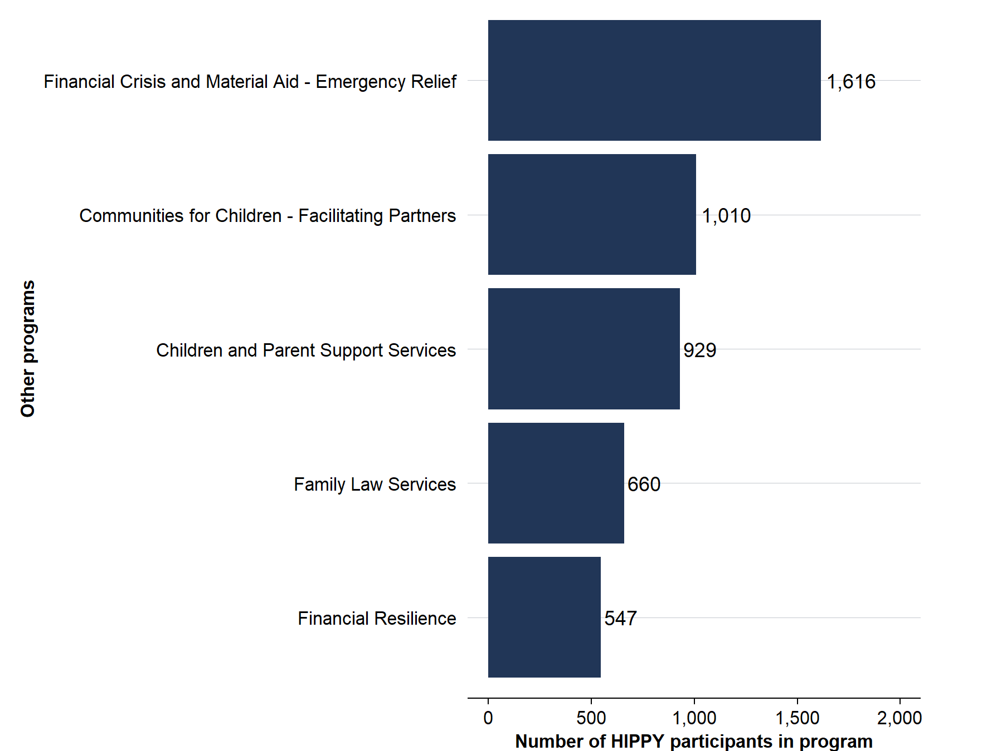
Source: DEX data.
Note: DEX only captures data on certain programs funded by DSS which are required to report into DEX. Many similar programs might be funded by other agencies, levels of government, or organisations. Therefore, this is not an exhaustive list of all the support services that families might access.
For HIPPY children, the other programs they most commonly used were ‘Communities for Children’ and ‘Children and Parent Support Services’ (Figure 9). Children were less likely than adults to have participated in other programs. This was likely because there are fewer programs that directly target them as participants.
Figure 9: Other services in DEX that child HIPPY participants accessed, 2017–‍2023
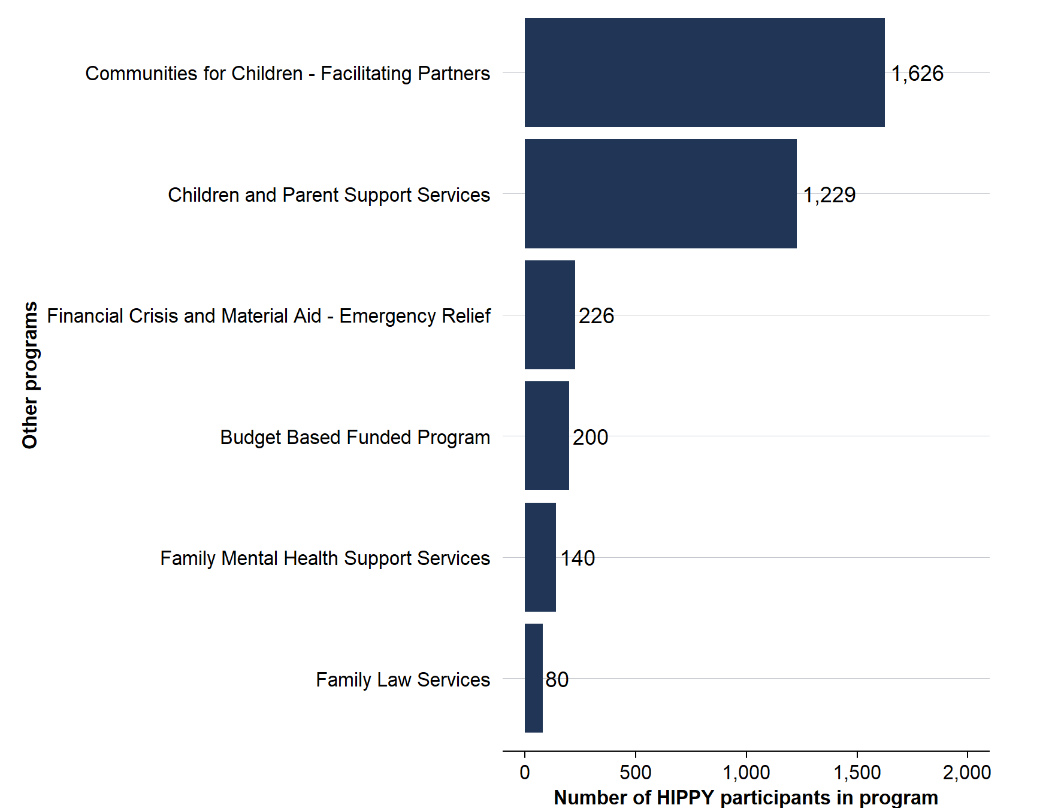
Source: DEX data.
Note: DEX only captures data on certain programs funded by DSS which are required to report into DEX. Many similar programs might be funded by other agencies, levels of government, or organisations. Therefore, this is not an exhaustive list of all the support services that families might access.

Section 5: HIPPY tutors
This section describes the characteristics of HIPPY tutors using BSL program data, as opposed to PLIDA/DEX data. This gives a picture of who became tutors and what they did after they moved on from being tutors. The data covers 586 HIPPY tutors between 2018 and 2025 and gives some information on their demographic characteristics and employment outcomes.
The number of variables BSL has collected has grown over time. This resulted in a significant amount of missing data, because BSL had not begun to collect certain data when some tutors were in the program. To provide some transparency around how much data is missing for each variable, this section reports counts rather than percentages.

Demographic characteristics
HIPPY tutors reflected the diversity of HIPPY participants. Figure 10 shows the number of HIPPY tutors who were Indigenous is roughly in line with the percentage of children in the program who were Indigenous (see Section 1). This corresponds to 22% of tutors being Aboriginal, Torres Strait Islander, or both.
Figure 10: HIPPY tutors by Indigenous status, 2018–‍2025
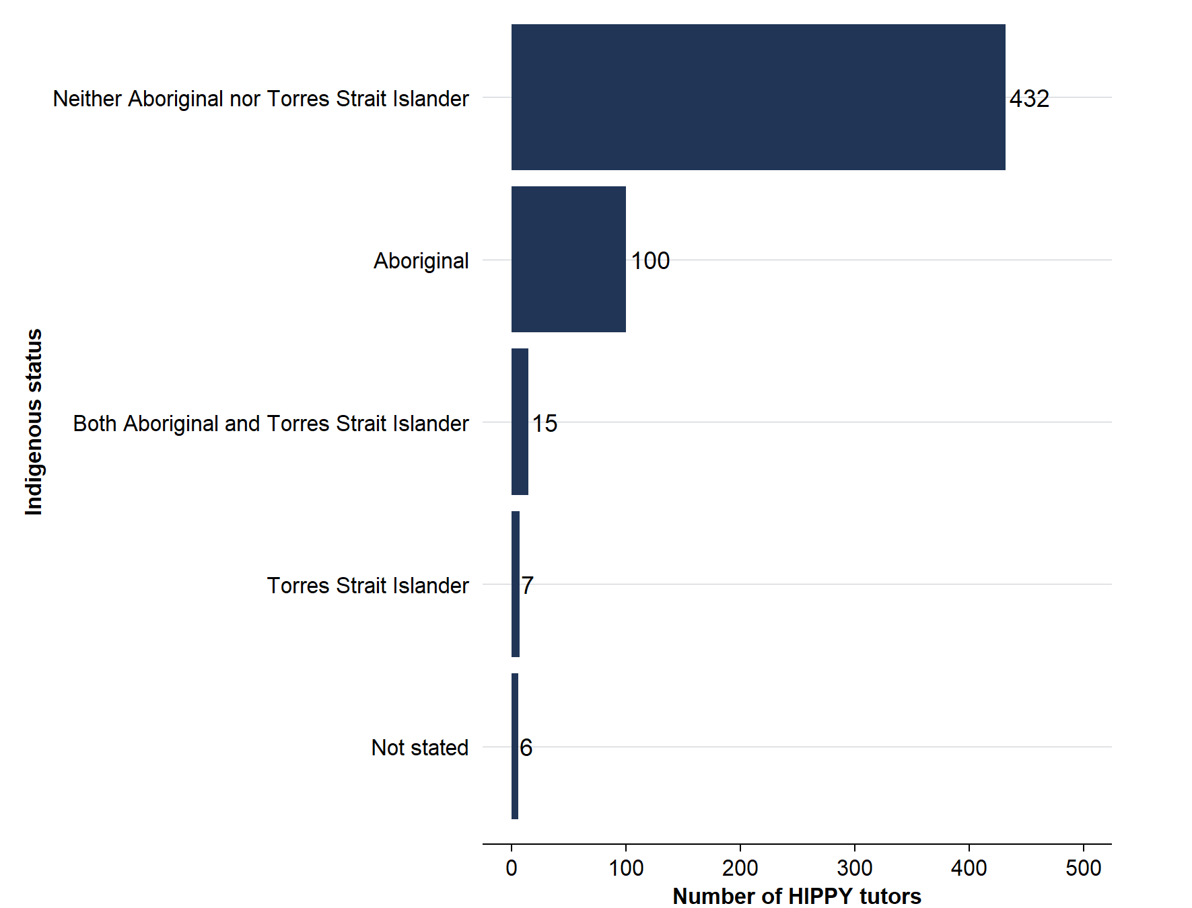
Source: BSL program data.
HIPPY tutors who spoke a language other than English (even if English was their first language) were able to nominate a main language other than English in the BSL data. There were 58 different languages identified here including at least 7 Indigenous languages. Around 34% of tutors spoke a language other than English and about 34% were born outside of Australia.
The characteristics measured here are not necessarily measured in exactly the same way as in PLIDA data for children and comparing tutors to children in the program is not an exact comparison. However, tutors seem roughly, if not more, diverse than the children in HIPPY. 22 per cent are Indigenous compared to 20% of children and 34% speak a second language compared to 28% of children who speak a language other than English at home. Of course, having a second language and speaking a second language at home are separate things, but this at least suggests the tutors are not substantially less linguistically diverse than HIPPY children.
HIPPY tutors had a range of educational backgrounds as shown in Figure 11.
Figure 11: HIPPY tutors’ highest level of education, 2018–‍2025
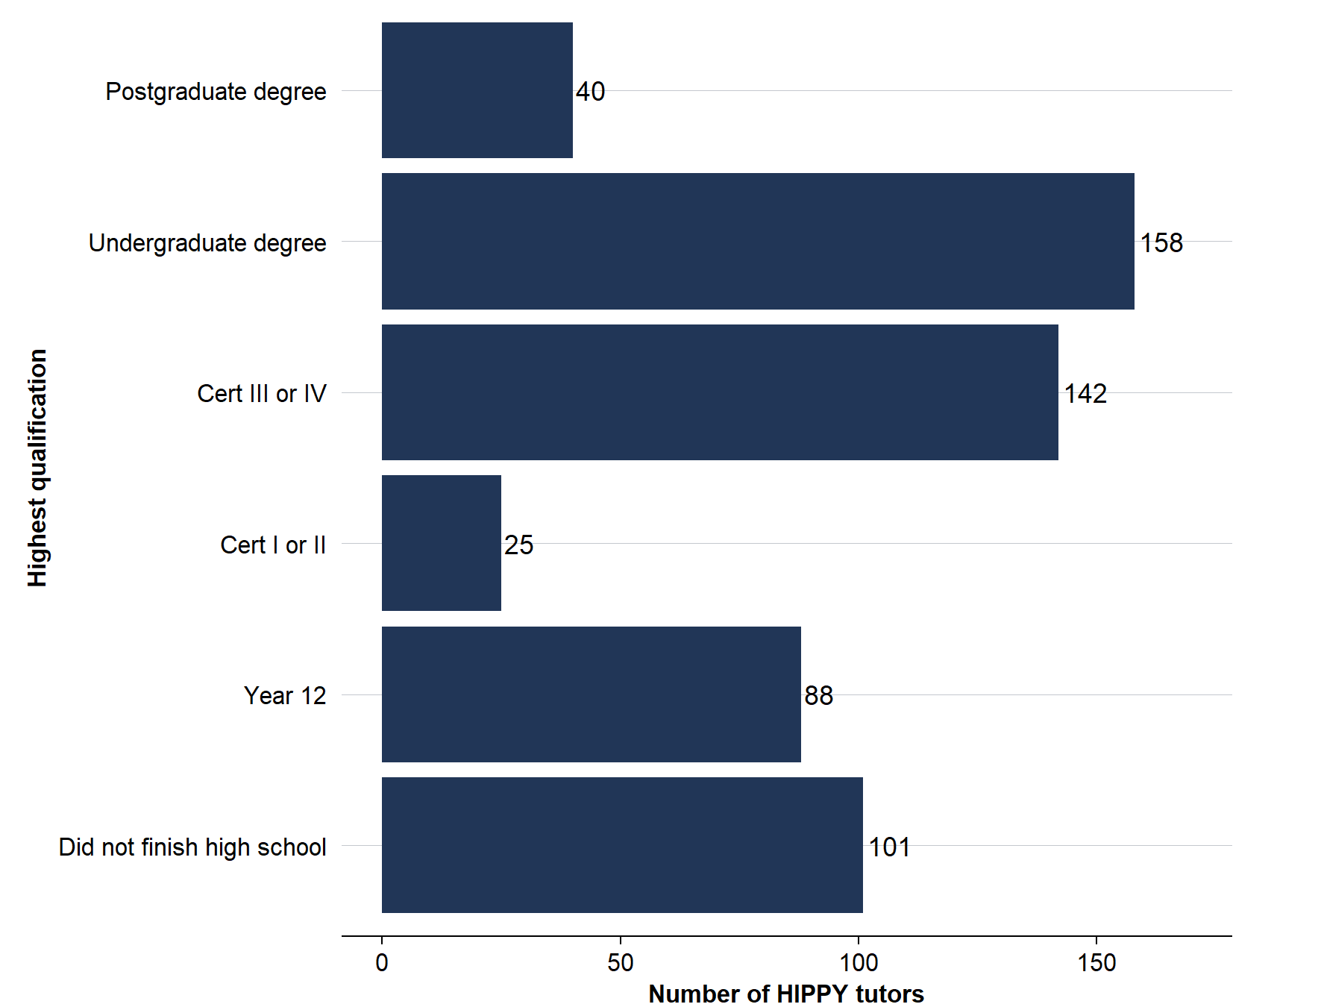
Source: BSL program data.

Employment and training
Many HIPPY tutors were studying at the time of their exit survey with 30% of those for which there is data studying and a further 14% planning to study (Figure 12).
Figure 12: Tutors’ education and training activity at the time of their exit survey, 2018–‍2025
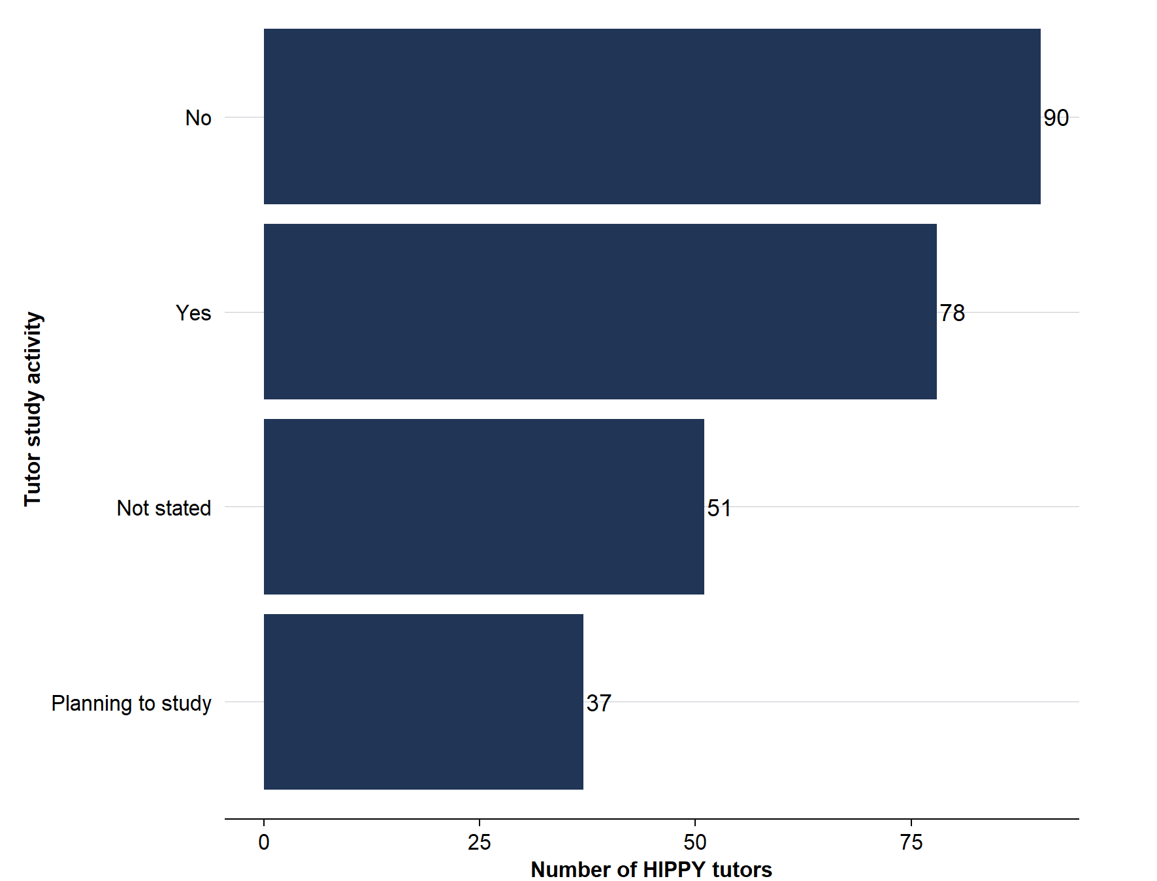
Source: BSL program data.
Most tutors were studying for a Certificate III or IV or an undergraduate degree at the time of their exit survey (Figure 13). The most common areas of study were education and training, community services and development, and administration and office support (Figure 14).
Figure 13: Type of education / training tutors were undertaking at the time of their exit survey, 2018–‍2025
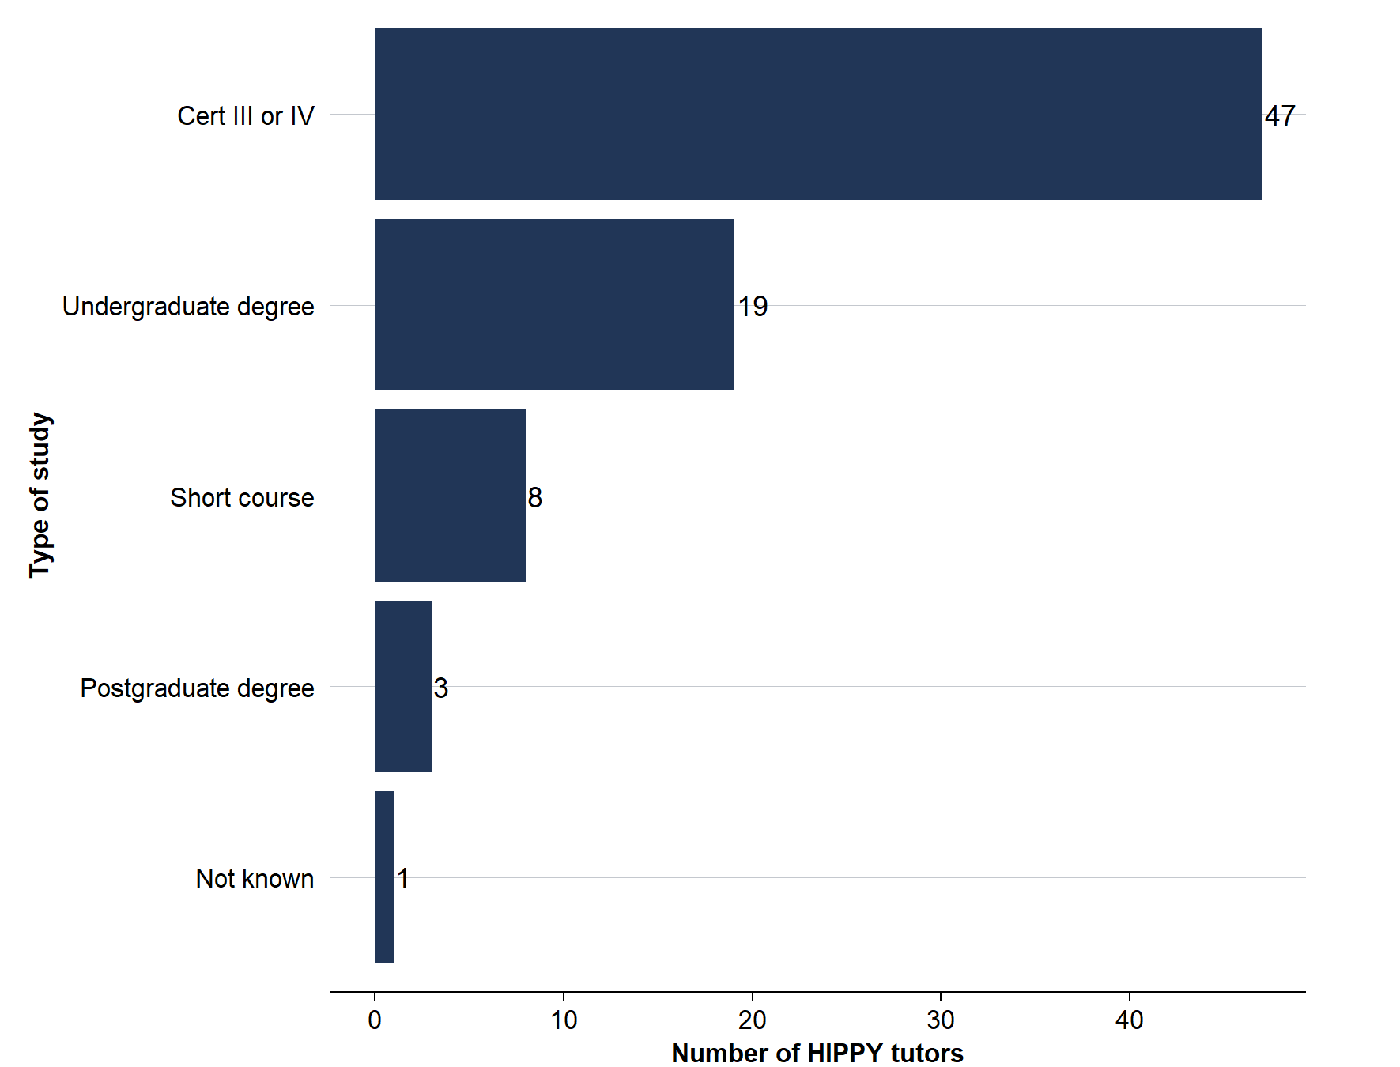
Source: BSL program data.
Note: This is only for tutors actively studying, not those planning to study.
Figure 14: Field of study for tutors at the time of their exit survey, 2018–‍2025
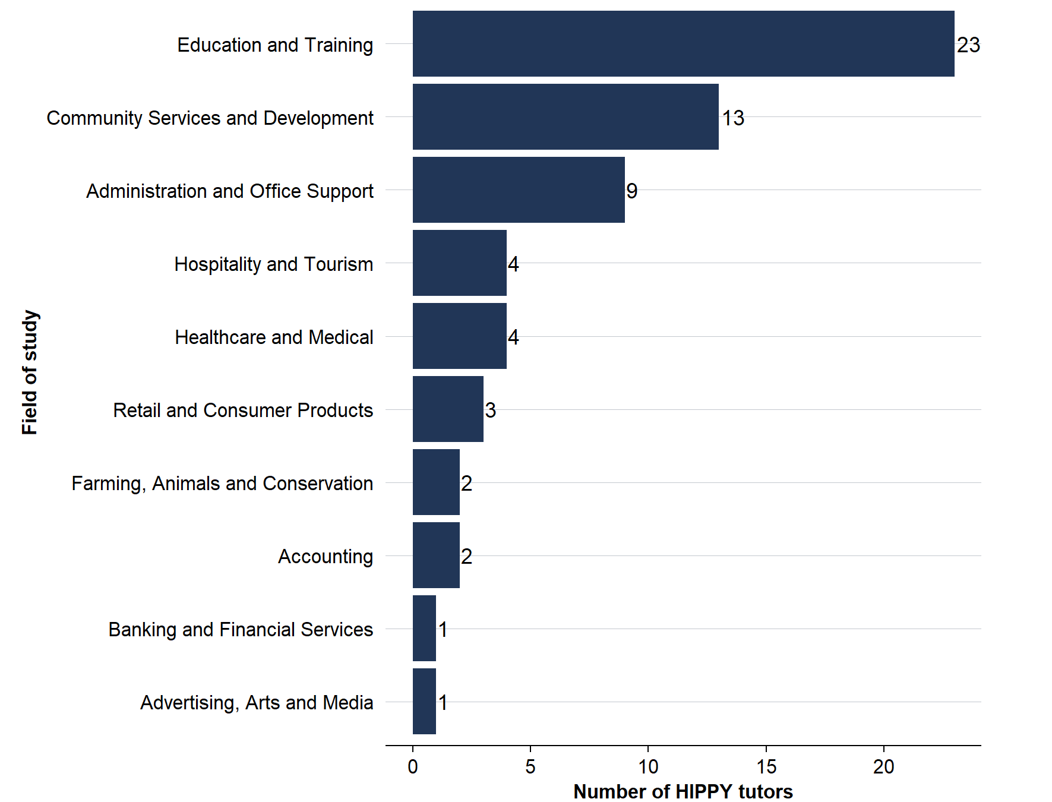
Source: BSL program data.
Note: This is only for tutors actively studying, not those planning to study. Note there is a large amount of missing data here because BSL started collecting more data over time. The ‘field of study’ was information that was only collected relatively recently.
Most HIPPY tutors did not have other jobs during the program (Figure 15). After leaving the program, 74% of tutors were looking for or had found a job. Of that group, 29% were still looking for work while the rest had found a job. Of those who found a job and who provided information on their employer in the exit survey, 39% of tutors found a job in the HIPPY provider organisation either working directly on HIPPY or in another capacity.
Figure 15: HIPPY tutors – other employment during the program, 2018–‍2025
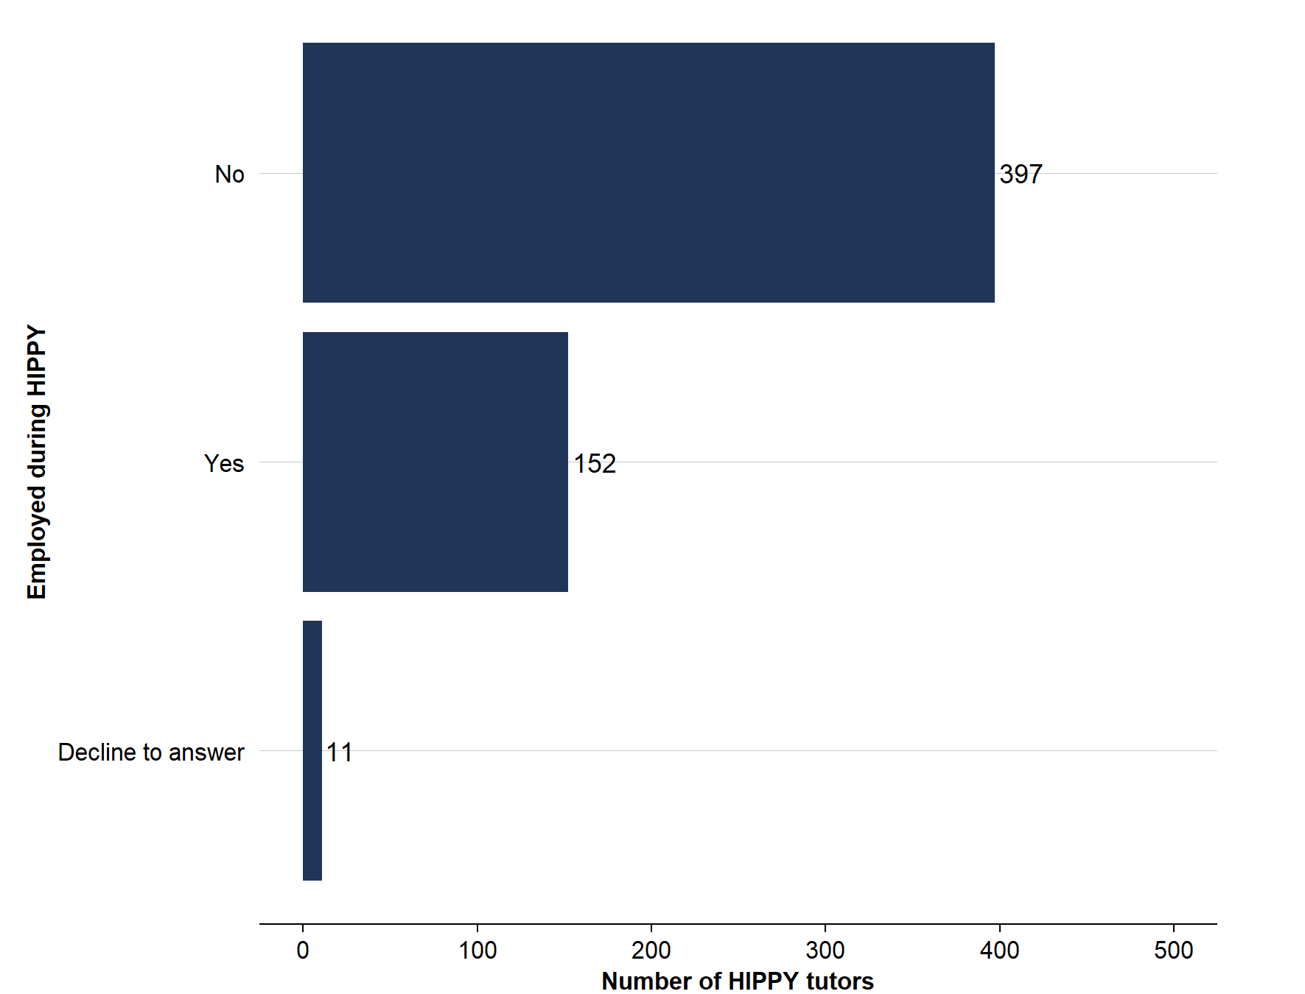
Source: BSL program data.
In the absence of a comparison cohort or a counterfactual estimate it is hard to know how much HIPPY improved the employability of tutors. However, given how important provider organisations were as employers of tutors after they finished the program, it seems likely that at least in some cases HIPPY opened up job opportunities in provider organisations.

Appendix A – Data used and limitations
This report used several data sources from within the ACE’s PLIDA project, titled Australian Public Policy Evaluations using Experimental or Quasi-Experimental Methods (Project number: 20240357), which covered different time periods and had different limitations. This appendix lists the data used for each calculation in full and comments on any limitations in the data. The DEX data does not clearly separate children from parents/carers. Consequently, for the purposes of this report, a child was defined as a participant under 10 years while an adult was defined as a participant over 17 years. Those aged between 10 and 17 were excluded from the sample as their role was unclear.
Section 1 – data sources, notes and sample size
Statistic | Data source | Measurement time and notes | Size of HIPPY sample
Aboriginal and/or Torres Strait Islander | 2021 Census | 2021 | 10,562
Language used at home not English | 2021 Census | 2021 | 10,673
Single parent family | 2021 Census | 2021 | 10,447
Child has special needs | 2021 Australian Early Childhood Development Census | 2021 (for those starting school that year so roughly the 2019 HIPPY cohort only) | 1632
Parent has a disability | 2021 Census | 2021 | 10,444
Child resides with a carer or in out-of-home care | 2021 Census | 2021 | 10,431
Family income is mostly government benefits | Tax returns | Financial year HIPPY participant started HIPPY. 2017–‍18 to 2020–‍21 only. | 6516
Family has no income | Tax returns | Financial year HIPPY participant started HIPPY. 2017–‍18 to 2020–‍21 only. Those who did not lodge a return are treated as having zero income. | 6516
Child is covered by a healthcare card | DOMINO | Financial year HIPPY participant started HIPPY. 2017–‍2023. | 10,673
Number of priority classifications | All datasets used for individual measures. | Time depends on each separate measurement. Most individuals lack data on special needs due to not being in an AEDC cohort. Those in a year missing tax data or who have missing data for another reason (aside from ‘special needs’) are excluded. | 6326

Sections 2–‍5 – data sources, notes and sample size
Statistic | Data source | Measurement time and notes | Size of HIPPY population with valid data
Activities for those with completion (Section 2) | DEX | The total activities analysis in Figures 4 and 5 was based on the number of activities recorded from 2020 to 2023.  Analysis based on completion status in Figure 6 used only the 2020 and 2021 cohorts as these groups had sufficient time to complete the program within the period for which data was available. | 5175 adults,  4403 children
SCORE (Section 3) | DEX | Varies significantly by measure but no measures outside 2020 to 2023. | Varies from 9278 assessments of community participation & networks post program, to 191 for changed skills post program.
Other DSS programs participants accessed (Section 4) | DEX | 2017 to 2023. | Coverage levels unclear (as it is not possible to know who was not covered and who just did not use any services). 6539 uses of services recorded for adults and 3707 for children.
Tutor analysis (Section 5) | BSL program data | 2018 to 2025. | 586 tutors

Appendix B – HIPPY activities: excerpts from DEX program-specific guidance
This is a table excerpted from DSS’s program-specific guidance from 2020 on entering HIPPY data into DEX. This categorises different activities and covers the period for which we have valid completions data. This covers 3 iterations of the guidance. The May 2020 guidance was in place through most of the period covered in this report. However, the classification was substantially overhauled in August 2022 and later in February 2023.
January 2017 activities
Service Type | Example of service type use within this program activity
Intake and Assessment | Family Enrolment and/or tutor employment.
Information / Advice / Referral | Group meetings, family contact, individual information provision and/or service connection.
Education and Skills training | Tutor Training (HIPPY program content/curriculum) and/or group meetings (where the enrichment topic relates to parents receiving employment and study skills pathways).
Community Capacity Building | Group meetings (where the enrichment topic relates to events or cultural celebrations such as HIPPY week, harmony day, graduation, seasonal holidays, NAIDOC week), HIPPY events.
Family Capacity Building | Home visits.
Facilitate Employment Pathways | Tutor Journey (professional development and training).

May 2020 activities
Service Type | Example
Intake and assessment | This service type is used for “Family Baseline Enrolment Journey” when the Site Coordinator meets with a HIPPY Parent/Carer/Child and completes an enrolment form and baseline journey (assessment) for measurement of the child/family and community outcomes and can be used for SCORE.
Information/Advice/ Referral | This service type is used when a HIPPY Parent/Carer/Child receives general information while attending a group meeting during enrichment.  It can also be used when a HIPPY Parent/Carer/Child receives individualised specific information or a referral/service connection as part of family engagement with HIPPY.  Note: HIPPY promotional events attended by the general public such as information sessions and community participation events are to be reported via Activity Work Plans.
Education and skills training | This service type is used when a HIPPY Parent/Carer/Child receives specific information while attending a group meeting during enrichment, such as computer skills/digital literacy/online safety or new skills and interests for HIPPY parents.  It can also be used when a HIPPY Tutor is undertaking education and skills training activities, including:  - tutor training (HIPPY program content/curriculum)  - supervised home visits and tutor reflection  - tutor professional development
Community capacity building | This service type is used when a HIPPY Parent/Carer/Child is attending group meetings where the enrichment topic relates to community capacity building, such as:  - safety (for example, child safety, fire safety, road safety, police safety)  - diversity and culture  - events, field trips and excursions  - getting to know the community, programs and services.  Note: HIPPY promotional events attended by the general public such as information sessions and community participation events are to be reported via Activity Work Plans.
Core component completed | This service type is used to assess that a HIPPY participant has completed core components of the program at the time of the session. This would also be the point in time where an exit interview or SCORE outcomes assessment would take place.
Family capacity building | This service type is used for home visits to a HIPPY family where a HIPPY Parent/Carer/Child receives delivery of the HIPPY curriculum via the HIPPY activity packs. It can also be used when a HIPPY Parent/Carer/Child receives information while attending a group meeting where the enrichment topic relates to family capacity building, such as:  - transition to school  - creative activities for the family  - early childhood development  - early literacy and numeracy  - family health, nutrition, behaviour and wellbeing and parenting techniques.

May 2020 activities (continued)
Service Type | Example
Facilitate employment pathways | This service type is used for group meetings with a HIPPY.  Parent/Carer, where the enrichment topic relates to employment and study skills pathways such as “employment/study seeking”.  It is also used when a HIPPY Tutor engages in the Pathways to Possibilities process, including:  - tutor professional development and training.  - Tutor Pathways to Possibilities (skills development activity)  - Tutor Pathways to Possibilities (review).
Service review | This service type is used to establish, through contact/time spent with the client, that they will no longer be considered an active participant, even though core components of the program may have not been completed. An exit interview and a SCORE assessment may also occur.  Note: this service review requires direct contact with the client (in person, by phone, or other form of interaction). It should not be used when there has not been direct contact with the client which could enable such a review.

August 2022 activities
Service Type | Example
Intake and assessment | This service type is used for “Family Baseline Enrolment Journey” when the Site Coordinator meets with a HIPPY Parent/Carer/Child and completes an enrolment form and baseline journey (assessment) for measurement of the child/family and community outcomes and can be used for SCORE.
Information/Advice/ Referral | This service type is used when a HIPPY Parent/Carer/Child receives general information while attending a group meeting during enrichment.  It can also be used when a HIPPY Parent/Carer/Child receives individualised specific information or a referral/service connection as part of family engagement with HIPPY.  Note: HIPPY promotional events attended by the general public such as information sessions and community participation events are to be reported via Activity Work Plans.
Education and skills training | This service type is used when a HIPPY Parent/Carer/Child receives specific information while attending a group meeting during enrichment, such as computer skills/digital literacy/online safety or new skills and interests for HIPPY parents.  It can also be used when a HIPPY Tutor is undertaking education and skills training activities, including:  - tutor training (HIPPY program content/curriculum)  - supervised home visits and tutor reflection  - tutor professional development
Community capacity building | This service type is used when a HIPPY Parent/Carer/Child is attending group meetings where the enrichment topic relates to community capacity building, such as:  - safety (for example, child safety, fire safety, road safety, police safety)  - diversity and culture  - events, field trips and excursions  - getting to know the community, programs and services.  Note: HIPPY promotional events attended by the general public such as information sessions and community participation events are to be reported via Activity Work Plans.
Core component completed | This service type is used to assess that a HIPPY participant has completed core components of the program at the time of the session. This would also be the point in time where an exit interview or SCORE outcomes assessment would take place.

August 2022 activities (continued)
Service Type | Example
Family capacity building | This service type is used for home visits to a HIPPY family where a HIPPY Parent/Carer/Child receives delivery of the HIPPY curriculum via the HIPPY activity packs.  It can also be used when a HIPPY Parent/Carer/Child receives information while attending a group meeting where the enrichment topic relates to family capacity building, such as:  - transition to school  - creative activities for the family  - early childhood development  - early literacy and numeracy  - family health, nutrition, behaviour and wellbeing  - parenting techniques.
Facilitate employment pathways | This service type is used for group meetings with a HIPPY Parent/Carer, where the enrichment topic relates to employment and study skills pathways such as “employment/study seeking”.  It is also used when a HIPPY Tutor engages in the Pathways to Possibilities process, including:  - tutor professional development and training  - Tutor Pathways to Possibilities (skills development activity)  - Tutor Pathways to Possibilities (review).
Service review | This service type is used to establish, through contact/time spent with the client, that they will no longer be considered an active participant, even though core components of the program may have not been completed. An exit interview and a SCORE assessment may also occur.  Note: this service review requires direct contact with the client (in person, by phone, or other form of interaction). It should not be used when there has not been direct contact with the client which could enable such a review.

February 2023 activities
Service Type | Example
Intake and assessment | This service type is only used for ‘Family Baseline Enrolment Journey’ when the Site Coordinator meets with a HIPPY Parent/Carer/Child and completes an enrolment form and baseline journey (assessment) for measurement of the child/family and community outcomes and can be used for SCORE.  Note: also use this service type when a Tutor has a ‘Staff Demographic information’ submitted  Note: if a HIPPY Parent/Carer/Child is not continuing into commencement; whether because they are not sure they want to continue or their circumstances may have changed, the Coordinator may engage in additional support-related activities before delivery to support their enrolment. These are to be recorded as the Information/Advice/Referral service type, even if unsuccessful in keeping them in the program.
Information/Advice/Referral | This service type is used when a HIPPY Parent/Carer/Child receives individualised specific information or a referral/service connection as part of family engagement with HIPPY.  Note: report HIPPY promotional events attended by the general public such as information sessions and community participation events via Activity Work Plans.
Child Focused Activity | This service type is used for the sessions that involve activities that specifically focus on the HIPPY child, such as the delivery of HIPPY activity packs.
Community capacity building | This service type is not used.  Note: HIPPY promotional events attended by the general public such as information sessions and community participation events are to be reported via Activity Work Plans.
Parenting Programs | This service type is used when a HIPPY Parent/Carer attends a ‘standard’ HIPPY group meeting or gathering.
Service review | This service type is used when a HIPPY participant has completed year one of HIPPY, regardless of whether they continue on to year two of program or exit HIPPY at that time without completing the core components of the program.  If the HIPPY participant is exiting before commencing year two of HIPPY, an exit interview and SCORE assessment should be completed.  Note: This service review requires direct contact with the client (in person, by phone, or other form of interaction). It should not be used when there has not been direct contact with the client which could enable such a review.
Core component completed | Completion of year two of HIPPY: This service type is used to assess that a HIPPY participant has completed all the core components of the program at the time of the final session signifying the participant has completed year two of HIPPY.  Note: This would also be the point in time where an exit interview or SCORE outcomes assessment should be completed.

February 2023 activities (continued)
Service Type | Example
Education and skills training (for Tutors) | This service type is used when a HIPPY Tutor is undertaking education and skills training activities, including tutor training (HIPPY program content/curriculum), and supervised home visits and tutor reflection
Facilitate employment pathways | For Tutors Only: This service type is used when a HIPPY Tutor engages in the Pathways to Possibilities process, including:  - tutor professional development and training  - Tutor Pathways to Possibilities (skills development activity)  - Tutor Pathways to Possibilities (review)  - Tutor Pathways to Possibilities (plan)  HIPPY tutors participate in the Pathways to Possibilities (P2P) program, which was specifically designed by HIPPY Australia to structure the coaching and mentoring provided to home tutors by site coordinators. Distinct from the training that prepares tutors to undertake home visits and deliver the integrated parental support and early learning program, P2P focuses on preparing tutors for future employment.
Tutor training completed | For Tutors Only: This service type is used when a HIPPY tutor has done a staff exit survey.

For more details on the Person Linkage Spine, see: https://www.abs.gov.au/about/data-services/data-integration/person-linkage-spine
Some of these individual records may be duplicates so the actual number of unique HIPPY children missing from the analysis will be less than this number. The number of individuals in the data differs from the impact evaluation report as the 2 reports draw on different sets of linked data and because of data availability cover different years.
The regions were defined as ‘Statistical Area Level 3’ (SA3) in the ABS’s statistical geography. These regions generally have a population of 30,000 to 130,000 and are designed to correspond to the area served by a regional city or a large urban local government area. There are 359 SA3s in Australia: as at early 2026, HIPPY served 109 SA3s. This analysis only covers 104 SA3s because it relies on data that lags several years behind the present.
The DEX data does not clearly separate children from parents/carers. Consequently, for the purposes of this report, a child was defined as a participant under 10 years while an adult was defined as a participant over 17 years. Those aged between 10 and 17 were included from the sample as their role was unclear.
HIPPY priority criteria refer to the main language not being English. However, the census does not specifically ask about the ‘main’ language spoken so this report instead uses responses to the question ‘does Person X use a language other than English at home’. Details on the specific variable can be found at: https://www.abs.gov.au/census/guide-census-data/census-dictionary/2021/variables-topic/cultural-diversity/language-used-home-lanp.
The AEDC ‘special needs’ indicator was used to account for children with developmental delays or disabilities. However, this indicator captures a broader population, including children with a range of chronic medical, physical, or developmental conditions.
This activity was redefined after the period in which this data was collected to only focus on tutor activities.
Completion status was based on whether a participant had ‘core component completed’ as an activity in DEX. This meant they had completed Year 2 of HIPPY.

