

An impact evaluation of the Home Interaction Program for Parents and Youngsters (HIPPY)
July 2026
Ramethaa Pirathiban, Vera Newman, Patrick Rehill, Scott Copley, Harry Greenwell and Eleanor Williams
© Commonwealth of Australia 2026
ISBN: 978-1-923278-62-2
This publication is available for your use under a Creative Commons Attribution 4.0 International licence, with the exception of the Commonwealth Coat of Arms, the Australian Centre for Evaluation logo, photographs, images, third party materials, materials protected by a trademark, signatures and where otherwise stated. The full licence terms are available from https://creativecommons.org/licenses/by/4.0/legalcode.
Use of Australian Government material under a Creative Commons Attribution 4.0 International licence requires you to attribute the work (but not in any way that suggests that the Australian Government endorses you or your use of the work).
Australian Government material used ‘as supplied’
Provided you have not modified or transformed Australian Government material in any way including, for example, by changing the Australian Government text; calculating percentage changes; graphing or charting data; or deriving new statistics from published Australian Government statistics – then the Australian Government prefers the following attribution:
Source: Pirathiban R, Newman V, Rehill P, Copley S, Greenwell H and Williams E (2026) An impact evaluation of the Home Interaction Program for Parents and Youngsters (HIPPY), the Australian Centre for Evaluation, the Australian Treasury.
Derivative material
If you have modified or transformed Treasury material, or derived new material from those of the Treasury in any way, then Treasury prefers the following attribution:
Based on The Commonwealth of Australia data.
Use of the Coat of Arms
The terms under which the Coat of Arms can be used are set out on the Department of the Prime Minister and Cabinet website (see www.pmc.gov.au/government/commonwealth-coat-arms).
Other uses
Enquiries regarding this licence and any other use of this document are welcome at:
Manager
Media Unit
The Treasury
Langton Crescent
Parkes ACT 2600
Email: media@treasury.gov.au
In the spirit of reconciliation, the Treasury acknowledges the Traditional Custodians of country throughout Australia and their connections to land, sea and community. We pay our respect to their Elders past and present and extend that respect to all Aboriginal and Torres Strait Islander peoples.

Acknowledgements
This evaluation was undertaken in collaboration with the Department of Social Services. The authors would like to thank all members of the working group for their contributions to this evaluation. The Australian Centre for Evaluation would also like to acknowledge the contributions of the Parenting Research Centre, IPS Management Consultants and Curijo to the data collection for the evaluation, and the generous support of Home Interaction Program for Parents and Youngsters (HIPPY) participants and site coordinators for sharing their experiences of the program. Finally, thanks to Max Kulbida (Australian Taxation Office) and Bilal Rafi (Department of Employment and Workplace Relations) for their technical advice.
Disclaimer
The results of the observational study in this report are based, in part, on data supplied to the Australian Bureau of Statistics (ABS) under the Taxation Administration Act 1953, A New Tax System (Australian Business Number) Act 1999, Australian Border Force Act 2015, Social Security (Administration) Act 1999, A New Tax System (Family Assistance) (Administration) Act 1999, Paid Parental Leave Act 2010 and/or the Student Assistance Act 1973. Such data may only be used for the purpose of administering the Census and Statistics Act 1905 or performance of functions of the ABS as set out in section 6 of the Australian Bureau of Statistics Act 1975. No individual information collected under the Census and Statistics Act 1905 is provided back to custodians for administrative or regulatory purposes. Any discussion of data limitations or weaknesses is in the context of using the data for statistical purposes and is not related to the ability of the data to support the Australian Taxation Office, Australian Business Register, Department of Social Services and/or Department of Home Affairs’ core operational requirements.
Legislative requirements to ensure privacy and secrecy of these data have been followed. For access to PLIDA and/or BLADE data under Section 16A of the ABS Act 1975 or enabled by section 15 of the Census and Statistics (Information Release and Access) Determination 2018, source data are de-identified and so data about specific individuals has not been viewed in conducting this analysis. In accordance with the Census and Statistics Act 1905, results have been treated where necessary to ensure that they are not likely to enable identification of a particular person or organisation.

Contents
Key messages 1
Executive Summary 2
Background 2
Evaluation approach 2
Key findings 3
Limitations 4
Conclusions 5
Introduction 6
Impact evaluation overview 8
Data and methods 11
Observational study of linked administrative data 12
BSL program data 14
Parent survey 15
Parent interviews 16
Ethics review and data safety 17
Results 18
Child outcomes 18
Parent outcomes 23
Limitations 32
Observational study of linked administrative data 32
BSL program data analysis 34
Parent survey data 35
Parent interviews 35
Conclusion 36
References 38
Appendix A: Further information on limitations 40
Observational study 40
Parent survey and interview 42

Appendix B: Observational study technical appendix 43
Ethics and pre-analysis plan 43
Data processing and missing values 43
Summary of the study sample 49
Primary/ secondary outcomes analysis 51
Additional analysis 55
HIPPY children who could not be linked to the PLIDA spine 56
Comparison of HIPPY children included, excluded, and unlinked in the observational study 57
Appendix C: HIPPY’s program logic 60
Appendix D: HIPPY site coordinator interviews 62
Summary of the data 62
Analytical approach 62
How do families gain awareness of HIPPY? 63
What factors influence whether a family participates in HIPPY? 65
What factors influence whether a family engages with or completes HIPPY? 68
Further details on site consultation recruitment and consent processes 70
Appendix E: BSL program data, parent survey and interviews 73
Summary of BSL program data and parent survey data results 73
Children’s outcomes 73
Parents’ outcomes 76
Family outcomes 92
PRC parent survey questions relevant to ACE 94
Interview guide 98
Participant Information/Consent Sheet 100
Verbal consent checklist 103

Key messages
Evaluation overview
The Australian Centre for Evaluation (ACE) assessed the impact of the Home Interaction Program for Parents and Youngsters (HIPPY) on children’s and parent’s outcomes.
The evaluation used mixed methods: an observational study of linked administrative data, analysis of HIPPY program data, a parent survey and parent interviews.
Findings
HIPPY likely had a small positive effect on children’s language and cognitive skills but there was no practically or statistically significant effect on other early childhood development domains. Parent survey respondents overwhelmingly reported that HIPPY improved their children’s school readiness however limitations in this evidence meant that this finding was less certain.
HIPPY likely contributed positively to parental engagement with their child’s learning, parental knowledge of how children learn, and parental confidence. There was also some evidence that HIPPY led to improvements in the home-learning environment, at least for some parents.
Key limitations
The observational study using linked administrative data had several limitations.
- The estimated results may have errors due to ‘selection bias’.
- Many children only had partial exposure to HIPPY at the time outcomes data was collected.
- Some HIPPY participants may have been incorrectly placed into the ‘comparison group’ due to administrative data linkage issues.
- The COVID‑19 pandemic may have disrupted HIPPY delivery during the study period.
- The study assessed the HIPPY program delivered between 2018 and 2021 for children aged 4‍–‍5 years, rather than the HIPPY Age 3 program (for children aged 3–4 years), which was introduced in 2023.
- The conventional ‘intent to treat’ approach to the analysis estimated HIPPY’s impact based on actual levels of program participation rather than full program participation.
Survey and interview samples may not be representative of the HIPPY parent population.
For HIPPY program data that tracked changes for children and parents over time, it was not possible to distinguish the impact of HIPPY from childhood development and parental learning that would have occurred anyway.
Conclusions
A plausible explanation for the gap between outcomes for parents and children is that, other than a small effect on language and cognitive skills, HIPPY’s impacts for parents were not large enough to produce a discernible impact on children’s school readiness.
It is also possible, however, that there were improvements in children’s outcomes but limitations in the observational study meant they were not captured in this evaluation.

Executive Summary

Background
The Home Interaction Program for Parents and Youngsters (HIPPY) is a 2-year, structured, early childhood and parent engagement program delivered in the home. It supports parents to be their child’s first teacher by developing their skills, confidence and capacity to create a positive home-learning environment. HIPPY aims to improve children’s readiness for school and parents’ ability to support learning and engagement.
HIPPY is delivered nationally through 100 sites by local not-for-profit organisations under a sub-licence from the Brotherhood of St Laurence (BSL), which holds the sole licence for HIPPY in Australia. Since 2023, all sites have been delivering the new HIPPY Age 3 program, which is offered to children aged 3‍–‍4 years.
The Department of Social Services (DSS) commissioned the Australian Centre for Evaluation (ACE) to conduct an impact evaluation of HIPPY, complementing a separate process evaluation undertaken by the Parenting Research Centre (PRC). ACE’s evaluation assessed whether HIPPY improves outcomes for children and parents, focusing on children’s early development and parents’ confidence, knowledge, behaviours and the home-learning environment.

Evaluation approach
The evaluation used a mixed-methods approach combining administrative data analysis, program and survey data, and interviews:
- Observational study of linked administrative data that compared outcomes for 1,688 children who participated in HIPPY between 2018 and 2021 with similar non-participants. The two groups were compared using ‘inverse probability weighting’. Outcomes were measured through the 2021 Australian Early Development Census (AEDC) across five early childhood development domains.
- BSL program data (cohort commencing in 2023) provided pre-, mid- and post-program measures of parent behaviours, confidence and the parent-child relationship.
- Parent survey (n = 319, HIPPY parents since 2022, conducted in July–August 2025) explored parents’ perceptions of HIPPY’s impact on their engagement, confidence and understanding of their child’s learning.
- Parent interviews (n = 23, HIPPY parents who completed HIPPY Age 3 in 2024, conducted in June‍–‍August 2025) examined how HIPPY influenced parental behaviours, confidence and the home-learning environment.
Ethics approval was obtained from the Macquarie University and PRC ethics committees. All administrative data handling was subject to the Australian Bureau of Statistics’ (ABS) security and confidentiality requirements.

Key findings

Children’s outcomes
HIPPY likely had a small positive effect on language and cognitive skills but there was no impact on other early childhood development domains. HIPPY likely had a small positive impact on children’s ‘Language and cognitive skills’ (an increase of 0.13 points on a 0–10 scale). The evidence suggested that HIPPY had no practically or statistically significant effect on the other four early childhood development domains: communication, emotional maturity, physical health and wellbeing, and social competence. These findings are subject to several limitations that are set out below.
Parent survey respondents overwhelmingly reported that HIPPY improved their children’s school readiness however this conclusion may be due to natural child development. Almost all parents who responded to a survey (96 per cent) reported that HIPPY positively influenced their child’s readiness for school, describing improvements in early literacy, enthusiasm for learning and ability to follow routines. In BSL program data, parents’ ratings of their children’s skills to start school increased over the 2-year program. Parent interview findings were also positive. While encouraging, these findings may not be representative of the broader parent population and could reflect natural child development rather than program effects.

Parents’ outcomes
HIPPY likely had a positive impact on parental engagement with their child’s learning. There is evidence from several sources that HIPPY improved how parents engaged with their child’s education. Teachers rated HIPPY parents as significantly more actively involved with school in supporting their child’s learning (5.8 percentage points higher than comparable parents). And surveyed parents themselves reported spending more time on structured learning, integrating educational play into daily routines, and being more intentional about teaching moments. This finding aligns closely with the program’s design, which emphasises empowering parents as educators.
Almost all responding parents reported that HIPPY improved their understanding of how their child learns. Although the survey was subject to limitations, most parents who responded to the survey reported that HIPPY helped them better understand how their child learns, with 85‍–‍95 per cent saying they gained more knowledge of their child’s learning style. Further, there is a plausible mechanism of how this occurs, as reflected in interview responses where parents described recognising milestones and tailoring play to their child’s interests.
HIPPY had a positive impact on the home learning environment, but this conclusion is less certain than others. Survey respondents described being more intentional and patient in how they engaged their children through everyday activities, and most parents perceived that HIPPY contributed to positive changes. This evidence was more persuasive for specific, practice-based behaviours than for broader measures related to fostering a positive home-learning environment. Parent interviews added some limited support to this conclusion. However, it is inherently complex to ask parents to assess how much HIPPY was responsible for any behavioural changes, which limits the strength of conclusions that can be drawn.
Parents reported that HIPPY improved their confidence. Interviews provided clear examples of how HIPPY had improved parents’ confidence with supporting their child’s learning, and this aligned with the program’s design. This was consistent with data from the survey and BSL program data although both sources were subject to limitations.

Limitations
Each of the four methods used in this evaluation were subject to limitations. These are noted where relevant throughout this report and discussed in more detail in the Limitations section.
The interpretation of the observational study of linked administrative data should take account of the following considerations (and others discussed in the Limitations section). First, the estimated effects may have errors due to selection bias. Second, only 17 per cent of ‘HIPPY children’ had graduated from HIPPY at the time of the AEDC. A further 54 per cent had completed the first year but had not yet graduated. Consequently, the AEDC outcomes may have been measured before the full effects of the program had sufficient time to materialise in children’s development. Third, some ‘HIPPY children’ who started school in 2021 may appear in the comparison group as a total of 1,248 records relating to HIPPY participants between 2018 and 2021 in the Data Exchange (DEX) dataset could not be linked to the PLIDA spine and thus were not included in the list of ‘HIPPY children’. Fourth, HIPPY’s delivery during the relevant period (2018 to 2021) may have been impaired by pandemic lockdowns. Fifth, this analysis related to children aged 4–5 years who participated in HIPPY between 2018 and 2021, rather than the newer ‘HIPPY Age 3’ program that took effect in 2023. Finally, the study used the conventional ‘intent to treat’ approach to the analysis, which estimated HIPPY’s impact based on actual levels of program participation. This provided the most policy-relevant estimate of program effectiveness estimates but will be necessarily lower than estimates conditional on full program participation.
The parent survey collected responses from 319 parents who had participated in HIPPY since 2022, representing a response rate of about 8 per cent. While this response rate may be reasonable for a voluntary survey, the results should be interpreted with caution, as respondents may not be representative of the broader HIPPY parent population. That is, the remaining 92 per cent of parents who did not respond may differ systematically from those who did, and their experiences and perspectives may therefore not be reflected in the findings. Further, the survey responses are self-assessments, with no objective measures or a comparison group to confirm apparent improvements.
The BSL program data on the 2023 HIPPY cohort provided good coverage of HIPPY participants at commencement however did not collect subsequent data from about one-third of families who exited HIPPY before graduation. Further, for some before-and-after comparisons, it is not possible to distinguish the impact of HIPPY from changes that were the result of childhood development or parental learning that would have occurred anyway.
The parent interviews provided deeper insights into parents’ experiences of HIPPY but are not intended to be representative of the broader population. The findings may reflect the experiences of more engaged or positively inclined participants, or they may be influenced by the tendency to answer questions in a way that will be viewed favourably by others.

Conclusions
This impact evaluation adds to the evidence base about the impact of HIPPY Australia. Notably, it is the first Australian evaluation of HIPPY to leverage linked administrative data. The use of an independent, population-wide outcome data source (the AEDC), separate from both the program provider and parents, and a contemporaneous comparison cohort are key strengths of the evaluation.
The evaluation found that HIPPY likely contributed positively to parental engagement with their child’s learning, parental knowledge of how children learn, and parental confidence. It also found some evidence that HIPPY led to improvements in the home-learning environment, at least for some parents. In many cases, these are central to the program’s design and consistent with its theory of change.
In contrast, the evaluation found a small positive effect on one domain of early childhood development – language and cognitive skills – but no effects on the other four domains measured by AEDC. Although most parents reported in the survey that HIPPY improved their child’s school readiness, this evidence was less certain because observed improvements may reflect natural child development rather than program effects.
The new ‘HIPPY Age 3’ program, which was introduced after the period considered in the observational study, may have different results. Future evaluations of HIPPY would be strengthened by using additional outcome data, such as NAPLAN, to assess longer-term impacts beyond the first year of school. Improvements to DEX data linkage and to program data systems would also improve the completeness and reliability of data for evaluation purposes. Nonetheless, this evaluation suggests there may be a gap between improvements in parents’ skills – where HIPPY likely had an impact –and the subsequent outcomes for children, specifically improvements in school readiness. A plausible explanation for this gap is that, other than a small effect on language and cognitive skills, HIPPY’s impacts for parents were not large enough to produce a discernible impact on children’s school readiness. However, it is also possible that there were improvements in children’s outcomes but limitations in the observational study meant they were not captured in this evaluation.

Introduction
HIPPY is a 2-year, structured, home-based parenting and early childhood program. In HIPPY, parents and carers are taught techniques and activities to support them to be their child’s first teacher. It aims to build the confidence and skills of parents to teach their child, foster a positive home learning environment, and prepare their child for school. HIPPY is a voluntary and free program that is designed to be integrated into a family’s daily life.
HIPPY was developed in Israel in the 1960s and has since spread to many other countries. HIPPY was first rolled out in Australia in 1998, commencing in one Victorian site. The program grew over time and is now delivered to 100 sites across Australia, including in remote or very remote locations, and Aboriginal and Torres Strait Islander communities.
HIPPY is a free and voluntary program, meaning that families are not obliged to complete any or all of the HIPPY modules throughout their enrolment in the program. To be eligible for the program, a family must meet both of the following criteria:
- the family has a child who is age-eligible in the year of enrolment
- the family lives in an area where HIPPY is being delivered in the year of enrolment.
In addition to the eligibility criteria, there are several criteria to support priority access to disadvantaged families, including:
- the family holds a Health Care Card
- the HIPPY child is Aboriginal and/or Torres Strait Islander
- the HIPPY child resides in out-of-home care
- the household has no income, or receives a government support payment as their primary source of income
- the family is a single parent family
- the child resides with a carer (not a parent)
- the main language spoken at home is not English
- child has a developmental delay or disability
- parent or carer lives with a disability or long-term health condition.
When HIPPY commenced in Australia, the 2-year program was offered to children aged 4–5 years. However, in 2020, a ‘HIPPY Age 3’ program was piloted to explore the demand for, acceptability and potential impact of commencing HIPPY at age three (versus age four). Following a successful pilot, all 100 sites across Australia transitioned to implementing HIPPY Age 3 from January 2023. The first cohort of HIPPY Age 3 graduated from the program in December 2024, with the Age 3 program continuing for future HIPPY intakes.
The Department of Social Services (DSS) provides funding to the Brotherhood of St Laurence (BSL), as the sole HIPPY licensee within Australia, who sub-contract responsibility for running HIPPY to providers through a sub-licencing agreement. Sites are run by not-for-profit organisations that are local to each of the HIPPY catchment areas.
In 2024, the DSS engaged the Australian Centre for Evaluation (ACE) to conduct an impact evaluation of HIPPY. DSS also commissioned the Parenting Research Centre (PRC) to deliver an evaluation assessing the program’s effectiveness, efficiency, and appropriateness. The two evaluations were intended to complement one another.
To streamline stakeholder engagement and minimise burden, ACE and PRC collaborated on primary data collection. PRC subcontracted IPS Management Consultants and Curijo to support culturally appropriate engagement. These organisations developed and implemented the Cultural Alignment Charter to ensure cultural safety. For the parent survey, questions specific to ACE’s evaluation were incorporated into the survey administered by PRC. Parent interviews for the ACE evaluation were conducted by IPS and Curijo.
Additionally, ACE has undertaken an evidence synthesis on the appropriateness, implementation and impact of HIPPY in Australia, summarising existing literature alongside the current PRC and ACE evaluations (Australian Centre for Evaluation, 2026b).

Impact evaluation overview
This evaluation sought to assess HIPPY’s impact on its intended outcomes, as set out in its program logic, for children, their parents or carers, for families, and for tutors. These outcomes are summarised in Table 1 and the program logic is available in Appendix C: HIPPY’s program logic.
Table 1: Summary of HIPPY’s intended outcomes
Actor | Desired outcomes
Children | Build children’s skills, knowledge and confidence to engage in formal learning  Support children to be socially, cognitively and emotionally ready for school
Parents | Improve parents’ engagement with their child’s learning  Increase parents’ knowledge of how their child learns  Provision of a positive home-learning environment  Increase parents’ confidence to prepare their child for school  Strengthen the parent/child relationship
Families | Support family connections with local services, and increase their confidence in accessing these services  Broaden family social connections  Contribute to an inclusive community that celebrates diversity and respect  Build family confidence and skills to advocate for their child’s education
Tutors | Provide access to and participation in regular training and professional development opportunities  Develop confidence and knowledge and skills in early childhood service delivery  Develop transferrable skills, confidence and knowledge for future employment
Source: adapted from HIPPY’s program logic – see Appendix C: HIPPY’s program logic

In practice, it was not possible to capture family or tutor outcomes within the time, budget and data constraints for this evaluation. Consequently, the key evaluation questions relate to outcomes for children and their parents or carers (hereafter just referred to as ‘parents’).
Key evaluation questions
- Children: Did participation in HIPPY improve:
  - children’s school readiness outcomes, as reflected in the five early childhood development domains in the Australian Early Development Census (AEDC)?
  - parents’ perception of their child’s school readiness?
- Parents: Did participation in HIPPY improve:
  - parental engagement with their child's learning?
  - parental knowledge about how their child learns?
  - the home-learning environment?
  - parents' confidence as educators?

AEDC is a national assessment to examine how children have developed by the time they start school. It looks at five areas of early childhood development: physical health and wellbeing, social competence, emotional maturity, language and cognitive skills, and communication skills and general knowledge. As such, this evaluation used the AEDC domains as indicators of various forms of school readiness. However, HIPPY’s program logic places greatest emphasis on cognitive, social, and emotional readiness for school, which are most directly reflected in three of the AEDC domains.

The outcomes captured in this evaluation and their data sources are summarised in Table 2. See the Data and methods section for details on the data sources and the associated methods.
Table 2: Outcome measures and data sources
Actor | Outcomes | Data source
Children | School readiness outcomes as measured in the AEDC | Linked administrative data
Children | Parents’ perceptions of their child’s school readiness | BSL program data  Parent survey  Parent interview
Parents | Parental engagement with their child’s learning | Linked administrative data  BSL program data  Parent survey  Parent interviews
Parents | Parental knowledge about how their child learns | Parent survey  Parent interviews
Parents | Home learning environment | Parent survey  Parent interviews
Parents | Parents’ confidence as educators | BSL program data  Parent survey  Parent interviews

Data and methods
This impact evaluation drew on four data sources and associated methods:
- Observational study of linked administrative data
- Analysis of BSL program data
- A survey of HIPPY parents
- Interviews with parents.
These data sources and methods are summarised in Table 3, and are discussed in more detail below. This section concludes with a discussion of ethics review and data safety.
Table 3: Overview of the HIPPY impact evaluation data and methods
Element | Description
Observational study of linked administrative data | Analysis of linked administrative data from the Person-Level Integrated Data Asset (PLIDA) to compare children’s outcomes for HIPPY participants, between 2018 and 2021, with a group of similar children not in HIPPY. Outcomes were drawn from the AEDC for 2021 and the sample frame included participation between 2018 and early 2021. The comparison used ‘inverse probability weighting’ (an observational approach that controls for observed characteristics).  Interviews were conducted with HIPPY site coordinators prior to the analysis of the linked administrative data to explore potential sources of selection bias.
BSL program data | Analysis of BSL program data collected from parents in the 2023 HIPPY cohort. This data was collected before commencement (pre), after one year (mid) and at HIPPY graduation (post). This data included parents’ ratings of parenting behaviours, confidence, and the parent-child relationship.
Survey of parents | A survey of HIPPY parents since 2022 to generate information about HIPPY’s impact on parents’: knowledge of their child’s learning style, engagement in learning activities, and confidence, and the parent-child relationship.
Parent interviews | Interviews with HIPPY parents who completed HIPPY Age 3 in 2024 to understand their overall perceptions of the program and how it had influenced their behaviours, home-learning environment, confidence and relationships with their children.

Observational study of linked administrative data
The aim of the observational study was to evaluate the impact of HIPPY on children’s development and school readiness using linked administrative data. The observational study compared HIPPY children (treated group) with similar children in the same communities (comparison group, or counterfactual). The HIPPY program data is recorded in the Data Exchange (DEX), a platform used by DSS for grants program reporting. DEX is linked to other Australian Government administrative datasets in PLIDA. Datasets available within PLIDA were used as the source for outcome data as well as variables used to control for differences between HIPPY and non-HIPPY children.

Outcome variables
The primary outcomes of interest were the five early childhood development domains measured in the 2021 wave of the AEDC. These were:
- communication skills and general knowledge
- emotional maturity
- language and cognitive skills
- physical health and wellbeing
- social competence.
The evaluation also explored three secondary outcomes that were aligned with HIPPY’s program logic: child adaptation to school, the number of domains where the child was assessed as being ‘on track’, and parents’ active engagement with the school.
The ACE selected outcomes from the available administrative data that aligned with HIPPY’s intended outcomes, as outlined in the program logic. However, some outcomes – like skills gained through HIPPY activities – were not available in the administrative data and were therefore not included in this analysis. Children’s love of learning outcomes as recorded in the BSL program data and also available as Australian version of the Early Development Instrument (AvEDI) questions in the AEDC were not captured in this evaluation (see Limitations for more details).

Sample frame
The sample frame for the observational study was based on children who:
- started school in 2021 (when the AEDC was conducted)
- were age-eligible for HIPPY in the preceding period (2018 to 2021)
- lived in areas where HIPPY was delivered, and
- had a PLIDA ‘spine linkage key’.
The final sample comprised 106,427 children, with 1,688 (about 1.6 per cent) in the treated group.
There are several points to note about this sample frame. First, some ‘HIPPY children’ were missing because they did not have a PLIDA spine linkage key. Second, as school starting ages vary across Australian states and territories, children in the sample were aged between four and seven years old in 2021. Most children included in the sample (79 per cent) were four years old in 2020, giving them the potential to participate in about 12–18 months of HIPPY before undertaking the AEDC (which was conducted between May and August 2021).
Finally, children were coded as ‘treated’ if they had enrolled (intake) in the program and received at least one HIPPY home visit or participated in at least one HIPPY educational or community capacity building activity between January 2018 to April 2021. This is consistent with the conventional ‘intent to treat’ approach to observational analysis and provides the most policy-relevant estimate for effectiveness evaluations. However, the implication of this approach is that some children will have completed the full two years of HIPPY while others may have only participated for a few weeks. At the time of the AEDC, only 17 per cent of the ‘HIPPY children’ had completed the full two years of the program and a further 54 per cent had completed at least the first year of the program (but had not yet graduated). That is, 71 per cent had completed the first year or more.
For further discussion of these points, see the Limitations section and Appendix B: Observational study technical appendix.

Method: Inverse Probability Weighting (IPW)
The primary analysis aimed to estimate how effective the program was in terms of the primary and secondary outcomes described above. To do this, the ACE used a statistical method called Inverse Probability Weighting (IPW) combined with a doubly robust approach. This method aims to make a fair comparison between children in the treated and comparison groups by adjusting for differences in their observable characteristics. More information about the analytical approach is provided in Appendix B: Observational study technical appendix.
All outcome definitions and statistical models were pre-specified in a pre-analysis plan (Australian Centre for Evaluation, 2026a) to ensure transparency, and any subsequent deviations were clearly justified. All data cleaning and analysis were carried out within the ABS’ secure DataLab environment, where datasets were made available with all personal identifiers removed. Outputs from the analysis were vetted by the ABS to ensure they were safe and non-disclosive before being released from the DataLab environment for use in this report. This is one aspect of ABS’ approach to keeping integrated data safe.

Selection bias and the Conditional Independence Assumption
The observational study relied on the Conditional Independence Assumption (CIA) – the idea that, after controlling for observable characteristics, treatment assignment is effectively random. In other words, the method assumes that, by controlling for observed characteristics, the risk of ‘selection bias’ was eliminated.
Selection bias could occur if, after controlling for observed characteristics, there remained systematic differences between the ‘HIPPY group’ and the ‘comparison group’ and those differences mattered for HIPPY’s intended outcomes. To explore potential sources of selection bias, prior to analysing administrative data, the ACE:
- considered the program eligibility and priority criteria
- reviewed the existing literature on early childhood program participation, and
- conducted interviews with HIPPY site coordinators.
For more information about the interviews, see Appendix D: HIPPY site coordinator interviews.
Despite these efforts, some unobserved characteristics influencing participation and outcomes may remain. In this case, the observational study would not fully eliminate selection bias. This is discussed further in the Limitations section.

BSL program data
The analysis of BSL program data aimed to build a foundational understanding of how HIPPY has impacted parents’ self-reported behaviours, confidence, and relationship with their children – one of the core areas of focus for this impact evaluation. This analysis also explored the breadth of parent and child experiences within HIPPY to supplement the observational study outlined above, and to overcome some of the limitations of the observational study (discussed in the Limitations section). BSL, as the organisation that runs HIPPY Australia, routinely collects program data from HIPPY participants during program delivery. Information is gathered from participants at three key points:
- Prior to participating in HIPPY: ‘Pre’ data
- At the end of the first year of participating in HIPPY: ‘Mid’ data
- Following graduation from HIPPY: ‘Post’ data
While majority of the data is collected from participating parents via a discussion with their home tutor or the site coordinator, who fills out the relevant questionnaire for them, post-graduation data is often completed by parents themselves. This means that, in most cases, the parent does not complete the form themselves (that is, provide feedback about HIPPY confidentially), and the HIPPY tutor or the site coordinator has direct visibility of the parents’ responses (for further discussion, see the Limitations section).
The data in scope for this impact evaluation was HIPPY program data from the cohort who commenced in 2023, as this is the cohort that had participated in, and finished, the new HIPPY Age 3 program. The BSL data contained a total of 2,629 observations of children for the 2023 HIPPY cohort, and 2,566 observations of parents/families. The ACE understands this is almost all (if not all) parents participating in the 2023 HIPPY cohort. This is a different cohort from the one studied in the observational study. (The time period for the BSL program data was 2023 and 2024, and the children were aged 3-4 years, whereas the observational study considered children who participated between 2018 and 2021, and were aged 4–5 years.)
Although all parents commencing HIPPY in 2023 were likely included in the BSL program data, there was a substantial decrease in sample size between the pre, mid and post-data points. This was largely due to some families dropping out of the program prior to graduation: 32.8 per cent of enrolled children, or 861 children, exited the program prior to graduation from the HIPPY Age 3 program. However, information on the timing of families’ exits from the program was not available in the data.
The BSL program data were used to measure changes from the start through to the completion of HIPPY for the 2023 cohort. The analysis was descriptive only and focused on questions relevant to this impact evaluation, specifically those related to parent outcomes as set out in Table 1. Other analysis of BSL’s program data can be found in the PRC Stream 1 evaluation report (Parenting Research Centre, 2026).

Parent survey
To build on the analysis of BSL program data, ACE designed a parent survey to deepen the understanding of HIPPY’s impact on parents’ outcomes. The survey aimed to generate insights into how HIPPY influences parental knowledge of their child’s learning style, engagement in educational activities at home, and the resulting effects on parents’ confidence and relationships with their children. It was designed to capture a broader range of information than what is routinely collected through BSL’s program data.
The ACE, via PRC, ran the survey of parents who had previously participated in HIPPY or were currently doing so at the time of the survey, between July and August 2025. All communications regarding the survey were passed from PRC to sites via HIPPY Australia. Approximately 4,000 parents who had taken part in HIPPY since 2022 and had consented to being contacted for research purposes were invited to participate in the survey by HIPPY site staff. Parents were invited to participate via email, and parents could choose to consent and participate in the survey if they wished to.
The survey questionnaire was jointly developed by the ACE and PRC, with workshops between ACE, PRC, IPS and Curijo to finalise the wording of the survey questions. The final survey questionnaire can be seen in Appendix E: BSL program data, parent survey and interviews.
The parent survey data contained a total of 319 observations, with 58 per cent of the sample coming from current HIPPY participants. The sample of survey respondents represents 8 per cent of 4,000 invited parents. While this may be reasonable for a voluntary survey, the survey respondents may not be representative of the broader HIPPY parent population (see Limitations section for further discussion).
All data in the survey were analysed descriptively to observe broad patterns. No inferential statistics were undertaken.

Parent interviews
The aim of the interviews with parents across a range of sites was to understand how HIPPY influenced their behaviours, attitudes, and beliefs relating to their child. As with the other approaches, the interviews were intended to build on the BSL program data and the parent survey, contributing to a clearer picture of whether and how HIPPY affects parental outcomes.
ACE, in collaboration with IPS and Curijo, developed the interview questions, with IPS and Curijo supporting the finalisation of the wording of the questions. IPS and Curijo conducted online and in-person interviews with 23 parents (12 online or telephone, 11 face-to-face) from a range of HIPPY sites across Australia between June and August 2025. Parents were eligible to participate if they were part of the 2023 HIPPY Age 3 cohort, which concluded by the end of 2024 and had consented to be contacted for research purposes. This is a different cohort from the one studied in the observational study. The interviewed parents were from the first cohort of the HIPPY Age 3 program with children aged 3–4 years whereas the observational study focussed children who participated between 2018 and 2021 and were aged 4–5 years.
Tutors and site coordinators were responsible for selecting parents for the interview representing diverse demographic characteristics. Interview questions were posed to parents as provided in the Interview guide in Appendix E: BSL program data, parent survey and interviews. Interviews lasted between 40 to 60 minutes.
Prior to commencing the interview, consent was obtained to participate and record the interview for analysis. Parents were provided with the opportunity to raise any questions relating to the interview and the Participant Information/Consent Sheet is provided in Appendix E: BSL program data, parent survey and interviews.
Interviews were recorded, transcribed verbatim and checked for accuracy and anonymised to protect interviewee confidentiality. Interviews were analysed thematically, with themes conceptualised as overarching ideas or concepts that emerged as significant in answering questions relating to the focus of inquiry. IPS and Curijo then collaborated to provide the ACE with a report that outlined the main themes of the interviews and provided descriptions and quotes alongside the themes. This report also began to unpack some of the proposed causal mechanisms, including whether parents ruled out alternative causal mechanisms, directly credited HIPPY, or attributed the findings to specific program activities.
Following receipt of the report on the interviews with parents, ACE considered all the findings and themes and integrated relevant insights into this report.

Ethics review and data safety
This impact evaluation was reviewed and approved by Macquarie University’s human research ethics service (Project ID: 18690). The research that was subject to ethics review included interviews with site coordinators, the administrative data analysis, and analysis of existing BSL program data. It was assessed as ‘low risk’ and so was not subject to further review by one of Macquarie’s human research ethics committees.
The survey of parents and interviews with parents were conducted by PRC and were approved by PRC’s internal human research ethics committee (Application number: App83). ACE researchers were listed as co-investigators on this application.
Datasets from the PLIDA available through the ABS were used in this evaluation. Use of this data asset for this evaluation was approved via the ACE’s PLIDA project titled Australian Public Policy Evaluations using Experimental or Quasi-Experimental Methods (Project number: 20240357).
As the BSL is the sole provider of HIPPY in Australia, releasing outputs from the above-mentioned PLIDA project could indirectly identify the BSL. To enable the observational study, BSL provided its consent to the ABS to publish or disseminate outputs that could indirectly identify BSL as the sole provider of HIPPY, in line with the requirement of section 13(I)(a) of the Census and Statistics (Information and Release) Determination, 2018.
BSL shared de-identified HIPPY program data with the ACE under a data sharing agreement. The data was transferred securely via SigBox, a platform approved for sensitive government information, providing an added safeguard despite the data not containing personal information. The data was stored on a secure internal network drive within the Department of the Treasury and accessed only by the evaluation team. It will be deleted from Treasury’s network drive six months after project completion.

Results
This section presents findings of HIPPY’s impact for children and parents, drawing on the various data sources described above.
For children, HIPPY likely had a small positive effect on one of the early childhood development domains (language and cognitive skills). However, for the other four domains, there was no practically or statistically significant effect. By contrast, some parents who responded to surveys or interviews reported that HIPPY had a positive impact on their child’s school readiness.
For parents, the evaluation found evidence that HIPPY improved parents’ engagement in their child’s learning, their confidence, understanding of how their child learns, and aspects of the home-learning environment – for some parents.
Each of these findings are subject to limitations that are noted briefly where relevant in this section. They are described in more detail in the Limitations section.
The discussion below includes selected quotes from interviews. These come from parents who were interviewed between June and August 2025, all of whom had completed HIPPY Age 3 at the time of the interview.

Child outcomes
HIPPY’s impact on child outcomes was assessed in two ways:
- by comparing the school readiness outcomes in the 2021 AEDC for children who participated in HIPPY with those who did not, based on linked administrative data
- by looking at parents’ perceptions of HIPPY’s impact on their child’s school readiness, based on parent survey data, BSL program data and parent interviews.

HIPPY likely had a small impact on one child development domain only
The evidence across the five early childhood development domains measured in the 2021 AEDC was mixed. The ‘Language and cognitive skills’ domain showed a statistically significant impact however the estimated effect was small: HIPPY children scored 0.13 points higher on a 0–10 scale (0.07 standard deviations) than comparable non-HIPPY children (Figure 1). See Appendix B: Observational study technical appendix for a discussion of the standardised effect sizes and how this effect size compares with findings from similar studies.
For the four remaining domains – communication skills and general knowledge, emotional maturity, social competence and physical health and wellbeing – the evidence suggested that HIPPY had no practically or statistically significant effect (the estimated effect sizes were 0.03 0.07 on a 0–10 scale with tight confidence intervals, see Appendix B: Observational study technical appendix).
Similarly, an aggregated measure recorded how many of the five domains each child was rated as ‘on track’. The evidence suggested that HIPPY had no practically or statistically significant improvement in this measure (the estimated increase was just 0.04 on a 5-point scale, p=0.16 with a tight confidence interval, see Appendix B: Observational study technical appendix).
Finally, the AEDC asked teachers for an assessment of whether a child was making good progress in adapting to the structure and learning environment of school. The evidence suggested that that HIPPY had no practically or statistically significant improvement in this measure (the estimated increase in teachers reporting ‘very true’ was 0.6 percentage points, p=0.30 with a tight confidence interval, see Appendix B: Observational study technical appendix).
Figure 1: Estimated impact of HIPPY on 2021 AEDC domain scores
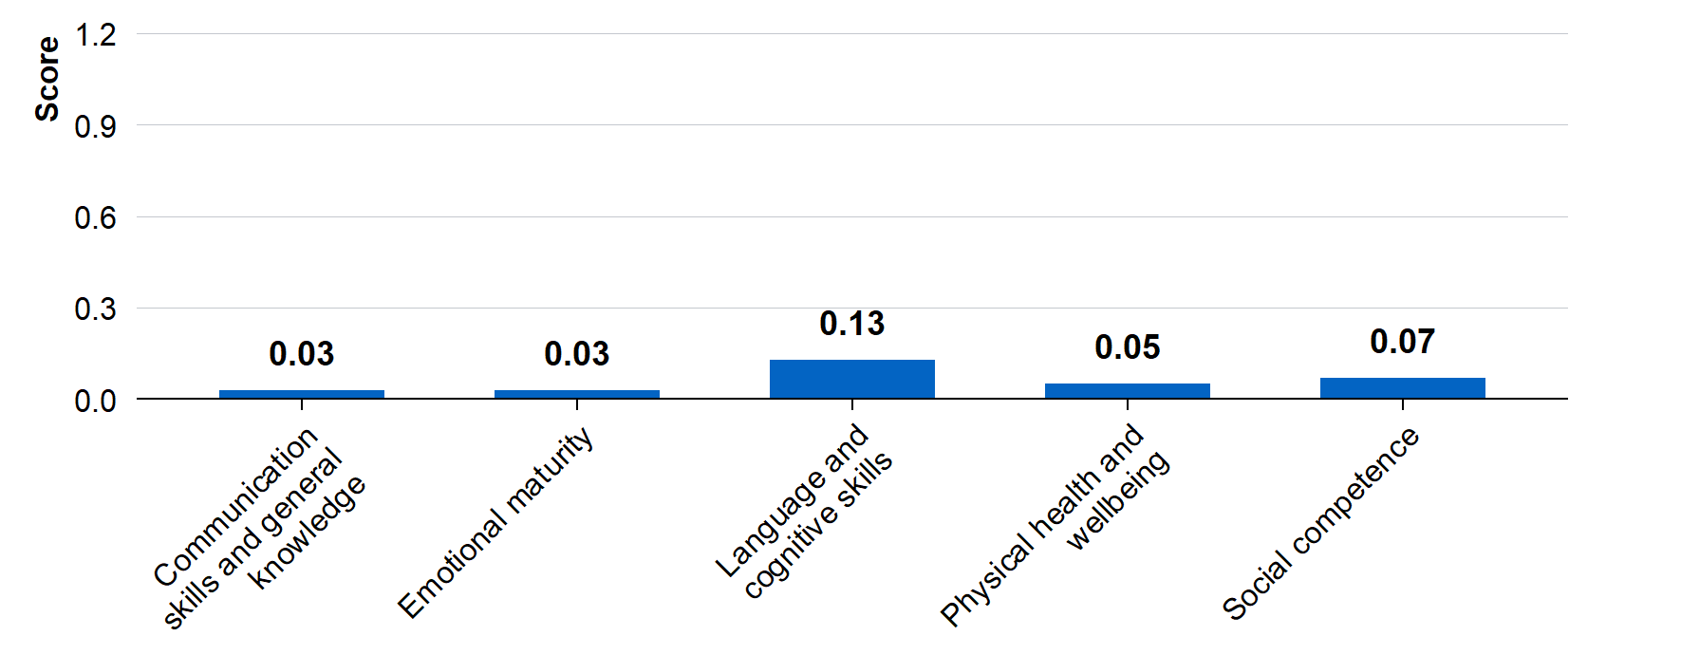
Source: Observational study of linked administrative data using inverse probability weighting.
All AEDC domain scores range between 0 to 10. Only ‘Language and Cognitive Skills’ was statistically significant (p=0.008). Sample sizes: Treatment group ranged from 1,681 to 1,688; Comparison group ranged from 104,368 to 104,718. See Appendix B: Observational study technical appendix for further results.

HIPPY likely had a small positive impact on ‘Language and cognitive skills’. However, there was no practically or statistically significant impact on the other four early childhood domains (nor on secondary outcomes regarding adapting to school or number of ‘on track’ developmental domains).
The analysis using the 2021 AEDC outcomes had some potential limitations. First, it may have been subject to ‘selection bias’. Second, many children in the ‘HIPPY group’ had only completed the first year of HIPPY or more at the time of the AEDC. Third, HIPPY implementation in 2020 and 2021 may have been affected by the COVID-19 pandemic and associated lockdowns. Fourth, some ‘HIPPY children’ who started school in 2021 may appear in the comparison group due to data linkage issues. Fifth, this analysis related to children aged 4–5 years who participated in HIPPY between 2018 and 2021, rather than the newer ‘HIPPY Age 3’ program that took effect in 2023. Finally, the conventional ‘intent to treat’ approach to the analysis estimated HIPPY’s impact based on actual levels of program participation rather than full program participation. For further discussion, see Limitations section.

Parent respondents overwhelmingly reported that HIPPY improved their child’s school readiness. However, this conclusion may be due to natural child development rather than HIPPY itself.
The previous section discussed direct measures of children’s development and teachers’ assessments of how well children had adapted to school. This section considers parents’ perceptions of HIPPY’s impact on children’s readiness to school, based on the parent survey, BSL program data, and parent interviews.
Figure 2: Parent’s perceptions of how HIPPY has changed how ready their child is for school
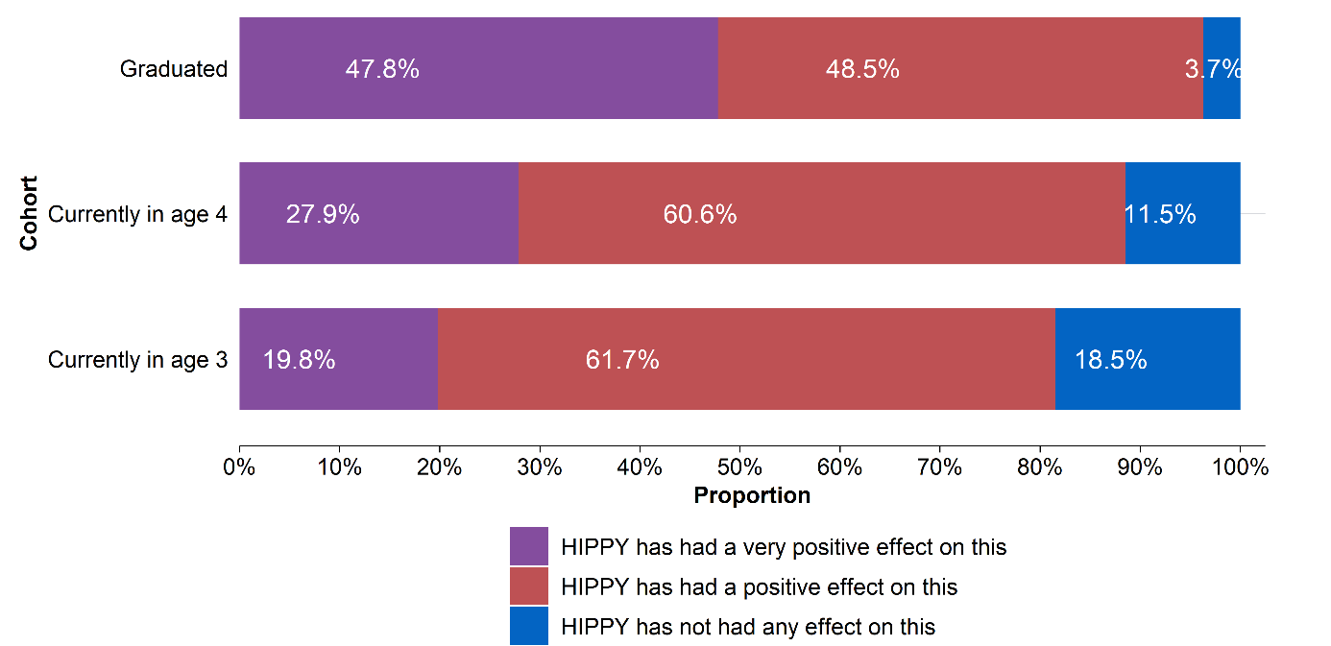
Source: Parent survey
N = 319. Question: How has HIPPY changed how ready your child is for school? Response options: HIPPY has had a very positive impact on this; HIPPY has had a positive impact on this; HIPPY has not had any impact on this; HIPPY has had a negative impact on this; HIPPY has had a very negative impact on this

Figure 3: Parent’s perceptions of children’s skills to start school
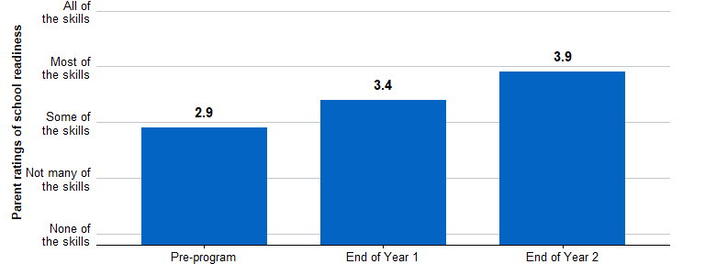
Source: BSL program data
N = Pre: 2,629, Mid: 1,685, Post: 1,478. Question: In terms of your child having the skills they need to start school, would you say your child has; Response options: None of the skills; Not many of the skills; Some of the skills; Most of the skills; All of the skills

The survey of parents asked: How has HIPPY changed how ready your child is for school? For respondents whose children had graduated from HIPPY, 96 per cent reported that HIPPY had a positive effect and, of these, 48 per cent said it had a very positive effect (Figure 2). However, it is inherently difficult for the parents to assess how much HIPPY has contributed to their child’s school readiness compared to the natural child development that would have occurred anyway. Furthermore, survey respondents were a small fraction (about 8 per cent) of the HIPPY parent population from that period, meaning they may not be representative of the broader population.
In the BSL program data, parents were also asked for their perceptions of whether their children had the skills needed to start school. (In most cases, this was collected from parents by the HIPPY tutors or the site coordinators.) On average, parents’ reported ratings of their children’s skills to start school increased over the 2-year program, from an average of 2.9 (3 = some of the skills), to 3.9 (4 = most of the skills) (Figure 3). However, it is unclear how much this would have increased anyway, in response to a child’s natural development over two years.

In interviews, parents typically reported that HIPPY benefitted their children, and they gave several reasons for this.
- Their child learned essential early literacy and numeracy skills through HIPPY. This included recognising numbers and letters, identifying colours and starting to read. Parents cited HIPPY as the reason for these visible advances (which at times exceeded age expectations).
“Tracing the numbers with our fingers… now he recognises and can point out numbers one to five… whereas he couldn’t before HIPPY”
- Their child had an improved enthusiasm to learn as a result of HIPPY. Parents believed their child had developed a positive mindset and attitude toward learning and school that was not previously present. Parents cited HIPPY as the reason for this alteration.
“She loves school. I feel like HIPPY has given HER that passion and love of education, which means she loves going to school now, which I always expected her to be that kid that would try and play sick every day, but she’s not.”
- Their child was better able to navigate and develop routines, share, make friends and transition into new environments. This included preparing children for school-like routines, developing the ability to focus on tasks and introducing practical life skills such as managing self-care, learning personal responsibility and following instructions.
“By coming to the gatherings and having to sit down and listen to say a teacher, read a book for 15 minutes. And then he has to sit, close his legs, put his hands on his knees and focus for a while. […] He has to share, give and take and has to wait his turn. […] So being exposed to new learning that I wouldn’t necessarily do and mixing with other kids”

There is clear evidence that responding parents felt that HIPPY had a positive impact on their child’s school readiness. However, survey respondents may not be representative of the broader HIPPY parent population. Similarly, improvements – between HIPPY commencement and HIPPY graduation – in parents’ perceptions of children’s school readiness skills may be due to natural childhood development over that time. Consequently, this evidence was less certain.

Parent outcomes
This section presents findings on HIPPY’s impact on four outcomes for parents:
- Parental engagement with their child’s learning
- Parental knowledge about how their child learns
- The home-learning environment
- Parents’ confidence as educators.

HIPPY likely had a positive impact on parental engagement with their child’s learning
Parental engagement refers to the type and frequency of in-home and out-of-home activities and behaviours that the parent displays to support their child’s learning. For example, reading to the child, interacting with the child, and using structured learning activities. Evidence on parental engagement comes from all sources used in this evaluation: the 2021 AEDC, the parent survey, parent interviews, and BSL’s program data.
The AEDC asked teachers to assess whether the child has parents who are ‘actively engaged with the school to support their child’s learning’. Example behaviours provided for this outcome included parents reading with their child, speaking to the teacher about their child’s learning or any concerns, and attending parent–teacher information sessions. Although some behaviours are specific to school this question directly relates to how actively parents had engaged with their child’s learning. The observational study indicated that HIPPY had a practically and statistically significant impact on parental engagement with the school. On average, teachers were 5.8 percentage points more likely to respond with ‘very true’ for HIPPY parents than for comparable non-HIPPY parents (p < 0.001, 0.14 standard deviations).
This finding was reinforced by the parent survey, which asked parents how HIPPY has influenced their behaviours. Responding parents indicated that HIPPY had increased or significantly increased the following behaviours (see Figure 13 in Appendix E: BSL program data, parent survey and interviews):
- The length of time they spend on a learning activity with their child: 89 per cent
- The frequency with which they undertake learning activities with their child: 92 per cent
- The range of learning activities they undertake with their child: 94 per cent
- The range of methods they use to support their child: 93 per cent
Very few (6–11 per cent) responding parents reported that HIPPY did not impact, or decreased, these behaviours.

When asked directly about how HIPPY has influenced their behaviours and engagement with everyday learning, parents reported spending more quality one-on-one time because of their participation in HIPPY, being more intentional with how they spend time with their child and deliberately integrating educational activities into the child’s daily routines.
“We’d spend all day together and we just do activities, mostly activities through the HIPPY book.”
“It has literally transformed… the way I used to interact with my children before I started doing HIPPY…”
“We actually do it way more than, like, we used to do it before... She’s really into the activities.”
“Because I wouldn’t have done it like without the routine, you know, without like an outside program.”
In BSL program data, HIPPY parents reported small increases in average frequencies of reading activities and using everyday teaching activities following participation in the first year of HIPPY (Figure 4). It appears there may have been ‘ceiling effects’ on these questions, with many parents responding that they undertook activities on ‘Most days (5–6 days)’ but few responding, ‘Every day’. Consequently, there may have been little room for improvement on this measure on ‘playing with your child’ or, after the first year of HIPPY, on ‘using an everyday activity to teach your child’. Parents also reported slightly higher average ratings of their involvement in their child’s learning following program participation (see Figure 15 in Appendix E: BSL program data, parent survey and interviews).
Figure 4: HIPPY parents’ average rated frequency of certain behaviours
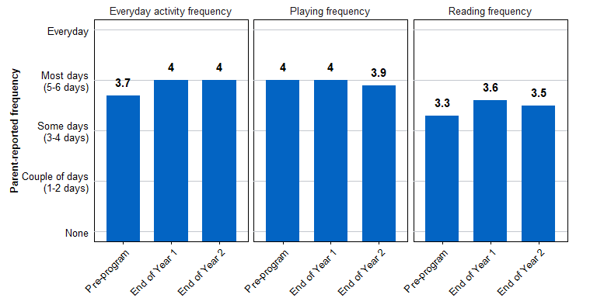
Source: BSL program data
Reading: N = Pre: 2,557, Mid: 1,685, Post: 1,482. Question: During the past week, how often did you read or share stories with your child?
Playing: N = Pre: 2,601, Mid: 1,686, Post: 1,482. Question: During the past week, how often did play with your child?
Everyday activities: N = Pre: 2,589, Mid: 1,690, Post: 1,481. Question: How often do you use an everyday activity to teach your child something new?
All questions: Response options: None; Couple of days (1–2 days); Some days (3–4 days); Most days (5–6 days); Every day

Several sources of evidence suggest HIPPY had a positive impact on parental engagement with their child’s learning. There was a material increase in the proportion of parents that teachers judged were ‘actively engaging with the school to support their child’s learning’, as reported in the 2021 AEDC. Furthermore, parents reported increases in the frequency of everyday learning activities and reading activities (which may have increased anyway but it seems plausible that these increases were largely due to HIPPY).
While the parent survey may not be representative, a large majority of those who responded indicated that HIPPY increased the frequency, duration and range of learning activities they undertook with their child. This finding aligns closely with the program’s design, which emphasises empowering parents as educators.

Almost all responding parents eported that HIPPY improved parental knowledge of how their child likes to learn
The evidence on whether HIPPY helped parents learn about how their child likes to learn came from the parent survey and interviews. (Parental knowledge was not captured in the AEDC or the BSL program data.)
Figure 5: Influence of HIPPY on parents’ understanding of how their child likes to learn
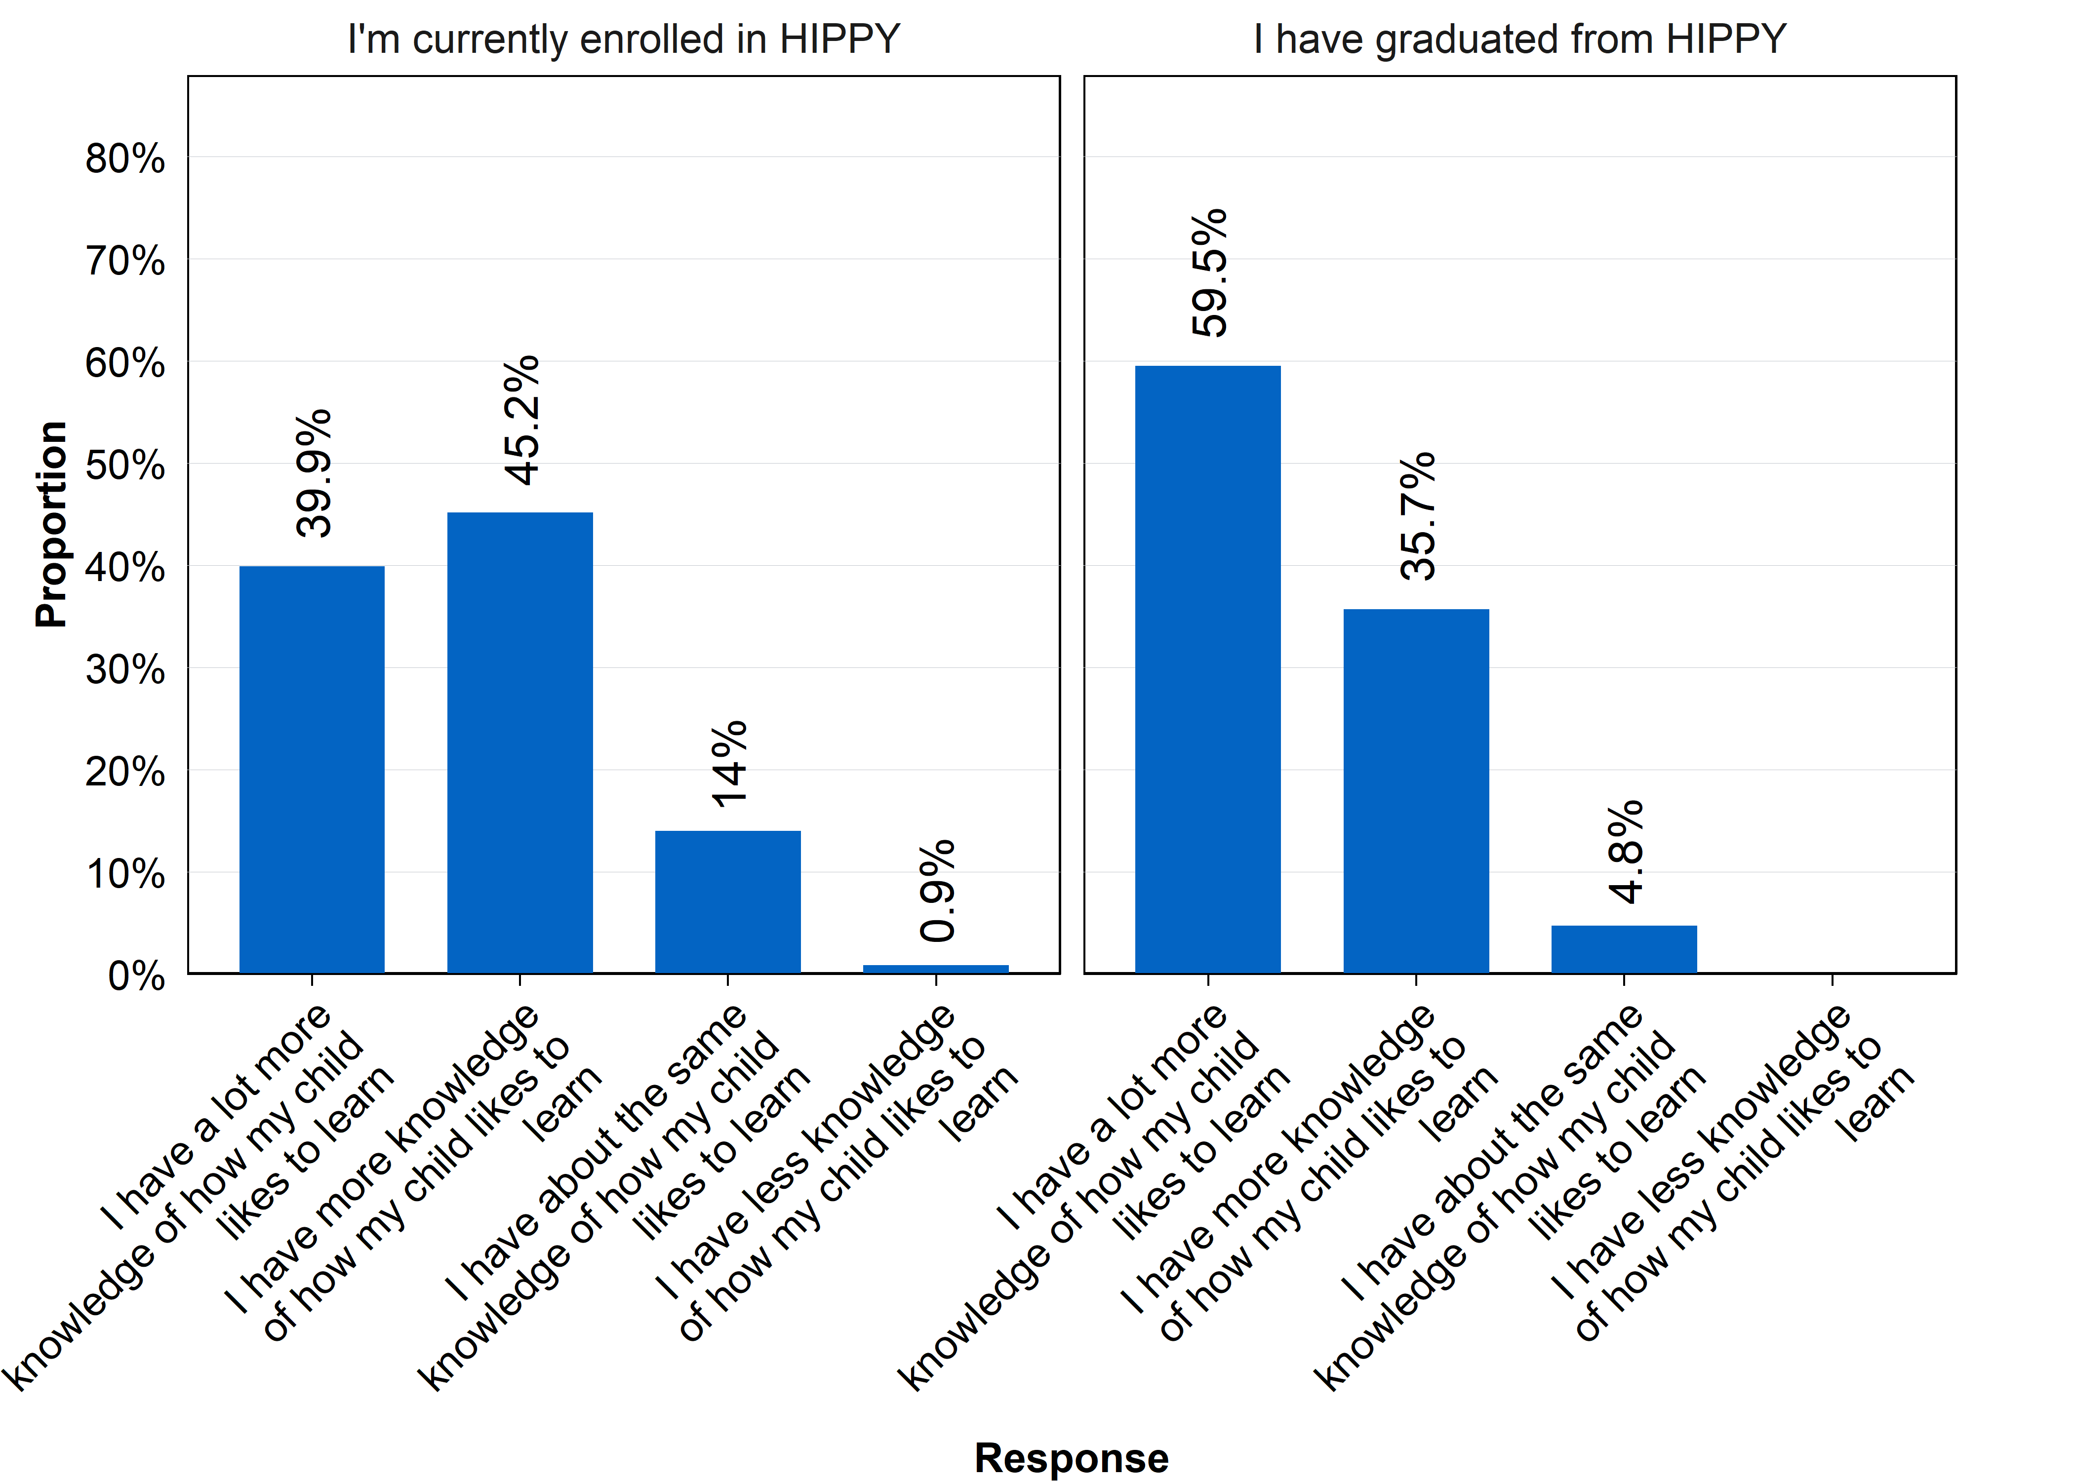
Source: Parent survey
N = 319. Question: How has HIPPY influenced your understanding of how your child likes to learn? Response options: I have a lot more knowledge of how my child likes to learn; I have more knowledge of how my child likes to learn; I have about the same knowledge of how my child likes to learn; I have less knowledge of how my child likes to learn; I have a lot less knowledge of how my child likes to learn.

A large majority of parents responding to the parent survey indicated that they have more or a lot more knowledge of how their child likes to learn because of HIPPY (Figure 5). Notably, 85 per cent of parents currently enrolled in HIPPY reported gaining ‘more’ or ‘a lot more’ knowledge. And for those who had already graduated from HIPPY, the proportion was even higher, at 95 per cent. In addition, the proportion reporting that they had gained ‘a lot more knowledge’ was substantially higher among HIPPY graduates as compared to those still enrolled (60 per cent versus 40 per cent).
Although the survey was likely subject to ‘non-response bias’ (see Limitations for details), the survey results were consistent with interview findings, where parents indicated that they felt they understood more about how children learn, and how to tailor learning activities specifically to their child. Furthermore, interview participants described a plausible mechanism for how HIPPY improved their learning about how their child likes to learn, such as HIPPY’s provision of age-appropriate activities and parent-to-tutor discussions about learning milestones relevant to their children.
For example, interviewed parents reported the following.
- Parents had a better understanding of how play could be used to support their child’s education, and that this could occur anywhere. In particular, parents reported having a greater understanding of both structured and unstructured play, and how to integrate sensory activities and broader developmental skills such as concentration and emotional intelligence into the HIPPY activities and daily life.
“HIPPY has taught me the importance of sensory play and the importance of getting used to the sand and water… There is a reason behind it and even playing with … play doh … That’s a good thing. … It all came just because of HIPPY. I never would have tried that with my girls.”
- Parents had an increased understanding of developmental milestones and age-appropriate activities. Parents reported entering HIPPY with a limited understanding of what milestones their child should be reaching. Through the provisions of age-appropriate learning materials, parents reported feeling more able to recognise and support developmental and educational milestones.
“Once you start getting the packs and you know that obviously those packs are age-appropriate activities that the child should be able to do ... HIPPY was sort of a starting point for me to start learning so much of realisation... learning about the brain development of the child.”
“I had no idea that he need to learn all the basic colours. He need to learn one to ten. He need to learn all the ABC. He need to make sounds. You need to make animal sounds. I had no idea.”
- HIPPY supported them to recognise a child’s interests or other needs, and tailor learning activities to these. The activities provided in HIPPY exposed parents to more ideas and examples of how play and learning could be integrated with a child’s interests or neurodevelopmental needs.
“I think the HIPPY program is like encourage parents to be. To have that focus on […] finding out what, what your child likes. What is he or she good at? What’s his strength? […] if I got like one family that there’s something, something like really likes dinosaur, like big into dinosaurs. So like do counting activities with dinosaurs. Do same and difference with dinosaurs. You know, colouring dinosaurs, you know, everything and everything dinosaurs. And that’s where you get, you know, that’s where you get the kids to actually enjoy doing the learning.”

Most parents who responded to the survey reported that HIPPY improved their learning about how their child likes to learn. Further, there is a plausible mechanism of how this occurs, as reflected in interview responses, such as HIPPY’s provision of age-appropriate activities and parent-to-tutor discussions about learning milestones relevant to their children.

Parents reported that HIPPY had a positive impact on the home-learning environment, but this conclusion is less certain than others
The home-learning environment refers to how the parent engages with their child. For example, it refers to whether the parent listens to and respects the child’s opinion, is sensitive to their needs during educational activities, encourages the child to persevere with difficult activities, and encourages the child to explore and ask questions. The home-learning environment also relates to parents’ displays of warmth, affection and responsiveness towards their children.
The evidence on whether HIPPY helped parents to provide a positive home-learning environment mainly came from the parent survey, although the parent interviews added some insights. (Relevant parental behaviours were not captured in the AEDC or the BSL program data.)
A large majority of parents who responded to the parent survey reported that HIPPY had a ‘positive’ or ‘very positive’ impact on various specific parental behaviours that shape the home learning environment, such as how they engage with their child during learning activities (Table 4). For responding parents who had more experience with HIPPY, a larger proportion agreed that HIPPY had had a positive or very positive impact on the listed outcomes.
The available data predominantly focuses on parents’ behaviour ‘during a learning activity’. However, it does not assess some broader parental behaviours that are relevant to the home-learning environment, such as whether the parent listens to and respects the child’s opinion or encourages the child to explore and ask questions.

Table 4: Parent ratings of HIPPY’s impact on positive home-learning environment behaviours
Question: To what extent do you think HIPPY has influenced: | Response | Per cent
How you interact with your child during learning activities? | Positive / very positive impact | 93.1
How you interact with your child during learning activities? | No impact | 6.3
How you interact with your child during learning activities? | Negative / very negative impact | 0.6
How you show your support to your child during a learning activity? | Positive / very positive impact | 93.4
How you show your support to your child during a learning activity? | No impact | 5.3
How you show your support to your child during a learning activity? | Negative / very negative impact | 1.2
How you encourage the child during a learning activity? | Positive / very positive impact | 93.1
How you encourage the child during a learning activity? | No impact | 5.3
How you encourage the child during a learning activity? | Negative / very negative impact | 1.5
How you manage your own reactions to your child’s behaviour during a learning activity | Positive / very positive impact | 85.0
How you manage your own reactions to your child’s behaviour during a learning activity | No impact | 13.8
How you manage your own reactions to your child’s behaviour during a learning activity | Negative / very negative impact | 1.2
How you show love or warmth to your child? | Positive / very positive impact | 79.0
How you show love or warmth to your child? | No impact | 19.7
How you show love or warmth to your child? | Negative / very negative impact | 1.2
Source: Parent survey
N = 319. Question: To what extent do you think HIPPY has influenced these behaviours? Response options: HIPPY has had a very positive impact on this; HIPPY has had a positive impact on this; HIPPY has not had any impact on this; HIPPY has had a negative impact on this; HIPPY has had a very negative impact on this

In interviews, parents reported that HIPPY supported them to integrate learning into daily activities. Parents also reported they felt more able to embrace types of play that did not come naturally to them (for example, messy or sensory play), to prioritise their child’s learning. However, the extent to which parents reported that HIPPY influenced how they engaged with their child during learning activities (that is, whether they were attentive, warm, encouraging, etc) was limited, even with direct questioning.

Most parents who responded to the survey reported that HIPPY had a positive impact on different aspects of the home-learning environment. Parent interviews added limited support to this conclusion. However, there are limits to the strength of conclusions that can be drawn because the available data did not assess some other parental behaviours relevant to the home learning environment, and it is possible that the parent respondents were not representative of the broader HIPPY parent population.

Parents reported that HIPPY improved their confidence
HIPPY parents consistently reported improved confidence across a range of measures collected in BSL program data, the parent survey and interviews. This included undertaking learning activities with their child, being their child’s first teacher, and supporting their child’s learning.
Evidence from parent interviews highlighted a range of ways in which HIPPY helped to improve parents’ confidence (and it is plausible that HIPPY had a similar effect on many parents). In particular, parents indicated that their confidence improved due to: having access to structured learning materials that had been ‘vetted’ by a reputable organisation; and practicing teaching the materials in ‘the right way’, in a safe environment with their tutor.
“I wouldn’t be as self-confident as a mum ... The tips and tricks, I call it from HIPPY. And that’s an ongoing thing and that’s an everyday thing that I can see in my day-to-day life. It just helps put the things together.”
“HIPPY has expanded my knowledge enough to a level where I can have confidence teaching that to my children.”
Interviewed parents also indicated that HIPPY supported their self-development and community engagement, improving parental empowerment and thereby confidence.
“She [the tutor] helped me with so many things and so many new words myself, before I teach my kids because she’s coming in and she read for me the book the first time and she try and make sure I’m understanding first before I’m teaching my daughter”
“I wasn’t confident in having a voice for my child, which now I do. I’m very confident in speaking up for my child’s education.”
Survey respondents were asked to recall how confident they felt doing learning activities with their child at the beginning of HIPPY. And they were also asked how confident they felt currently (at the time of the survey). The ‘current’ confidence levels were markedly higher than at the beginning of HIPPY (Figure 6). This difference in ‘pre-HIPPY’ and ‘current confidence should, however, be interpreted with caution since the ‘current’ period, for 42 per cent of the parents, was 2–3 years since their child had graduated from HIPPY. The ‘before’ period may have been subject to faulty recall (recall bias). Furthermore, the survey respondents were unlikely to be representative of the broader HIPPY parent population.
Figure 6: Parent confidence doing learning activities
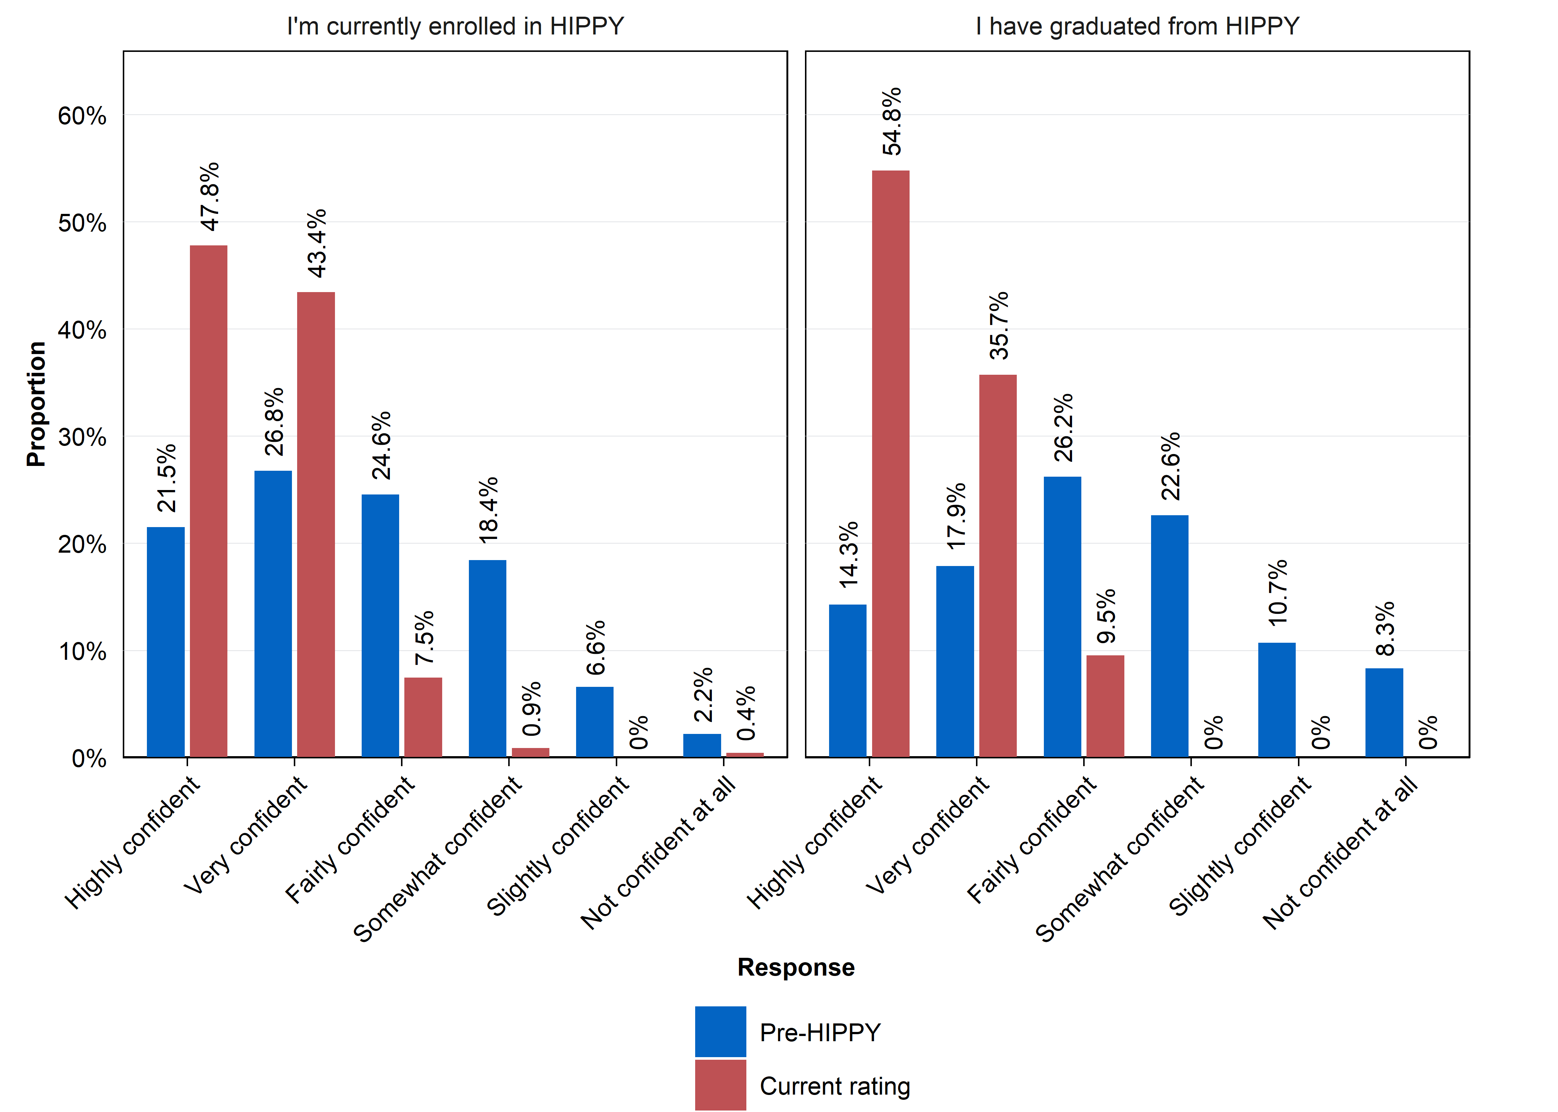
Source: Parent survey
N = 319. Questions: How confident did you feel doing learning activities with your child at the beginning of HIPPY? How confident do you currently feel doing learning activities with your child? Response options: Not confident at all; Slightly confident; Somewhat confident; Fairly confident; Very confident; Highly confident.

Figure 7: Parent’s ratings of their ability to use different methods to teach their child
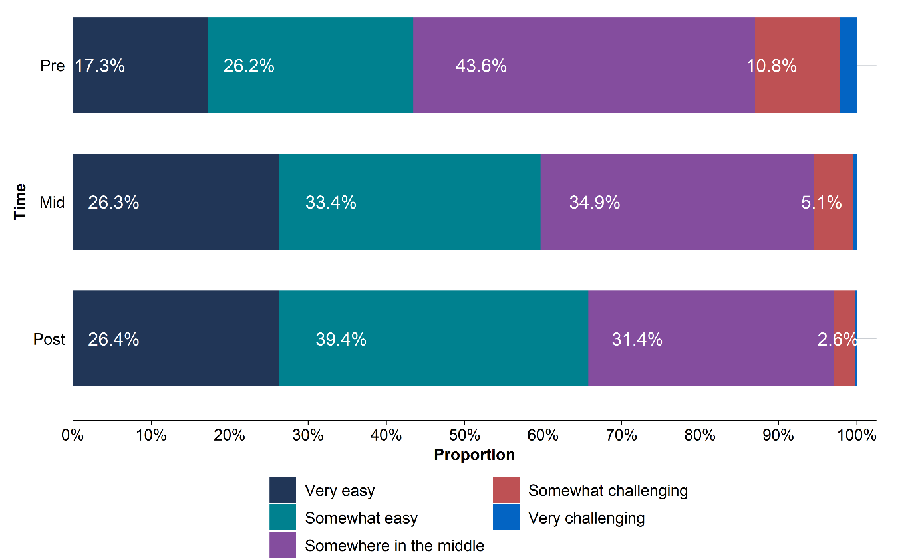
Source: BSL program data
N = Pre: 2,537, Mid: 1,690, Post: 1,480. Question: How would you rate your ability to use a range of ways to teach your child? Response options: Very challenging; Somewhat challenging; Somewhere in the middle; Somewhat easy; Very easy;
Missing data labels for ‘very challenging’: Pre: 2.2 per cent; Mid: 0.4 per cent; Post: 0.3 per cent.

When asked about their perceived ability to teach their child in a range of ways, the proportion saying ’somewhat easy’ or ‘very easy’ increased from commencement to the midpoint through to graduation. However, only 58 per cent of the initial respondents completed the data collection at ‘graduation’, which may have introduced sampling bias due to program attrition (see Limitations).

Interviews provided clear examples of how HIPPY had improved parents’ confidence with supporting their child’s learning, and this aligned with the program’s design. Although there were some limitations on the BSL program data and survey data, it is likely that HIPPY helped with parental confidence for many parents who were able to remain engaged with the program.

Limitations
This section discusses the limitations of the data and methods described above, and how they may have affected the findings of this impact evaluation. Additional, less substantive limitations are outlined in Appendix A: Further information on limitations.

Observational study of linked administrative data
This section discusses eight considerations relevant to the interpretation of the observational study.
Selection bias is a potential limitation for the observational study. As discussed in the ‘Data and methods’ section, selection bias in observational studies occurs when there is a systematic difference between the ‘treatment’ and ‘comparison’ groups and this difference matters for the outcomes of interest.
In the context of the observational study, selection bias may arise at several points in the 5-step process of accessing HIPPY: living in a HIPPY area, hearing about the program, meeting the eligibility criteria, choosing to apply, and being accepted. The analysis sought to eliminate selection bias from the first and third of these steps by only selecting children who lived in HIPPY locations and who were age-eligible for HIPPY. For the remaining steps, it used variables available in the administrative data to control for observable differences – such as whether a family held a health care card and the educational levels of the parent/carer.
It is unlikely, however, that controlling for observables fully accounted for the factors influencing who heard about the program, who applied, and who was accepted – and some of these factors may have mattered for children’s development, school readiness, or other outcomes. This may have introduced positive or negative selection bias (that is, estimates of HIPPY’s actual impact that were overstated or understated, respectively).
Parents may have been more likely to hear about and apply for HIPPY if they were more engaged with community networks, more motivated about their child’s development, more aware of their limitations as parents, had greater time to participate in HIPPY, or had greater commitment to see through a 2-year program. A proxy for motivation was used in the analysis. This was based on children’s and families’ participation in selected early childhood learning and support programs recorded in DEX. However, this was imperfect (see Appendix A: Further information on limitations for details). Otherwise, these unmeasured factors may have led to an overestimation of HIPPY’s impact, if families in the ‘treatment’ group had characteristics that, independent of their participation in HIPPY, would have helped their child’s development.
Another possible source of selection bias is the judgement exercised by individual HIPPY sites when deciding whether to accept a family into the program. This discretion is particularly relevant in oversubscribed sites. Site-level decisions may reflect assessments of parents’ ‘readiness’ for the program or perceived parental commitment, holistic views of need or disadvantage beyond formal priority criteria, referrals from other programs, operational constraints, placement availability, and community-specific considerations. This may have led to positive bias (if HIPPY sites selected parents who were more ‘ready’) or negative bias (if HIPPY sites prioritised families facing greater disadvantage). This is discussed in more detail in Appendix B: Observational study technical appendix.
The surest way to remove uncertainty arising from selection bias would be to conduct a well-designed randomised controlled trial of HIPPY (see similar comments from Liddell, Barnett, Diallo-Roost, and McEachran, 2011, p. 69).
Some ‘HIPPY children’ who started school in 2021 may appear in the comparison group. A total of 1,248 records relating to HIPPY participants between 2018 and 2021 in the DEX dataset could not be linked to the PLIDA spine and thus were not included in the list of ‘HIPPY children’. This was largely due to families not using their legal names on enrolment forms for various reasons, which may have impeded accurate record linkage. It was estimated that about 231 treated children (out of the 1,248 unlinked records) were likely misclassified and included in the comparison group. This potential misclassification may have attenuated the estimated effect sizes, but the impact is likely to be modest. See Appendix B: Observational study technical appendix for further details.
Only some children in the observational study had the opportunity to participate in HIPPY for the full two years. Most ‘treated’ children (79 per cent) were aged five years when they commenced school in 2021. This meant they commenced HIPPY (at age four) the year before and may have only partly completed HIPPY when the AEDC was conducted between May and August 2021. Depending on when they commenced HIPPY in 2020, these children had the opportunity to complete about 12–18 months of the program. Consistent with this, the observed data show that, at the time of the AEDC, only 17 per cent of treated children had graduated from HIPPY and a further 54 per cent had completed the first year or more (but had not yet graduated). Any benefits from the remaining months of HIPPY participation – or benefits that might have taken some time to materialise after that – would not be reflected in the AEDC outcomes.
The definition of HIPPY participation may have diluted the estimated impacts but provides the most policy-relevant estimate of program effectiveness. In the observational study, children were classified as ‘treated’ (that is, as ‘HIPPY participants’) if they had enrolled in the program and received at least one HIPPY session (home visit or educational or community capacity building activity). This aligns with the conventional ‘intent to treat’ approach to such observational analysis and provides the most policy-relevant estimate of program effectiveness. It reflects real-world conditions where families are not required to complete all HIPPY modules, and where government funding supports all children and families offered the program, regardless of whether they complete the full 2-year program or participate for only for a few weeks. However, as with any ‘effectiveness’ study, this approach may provide diluted estimates of impact when compared to the impact of HIPPY in ideal conditions (that is, conditions where every participant completes the full program).
The COVID-19 pandemic and associated lockdowns may have interfered with HIPPY’s delivery for some children in 2020 and 2021, prior to when the AEDC was conducted. While pandemic related disruptions may have affected program delivery across multiple locations – through lockdowns or local measures to reduce infection risk – the impact is likely to have been greatest for children in Melbourne, who experienced the most prolonged and stringent restrictions during this period. These conditions may have affected program delivery modes, parental capacity, and child engagement, which could have affected the fidelity and consistency of HIPPY participation. (This evaluation did not assess whether or how HIPPY delivery changed during the pandemic.)
The observational study assessed the impact of the ‘original’ HIPPY program for those who participated between 2018 and 2021. Due to the timing of the AEDC, it was not possible to assess the impact of the HIPPY Age 3 program. (This will be possible once the 2027 AEDC is conducted.) It is possible that HIPPY Age 3 is more effective than the original program if, as intended, the age shift has led to higher program retention. By contrast, the other data sources used in this evaluation – including BSL program data, the parent survey, and interviews – primarily reflect the experiences of parents and children who participated in HIPPY Age 3.
Several other, less material limitations are listed briefly below. For more details, see Appendix A: Further information on limitations.
- Child developmental domains measured by the AEDC may not fully capture all of HIPPY’s benefits for children.
- Missing records may have led to under-representation of the most disadvantaged HIPPY families in the data. Some of the variables used to control for the differences between treated and comparison group were limited in quality and coverage.
- Quality of the DEX data was limited due to data entry errors, incomplete records and changes in Program Specific Guidance.
- A dose-response sensitivity analysis was not undertaken.
- The effects presented in this report are average treatment effects of all treated children (meaning that the change will be larger for some children and smaller for others).
- AEDC domain scores for children with special needs were limited; therefore, the number of on-track domains outcome was unavailable for these children.

BSL program data analysis
The BSL program data may have been subject to sampling bias due to attrition. While the data collected at program commencement (‘pre’) likely captured most HIPPY participants, the data collected at graduation did not include data from the substantial minority (32.8 per cent) who dropped out of the program. This potentially produces a positive skew in the results since those who dropped out may be systematically different from those who did not. In particular, those who dropped out would be more likely to report that HIPPY had not helped them.
The BSL program data may have been subject to reporting bias and social desirability bias. That is, parents may have provided responses that were perceived as more desirable to the tutors or site coordinators who collected the data. While the templates used to guide parent-tutor discussions may help to reduce these potential biases, they cannot fully eliminate them.
Before-after comparisons may just reflect changes that would have occurred anyway, independent of HIPPY. Some of the BSL program data was used to compare changes from pre- to mid- to post-program. However, these changes (for parents or children) may have been due to natural parental learning or childhood development, rather than due to HIPPY participation.

Parent survey data
The parent survey was likely subject to non-response bias. The parent survey was limited to parents who had previously consented to be contacted for research, who had valid contact information, and who consented to participate in the survey itself. The survey sample was approximately 8 per cent of eligible HIPPY parents and may not be representative of the broader HIPPY population. While this response rate may be reasonable for a voluntary survey, the remaining 92 per cent of parents who did not respond may differ systematically from those who did, and their experiences and perspectives may therefore not be reflected in the findings.

Parent interviews
Parent interviews are not intended to be representative of the parent population. Parent interviews provided deeper insights into participants’ experience of HIPPY, but they were conducted on a voluntary basis with a small number of parents. The findings may reflect the experiences of more engaged or positively inclined participants, or they may be influenced by social desirability bias (a tendency to answer questions in a way that will be viewed favourably by others) and should therefore be interpreted accordingly.

Conclusion
This impact evaluation adds to the evidence base about the impact of HIPPY Australia. Given the limitations outlined in the previous section, it does not provide definitive conclusions on HIPPY’s impact but provides further insights based on the data, time and budget available.
The evaluation found that HIPPY likely contributed positively to parental engagement with their child’s learning, parental knowledge of how children learn, and parental confidence. It also found some evidence that HIPPY led to improvements in the home-learning environment, at least for some parents. These findings are consistent with how HIPPY is delivered, which centres on empowering parents as educators in the home. They are also consistent with the underpinning program theory and align with prior research (for example, by Liddell et al., 2011, pp.29–30).
The evaluation also found a small positive effect on one early childhood development domain – language and cognitive skills – but not on the other four domains measured by AEDC: physical health and wellbeing, social competence, emotional maturity, and communication skills and general knowledge. While parent survey respondents overwhelmingly reported that HIPPY improved their child’s school readiness, this evidence was less certain because the children’s improvements may have been due to natural child development rather than HIPPY itself.
The small impact of HIPPY on children’s language and cognitive skills is only partially consistent with prior research on HIPPY. Various studies show improvement in early literacy and numeracy immediately post-HIPPY, as measured by the ‘Who Am I’ (WAI) test (Liddell, Barnett, Diallo-Roost, & McEachran, 2011, p. 25; Liddell, Barnett, Hughes, & Diallo-Roost, 2009, pp. 17–19; Connolly & Mallett, 2020, p. 48). However, most of the WAI test findings are based on comparisons of HIPPY children immediately post-program with ‘Australian norms’, which may not be a reliable basis for comparison. The apparent improvements in these studies relative to the Australian norm could reflect the natural progress in cognitive abilities among young children as they get older, particularly for those who are initially further behind.
Another conclusion of this evaluation – that there was an absence of evidence for HIPPY’s impact on social competence and emotional maturity – contrasts with several previous evaluations. They reported that HIPPY had positive benefits for HIPPY children’s social and emotional development as measured by: the Strengths and Difficulties Questionnaire (Liddell M. , Barnett, Diallo-Roost, & McEachran, 2011, pp. 26-28); social-emotional difficulties (Connolly & Mallett, 2020, pp. 49-50); and emotional maturity and social competence (ACIL Allen, 2018, p. 59). However, these reports are primarily based on before-after comparisons, which may just reflect natural social or emotional development. The only ‘counterfactual-based assessment’ of HIPPY’s impact on children’s social and emotional development – evaluating what would have happened in the absence of the intervention – reported inconsistent effects (Liddell M. , Barnett, Diallo-Roost, & McEachran, 2011, pp. 26-27).
Taken together, this evaluation supports two conclusions. First, HIPPY likely influenced certain parental outcomes, notably parental knowledge, confidence, and engagement with their child’s learning. Second, HIPPY likely had no effect or only a small positive effect on the child development outcomes measured by the AEDC. A plausible explanation for this gap is that, other than a small effect on language and cognitive skills, HIPPY’s impact for parents were not large enough to produce a discernible impact on children’s school readiness. However, it is also possible that there were improvements in children’s outcomes but limitations in the observational study meant they were not captured in this evaluation.
This evaluation provides insights that build on the previous evaluations of HIPPY to date. A key strength of this evaluation is that it benefits from access to a comprehensive range of administrative datasets including the AEDC, a population-wide data source that gathers teachers’ ratings of children’s development. This enabled the construction of a large, contemporaneous comparison cohort with robust outcome measures.
The new ‘HIPPY Age 3’ program, which was introduced after the period considered in the observational study, may have different results. Future evaluations of HIPPY could be strengthened in two ways. First, through use of additional data, such as NAPLAN, to consider longer-term outcomes beyond the first year of school. Second, future evaluations would also benefit from improvements to DEX for evaluation purposes, particularly in relation to data linkage. While BSL’s program data complies with DEX reporting requirements, limitations in the DEX linkage to the PLIDA spine have contributed to unlinked records, reducing the completeness of the linked dataset. Additionally, various improvements in the systems used to capture and manage program data would help minimise erroneous entries at the point of data entry and improve the reliability of records for evaluation purposes. (These improvements could include, for example, a validation-based database design that used automated checks for duplicate records, missing intake information, and inconsistent program sequencing.)
The strength of the evidence on HIPPY’s impact in Australia is constrained by the absence of a high-quality randomised trial. Such a trial would offer more definitive insights into the causal effects of HIPPY on both parent and child outcomes. There may also be value in replicating the observational study using the 2027 AEDC data, when it becomes available. This replication would overcome at least two of the limitations of the current evaluation (the impact of the COVID pandemic and the associated lockdowns and the change from the original HIPPY model to HIPPY Age 3).

References
ACIL Allen. (2018). Evaluation of the Home Interaction Program for Parents and Youngsters. ACIL Allen Consulting.
Australian Centre for Evaluation. (2026a). Pre-analysis plan: Impact evaluation of the Home Interaction Program for Parents and Youngsters (HIPPY). The Australian Treasury.
Australian Centre for Evaluation. (2026b). Synthesis of Australian Evidence on Home Interaction Program for Parents and Youngsters. The Australian Treasury.
Australian Early Development Census. (2021). Australian Early Development Census National Report. Department of Education, Skills and Employment.
Barnett, S., & Jung, K. (2021). Effects of New Jersey’s Abbott Preschool Program on Children’s Achievement, Grade Retention, and Special Education through Tenth Grade. Early Childhood Research Quarterly 56, 248–59.
Baxter, J., & Evans-Whipp, T. (2022). Child wellbeing during the COVID pandemic: Parental concerns (Families in Australia Survey report). Melbourne: Australian Institute of Family Studies.
Blanden, J., Del Bono, E., Hansen, K., & Rabe, B. (2022). Quantity and Quality of Childcare and Children’s Educational Outcomes. Journal of Population Economics 35 (2), 785–828.
Centre for Community Child Health. (2022). The impact of the COVID-19 pandemic on children. Rapid review prepared by the Centre for Community Child Health, Murdoch Children’s Research Institute for the Commonwealth Department of Education, Skills and Employment.
Connolly, J., & Mallett, S. (2020). Changing children’s trajectories: Results of the HIPPY Longitudinal Study. Brotherhood of St Laurence.
Deloitte Access Economics. (2023). Three-year-old Preschool Return on Investment Analysis prepared for Royal Commission into Early Childhood Education and Care, Attorney-General’s .
HIPPY International. (2025, April 3). HIPPY International. Retrieved from HIPPY Worldwide: https://hippy-international.org/worldwide/
Howells, S., Lam, B., Marrone, R., & Brinkman, S. A. (2022). Rapid review of the literature and results of an academic pulse survey to determine the evidence behind pre-school for 3-year-old children. Commissioned report for the Royal Commission into Early Childhood Education and Care, South Australia.
Liddell, M., Barnett, T., Diallo-Roost, F., & McEachran, J. (2011). Investing in our Future: An evaluation of the national rollout of the Home Interaction Program for Parents and Youngsters (HIPPY). Department of Employment and Workplace Relations.
Liddell, M., Barnett, T., Hughes, J., & Diallo-Roost, F. (2009). The home learning environment and readiness for school: A 12 month evaluation of the Home Interaction Program for Parents and Youngsters (HIPPY) In Victoria and Tasmania. Brotherhood of St Laurence.
Lo , C. K., & Wong, S. (2020). The effeciveness of parenting programs in regard to improving parental reflective functioning: a meta-analysis. Attach Hum Dev, 76-92.
Molloy, C., Quinn, P., Harrop, C., Perini , N., & Goldfeld, S. (2019). Restacking the Odds: Restacking the Odds – Communication Summary: Early childhood education and care: An evidence-based review of indicators to assess quality, quantity, and participation. Australia.
Parenting Research Centre. (2026). Stream 1 Report (Effectiveness and Efficiency Analysis). Independent evaluation of the Home Interaction Program for Parents and Youngsters (HIPPY). Melbourne, Australia.
Sprenger, M., van Mourik, K., Joosse, E. D., & et al. (2025). Identifying Effective Components in Preventive Parenting Behaviour Change Interventions: A Meta-Analysis. J Child Fam Stud 34, 867–882.
Strawa, C. (2025). Effective parenting programs: What does the evidence say? Australian Institute of Family Studies.
Ulferts, H., & Anders, Y. (2015). Effects of ECEC on Academic Outcomes in Literacy and Mathematics: Meta-Analysis of European Longitudinal Studies.

Appendix A: Further information on limitations
This appendix outlines the less substantive limitations associated with each component of this impact evaluation.

Observational study
Child developmental domains measured by the AEDC may not fully capture all of HIPPY’s benefits for children. The observational study used the child outcomes from the AEDC that aligned with HIPPY’s program logic. However, these measures may not capture other aspects of HIPPY’s potential benefits – such as children’s enjoyment of learning, interest in reading books, ability to take part in imaginary play, ability to take turns, confidence, and other skills developed through parent–child activities. While some of these outcomes are included in the AEDC, they were not examined in this evaluation because they are not explicitly stated in HIPPY’s program logic and they are typically ‘intermediate outcomes’ that should lead to stated outcomes like ‘Support children to be socially, cognitively and emotionally ready for school’.
Missing records may have led to under-representation of the most disadvantaged HIPPY families in the data. Some children were missing from the analysis due to missing records in the 2021 Census of population and housing or unlinked DEX records. It was still possible to collect some demographic information about these children, and they tended to be more vulnerable than the average HIPPY participant. These exclusions were higher than expected among Aboriginal and Torres Strait Islander participants, families receiving government benefits or holding a Health Care Card, and those with indicators of greater socioeconomic disadvantage. Consequently, it is possible some of the most disadvantaged families were under-represented in the analysis. See Appendix B: Observational study technical appendix for further information.
Quality and coverage of control variables. Some of the variables used to control for the differences between treated and comparison group were limited in quality and coverage. For example, location data or tax record data may have been inaccurate, leading to misclassifications or residual uncertainty in the estimates of the treatment effect.
Parental motivation was proxied using whether children participated in other early childhood learning and support programs recorded in DEX. This was an imperfect proxy for motivation, as participation may reflect other factors such as service availability, or referral pathways rather than intrinsic motivation.
The AEDC ‘special needs’ indicator was used to account for children with developmental delays or disabilities. However, this indicator captures a broader population, including children with a range of chronic medical, physical, or developmental conditions. This over-counting could lead to imperfect adjustment for developmental vulnerability.
The 2021 Census of population and housing was used to derive several family, household, and parent-related variables. These data are self-reported and subject to reporting error or non-response bias.
If misreporting or control data availability was systematically related to program participation (for example, households with higher engagement more accurately report education or employment), this would have introduced measurement error in the controls. This leaves some residual differences between groups, potentially biasing the estimated effects.
Reliability of program participation data in DEX. The quality of the DEX data was limited due to data entry errors, incomplete records and changes in Program Specific Guidance. For example, some children had multiple intake records, completed year 1 or year 2 of the program without an intake record, or had program session dates that did not align with the expected sequence of program delivery.
Although the ACE took steps to verify and cross-check program participation data, it is possible that some participants were excluded from the analysis due to poor data quality. Although less likely, it is also possible that non-participants (for example those who expressed interest in the program but never formally enrolled) were included in the analysis.
A dose-response sensitivity analysis was not undertaken. The intent to treat approach used in this observational study provides the most policy-relevant estimate for effectiveness evaluations. However, the implication of this approach is that some children will have completed the full two years of HIPPY while others may have only participated for a few weeks. That is, different children received different ‘doses’ of the HIPPY program. However, a dose-response analysis was not undertaken for two reasons. First, defining ‘treatment’ status based on completion of a certain ‘dose’ (for example, less than one year, one year, or two full years) of HIPPY would substantially increase the risk of selection bias, as families who complete the program are likely to differ systematically from those who discontinue. Second, as noted above, limitations in the quality and completeness of the DEX data constrained the ability to reliably assess the duration of HIPPY participation. The estimated impacts should be interpreted as conservative, policy-relevant effects of offering HIPPY rather than the effect of completing the full program.
The effects presented in this report are average treatment effects of all treated children (meaning that the change will be larger for some children and smaller for others). It may be feasible for future evaluations to explore differential impacts for specific cohorts, such as Indigenous children or children from culturally and linguistically diverse groups (CALD), if there a sufficient sample size. However, subgroup analyses were not undertaken for this report because the overall estimated effects were very small and, in most cases, not statistically significant.
Measurement and coverage of special needs children in the outcomes. AEDC domain scores for children with special needs were limited and should not be interpreted in the same way as scores for other children. Teachers may rate these children differently, either reflecting functional skills, or adjusting based on the child’s diagnosis. As a result, scores may not measure developmental vulnerability in the same way as for typically developing children.
A secondary outcome, the number of on-track domains, was not available for children with developmental delays or disabilities. Results for this outcome should be interpreted as applying to the non-special-needs population only.

Parent survey and interview
Reporting bias is less substantial in parent survey and interview. The parent survey and interview relied primarily on self-reported data. This was expected due to the kinds of questions being answered via this approach, including parents’ experiences of HIPPY and its impact on their knowledge, attitudes and behaviours.
The parent survey and interview were deliberately designed to use self-reported data where the ACE believed that HIPPY participants were likely to have the most insight into the causal link between participating in HIPPY and the outcomes achieved: parental outcomes. For example, a parent is much more likely to be able to state confidently that they felt HIPPY influenced their confidence as a parent, as they experienced the change themselves. In contrast, a parents’ report that HIPPY influenced their child’s school readiness is much less likely to be accurate, as the parent did not experience the change themselves, and cannot rule out alternative explanations.
While self-reported data is valuable in capturing personal experiences, it is subject to reporting bias – the tendency for respondents to provide answers they believe are expected, socially desirable or aligned with their perception of the researcher’s goals.
Reporting bias was a possibility but less substantial for the surveys and the interviews with parents. This is because the research is clearly being undertaken by a third party and is collected anonymously – these factors are likely to allow a parent to provide a more honest assessment of their experience in HIPPY.

Appendix B: Observational study technical appendix
This appendix provides further detail on how the observational study was conducted in accordance with the pre-analysis plan. It details:
- ethics and pre-analysis plan
- data processing and missing values
- summary of the study sample
- primary/ secondary outcomes analysis
- additional analysis
- comparison of HIPPY children included in the observational study and those excluded

Ethics and pre-analysis plan
The observational study was reviewed and approved by Macquarie University’s human research ethics service (Project ID: 18690) on 6 February 2025. It was assessed as ‘low risk’ and so was not subject to further review by one of Macquarie’s Human Research Ethics Committees.
All outcome definitions and statistical methods were pre-specified in a pre-analysis plan (Australian Centre for Evaluation, 2026a), and it was reviewed on 29 July 2025 at a session with members from ACE and DSS and other experts with experience in the method and PLIDA datasets. Any subsequent deviations were recorded and clearly justified in Appendix C of the pre-analysis plan (Australian Centre for Evaluation, 2026a).

Data processing and missing values
An analysis ‘dataset’ was constructed for the observational study using the following datasets in PLIDA: the Core locations (location-specific information from core PLIDA data sources), Data Exchange (DEX), Census of population and housing 2021 (Census), Data Over Multiple Individual Occurrences (DOMINO), Income Tax Return (ITR) and Medicare Benefits Schedule (MBS). More information on the construction of this dataset is described in detail in the pre-analysis plan (Australian Centre for Evaluation, 2026a).
This initial dataset contained 124,904 children with 2,041 children in the treated group and 122,863 children in the comparison group.
The ACE verified this dataset for missing information and whether selection into the program was influencing missing information. The percentage of missing information was roughly the same across both treated and comparison groups, providing evidence that missingness was not related to program take-up.

Due to missing data, the ACE undertook the following exclusions or imputations to obtain the final dataset for the observational study.
- Children missing from Census 2021: As the Census was a key data source which was used to extract a number of variables to control the difference between treated and comparison groups, 13,527 children who did not appear in the Census were excluded from the analysis. The proportion of children who were excluded from the analysis was comparable across treatment status: 14 per cent (295) of children in the treated group were excluded due to missing Census data, and 11 per cent (12,232) of children in the comparison group were excluded for the same reason.
- Children not linked to parents/carers: 2,485 children could not be linked to their parents or carers even though they appear in the Census. These children were removed from the observational study as characteristics of the parents or carers were important to control for the differences between the treated and comparison groups. The proportion of children excluded for this reason was similar in the treated (47, 2 per cent) and comparison (2,438, 2 per cent) groups.
- Children with no outcome data: Children missing data on all primary outcomes (285 in total) were excluded. This included 11 children (0.5 per cent) in the treated group and 274 (0.2 per cent) in the comparison group. Children missing data on only some outcomes were excluded from analysis of those specific outcomes only. Notably, data on the ‘number of on-track domains’ were missing for 6 per cent of children (Table 5), as this information was unavailable for those with special needs – a limitation discussed in the Appendix A: Further information on limitations.
- Missing values in covariates: Some variables used to control for group differences contained missing data – ranging from 9 per cent (child attended daycare/preschool) to 0.23 per cent (parent/carer born in an English-speaking country). Missingness was similar across the treated and comparison groups (Table 5). Because of this, the ACE used simple imputation to replace missing values.
- Comparison group children in areas without treated children: Although comparison group children were initially selected from Statistical Area Level 3 (SA3) regions where treated children were present, some SA3s ended up with no treated children after data cleaning (due to exclusions). To maintain geographical comparability, the ACE removed 2,180 comparison children from these SA3s.

Table 5: Number of missing values for each variable in the observational study dataset
Variable | Category | Sample |  | Comparison |  | Treatment
Variable | Category | No. | % | No. | % | No. | %
Child attending childcare/preschool | Covariate | 9,305 | 8.74 | 9,180 | 8.76 | 125 | 7.41
Housing stability | Covariate | 1,047 | 0.98 | 1,029 | 0.98 | 18 | 1.07
Parent/carer has a disability or health condition | Covariate (Priority criterion) | 1,874 | 1.76 | 1,833 | 1.75 | 41 | 2.43
Parent/carer has mental health condition | Covariate | 1,641 | 1.54 | 1,608 | 1.54 | 33 | 1.95
Parent/carer born in English-speaking country | Covariate | 242 | 0.23 | NA | NA | NA | NA
Parent/carer highest education | Covariate | 2,188 | 2.06 | 2,120 | 2.02 | 68 | 4.03
Communication skills and general knowledge | Primary outcome | 32 | 0.03 | NA | NA | NA | NA
Emotional maturity | Primary outcome | 378 | 0.36 | NA | NA | NA | NA
Language and cognitive skills | Primary outcome | 111 | 0.10 | NA | NA | NA | NA
Physical health and wellbeing | Primary outcome | 21 | 0.02 | NA | NA | NA | NA
Social competence | Primary outcome | 45 | 0.04 | NA | NA | NA | NA
Number of on-track domains | Secondary outcome | 6,084 | 5.72 | 5,928 | 5.66 | 156 | 9.24
Adapting to school | Secondary outcome | 247 | 0.23 | NA | NA | NA | NA
Parent engaged with the school | Secondary outcome | 732 | 0.69 | 721 | 0.69 | 11 | 0.65
Total children with missing values in at least one variable |  | 19,392 | 18.22 | 19,024 | 18.16 | 368 | 21.80
Source: Observational study of linked administrative data

Table 6: Sample composition for categorical covariates and outcomes
Variable | Category | Level | Sample |  | Comparison |  | Treatment
Variable | Category | Level | N | % | N | % | N | %
Child age | Covariate | 4 | 4,224 | 4.0 | 4,169 | 4.0 | 55 | 3.3
Child age | Covariate | 5 | 84,400 | 79.3 | 83,135 | 79.4 | 1,265 | 74.9
Child age | Covariate | 6/ 7 | 17,803 | 16.7 | 17,435 | 16.7 | 368 | 21.8
Child gender | Covariate | male | 54,594 | 51.3 | 53,752 | 51.3 | 842 | 49.9
Child gender | Covariate | female | 51,833 | 48.7 | 50,987 | 48.7 | 846 | 50.1
Remoteness area | Covariate | major cities | 71,776 | 67.4 | 71,047 | 67.8 | 729 | 43.2
Remoteness area | Covariate | outer regional | 11,015 | 10.4 | 10,678 | 10.2 | 337 | 20.0
Remoteness area | Covariate | inner regional | 21,079 | 19.8 | 20,614 | 19.7 | 465 | 27.6
Remoteness area | Covariate | remote | 1,783 | 1.7 | 1,660 | 1.6 | 123 | 7.3
Remoteness area | Covariate | very remote | 774 | 0.7 | 740 | 0.7 | 34 | 2.0
Child is Indigenous | Covariate (Priority criterion) | no | 98,446 | 92.5 | 97,084 | 92.7 | 1,362 | 80.7
Child is Indigenous | Covariate (Priority criterion) | yes | 7,981 | 7.5 | 7,655 | 7.3 | 326 | 19.3
Child resides with a carer | Covariate (Priority criterion) | no | 104,353 | 98.1 | 102,713 | 98.1 | 1,640 | 97.2
Child resides with a carer | Covariate (Priority criterion) | yes | 2,074 | 2.0 | 2,026 | 1.9 | 48 | 2.8
Child has special needs | Covariate (Priority criterion) | no | 100,343 | 94.3 | 98,811 | 94.3 | 1,532 | 90.8
Child has special needs | Covariate (Priority criterion) | yes | 6,084 | 5.7 | 5,928 | 5.7 | 156 | 9.2
Language used at home is not English | Covariate (Priority criterion) | no | 80,268 | 75.4 | 79,081 | 75.5 | 1,187 | 70.3
Language used at home is not English | Covariate (Priority criterion) | yes | 26,159 | 24.6 | 25,658 | 24.5 | 501 | 29.7
Child attending childcare/preschool | Covariate | no | 4,289 | 4.4 | 4,220 | 4.4 | 69 | 4.4
Child attending childcare/preschool | Covariate | yes | 92,833 | 95.6 | 91,339 | 95.6 | 1,494 | 95.6
Single parent family | Covariate (Priority criterion) | no | 84,912 | 79.8 | 83,724 | 79.9 | 1,188 | 70.4
Single parent family | Covariate (Priority criterion) | yes | 21,515 | 20.2 | 21,015 | 20.1 | 500 | 29.6
Family holds a healthcare card | Covariate (Priority criterion) | no | 74,833 | 70.3 | 73,872 | 70.5 | 961 | 56.9
Family holds a healthcare card | Covariate (Priority criterion) | yes | 31,594 | 29.7 | 30,867 | 29.5 | 727 | 43.1
Major source of household income is government benefits | Covariate (Priority criterion) | no | 95,808 | 90.0 | 94,420 | 90.2 | 1,388 | 82.2
Major source of household income is government benefits | Covariate (Priority criterion) | yes | 10,619 | 10.0 | 10,319 | 9.9 | 300 | 17.8
Housing stability | Covariate | no | 20,491 | 19.4 | 20,157 | 19.4 | 334 | 20.0
Housing stability | Covariate | yes | 84,889 | 80.6 | 83,553 | 80.6 | 1,336 | 80.0
Parent/carer has disability/ health condition | Covariate (Priority criterion) | no | 67,456 | 64.5 | 66,435 | 64.6 | 1,021 | 62.0
Parent/carer has disability/ health condition | Covariate (Priority criterion) | yes | 16,617 | 15.9 | 16,273 | 15.8 | 344 | 20.9
Parent/carer has disability/ health condition | Covariate (Priority criterion) | only one | 20,480 | 19.6 | 20,198 | 19.6 | 282 | 17.1
continued on next page
Table 6: Sample composition for categorical covariates and outcomes (continued)
Variable | Category | Level | Sample |  | Comparison |  | Treatment
Variable | Category | Level | N | % | N | % | N | %
Parent/carer has a mental health condition | Covariate | no | 87,010 | 83.0 | 85,697 | 83.1 | 1,313 | 79.3
Parent/carer has a mental health condition | Covariate | yes | 7,995 | 7.6 | 7,809 | 7.6 | 186 | 11.2
Parent/carer has a mental health condition | Covariate | only one | 9,781 | 9.3 | 9,625 | 9.3 | 156 | 9.4
Parent/carer’s highest education | Covariate | postgraduate degree | 3,444 | 3.3 | 3,400 | 3.3 | 44 | 2.7
Parent/carer’s highest education | Covariate | graduate diploma/ certificate | 1,685 | 1.6 | 1,671 | 1.6 | 14 | 0.9
Parent/carer’s highest education | Covariate | bachelor’s degree | 18,351 | 17.6 | 18,166 | 17.7 | 185 | 11.4
Parent/carer’s highest education | Covariate | advanced diploma | 11,973 | 11.5 | 11,795 | 11.5 | 178 | 11.0
Parent/carer’s highest education | Covariate | certificate III & IV | 29,046 | 27.9 | 28,557 | 27.8 | 489 | 30.2
Parent/carer’s highest education | Covariate | year 10 and above | 33,361 | 32.0 | 32,782 | 32.0 | 579 | 35.7
Parent/carer’s highest education | Covariate | certificate I and II/ year 9 and below | 5,198 | 5.0 | 5,085 | 5.0 | 113 | 7.0
Parent/carer’s highest education | Covariate | no education/ inadequate description | 1,181 | 1.1 | 1,163 | 1.1 | 18 | 1.1
Parent is employed | Covariate | no | 17,997 | 16.9 | 17,541 | 16.8 | 456 | 27.0
Parent is employed | Covariate | yes | 77,680 | 73.0 | 76,632 | 73.2 | 1,048 | 62.1
Parent is employed | Covariate | only one | 10,750 | 10.1 | 10,566 | 10.1 | 184 | 10.9
Parent motivation | Covariate | no | 99,270 | 93.3 | 97,747 | 93.3 | 1,523 | 90.2
Parent motivation | Covariate | yes | 7,157 | 6.7 | 6,992 | 6.7 | 165 | 9.8
Parent/carer social marital status | Covariate | registered marriage | 70,224 | 66.0 | 69,281 | 66.2 | 943 | 55.9
Parent/carer social marital status | Covariate | de facto marriage | 14,688 | 13.8 | 14,443 | 13.8 | 245 | 14.5
Parent/carer social marital status | Covariate | not married | 21,515 | 20.2 | 21,015 | 20.1 | 500 | 29.6
Parent/carer born in an English-speaking country | Covariate | no | 22,535 | 21.2 | 22,118 | 21.2 | 417 | 24.8
Parent/carer born in an English-speaking country | Covariate | yes | 73,636 | 69.4 | 72,484 | 69.4 | 1,152 | 68.6
Parent/carer born in an English-speaking country | Covariate | only one | 10,014 | 9.4 | 9,903 | 9.5 | 111 | 6.6
Adapting to school | Secondary outcome | not true/ somewhat true | 26,706 | 25.2 | 26,205 | 25.1 | 501 | 29.7
Adapting to school | Secondary outcome | very true | 79,474 | 74.9 | 78,291 | 74.9 | 1,183 | 70.3
Parent engaged with the school | Secondary outcome | not true/ somewhat true | 27,672 | 26.2 | 27,201 | 26.2 | 471 | 28.1
Parent engaged with the school | Secondary outcome | very true | 78,023 | 73.8 | 76,817 | 73.9 | 1,206 | 71.9
Source: Observational study of linked administrative data

Table 7: Sample means and standard deviations for continuous covariates and outcomes
Variable | Category | Sample |  |  | Comparison |  |  | Treatment
Variable | Category | N | Mean | SD | N | Mean | SD | N | Mean | SD
Count of dependent children in the family | Covariate | 106,427 | 2.4 | 1.0 | 104,739 | 2.4 | 1.0 | 1,688 | 2.5 | 1.0
Count of people in the household | Covariate | 106,427 | 4.5 | 1.2 | 104,739 | 4.5 | 1.2 | 1,688 | 4.5 | 1.3
Parent/  carer age | Covariate | 106,427 | 37.1 | 6.2 | 104,739 | 37.1 | 6.2 | 1,688 | 36.2 | 6.8
Percentage of population under the age of 5 | Covariate | 106,427 | 6.2 | 1.1 | 104,739 | 6.2 | 1.1 | 1,688 | 6.1 | 1.2
SEIFA (IRSD) | Covariate | 106,427 | 969.6 | 79.2 | 104,739 | 970.3 | 79.0 | 1,688 | 924.5 | 82.1
Total MBS fee | Covariate | 106,427 | 400.5 | 472.2 | 104,739 | 399.8 | 472.0 | 1,688 | 444.3 | 484.9
Communication skills and general knowledge | Primary outcome | 106,395 | 8.1 | 2.5 | 104,707 | 8.1 | 2.5 | 1,688 | 7.7 | 2.7
Emotional maturity | Primary outcome | 106,049 | 8.2 | 1.7 | 104,368 | 8.2 | 1.7 | 1,681 | 8.0 | 1.8
Language and cognitive skills | Primary outcome | 106,316 | 8.6 | 1.9 | 104,631 | 8.6 | 1.9 | 1,685 | 8.3 | 2.1
Physical health and wellbeing | Primary outcome | 106,406 | 8.9 | 1.5 | 104,718 | 8.9 | 1.5 | 1,688 | 8.8 | 1.6
Social competence | Primary outcome | 106,382 | 8.3 | 2.0 | 104,694 | 8.3 | 2.0 | 1,688 | 8.1 | 2.1
Number of on-track domains | Secondary outcome | 100,343 | 3.9 | 1.5 | 98,811 | 3.9 | 1.5 | 1,532 | 3.7 | 1.7
Source: Observational study of linked administrative data

Summary of the study sample
The final study sample included 106,427 children of whom 1,688 (1.6 per cent) were in the treated group (that is, received at least one session of HIPPY). Most treated children (about 71 per cent) had completed the first year of HIPPY at the time of the AEDC. In contrast, only 17 per cent had completed year 2 of HIPPY by that time. Some children completed the program subsequently, increasing the proportion who completed year 2 of HIPPY to 61 per cent.
Differences were observed in socio-economic and demographic characteristics of the children, family, household and their parents or carers (Table 6 and Table 7). Differences in these characteristics are discussed in subsequent section. Importantly, the analysis adjusted for observable differences in these characteristics between the treated and comparison groups when estimating the treatment effect. These characteristics were used as covariates in the models fitted (see Covariate as the Category in Table 6 and Table 7). This means that although the treated and comparison groups differed on these variables, the analysis accounted for these differences.

Children and their location-specific characteristics
Most children were aged five years (79 per cent), with slightly more older children (ages 6–7) in the treated group (22 per cent versus 17 per cent). Boys and girls were almost equally represented. The treated group also included a substantially higher proportion of Aboriginal and Torres Strait Islander children than the comparison group (19 per cent versus 7 per cent).
Most children lived in stable housing (81 per cent), did not reside with a carer (98 per cent) and attended childcare or preschool (95 per cent). Most children also spoke English at home (75 per cent), although children in the treated group were more likely to speak a language other than English at home (30 per cent versus 25 per cent).
Children in the treated group were more geographically dispersed and more likely to live outside of major cities. While 68 per cent of comparison group children lived in major cities, fewer than half (43 per cent) of children in the treated group did. Instead, treated group children were overrepresented in inner regional (28 per cent versus 20 per cent), outer regional (20 per cent versus 10 per cent), remote (7 per cent versus 2 per cent), and very remote (2 per cent versus <1 per cent) areas. Although comparison group children were selected from the same SA3s as HIPPY, differences in population density and family selection help explain the geographic imbalance. Within these SA3s, there are more eligible children living in major cities; however, only a proportion of them take up HIPPY. By contrast, families in regional and remote areas may be more likely to participate where HIPPY is offered, leading to a greater representation of these children in the treated group compared to the comparison group.
The proportion of the population aged under five years – a site selection criterion used by HIPPY Australia – is approximately 6 per cent in both the treated and comparison groups, confirming that the groups are comparable on this demographic characteristic.
Compared with the comparison group, the treated group had a lower Index of Relative Socio-Economic Disadvantage (ISRD) score (a measure of SEIFA) (924 versus 970), consistent with higher levels of socio-economic disadvantage. The treated group also had slightly higher Medicare Benefits Schedule (MBS) fee totals ($444 versus $400), suggesting greater use of healthcare services.

Family and household characteristics
Children in the treated group were also more likely to come from single-parent families (30 per cent versus 20 per cent), hold a health care card (43 per cent versus 30 per cent), and live in households where the main source of income was government benefits (18 per cent versus 10 per cent), suggesting that the treated group was relatively more socio-economically disadvantaged.
Across the whole sample, families had on average two dependent children and five people living in the household. The average ISRD score was 970, with a standard deviation of about 79, indicating moderate variation across families.

Parent or carer characteristics
Parents or carers were on average 37 years old, but their characteristics differed between groups. Parents or carers of children in the treated group were less likely to be employed (62 per cent versus 73 per cent) and slightly more likely to report a disability or long-term health condition (21 per cent versus 16 per cent). They were less likely to be married (56 per cent versus 66 per cent).
Parents in the treated group generally had lower levels of formal education compared to those in the comparison group. A smaller share of treated parents held a bachelor’s degree or higher (15 per cent versus 23 per cent), while a larger share had Year 10 or equivalent as their highest qualification (36 per cent versus 32 per cent). Certificate-level qualifications (Certificate III/IV) were slightly more common among treated group parents (30 per cent versus 28 per cent).
Slightly higher participation in other early childhood learning programs was observed among HIPPY families (10 per cent compared with 7 per cent), used as a proxy for parental motivation. However, this proxy is imperfect and is discussed in detail in the Limitations section.

Outcome distributions
The primary outcomes had a mean of 8.1 to 8.9 across the sample with standard deviations ranging between 1.5 for physical health and wellbeing to 2.5 for Communication skills and general knowledge (see Table 7). Mean number of on-track domains was 3 with a standard deviation of 1.5. With respect to the secondary outcomes, most children were making good progress in adapting to the structure and learning environment of the school (75 per cent) and most parents were actively engaged with school in supporting their child’s learning (74 per cent).

Primary/secondary outcomes analysis
The ACE focused on the Average Treatment Effect on the Treated (ATT) to measure the program’s effectiveness for both primary and secondary outcomes. Because HIPPY targets a selected group of children, the ATT provides an appropriate estimate of the program’s impact on the intended population.
A series of analyses were conducted using Inverse Probability Weighting (IPW) with a doubly robust estimator. This approach is sometimes referred to as augmented IPW (AIPW). This approach adjusts for observed differences between treated and comparison groups by combining a propensity score model with an outcome regression model, providing consistent estimates (as the sample size increases estimates converge to the true value of the parameter being estimated) if either model was correctly specified. However, this property of double robustness does not protect against bias that might be introduced by omitting important ‘control’ variables from the analysis entirely.
The propensity score models were specified as a logistic regression. Outcome regression models were specified as ordinary least squares regression for all primary outcomes and for the number of on-track developmental domains. The 3-level categorical outcomes – adapting to school and parent engagement with the school – had response options of ‘not true’, ‘somewhat true’, and ‘very true’. However, these variables contained only a few observations in the ‘not true’ category, and the ‘somewhat true’ category is ambiguous and lacks a clear interpretation. To improve interpretability and the reliability of estimates, these outcomes were coded as binary by combining not true and somewhat true into a single category. Linear probability models were used to analyse these outcomes.
Standard errors were obtained using bootstrapping to account for uncertainty in both the propensity score estimation and outcome modelling steps. Further information about the observational study approach is provided in the pre-analysis plan (Australian Centre for Evaluation, 2026a).

Common support of the propensity scores
Propensity scores were estimated using logistic regression, with treatment status as the response variable and pre-specified covariates as predictors (see Pre-analysis plan). Visual inspection of the propensity score distributions indicated good common support across all outcomes (Figure 8), with the distribution of the treated group falling entirely within that of the comparison group. Extreme propensity scores were observed only in the lower tail and were trimmed at 0.01 to reduce variance and improve stability of the estimates. The threshold of 0.01 was chosen after verifying that the results were robust to this trimming.

Hypothesis and the treatment effects
The hypothesis was that participation in HIPPY would lead to better school readiness outcomes for children and greater school engagement for parents, compared with those who did not participate. Because this was a directional hypothesis, one-sided tests at a significance level of 0.05 were conducted. Table 8 presents the estimated ATTs, standard errors and the p-values for both primary and secondary outcomes from the observational study. Standardised effect sizes are presented only for the statistically significant outcomes.
Figure 9 presents the one-sided 95 per cent lower bounds of the estimated ATT. Since one-sided tests were used the confidence intervals represent the lower bound of the plausible effect size range.
Consistent with the p-values reported in Table 8, the lower bounds remain above zero for only two outcomes: language and cognitive skills and parent engagement with the school. This means that HIPPY is estimated to have a statistically significant positive effect for these two outcomes. However, the size of the effect for language and cognitive skills was very small, suggesting limited practical impact despite statistical significance. This is discussed in more detail in Results section.
The lower bound for all other outcomes crosses zero and p-values for these outcomes were above the statistical significance threshold, suggesting that while the point estimate was positive an effect of zero, or even a small negative effect could not be ruled out. Moreover, the relatively tight confidence intervals – particularly the lower bounds – suggest evidence of no practically or statistically significant impact, rather than lack of evidence of an effect.
Table 8 shows the very small effect observed for the language and cognitive skills (0.13 on a 0–‍10 scale, 0.07 standard deviations). The Royal Commission into early childhood education and care assessing preschool programs for 3- and 4-year-old children in South Australia using the AEDC data also found a significant effect similar in size (0.16 on a 0–10 scale) for language and cognitive skills with null effects in all the other domains (Deloitte Access Economics, 2023).

Table 8: Impact estimates from the observational study
Outcome | ATT | SE | p-value | One-sided 95%  lower bound | Standardised  effect size
Communication skills and general knowledge | 0.03 | 0.06 | 0.286 | -0.06 | NA
Emotional maturity | 0.03 | 0.04 | 0.252 | -0.04 | NA
Language and cognitive skills | 0.13 | 0.05 | 0.008 | 0.04 | 0.07
Physical health and wellbeing | 0.05 | 0.04 | 0.088 | -0.01 | NA
Social competence | 0.07 | 0.05 | 0.097 | -0.02 | NA
Number of on-track domains | 0.04 | 0.04 | 0.162 | -0.03 | NA
Adapting to school | 0.01 | 0.01 | 0.303 | -0.01 | NA
Parent engaged with the school | 0.06 | 0.01 | < 0.001 | 0.04 | 0.14
Source: Observational study of linked administrative data

The broader literature provided context for interpreting these magnitudes. Meta‑analyses generally found that parenting programs and early childhood interventions tend to yield stronger effects on cognitive and language outcomes than on social‑emotional outcomes (Molloy, Quinn, Harrop, Perini , & Goldfeld, 2019; Howells, Lam, Marrone, & Brinkman, 2022; Strawa, 2025), noting that social and emotional skills could be more challenging to measure reliably. Early childhood interventions were generally found to increase cognitive outcomes by between 0.1 to 0.2 standard deviations (Barnett & Jung, 2021; Blanden, Del Bono, Hansen, & Rabe, 2022; Ulferts & Anders, 2015). Where larger impacts were found, these generally reflected targeted programs benefitting more disadvantaged cohorts or programs where a higher quality of delivery had been achieved. Against this benchmark, an effect of 0.07 standard deviations in this evaluation is well below the typical range, suggesting no impact or only a small impact on language and cognitive outcomes.
Moreover, the sample standard deviation for the language and cognitive skills was 1.9 points on 0‍–‍10 scale. This indicates that a randomly selected child’s (from the sample) score may vary by approximately ±1.9 points around the mean. Given this level of natural variation, a program effect of 0.07 points is unlikely to be practically meaningful.
The standardised effect size for parental engagement with their child’s learning in this evaluation is 0.14 (Table 8). While small, this is within the lower range of effects typically reported in the literature for early childhood and parenting interventions, where standardised effects on parental behaviour or engagement often range from approximately 0.1 to 0.3 (Lo & Wong, 2020; Sprenger, van Mourik, Joosse, & et al, 2025).
Figure 8: Distribution of the propensity scores by treated and comparison groups
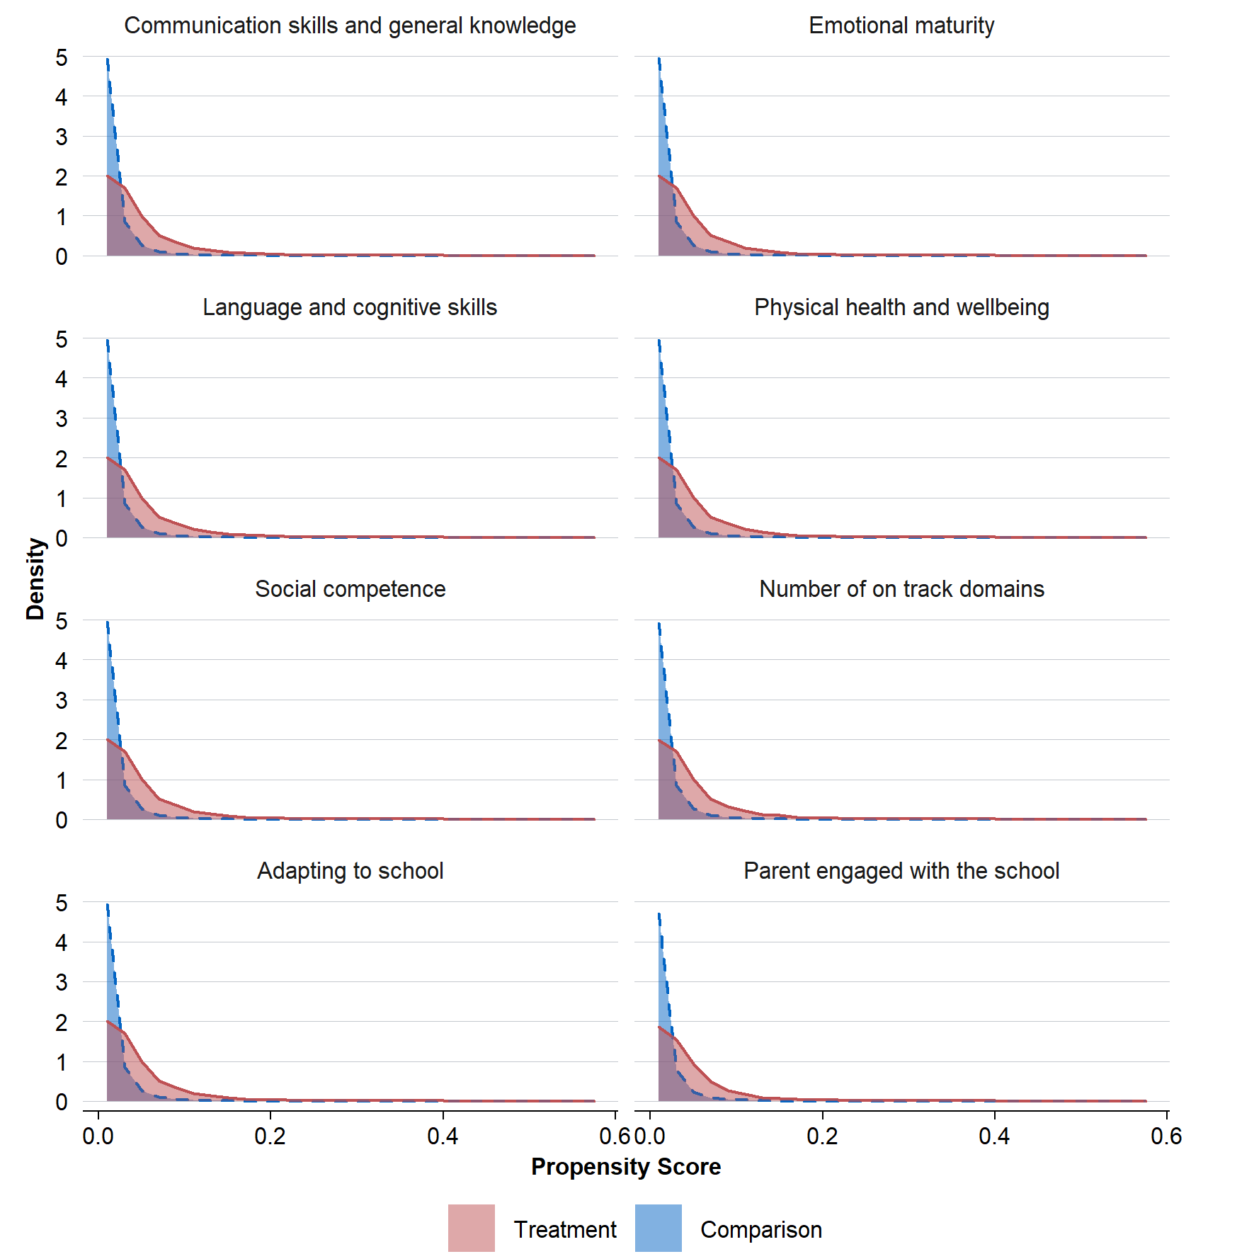
Source: Observational study of linked administrative data
Distribution of the propensity scores are provided for treated and comparison groups for each outcome.

Figure 9: Effect sizes and one-sided lower bounds of the estimates
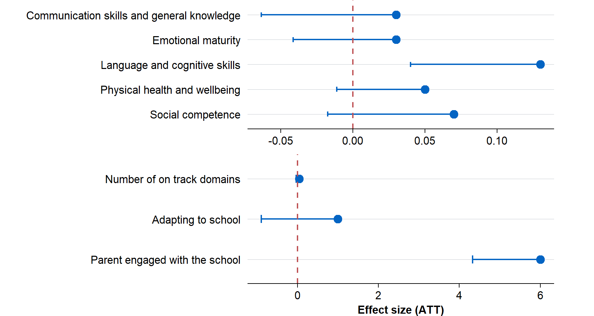
Source: Observational study of linked administrative data
Effect sizes are presented in the scale of each measure. The primary outcomes are domain scores ranging from 0 to 10, while the number of on-track outcomes is a count ranging from 0 to 5. Linear probability models were used for the outcomes ‘adapting to school’ and ‘parent engaged with the school’; therefore, the estimated effects represent percentage point differences for these outcomes. Since one-sided hypothesis tests are used, the confidence intervals represent one-sided 95 per cent lower bounds of the estimated effects.

Additional analysis
This section presents a series of additional analyses which aim to provide evidence that findings are not dependent on method choice and that key assumptions have been met.

Sensitivity to model choice
To test whether the results were sensitive to the statistical method used, 1:1 nearest-neighbour Propensity Score Matching (PSM) approach was used as an alternative to IPW. The key difference between these methods is that PSM discards unmatched comparison group units, whereas IPW retains all units but assigns lower weights to those with a lower propensity score.
All treated units were successfully matched with a comparison group unit. Statistically significant results were observed only for language and cognitive skills and parent engagement with the school, in the same direction and with very similar effect sizes to the IPW estimates. This suggests that the key findings are robust to the choice of method.

Investigating conditional independence assumption
A placebo test was conducted to probe the conditional independence assumption. The test applied a fake (null) treatment in a context where the true causal effect was expected to be zero and checked whether the estimated effect was close to zero. Estimating a value near zero supports the conditional independence assumption that, conditional on covariates, treated and control units are comparable. This placebo test was repeated 500 times, and the permutation p-value was calculated as the share of placebo estimates that were as extreme as the original estimate.
The permutation p-values provided additional support for the validity of the conditional independence assumption. In particular, permutation p-values were very small for language and cognitive skills and parent engagement with the school (p<0.01), indicating that these results are highly unlikely to have occurred by chance. For all other outcomes, permutation p-values were greater than 0.05, suggesting weak or no evidence of impact.

HIPPY children who could not be linked to the PLIDA spine
Based on the DEX program participation data, there were records for 1,248 children who participated in HIPPY between 2018–2021 (the same period as the treated group) but who could not be linked to the PLIDA spine because of incomplete or inconsistent identifiers in DEX during data linkage. It is plausible some of the ‘unlinked HIPPY children’ in DEX who started school in 2021 may have been misclassified as untreated and appeared in the observational study in the comparison cohort as their AEDC outcomes were still available.
Approximately 231 treated children out of the 1,248 unlinked records were estimated to be likely misclassified and may have appeared in the comparison group. This estimate was based on two assumptions. First, a proportion (12 per cent) of the 1,248 records were duplicates – that is, multiple records relating to the same child – and were therefore excluded. Second, only 21 per cent of the remaining unique children were estimated to have commenced school in 2021 and to have corresponding AEDC data. These proportions were derived from records that were successfully linked to the PLIDA spine and were applied to the unlinked records to estimate the number of potentially misclassified treated children.
This potential misclassification of about 231 children would have attenuated the estimated treatment effects. This represented 14 per cent of the treated children in the sample, which provides an indication of the likely magnitude of the attenuation of the treatment effect. On this basis, the evaluation team concluded that the misclassification would likely have had a modest impact.

Comparison of HIPPY children included, excluded, and unlinked in the observational study
The following sections refer to the following categories of children.
- Included children, the 1,688 children who participated in HIPPY between 2018–2021 and were included in the treated group in the observational study.
- Excluded children, the 350 children who participated in HIPPY during the same period as the treated group but were excluded during data cleaning and removed from the analysis due to missing information in key analysis variables.
- Unlinked children, the 1,248 records of children, described above, who could not be linked to the PLIDA spine because of incomplete or inconsistent identifiers in DEX during data linkage.
- This section compares these children based on the available data (Table 9 and Table 10).
Table 9: Comparing children included versus excluded from the observational study based on the continuous covariates
Variable | Included children  N | Included children  Mean | Included children  SD | Excluded children  N | Excluded children  Mean | Excluded children  SD
Count of dependent children in the family | 1,688 | 2.5 | 1.0 | 21 | 2.4 | 1.0
Count of people in the household | 1,688 | 4.5 | 1.3 | 41 | 3.7 | 1.9
Percentage of population under the age of five | 1,688 | 6.1 | 1.2 | 353 | 6.1 | 1.2
SEIFA (IRSD) | 1,688 | 924.5 | 82.1 | 353 | 903.0 | 86.8
Total MBS fee | 1,688 | 444.3 | 484.9 | 353 | 367.8 | 417.0
Source: Observational study of linked administrative data

Taken together, the excluded and unlinked children numbered almost the same as the HIPPY participants included in the study. Their characteristics, where available, provide insight into whether the included children in the observational study captured the most vulnerable children. Overall, the observational study captured many HIPPY children experiencing socio-economic disadvantage, but it likely underrepresents the most vulnerable groups. Excluded and unlinked children were more likely to be Aboriginal and/or Torres Strait Islander, live in single-parent households, rely on government income and have lower SEIFA scores – suggesting that the HIPPY children in the observational study cohort may be slightly less disadvantaged than the broader population of children and families participating in HIPPY.

Child and location characteristics
- Age: Children included in the observational study were mostly aged five years (75 per cent). Excluded children were similar, with 75 per cent aged 5, but the unlinked group had a much wider age distribution, with some 5-year-olds (19 per cent) and many children aged 6–10 years (73 per cent).
- Aboriginal and Torres Strait Islander identification: Among included HIPPY children, 19 per cent identified as Aboriginal and/or Torres Strait Islander. This proportion was much higher among HIPPY children excluded for data reasons (52 per cent) and still higher among unlinked children (30 per cent), suggesting that First Nations children may be disproportionately missing from the observational study dataset.
- Language: Around 30 per cent of included children spoke a language other than English at home. This was similar among both unlinked children (34 per cent) and excluded children (25 per cent).
- Geography: Included children were geographically dispersed, with less than half living in major cities. The pattern was broadly similar among excluded and unlinked children, though excluded children were slightly more concentrated in outer regional (31 per cent) and very remote areas (9 per cent). Children excluded from the observational study were from areas with lower socio-economic status, as shown by a lower SEIFA (IRSD) score compared to included children (903 versus 924).

Family and Household Characteristics
- Family composition: Around 30 per cent of included children lived in single-parent households. Among the excluded children with available data, 40 per cent lived in single-parent households, while among the unlinked children with available data 24 per cent lived in single-parent households. Both included and excluded children lived in similar size of households (four members each) and families had a similar number of dependent children (around two each).
- Socio-economic disadvantage: Included children frequently came from disadvantaged families, with 43 per cent holding a health care card and 18 per cent reporting government benefits as the main income source. Excluded children appeared more disadvantaged again, with 61 per cent holding a health care card. Household income related information was missing for most of the excluded and unlinked children, but where reported, 72 per cent of the excluded children were relying on government payments as their main income source. Unlinked children were slightly more mixed – 54 per cent relied on government payments, but 46 per cent reported wages or salaries as the main source of income. Excluded children also had lower total MBS fees ($368 versus $444), suggesting lower use of health services.
- Housing stability: Most included children lived in stable housing (80 per cent). Among excluded children, housing information was missing for most, but where reported, stable housing was much lower (28 per cent). Comparable data for unlinked children was not available.

Parent or Carer Characteristics
- Engagement and motivation: Most parents of included HIPPY children (92 per cent) were not engaged in other early childhood learning programs – a proxy for parental motivation. Similar percentage was observed for the excluded children as well (92 per cent). Comparable data for unlinked children was not available.
Table 10: Comparing children included, excluded and unlinked based on categorical covariates
Variable | Level | Included children |  | Excluded children |  | Unlinked children
Variable | Level | N | % | N | % | N | %
Child age | 4 | 55 | 3.3 | 15 | 4.3 | 86 | 6.9
Child age | 5 | 1,265 | 74.9 | 263 | 74.5 | 242 | 19.4
Child age | 6/ 7 | 368 | 21.8 | 75 | 21.3 | 572 | 45.8
Child age | 8/ 9/ 10 | NA | NA | NA | NA | 348 | 27.9
Child gender | male | 842 | 49.9 | 186 | 52.7 | 576 | 46.3
Child gender | female | 846 | 50.1 | 167 | 47.3 | 668 | 53.7
Remoteness area | major cities | 729 | 43.2 | 99 | 28.1 | 407 | 32.6
Remoteness area | outer regional | 337 | 20.0 | 110 | 31.2 | 573 | 45.9
Remoteness area | inner regional | 465 | 27.6 | 93 | 26.4 | 167 | 13.4
Remoteness area | remote | 123 | 7.3 | 19 | 5.4 | 55 | 4.4
Remoteness area | very remote | 34 | 2.0 | 32 | 9.1 | 46 | 3.7
Child is Indigenous | no | 1,362 | 80.7 | 170 | 48.2 | 865 | 70.3
Child is Indigenous | yes | 326 | 19.3 | 183 | 51.8 | 365 | 29.7
Child has special needs | no | 1,532 | 90.8 | 321 | 90.9 | NA | NA
Child has special needs | yes | 156 | 9.2 | 32 | 9.1 | NA | NA
Language used at home is not English | no | 1,187 | 70.3 | 264 | 74.8 | 828 | 66.4
Language used at home is not English | yes | 501 | 29.7 | 89 | 25.2 | 420 | 33.7
Child attending childcare/preschool | no | 69 | 4.4 | 22 | 7.7 | NA | NA
Child attending childcare/preschool | yes | 1,494 | 95.6 | 262 | 92.3 | NA | NA
Single parent family | no | 1,188 | 70.4 | 163 | 59.7 | 514 | 76.4
Single parent family | yes | 500 | 29.6 | 110 | 40.3 | 159 | 23.6
Family holds a healthcare card | no | 961 | 56.9 | 139 | 39.4 | NA | NA
Family holds a healthcare card | yes | 727 | 43.1 | 214 | 60.6 | NA | NA
Major source of household income is government benefits | no | 1,388 | 82.2 | 56 | 27.9 | 188 | 45.7
Major source of household income is government benefits | yes | 300 | 17.8 | 145 | 72.1 | 223 | 54.3
Housing stability | no | 334 | 20.0 | 11 | 28.2 | NA | NA
Housing stability | yes | 1,336 | 80.0 | 28 | 71.8 | NA | NA
Parent motivation | no | 1,523 | 90.2 | 324 | 91.8 | NA | NA
Parent motivation | yes | 165 | 9.8 | 29 | 8.2 | NA | NA
N |  |  | 1,688 |  | 353 |  | 1,248

Appendix C: HIPPY’s program logic
Objective
To build the confidence and skills of parents/carers of children in disadvantaged communities to create a positive home learning environment that assists children prepare for school and strengthen the parent/carer child relationship.
Needs statement
There is a link between disadvantage and poverty that can impact a child’s learning and subsequent life outcomes, including low educational outcomes that perpetuate intergenerational poverty. Early years learning aims to improve the wellbeing of children and young people, to enhance family and community functioning, and increase the participation of vulnerable people in community life.
Table 11: HIPPY program logic – inputs, activities and outputs
Inputs | Activities | Outputs
Commonwealth funding  Partnerships  DSS and Brotherhood of St Laurence (BSL)  BSL HIPPY Australia and HIPPY International  BSL & local HIPPY Provider  Local HIPPY Provider and parents/carers and community  National Indigenous Australians Agency  HIPPY curriculum, guidance and promotional materials  HIPPY site infrastructure (in-kind contribution)  Partnerships and collaboration between  HIPPY local workforce including Home Tutors  Local Advisors on Indigenous Early Childhood  Network of community-based support services | HIPPY Australia  Support local HIPPY providers to establish and sustain the capacity and capability required to deliver HIPPY  Provide resources to support recruitment, retention and engagement of families  Data collection, quality assessment, continual improvement and reporting  HIPPY Research  Building capacity of Aboriginal Community Controlled Organisations  HIPPY providers:  Recruit and enrol eligible families  Support and development of parents/carers of participating families  Deliver HIPPY to families  Establish Community Networks, Employment Pathways and Community of Practice  Recruit and train home tutors  DSS  Contract management  HIPPY independent eval  NIAA  Indigenous advice and linkages | Selected communities established and supported to deliver HIPPY  Parents/carers engage in educational activities in the home and in their community  Children participate in activities that support development across multiple developmental domains  Target Families participate in HIPPY over 2 years  Families are made aware of local events and services  HIPPY parents/carers realise the opportunity to work as HIPPY Tutors  Tutors have access to regular training and professional development opportunities  Service providers, including ACCOs, attend national learning event / receive coaching, participate in Community of Practice  Reports on program delivery:  Age 3 Transition Strategy  National Recruitment and Retention Strategy  HIPPY independent evaluation  HIPPY aligns and contributes to NIAA Indigenous policies

Table 12: HIPPY program logic - outcomes
Area | Short-term outcomes  Year one of HIPPY | Medium-term outcomes  Year 2 of HIPPY | Long-term outcomes  After HIPPY
Children | Children learn new skills as they engage in HIPPY Activities | Children have the skills, knowledge and confidence to actively participate in formal learning | Children acquire skills and confidence that promote school readiness. Children are cognitively, socially and emotionally ready for school
Families –Parents / Carers | Parents/carers are learning about their child's learning style and engage in educational activities in the home  Parents provide a positive home learning environment that supports children’s learning | Parents/carers are active and confident as their child's first teacher to prepare their child ready for school | Strengthens the parent/carer and child relationships
Families –Communities | Families feel connected with their local community including education settings and services  Families broaden their social connections and engagement opportunities | Families feeling confident in being able to access local services when required | Contribute to a community that celebrates cultural diversity and respect  Parents/Carers have the confidence and skills to advocate for their child’s education
Training and Employment | Tutors participate in regular training and professional development opportunities  Tutors develop confidence, knowledge and skills in Early Childhood and Parenting service delivery | Tutors develop transferrable skills and confidence toward future employment or further education | Tutors have the confidence to and knowledge on how best to continue their employment or study

Appendix D: HIPPY site coordinator interviews
This appendix provides a summary of the findings from the interviews ACE conducted with site coordinators and describes some of the factors which influence a family’s awareness of HIPPY, their participation in HIPPY, and their retention in HIPPY (if they enrol).
Direct quotes are provided from site coordinators where these are illustrative. All quotes in the summary of findings are taken from the interviews and should be attributed to HIPPY site coordinators.

Summary of the data
The ACE undertook consultations with site coordinators in February and March 2025. Sites were selected by the Early Years Delivery team at the Department of Social Services based on a range of characteristics to ensure the interview findings were broadly representative of other HIPPY sites. These characteristics included representation across different states, urban versus rural, and First Nations-focused versus non-First Nations focused sites.
Site coordinators were interviewed as it was the most feasible approach given time and budget constraints. While direct interviews with families and parents may have provided additional insights into their motivations and barriers, the perspectives shared by site coordinators offered valuable and sufficient information to inform the observational study.
Potential participants were contacted initially via email and provided their consent to participate before a 60-minute discussion was scheduled. All interviews were conducted online via Microsoft Teams by one interviewer, with a notetaker present in the meeting (but with camera off). The interview followed a semi-structured format, which allowed for the interviewer to ask prompting or follow-up questions as appropriate throughout the interview.
A total of eight site coordinators were interviewed, and this number was determined by evaluation timing and resourcing constraints. Although a small sample size, the ACE saw thematic saturation in the sample.

Analytical approach
The ACE conducted an inductive thematic analysis of interview notes. The main interviewer coded interview notes and subsequently grouped these codes into themes, to answer the three key research questions. The thematic analysis was also reviewed by the secondary interviewer to ensure completeness and accuracy.

How do families gain awareness of HIPPY?

Locally targeted approaches including local community networks, community events and multi-cultural organisations
All site coordinators interviewed noted the importance of engaging local community via approaches targeted to the relevant HIPPY audience. Engagement is different for each site and often involves some trial and error depending on the site. This included attending and organising various community events, such as local council events, pre-school or kinder enrolment days, school fair days, library events, and other events where HIPPY could be promoted. Site coordinators typically have a lot of discretion to decide which events they attend to promote HIPPY but ultimately attend most community events that they believe there could be a relevant audience in attendance.
In addition, site coordinators expressed the necessity of taking part in events targeted toward local Indigenous and multi-cultural families. These communities are perceived as more difficult-to-reach, but are in the priority access cohort, so site coordinators go to significant efforts to sustain engagement with local multi-cultural and Indigenous organisations.
“We also try to participate in other local community events, particularly indigenous community events. If we are asked to participate in an event we always say yes, even if they don’t involve families with young kids”
Although some sites noted engagement with local childcare centres, these are typically seen as less successful recruitment pathways. The reasons given by coordinators included that childcare centres do not have a thorough understanding of specific family need for the program due to the number of families they serve, that parents are often difficult to engage during drop-off and pick-up as they are typically rushing, and that some childcare providers perceive that HIPPY is ‘taking enrolments away from them’.
“I have really struggled to connect to early childhood centres. So, even though I do have an early childhood background, [...] I’ve really struggled to connect with them about the benefits of HIPPY. I really feel like they think I’m taking enrolments away from them”
In contrast, local playgroups were mentioned by some site coordinators as a good mechanism to seek enrolments.
“Playgroups, so they’re a really nice referral point because they’ve got the relationships with the families, and younger children going into the age three group. We get quite a few referrals from the playgroups.”

Word of mouth approaches, including via recent families and tutors
Many site coordinators indicated that they receive referrals from various sources, including maternal child and family health nurses, local child and family learning centres, and other not-for-profits. Families that are referred from these sources are typically well-suited to HIPPY and frequently meet at least some of the priority access criteria. Such referrals from formal sources are often a large source of enrolments for sites.
“I would say that the family nurse is very good at identifying families that are priority access. The ones they refer are generally high priority.”
Previous HIPPY families and tutors are also an important awareness raising mechanism for HIPPY sites and constitute ‘warm referrals’ to HIPPY. Families who have already participated in HIPPY frequently tell their friends and family about the program and its benefits to them. Some families with another eligible child wish to enrol their second child in the program, however this can present issues for the site, as previous HIPPY families are no longer considered priority access families, regardless of how many priority criteria they meet. Tutors are also a valuable source of awareness, and this is particularly the case for tutors from multi-cultural or otherwise more vulnerable communities.
“The mentors/tutors are the key to recruitment. They know their communities well”

The most successful sites consistently engage with the community over time to build trust and a positive reputation
Most site coordinators emphasised the importance of being seen as a trusted, community-oriented, and stable organisation. Site coordinators are the interface between HIPPY Australia and their community and often require some time to become a trusted person or organisation. Site coordinators noted that they feel they need to get out and about in their community to build these positive and trusting relationships, and that the return on investment for these efforts compounds over their years of employment.
“This is my fourth year and I’m just starting to be a trusted person with our Aboriginal-specific organisations … that relationship takes a long time to build”
“It is really around relationships, which are the biggest part of the success. I’ve been in role coming up to two years. People are starting to know more of who we are and what we do. It is really that connection in the community being that familiar face at local events on the weekend.”

What factors influence whether a family participates in HIPPY?

Sites deploy significant flexibility in deciding who to prioritise for the program
Overall, site coordinators reported using their judgement within the basic HIPPY guidelines to determine which families are prioritised for the program, and this entailed significant flexibility. This was particularly the case where site coordinators had a history of oversubscription in their sites (and applied to a lesser extent where sites may be undersubscribed). All site coordinators noted that they adhere to the priority access criteria when determining suitability for the program, likely due to the requirements for 65 per cent of enrolments to meet priority access criteria. However, site coordinators noted that they also consider other factors in prioritising families for enrolment, such as family fit with available tutors (which changes on a yearly basis), and whether the site can provide additional supports for families requiring adjustments to the basic program.
“I’m thinking about my tutors. So, who are the tutors who are going to be out delivering these programs”
Notably, most site coordinators mentioned informal criteria that they use to determine whether families are vulnerable or have a need for HIPPY. These criteria are often not included in the priority access guidelines.
“I have some extra areas of priority: have you lived in Australia for less than five years, so they are more likely to be socially isolated and not have those connections. If they come from refugee or asylum seeker background, perhaps there’s trauma there. If the parent and carer is less than 25, or highest level of education is year 12 or under.”
One site coordinator also noted that some families who have not immunised their children appear to use HIPPY as a substitute for childcare or preschool based programs, due to the requirement for proof of vaccination in these other programs. However, this was not a major theme of the interview discussions.

A family’s understanding of the intent of the program, the significant time commitment, and their comfort with the delivery approach are strong drivers of enrolment
The extent to which a family understands and is comfortable with HIPPY’s intent, commitment and delivery methods strongly influences whether a family chooses to ultimately participate in the program. Families who are committed to supporting their child’s learning prior to school, or see the importance and value of HIPPY, are more likely to sign up; this is used as a selling point for HIPPY by site coordinators. This evidence is suggestive that the families who are more motivated to support their children will end up participating in HIPPY, versus families who are less inclined to provide these early learning supports.
“Most common thing is their commitment to their child’s learning. The ones that are easily engaged, usually see out the program and find that as a top priority.”
Site coordinators indicated that families who understand the 2-year time commitment and could commit to the time requirements were much more likely to enrol in the program, compared to families who do not feel they are able to commit. There were a variety of reasons site coordinators listed for families being unable to commit to the 2-year program, but site coordinators frequently mentioned employment and moving homes as two reasons families are unable to enrol.
“The commitment is a big one – even for those who show interest, when they learn the time commitment it scares them off.”
“[…] we follow up and they say they can’t commit as they have just returned to work”
Families who are comfortable with the delivery methods (home visits, group gatherings and role play) are more likely to enrol in the program. Multiple site coordinators indicated that families are not always comfortable with being visited in their home by others, with one site coordinator suggesting this may particularly be the case for Aboriginal and Torres Strait Islander families, for whom home visits by the authorities may hold traumatic memories, or have negative connotations. Instead, some families preferred to do the ‘home visit’ activities in town – this was particularly the case for families from more rural communities, who appreciated the opportunity to travel into town. Further, some site coordinators indicated that the role play element is sometimes perceived as demeaning – these were frequently listed as reasons that families choose not to enrol.
“Home visits – people don’t like the idea of that.”
“We have to be mindful that’s’ not always been a great outcome for First Nations families to have someone in their home”

Very few sites actively turn families away, due to difficulties in meeting recruitment targets
Although site coordinators do value the flexibility, they have to decide who to enrol in the program, very few sites reported having to actively turn families who wanted to commit to HIPPY away. Some site coordinators noted they do ask families who may not meet specific priority criteria to wait until the end of the enrolment period, to initially prioritise entry for families who meet a greater number of priority criteria. However, ultimately most families who wish to enrol in HIPPY do receive the program.
“We have never had to turn anyone away from the program. We have 30 places in the program each year and we have to try pretty actively to fill those.”
Site coordinators frequently expressed difficulties in meeting recruitment targets for their sites, and this is likely the driver behind not turning any families who want to enrol in HIPPY away. One site coordinator noted a potential downside of the recruitment and retention targets, which is that they may unintentionally incentivise site coordinators to enrol families who are unlikely to drop out of the program. However, many site coordinators noted that families who are most in need of HIPPY are families who are experiencing particular vulnerabilities and are therefore the most likely to drop out. Thus, site coordinators must make a decision to trade-off potentially not meeting their recruitment targets with providing the program to families with the greatest need.
“If I think they’re vulnerable, I will also put them on the program even if they might not end up finishing the program. There are incentives from HIPPY Australia to retain your 30, so there’s a balance of picking the 30 families who don’t need it but meet the criteria, because they can commit, or do you choose the families who might benefit from the program but might not stick. It’s a bit of a juggle”

Families in vulnerable or difficult situations do not end up participating in the program, despite a demonstrated need for additional parenting supports
Families who are experiencing multiple vulnerabilities, such as violence in the home, interactions with the criminal justice system, mental health concerns or housing instability typically choose not to participate in the program. However, site coordinators also noted that families experiencing these acute vulnerabilities are unlikely to be ‘ready’ for the program, and instead need crisis support or interventions for their more immediate needs.
“[Families with] Complicated lives: relationships, family violence, housing is a big one, mental and physical health issues. […] People who are really struggling with mental health and wellbeing. They don’t have the capacity to engage, and they don’t have the confidence.”
Some site coordinators noted that they use difficulty making and committing to regular appointments as a yardstick for a family not being appropriate for HIPPY. This suggests that HIPPY does not typically reach families with acute vulnerabilities or needs, with site coordinators instead focusing on providing HIPPY to families with more stable family and home lives.

What factors influence whether a family engages with or completes HIPPY?

The strength of the tutor-family relationship is the dominant characteristic which supports retention and ultimately, the success of the program for the family
Almost all site coordinators mentioned the quality and strength of the tutor-family relationship as one of the top, if not the top factor which contributes to a family completing the program. Tutors deliver HIPPY on the frontline to families, and ultimately the family’s understanding and implementation of the program depends on the tutor’s ability to work flexibly with each family to improve their understanding of HIPPY.
“Their relationship with the tutor. The most key thing is the relationship with the tutor.”
“A lot of it comes down to relationships with the HIPPY tutor. […] All our tutors are down to earth. We are all just mums sitting around a kitchen table to support children. It’s not about us & them.”
Tutors have flexibility in how they deliver the program. This means that tutors can adapt their delivery methods to the needs of the family and meet each family where they are at. Tutors are a key source of support for families, with multiple site coordinators indicating that the consistency with which a tutor engages with a family and continues to show up despite repeated cancellations, or demonstrate to the family they are valued, is a key determinant of program completion.
“It’s building that relationship initially, so the families feel safe and not judged. Even if they keep cancelling every session”
This is a significant role for the tutors and requires resilience. However, the importance of the tutor’s role does not necessarily align with HIPPY’s model, in which tutors are often employed casually for two years, with no guarantee of any ongoing employment.

Parental mindset matters: Parents who are open to learning and the HIPPY approach more generally stay in the program
Multiple site coordinators emphasised the importance of the parent’s attitude and mindset toward HIPPY, everyday learning and openness to learning tools to teach their child. Parents who are open to new ways to teach their child or are looking for support on how to teach their child are more likely to stay in the program. These parents tend to be open and curious about different ways to structure learning, and value the additional ideas on how they can support their child.
“None of us get an instruction book when we have a child.”
Site coordinators believe that, through HIPPY, parents are taught a new way of learning and begin to understand the importance of seeking opportunities to teach their children in the everyday. Parents who embrace HIPPY’s philosophy that learning doesn’t just happen at a desk, and that play-based learning is important, tend to be the parents who graduate from the program.
“People who are new to Australia and have had different educational backgrounds. Families might not understand play-based learning or making learning fun when their experience has been structured and rigid, there’s often fear-based learning. […] They [parents] can see the education is more valuable than perhaps the way they were taught. ... Perhaps, learning a different way to engage your child.”

Families without the available time to take part in the program struggle to complete it
Families with young children are often juggling multiple commitments, and HIPPY is perceived as a negotiable additional element by many. A key factor that drives program retention is whether families have the available time to engage completely with the program. Employment was listed by several site coordinators as a barrier to retention, with many families having to return to paid employment due to cost-of-living challenges. Due to the delivery of HIPPY during business hours, families who work during business hours often drop out, as they cannot complete the required activities.
“Generally, it’s really rare that they’ve dropped out because they haven’t liked it. It’s other reasons because they have to work, or they’re moving away and they can’t manage it, or their studies got too much, or other. Life has become too complicated and they can’t deal with the extra thing of HIPPY. It is about other commitments that the families have, is why they leave.”
Some site coordinators also indicated that families with the time available to attend various HIPPY events were typically the families who graduated from the program. This was particularly true for the HIPPY gatherings, which are run by site coordinators to encourage families to interact with one another, promoting social connections with other HIPPY families. However, attendance at group gatherings and other HIPPY events may also be confounded with overall motivation to support a child’s learning, rather than simply the available time to engage.

Priority families, or those experiencing multiple vulnerabilities, are the families which struggle to stay engaged in the program
Families who enrol in HIPPY are typically more disadvantaged than the average and sometimes require additional supports to fully engage with the program. This is by design. However, ironically, site coordinators reported that in their experience, the families who are most vulnerable, and/or meet the greatest number of priority access criteria tend to be the families who are most susceptible to dropping out of the program. This is particularly concerning, as it suggests that although HIPPY is targeted toward families with a specific need, it does not necessarily meet all their requirements to enable the families to finish the program.
“All the cohorts that they’re trying to reach are the first ones to drop off. Single parents, Aboriginal families etc. Usually people who are in challenging situations are more susceptible to falling into crisis, or have multi-layers of things going on in their life. It’s not straightforward. Families that have disengaged have had something significant in their lives, and they’ve struggled to reengage”

Further details on site consultation recruitment and consent processes

Recruitment
ACE initially intended contacted nine sites selected by DSS via publicly available contact information (that is, the site coordinator email addresses listed on the HIPPY website). The ACE also requested details for a further two sites, due to limited responses from some HIPPY sites. In total, the ACE contacted 11 site coordinators for participation in the interviews and conducted eight interviews.
To recruit sites, ACE sent the recruitment email to the relevant HIPPY coordinator listed on HIPPY Australia’s website, with the Participant Information Sheet included as an attachment. Where site coordinators replied to ACE’s recruitment email, ACE confirmed their consent and organised interview dates according to site availability.

Initial recruitment email
Dear [name],
You are invited to take part in an evaluation being run by the Australian Centre for Evaluation (ACE) within the Commonwealth Department of Treasury. The ACE evaluates programs to understand whether the programs work, and how they could work better.
We value your contributions to HIPPY and the connections you have with the families and communities involved in HIPPY. We want to hear your views to make this program better.
Your participation in this evaluation is voluntary. If you choose to take part, your participation will involve a one-on-one online interview with the evaluation team to talk about your role in HIPPY, and how you make decisions about which families are recruited and admitted into HIPPY. There are no repercussions for you if you choose not to take part in this evaluation, and we will not tell your employer.
Please find the attached ‘Participant Information Sheet’ which will tell you why we are running this evaluation, what your participation will involve in more detail, and how we will protect your information and privacy.
If you would like to participate, you can reply directly to [researcher email] to schedule an interview at a time that is suitable for you. You can also reach out to [researcher] with any questions about the evaluation.
Thank you!

Participant consent
Participants provided written consent via email in addition to verbal consent prior to each interview. In line with the ethics approval received for these interviews, participants also provided explicit consent to have their interviews recorded for note taking purposes.
The Participant Information Statement is available in the Interim Report, delivered to DSS in July 2025.

Interview guide

Section 1: Recruitment Process (15 minutes)
- Can you describe the recruitment strategies your site uses to attract families to the HIPPY program?
- What specific methods do you use (for example, flyers, community events, social media)?
- How do you inform families about the program and its benefits?
- Which recruitment approaches have you found to be the most successful (attract the most suitable families)?
- Can you provide examples of what has worked well?
- Are there any approaches that have been less effective? Why do you think that is?
- How do you reach out to diverse demographic groups within your community?
- What strategies might you use for different cultural or socio-economic groups? Which of these are more or less effective?
- How does most families seek information for enrolment into HIPPY (for example, phone, email, in-person contact etc.)?

Section 2: Families’ Decision to Apply (10 minutes)
Now, we are moving further down the process to understand a little bit more about which families might apply for HIPPY after hearing about it.
In your experience, what factors make a family more likely to enrol in HIPPY?
- What are the particular characteristics or circumstances that influence their decision?
- Some families don’t apply for the program, even if they hear about it. What do you think are some of the reasons these families don’t apply for HIPPY?
- What are the barriers or challenges to participating in HIPPY that families commonly face?
- Do you make further contacts with those families who don’t apply for HIPPY? If so, how?
  - How would the families usually respond to such contact?

Section 3: Selection Process (15 minutes)
Now, once a family has applied for HIPPY, we understand your site assesses the family’s suitability. I’d like to talk through how your site decides which applicants are suitable for the program or not.
- Can you walk me through the HIPPY family selection process at your site?
- What are the formal criteria used to determine a family’s suitability for the program?
- Are there any informal criteria that you consider? [interviewer note: whether a child attends childcare]
- What do these criteria look like in practice?
- How do you assess whether a family meets these criteria?
- What kind of information do you collect from families during the application process?
- What kinds of reasons might mean a family is deemed unsuitable for the program?
- What are these criteria?
- How do families react if they are deemed unsuitable? (i.e., do they seek other services and supports?)
- Does your site usually have more applicants than places?
If YES – What criteria do you use to decide whether a family receives HIPPY starting now or later?
- How do families asked to wait for the program tend to react?

Section 4: HIPPY Completion (10 minutes)
What kinds of things do you think make a family more likely to finish the full two years of HIPPY?
- What kind of things help families stay engaged with HIPPY?
In your view, what kind of families are more likely to benefit from the program? [interviewer prompt: motivation, parental involvement, access to other daycare programs]
- What positive benefits of HIPPY do you observe in these families?

Conclusion (5 minutes)
- Is there anything else you would like to add about the HIPPY recruitment, selection and retention process that we haven’t covered?
- Do you want to add or change any of your responses?
- Thank you again for your time and your insights into the HIPPY program. They have been very helpful in helping us to understand how your site operates and will help us to design an evaluation of the program keeping these details in mind. If you have any questions, please reach out to us at [email]. Have a great day.

Appendix E: BSL program data, parent survey and interviews

Summary of BSL program data and parent survey data results
This appendix presents the results from the analysis of the two data sources described above. It is organised according to three of the main actors in HIPPY: children, parents and families. Under these headings, the results are organised against the more specific outcomes set out in the HIPPY program logic and in ACE’s evidence synthesis.
The survey and program data analyses were scoped to provide evidence about outcomes mostly related to parents and parents’ perceptions of their children. As such, some of the outcomes in ACE’s evidence synthesis are not covered by this analysis. This is noted throughout the results section where relevant.
This discussion of analysis outputs is intended to be a descriptive overview of the main findings and does not seek to examine consistencies or links across the HIPPY impact evaluation findings.

Children’s outcomes
The survey and program data questions assessing children’s outcomes that were analysed for the purpose of this report only relate to a child’s school readiness. (In the evidence synthesis, this outcome fell under the broader heading of a child’s ‘skills, knowledge and confidence to engage in formal learning’). Other outcomes, such as ‘love of learning’ is captured in BSL program data but was not analysed in this report.

School readiness
Both data sources suggest that responding parents generally agree that their child is ready for school and has most of the relevant skills to start school at the point of graduation from HIPPY. Responding parents also state that they believe HIPPY had a positive influence on how ready their child is for school, regardless of whether the child has completed HIPPY or not.
Consistent with parents’ ratings of how many skills their child had to start school, overall, responding parents’ agreement of whether their child is ready for school increased over time and experience with HIPPY. 42 per cent of responding parents agreed that their child is ready for school in the first year of HIPPY (age 3), and this rose to 80 per cent and 79 per cent for responding parents in the second year of HIPPY (age 4), and whose child has graduated from HIPPY, respectively (Figure 10). For parents currently in the age 3 program, they had received only approximately six months of HIPPY at the point of survey completion.
Conversely, in the first year of HIPPY, 22 per cent of responding parents disagreed that their child is ready for school, but this decreased to 9 per cent in the second year of HIPPY. Interestingly, the rate of disagreement increased slightly for responding parents whose child has graduated from HIPPY, from 9 per cent in the second year of HIPPY to 14 per cent after graduation: this may be driven by various factors, including a parents’ optimism about their child starting school prior to school commencing, or the realities of school attendance becoming apparent to the parent after their child commences school.
Figure 10: Parent’s perception of whether their child is ready for school
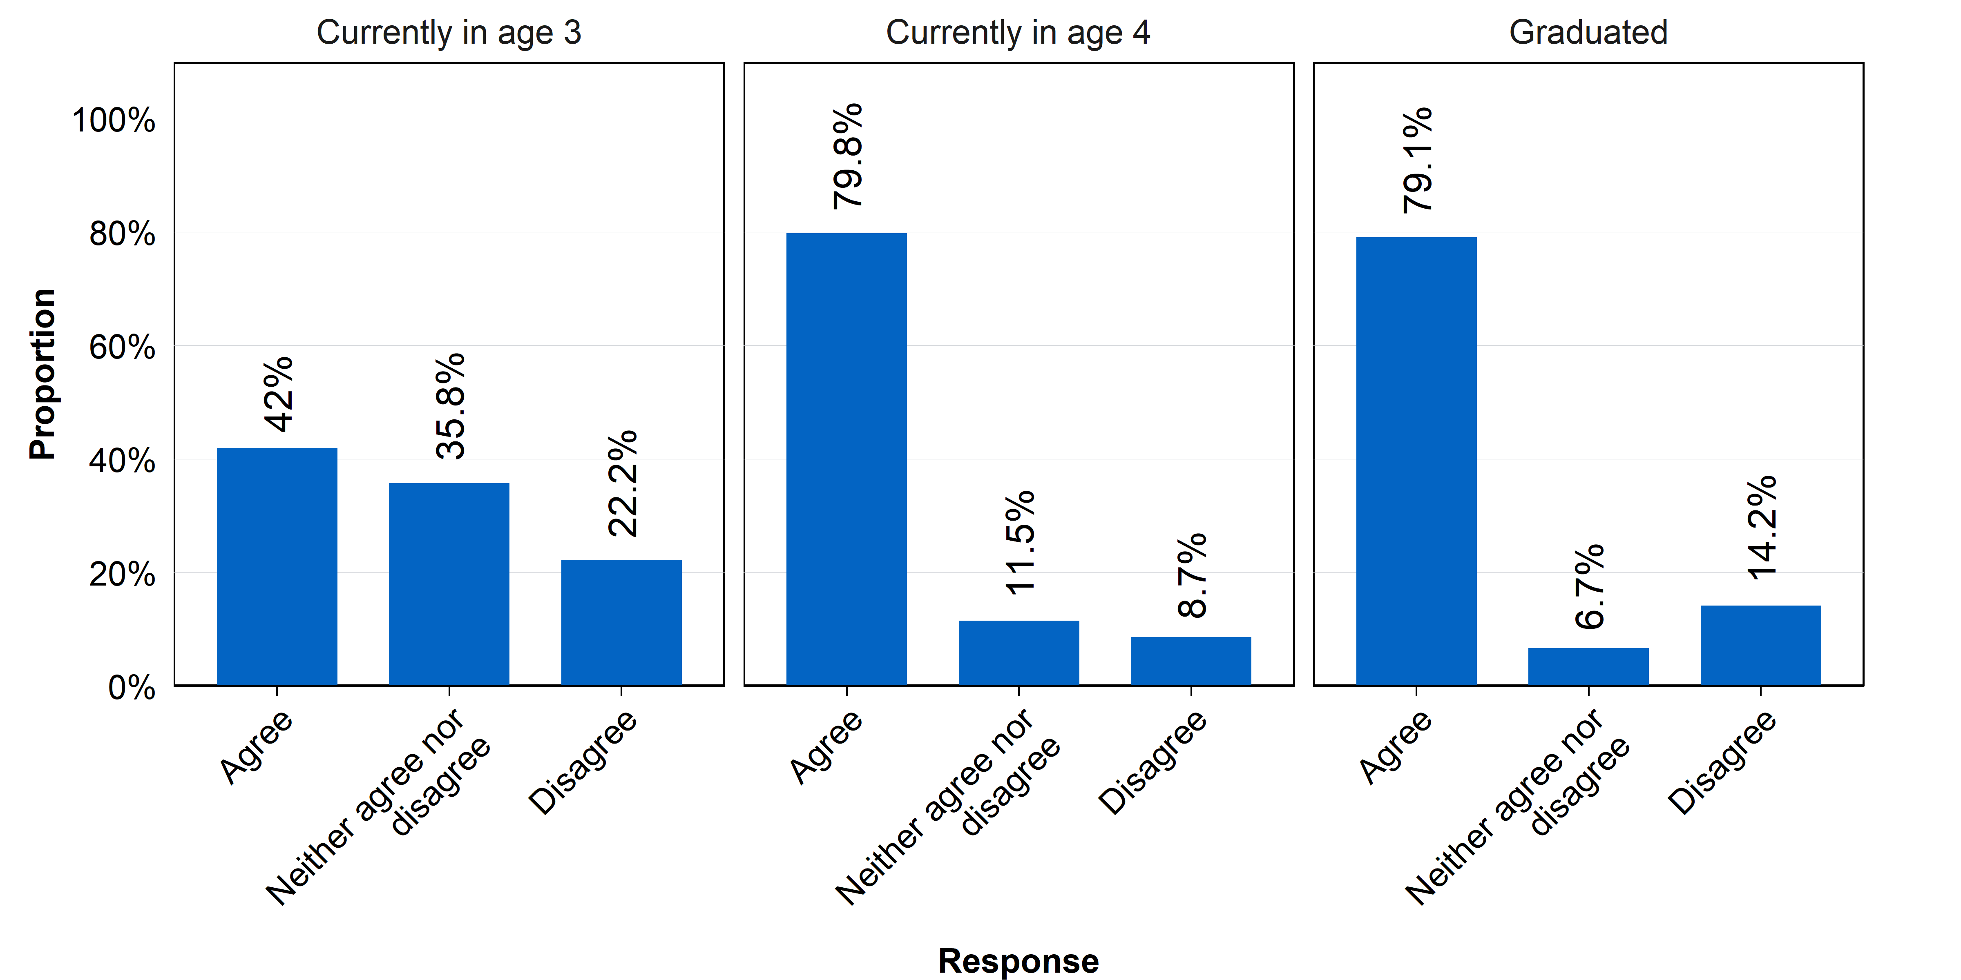
Source: Parent survey
N = 319. Question: Please rate your level of agreement with the following statement: My child is ready for school; Response options: Strongly disagree; Disagree; Neither agree nor disagree; Agree, Strongly agree

As is seen across other indicators of a child’s school readiness, responding parents’ ratings of whether HIPPY had an influence on their child’s school readiness also increased over time (Figure 11). 20 per cent of responding parents currently enrolled in the first year of HIPPY indicated that HIPPY had a very positive effect on how ready their child is for school. This increased to 28 per cent and 48 per cent in the second year of HIPPY and who have graduated from HIPPY, respectively. In addition, responding parents’ ratings that HIPPY did not have any impact on their child’s school readiness decreased over time: from 19 per cent to 12 per cent to 4 per cent, in the first and second years of HIPPY and for graduated parents, respectively.
Figure 11: Parent’s perceptions of how HIPPY has changed how ready their child is for school
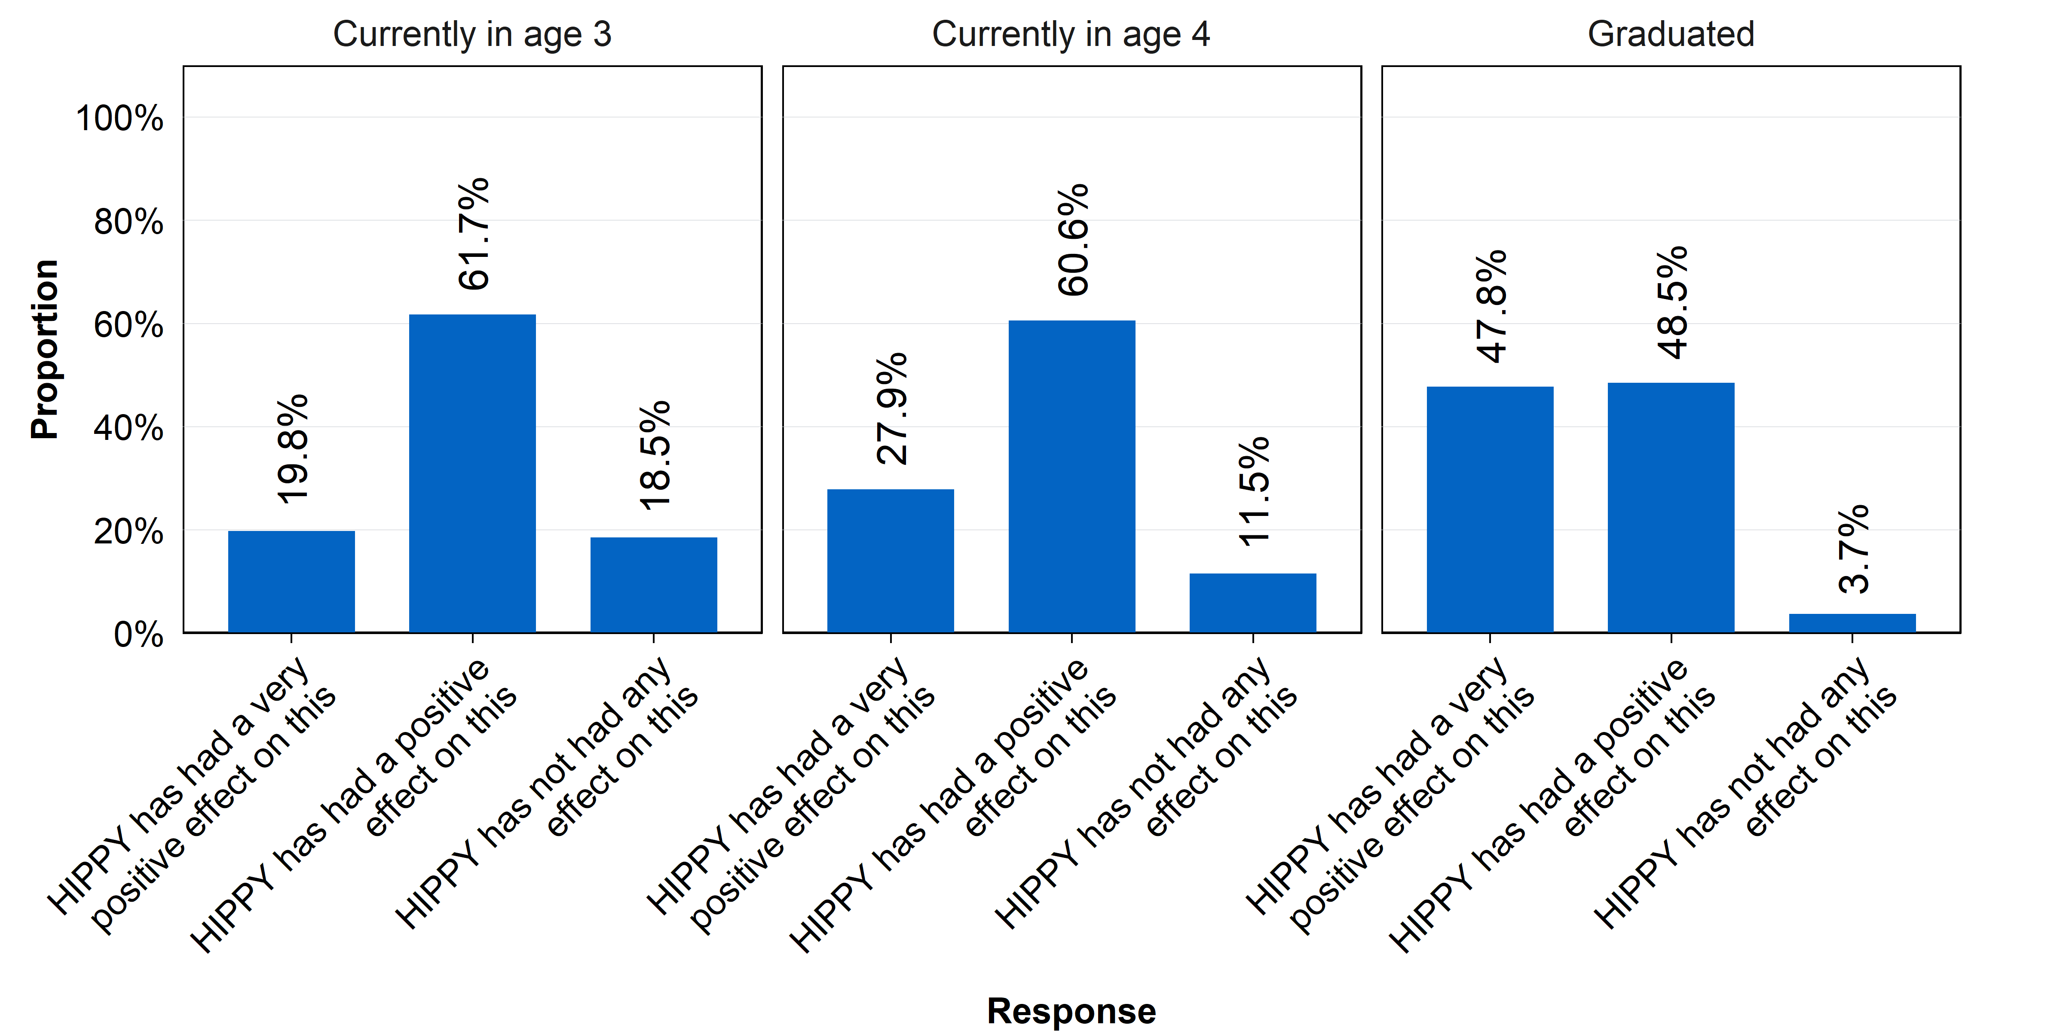
Source: Parent survey
N = 319. Question: How has HIPPY changed how ready your child is for school? Response options: HIPPY has had a very positive impact on this; HIPPY has had a positive impact on this; HIPPY has not had any impact on this; HIPPY has had a negative impact on this; HIPPY has had a very negative impact on this

Parents’ outcomes
The HIPPY program appears to have had a positive impact on parents in several key areas.
Parents report an improved understanding of how children learn, indicating that HIPPY positively influences their knowledge in this area. When it comes to behaviours, parents also believe that HIPPY had a positive impact, although there is some mixed evidence regarding the frequency of these behaviours. There are also improvements in the home-learning environment, with parents engaging more in positive behaviours. Self-reported confidence among parents increases due to HIPPY, but there are still some areas where abilities remained limited. Lastly, the parent-child relationship is reported to be positively impacted by HIPPY, though there were some limitations to this influence.
This section includes questions that explored parents’ outcomes, including:
- their knowledge of how children learn
- their behaviours to support the child’s learning
- their provision of a positive home-learning environment
- their confidence as educators, and parenting skills, and
- the parent-child relationship.
As this data analysis of the survey questions and program data was primarily designed to provide a parent’s perspectives on how HIPPY had influenced their own knowledge, attitudes and behaviours, the majority of the ACE’s analysis considered these outcomes.

Parents’ knowledge of how children learn
Parents responding to the survey indicate that HIPPY positively influenced their understanding of how their child likes to learn.
A large majority of responding parents reported that they have more or a lot more knowledge of how their child likes to learn as a result of HIPPY (Figure 12). Notably, 85 per cent of parents currently enrolled in HIPPY reported more or a lot more knowledge, and this number increased to 95 per cent of responding parents who have graduated from HIPPY.
This suggests that, over the duration of the program, HIPPY appears to improve parents’ perceived knowledge of how their child learns, with few responding parents reporting that they have about the same level of knowledge (14 per cent for current HIPPY parents, and 5 per cent for graduated parents), or less knowledge (1 per cent for current parents, 0 per cent for graduated parents), for how their child learns.
Figure 12: Influence of HIPPY on parents’ understanding of how their child likes to learn
Source: Parent survey
N = 319. Question: How has HIPPY influenced your understanding of how your child likes to learn? Response options: I have a lot more knowledge of how my child likes to learn; I have more knowledge of how my child likes to learn; I have about the same knowledge of how my child likes to learn; I have less knowledge of how my child likes to learn; I have a lot less knowledge of how my child likes to learn

Parent behaviours
In both data sources, parents report that they believe HIPPY had positive benefits on their learning activity behaviours. However, the changes in responses from commencement to mid-point to graduation only partly supported this conclusion. After HIPPY commencement, there were only small increases in parents’ ratings of: their involvement in their child’s learning, reading to their child, and using everyday learning activities. And there was a minor decrease in the frequency with which parents report playing with their child, which may be due to children’s increasing independence and participation in structured activities, although most parents still report playing with their child most days.
There are two questions that directly ask parents how HIPPY has influenced their behaviours, specifically in relation to their role in learning activities.
The survey asks parents: How has HIPPY influenced:
  - How often you do learning activities with your child in a week? (for example, reading, drawing, play-based learning, everywhere learning)
  - The range of learning activities you do with your child?
  - How long you spend doing a learning activity with your child?
  - The range of methods you use to show your support to your child?
And the BSL program data asks parents at the mid-point and at graduation: Have you learned anything useful such as new skills or knowledge through the HIPPY program?
In addition, the BSL program data includes a series of questions about the frequency of parental behaviours that can be tracked from commencement to mid-point and graduation. These relate to:
  - Involvement in their child’s learning
  - Reading stories with their child
  - Playing with their child
  - Using an everyday activity to teach their child something new
This section summarises these findings.
The survey asked parents how HIPPY has influenced their behaviours. Responding parents indicated that HIPPY had increased or significantly increased the following behaviours (Figure 13):
- The length of time they spend on a learning activity with their child: 89 per cent
- The frequency with which they undertake learning activities with their child: 92 per cent
- The range of learning activities they undertake with their child: 94 per cent
- The range of methods they use to support their child: 93 per cent
Very few responding parents reported that HIPPY did not impact or decreased these behaviours.
Figure 13: Influence of HIPPY on parents’ learning activity behaviours
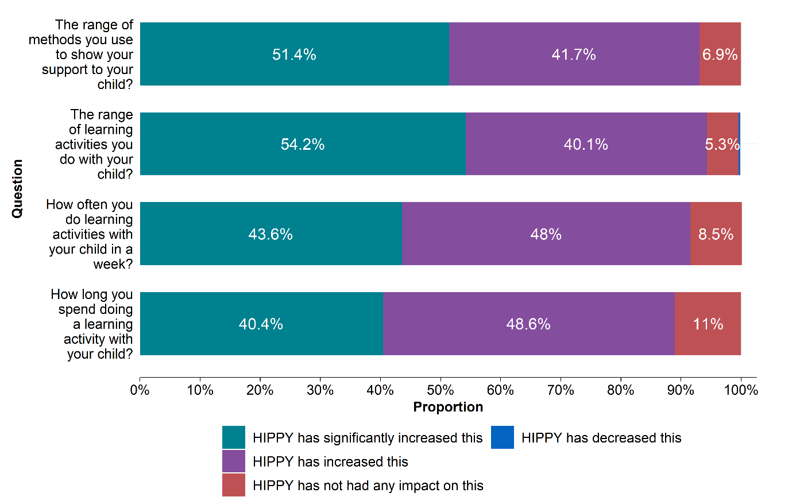
Source: Parent survey
N = 319. Question: How has HIPPY influenced: 1) How often you do learning activities with your child in a week? (for example, reading, drawing, play-based learning, everywhere learning) 2) The range of learning activities you do with your child? 3) How long you spend doing a learning activity with your child? 4) The range of methods you use to show your support to your child? Response options are depicted in the chart.

When asked directly whether they felt had learnt anything useful from HIPPY, 70 per cent of parents mid-way through HIPPY and 81 per cent of parents who graduated from HIPPY indicated that they definitely learnt something useful from HIPPY (Figure 14).
A small number of parents did not agree or were unsure that they had learnt anything useful from HIPPY. However, note that responses to this question are likely subject to reporting biases.
Figure 14: Parent’s perception of having learnt anything useful from HIPPY
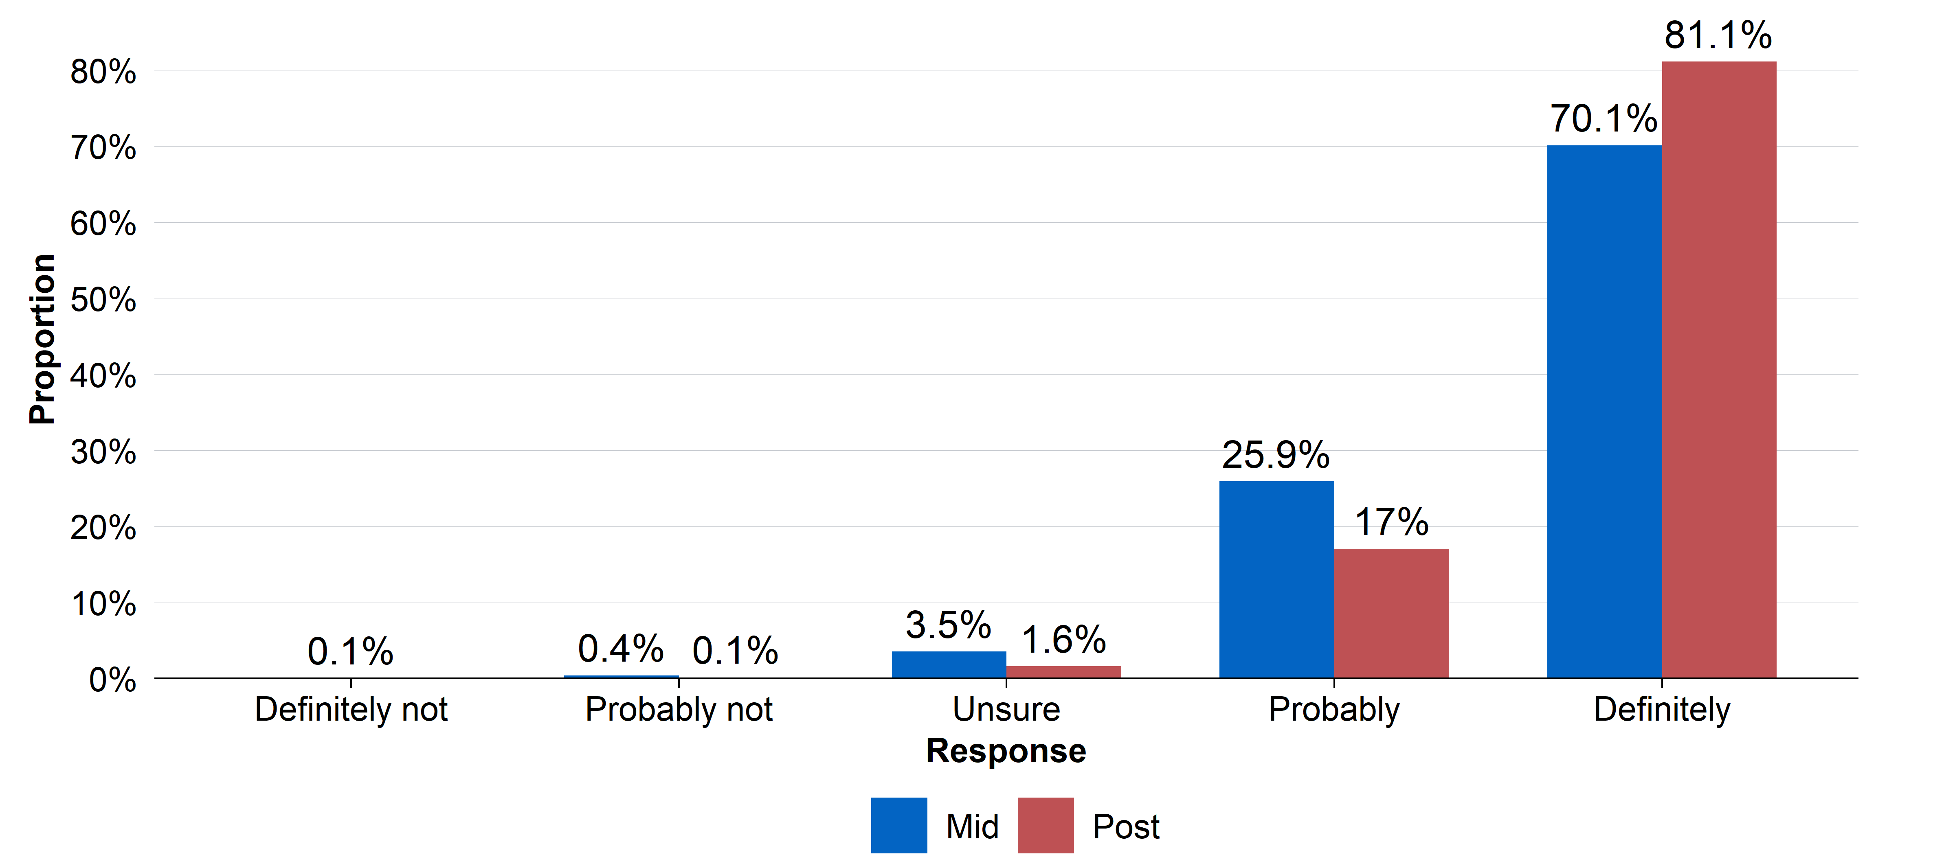
Source: BSL program data
N = Mid: 1,693, Post: 1,484. Question: Have you learned anything useful such as new skills or knowledge through the HIPPY program? Response options: Definitely not; Probably not; Unsure; Probably; Definitely

There was a small increase in parents’ reports of their involvement in their child’s learning from the beginning to the end of HIPPY (Figure 15). However, average ratings started from a very high base: at the commencement of HIPPY, on average parents reported that they were involved in most parts of their child’s learning. This means that, on this measure, there was little room for improvement.
When considering how often parents reported reading to their child, there was a slight reported increase in the average frequency with which parents reported reading to their child per week (Figure 16). This appeared to be largely due to parents who reported not reading to their child at all or were reading to their child a couple of days per week prior to HIPPY increasing their reading frequency following HIPPY (34 per cent reported reading to their child a couple of days a week or less prior to HIPPY, versus 18 per cent following HIPPY).

Figure 15: Parent’s ratings of their involvement in their child’s learning
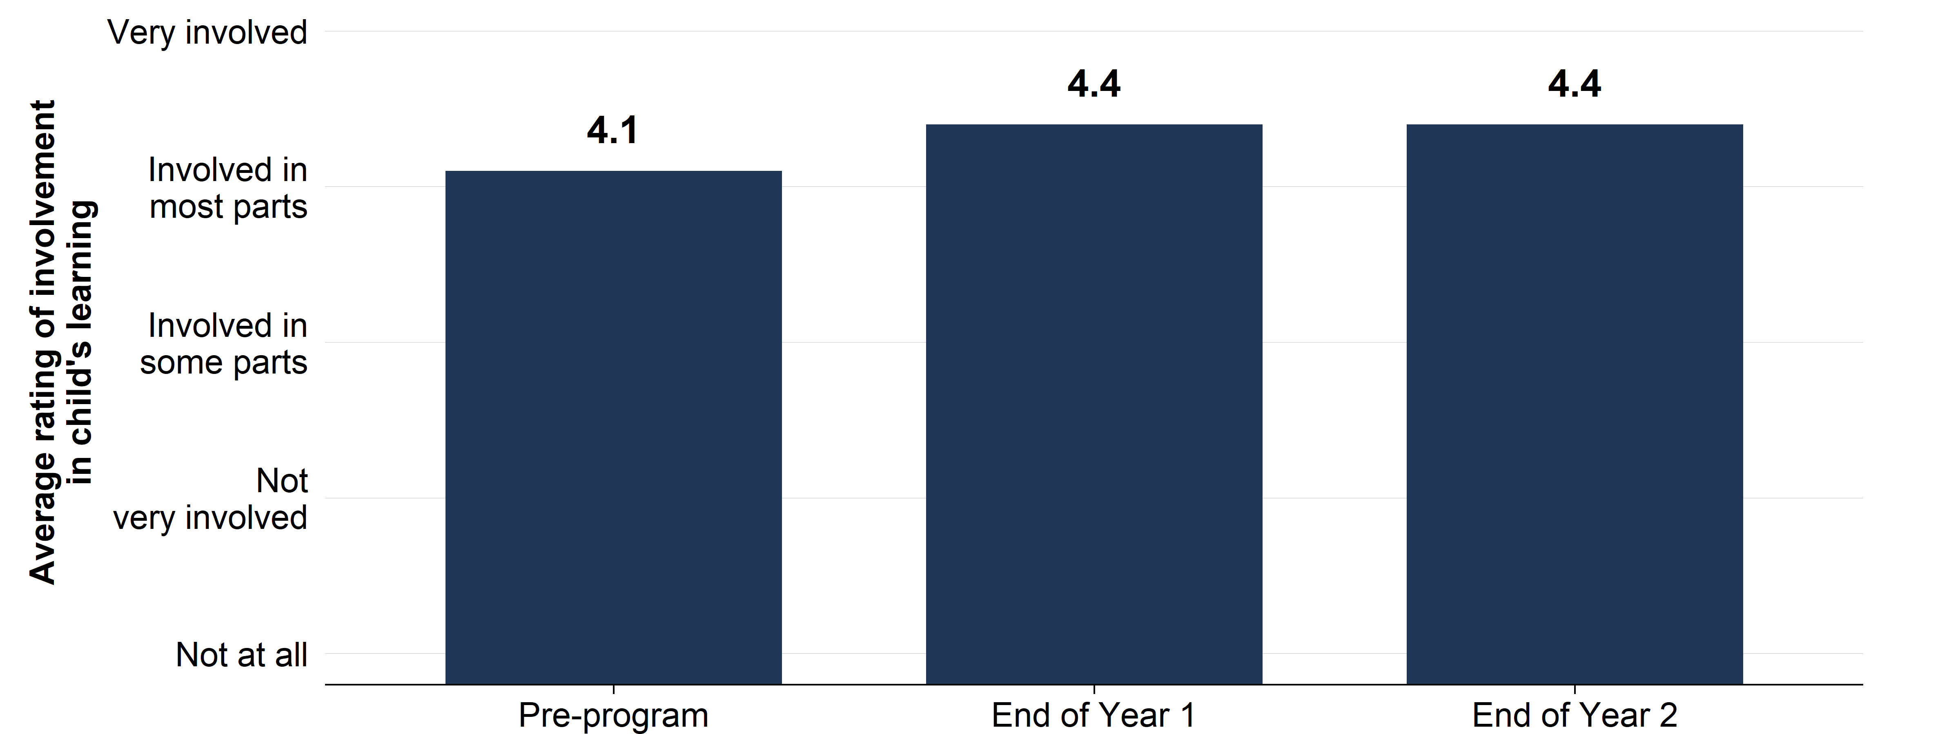
Source: BSL program data
N = Pre: 2,592, Mid: 1,688, Post: 1,483. Question: How involved are you in your child’s learning? Response options: Not at all; Not very involved; Involved in some parts; Involved in most parts; Very involved

Figure 16: Parent-rated frequency of reading to their child
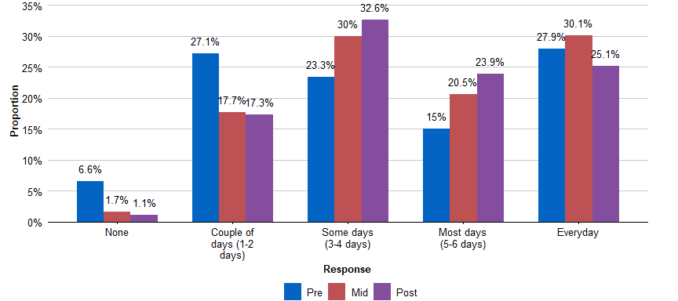
Source: BSL program data
N = Pre: 2,557, Mid: 1,685, Post: 1,482. Question: During the past week, how often did you read or share stories with your child? Response options: None; Couple of days (1–2 days); Some days (3–4 days); Most days (5–6 days); Every day

Prior to HIPPY, almost half (44 per cent) of parents reported playing with their child every day (Figure 17). This number decreased over time in HIPPY, with one-third of parents (34 per cent) reporting that they played with their child every day of the week at the end of HIPPY. The number of parents that reported playing with their child at least some of the days, but not all of the days, increased over time in HIPPY.
Figure 17: Parent-rated frequency of playing with their child
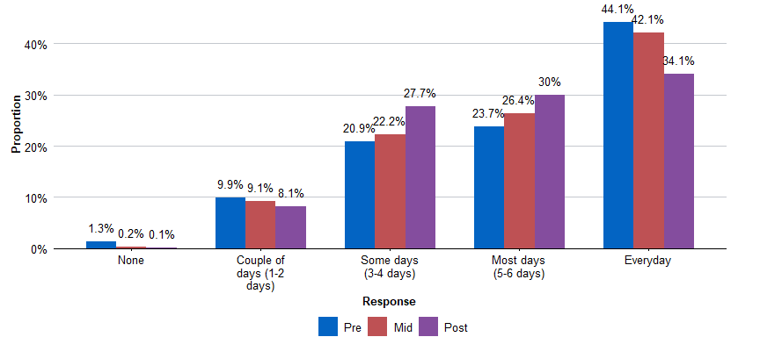
Source: BSL program data
N = Pre: 2,601, Mid: 1,686, Post: 1,482. Question: During the past week, how often did play with your child? Response options: None; Couple of days (1–2 days); Some days (3–4 days); Most days (5–6 days); Every day

Prior to HIPPY, 56 per cent of parents reported using an everyday activity to teach their child regularly or often; this increased to 75 per cent following HIPPY (Figure 18). As previously, this increase in behaviour appears to be due to small increases in frequency among some parents – and most notably, among parents who were reporting that they did not do this at all, rarely or sometimes used everyday activities to teach their child prior to HIPPY.
Figure 18: Parent-rated frequency of using an everyday activity to teach their child
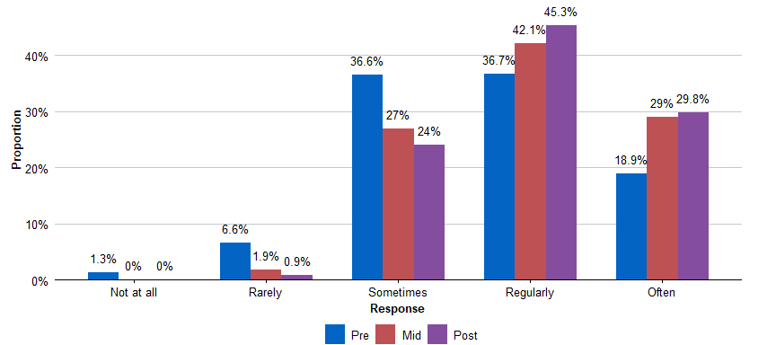
Source: BSL program data
N = Pre: 2,589, Mid: 1,690, Post: 1,481. Question: How often do you use an everyday activity to teach your child something new? Response options: Not at all; Rarely; Sometimes; Regularly; Often

Provision of a positive home-learning environment
Parents report engaging in a broad number of behaviours that stimulate a positive home-learning environment and largely attribute these changes to HIPPY. Parent’s reported behaviours surrounding the home-learning environment also appear to improve over time in HIPPY.
There are two questions in the parent survey and no questions in the BSL program data that assess HIPPY’s impact on or parents’ provision of a positive home-learning environment.
Overall, responding parents generally reported that they engaged in positive home-learning environment behaviours with high frequency, or that they did not engage with harmful home-learning environment behaviours frequently (Table 13). However, while responding parents broadly reported engaging in positive home learning behaviours, there was still a small number of parents (3‍–‍4 per cent) who reported that they never, rarely or only sometimes engaged in these behaviours.
The two least endorsed positive home-learning environment behaviour were:
- Encourage the child to keep up with an activity, even when they find it difficult: 10 per cent of parents reported doing this sometimes or less frequently
- Find yourself getting upset or angry with your child during a learning activity: 10 per cent of parents reported doing this often or more frequently

Table 13: Parents’ frequency of behaviours promoting a positive home-learning environment
Question: Since joining HIPPY, how often do you: | Response | Per cent
Demonstrate warmth to your child during a learning activity? | Always | 51.1
Demonstrate warmth to your child during a learning activity? | Most of the time | 33.5
Demonstrate warmth to your child during a learning activity? | Often | 11.9
Demonstrate warmth to your child during a learning activity? | Sometimes | 2.2
Demonstrate warmth to your child during a learning activity? | Rarely | 0.6
Demonstrate warmth to your child during a learning activity? | Never | 0.6
Listen to the child and respect the child’s opinion during a learning activity? | Always | 50.2
Listen to the child and respect the child’s opinion during a learning activity? | Most of the time | 37.0
Listen to the child and respect the child’s opinion during a learning activity? | Often | 11.0
Listen to the child and respect the child’s opinion during a learning activity? | Sometimes | 0.9
Listen to the child and respect the child’s opinion during a learning activity? | Rarely | 0.3
Listen to the child and respect the child’s opinion during a learning activity? | Never | 0.6
Encourage the child to explore and ask questions? | Always | 62.4
Encourage the child to explore and ask questions? | Most of the time | 25.4
Encourage the child to explore and ask questions? | Often | 9.1
Encourage the child to explore and ask questions? | Sometimes | 1.6
Encourage the child to explore and ask questions? | Rarely | 0.6
Encourage the child to explore and ask questions? | Never | 0.9
Encourage the child to keep up with an activity, even when they find it difficult? | Always | 39.8
Encourage the child to keep up with an activity, even when they find it difficult? | Most of the time | 36.4
Encourage the child to keep up with an activity, even when they find it difficult? | Often | 14.1
Encourage the child to keep up with an activity, even when they find it difficult? | Sometimes | 5.3
Encourage the child to keep up with an activity, even when they find it difficult? | Rarely | 2.8
Encourage the child to keep up with an activity, even when they find it difficult? | Never | 1.6
Find yourself getting upset or angry with your child during a learning activity? | Always | 3.4
Find yourself getting upset or angry with your child during a learning activity? | Most of the time | 3.1
Find yourself getting upset or angry with your child during a learning activity? | Often | 3.4
Find yourself getting upset or angry with your child during a learning activity? | Sometimes | 13.2
Find yourself getting upset or angry with your child during a learning activity? | Rarely | 41.1
Find yourself getting upset or angry with your child during a learning activity? | Never | 35.7
Get upset and raise your voice when the child does not meet your expectations in an activity? | Always | 2.5
Get upset and raise your voice when the child does not meet your expectations in an activity? | Most of the time | 2.5
Get upset and raise your voice when the child does not meet your expectations in an activity? | Often | 3.1
Get upset and raise your voice when the child does not meet your expectations in an activity? | Sometimes | 4.1
Get upset and raise your voice when the child does not meet your expectations in an activity? | Rarely | 21.6
Get upset and raise your voice when the child does not meet your expectations in an activity? | Never | 66.1
Source: Parent survey
N = 319. Question: Since joining HIPPY, how often do you do the following? Response options: Always; Most of the time; Often; Sometimes; Rarely; Never

Table 14: Parent’s ratings of the impact of HIPPY on positive home-learning environment behaviours
Question: To what extent do you think HIPPY has influenced: | Response | Per cent
How you interact with your child during learning activities? | Positive impact | 93.1
How you interact with your child during learning activities? | No impact | 6.3
How you interact with your child during learning activities? | Negative impact | 0.6
How you show your support to your child during a learning activity? | Positive impact | 93.4
How you show your support to your child during a learning activity? | No impact | 5.3
How you show your support to your child during a learning activity? | Negative impact | 1.2
How you encourage the child during a learning activity? | Positive impact | 93.1
How you encourage the child during a learning activity? | No impact | 5.3
How you encourage the child during a learning activity? | Negative impact | 1.5
How you manage your own reactions to your child’s behaviour during a learning activity | Positive impact | 85.0
How you manage your own reactions to your child’s behaviour during a learning activity | No impact | 13.8
How you manage your own reactions to your child’s behaviour during a learning activity | Negative impact | 1.2
How you show love or warmth to your child? | Positive impact | 79.0
How you show love or warmth to your child? | No impact | 19.7
How you show love or warmth to your child? | Negative impact | 1.2
Source: Parent survey
N = 319. Question: To what extent do you think HIPPY has influenced these behaviours? Response options: Positive impact; No impact; Negative impact

Responding parents consistently reported that HIPPY has had a very positive or positive impact on how they engage with their child during learning activities. For responding parents who have more experience in HIPPY, they also reported a more positive influence of HIPPY on the outcomes. The reported impact of HIPPY was the weakest for how parents show love or warmth to their child, with 21 per cent of parents indicating that HIPPY did not have any impact on this (Table 14).

Parents’ confidence as educators, and parenting skills
Both sources of data indicate that HIPPY appears to positively impact parents’ reported confidence across a range of measures. This includes undertaking learning activities with their child, being their child’s first teacher, and supporting their child’s learning. However, when asked about their perceived ability to teach their child in a range of ways, many parents rate their ability as ‘somewhere in the middle’ even following completion of HIPPY – suggesting that HIPPY is not a panacea to improve parental confidence, and/or that parents still feel their abilities are limited relative to other parents.
Generally, responding parents’ self-reported confidence in undertaking learning activities with their child increased following graduation from HIPPY (Figure 19). Very few responding parents indicated that they currently felt not at all, slightly or somewhat confident engaging in learning activities with their child currently (Currently enrolled parents: 1 per cent; Graduated parents: 0 per cent).
Figure 19: Parent confidence doing learning activities
Source: Parent survey
N = 319. Question: How confident did you feel doing learning activities with your child at the beginning of HIPPY? How confident do you currently feel doing learning activities with your child? Response options: Not confident at all; Slightly confident; Somewhat confident; Fairly confident; Very confident; Highly confident.

When parents were asked about their ability to use a range of ways to teach their child, generally parents’ perceptions of their ability improved over time in HIPPY (Figure 20). Prior to commencing HIPPY, 44 per cent of parents rated their ability as ‘somewhere in the middle’, with 13 per cent of parents rating their ability as somewhat or very challenging. Following completion of HIPPY there was some improvement, but almost one third (31 per cent) of parents still rated their ability as ‘somewhere in the middle’, and three per cent of parents still felt their abilities were being challenged.
Responding parents’ reported impact of HIPPY on their comfort and confidence was positive (Figure 21), with:
- 95 per cent of responding parents reporting that HIPPY positively influenced their comfort using learning activities to teach their child
- 94 per cent of responding parents reporting that HIPPY positively influenced how confident they feel being their child’s first teacher
- 94 per cent of responding parents reporting that HIPPY positively influenced how confident they feel supporting their child’s learning.
Figure 20: Parent’s ratings of their ability to use different methods to teach their child
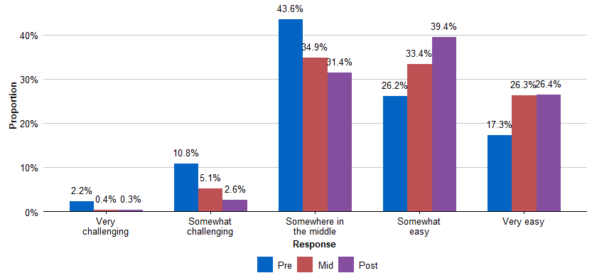
Source: BSL program data
N = Pre: 2,537, Mid: 1,690, Post: 1,480. Question: How would you rate your ability to use a range of ways to teach your child? Response options: Very challenging; Somewhat challenging; Somewhere in the middle; Somewhat easy; Very easy

Figure 21: Influence of HIPPY on parent confidence
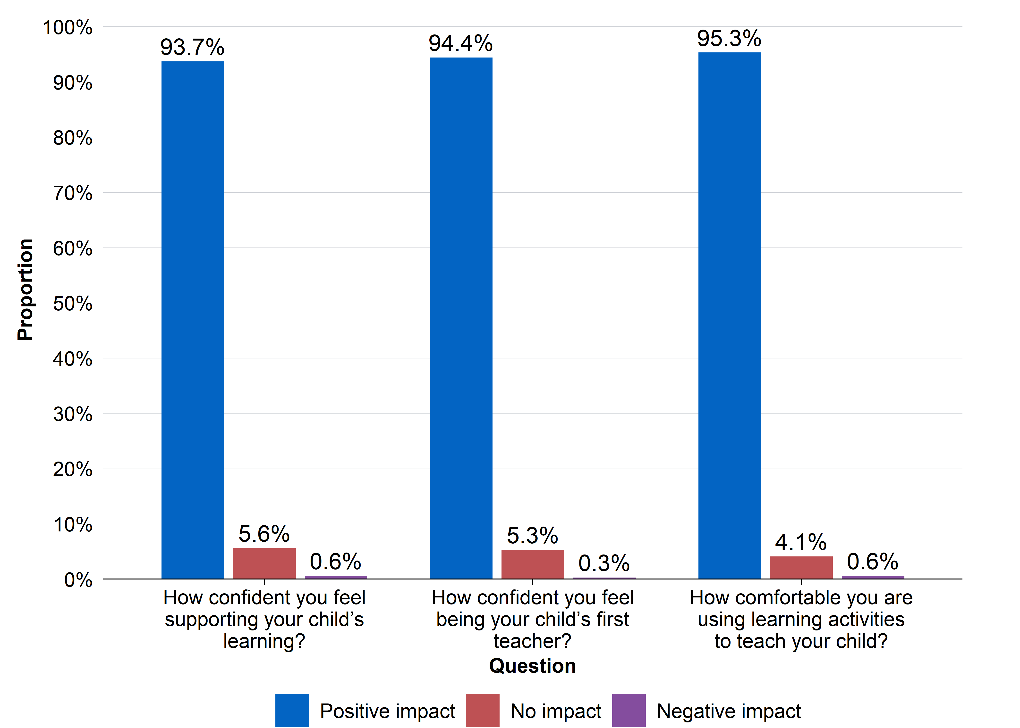
Source: Parent survey
N = 319. Question: How has HIPPY influenced: a) How confident you feel being your child’s first teacher? b) How confident you feel supporting your child’s learning? c) How comfortable you are using learning activities to teach your child? Response options: HIPPY has had a very positive impact on this; HIPPY has had a positive impact on this; HIPPY has not had any impact on this; HIPPY has had a negative impact on this; HIPPY has had a very negative impact on this

Parent-child relationship
Data from both sources indicates that parents generally feel HIPPY has had a positive influence on the parent-child relationship and has brought them closer. However, when the parent-child relationship was broken down into specific actions, some parents report that they do not always feel close to their child or enjoy doing things with them.
Overall, a majority of responding parents reported that HIPPY positively influenced their relationship with their child (Figure 22). The number of responding parents who reported positive changes in their parent-child relationship increased with duration in HIPPY: 83 per cent of parents in the first year of HIPPY (that is, who had experienced less than six months of HIPPY at the time of the survey) reported a positive influence in their relationship with their child. This increased to 87 per cent for responding parents currently in the second year of HIPPY, and 92 per cent for responding parents who had graduated from HIPPY.
Figure 22: Influence of HIPPY on the parent-child relationship
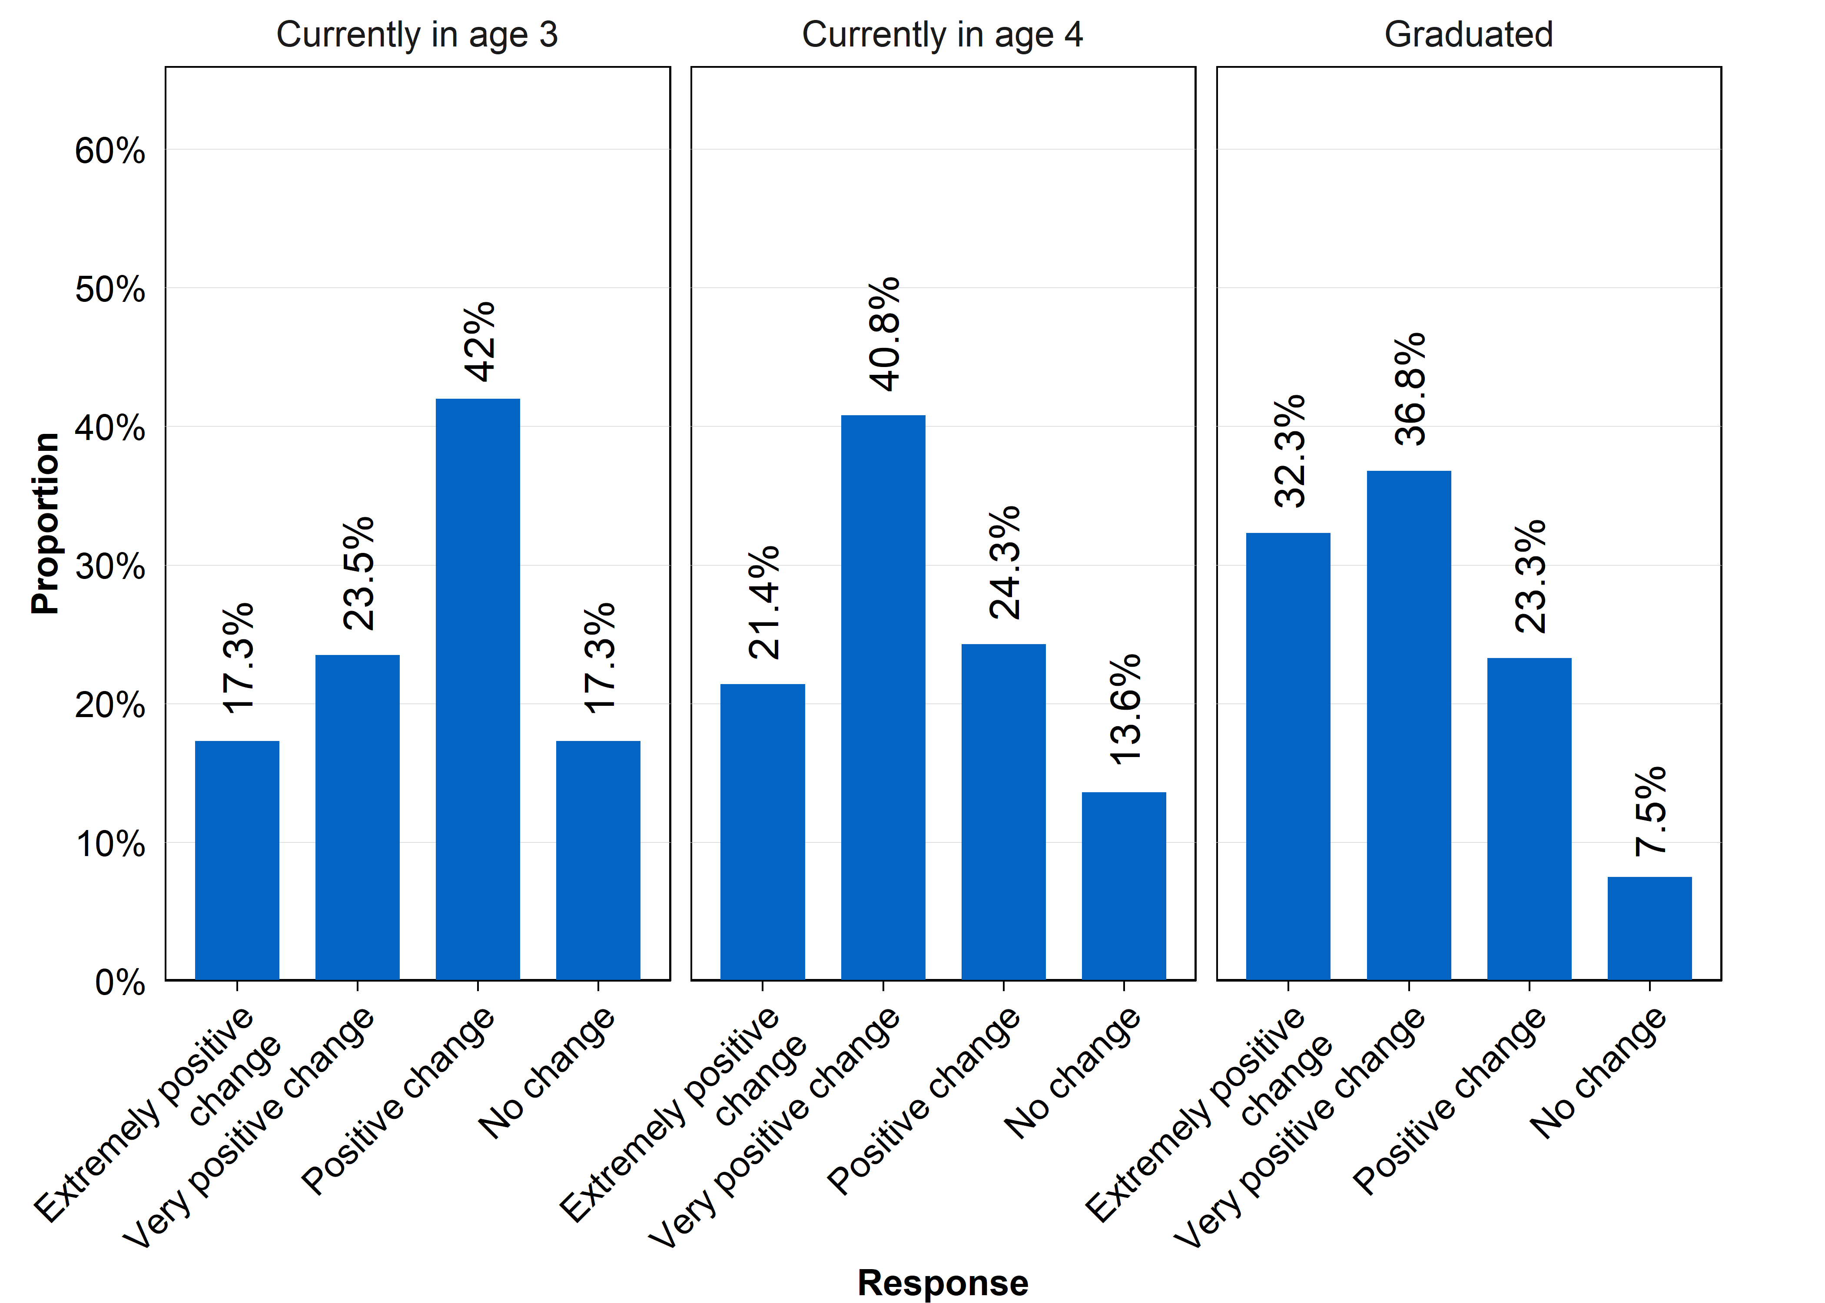
Source: Parent survey
N = 319. Question: How has HIPPY changed your relationship with your child? Response options: Extremely positive change; Very positive change; Positive change; No change; Negative change; Very negative change; Extremely negative change.

In general, parents reported that their relationship with their child improved as a result of participating in HIPPY. 83 per cent of parents reported feeling mostly or a lot closer to their child mid-way through HIPPY (after one year), and 89.5 per cent reported feeling mostly or a lot closer to their child following program completion (Figure 23). However, one in 10 parents (10 per cent) felt that HIPPY helped them to feel only somewhat closer or less following graduation from HIPPY.
Figure 23: Influence of HIPPY on the closeness and connection between parent and child
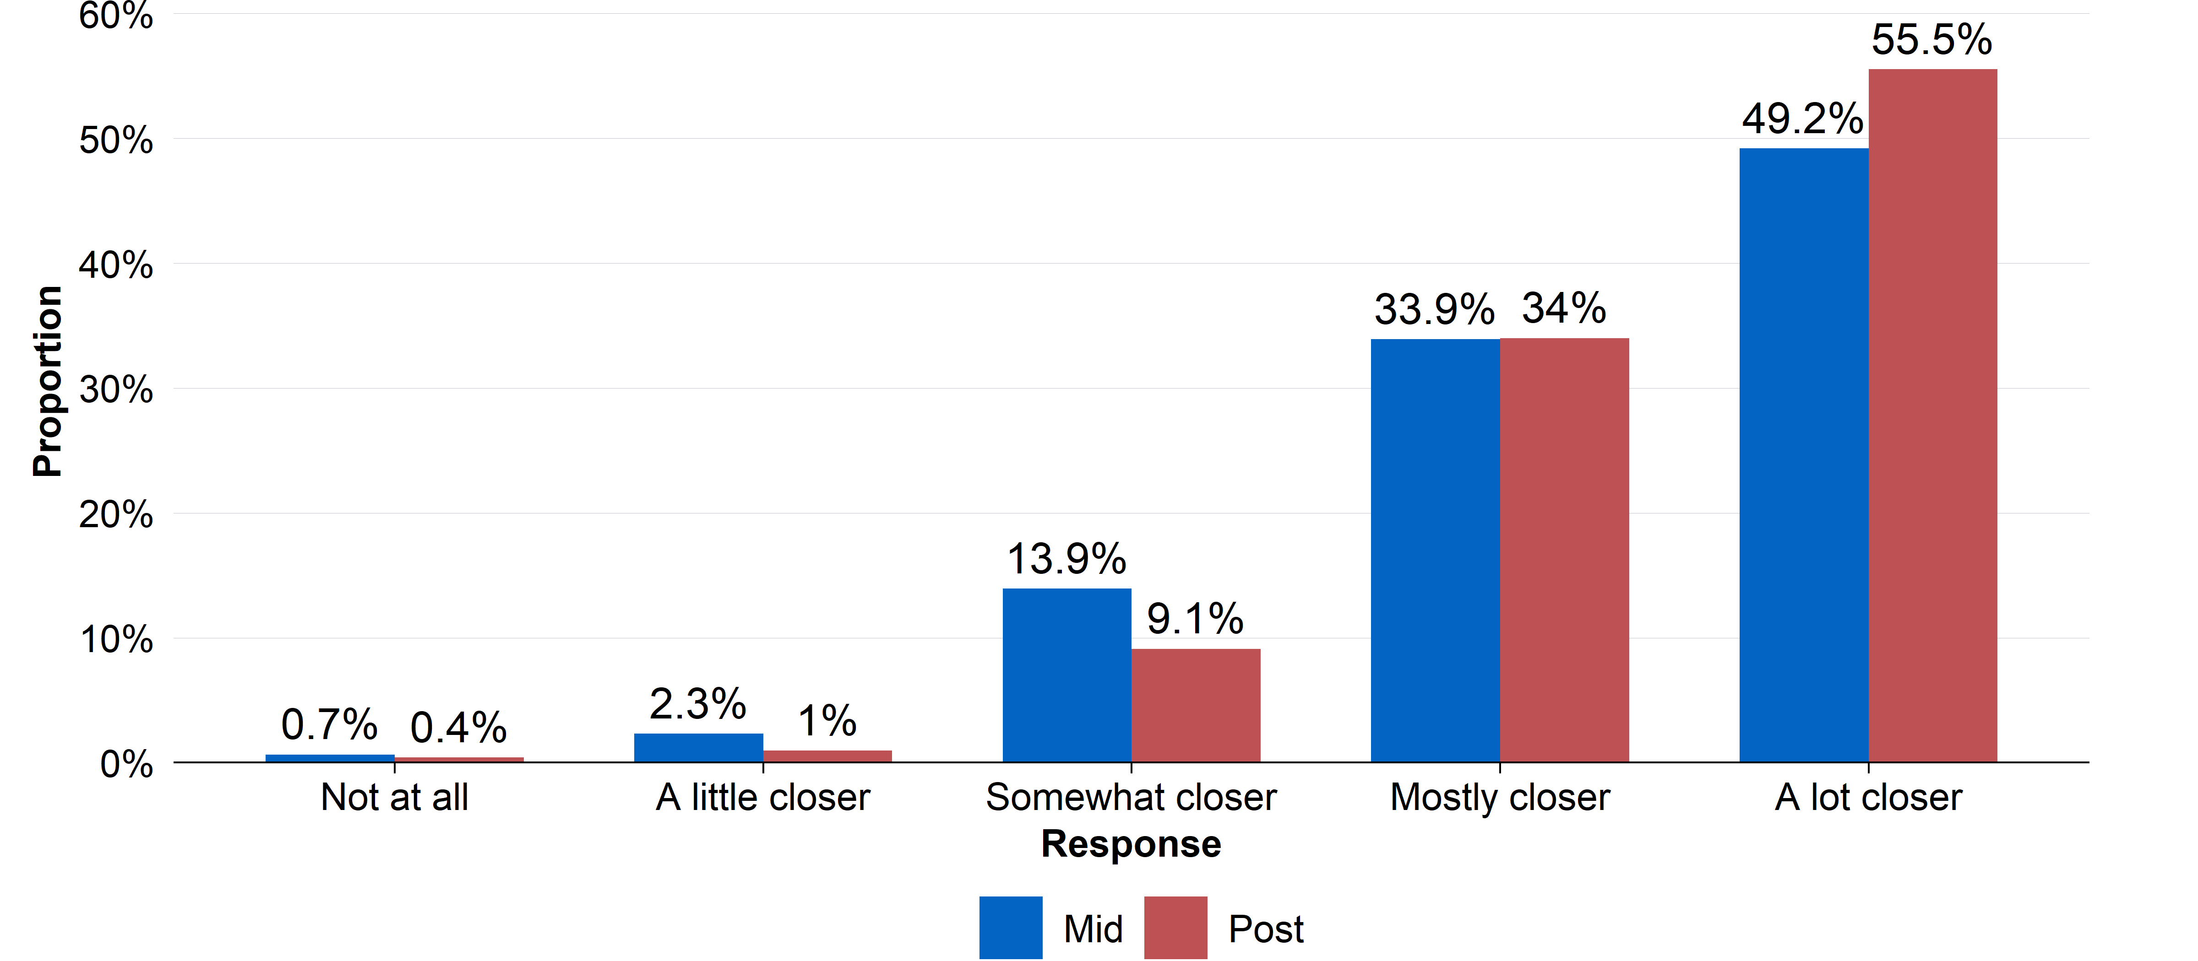
Source: BSL program data
N = Mid: 1,697, Post: 1,471. Question: Has HIPPY helped you to feel closer or connect better with your child? Response options: Not at all; A little closer; Somewhat closer; Mostly closer; A lot closer

Figure 24: Parent’s ratings of frequency of positive emotions toward their child
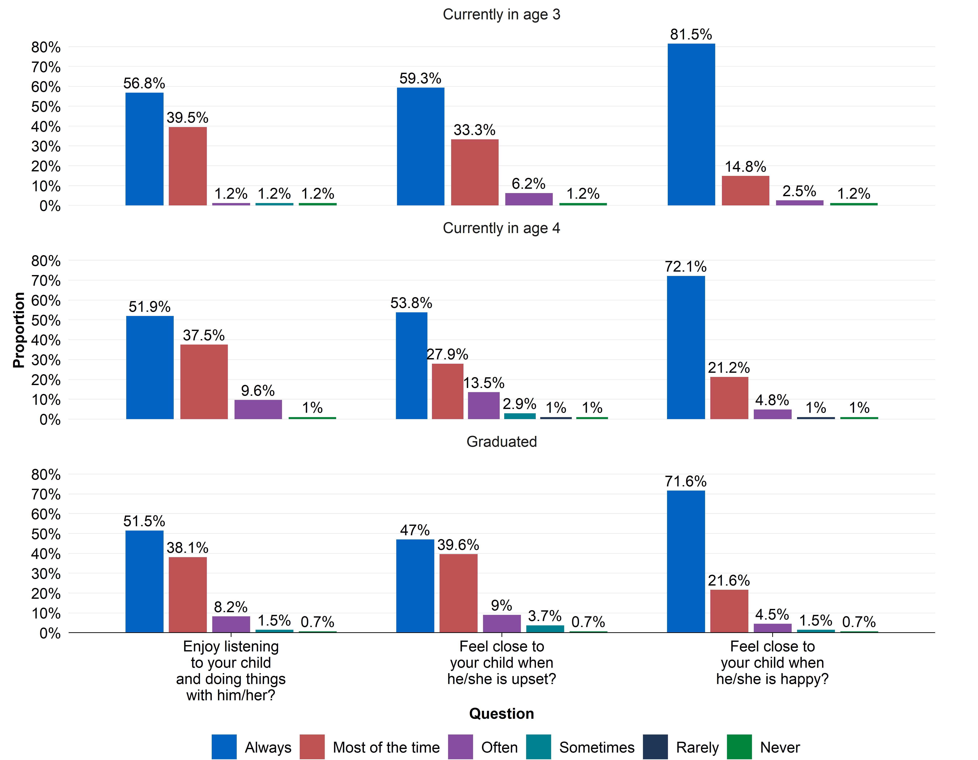
Source: Parent survey
N = 319. Question: How often do you: a) Enjoy listening to your child and doing things with him/her? b) Feel close to your child when he/she is happy? c) Feel close to your child when he/she is upset? Response options: Never; Rarely; Sometimes; Often; Most of the time; Always

The vast majority of responding parents reported always feeling close to their child when they are happy, but this level decreased with experience in HIPPY (Figure 24). In contrast, although responding parents broadly agreed they feel close to their child when they are upset and enjoy doing things with their child, approximately one-third of responding parents indicated that they feel this only most of the time, compared to always.

Family outcomes
Only one survey question explicitly considered an outcome relevant to those considered ‘family’ outcomes: whether a parent feels they have the confidence to work with others to support their child’s learning.
No questions were analysed for the following family outcomes:
- Confidence accessing local services
- Family social connections
- Contributions to the local community

Confidence to advocate for child’s education
Data from the survey of parents indicates that HIPPY had a positive influence on responding parents’ confidence to work with those who support their child’s learning. However, whether parents feel more confidence prior to versus following HIPPY in working with others who support their child’s learning is an open question.
ACE did not have access to the BSL program data relevant to this outcome.
Overall, 95 per cent of responding parents reported that HIPPY had a positive or very positive impact on their confidence to work with others who support their child’s learning. Approximately 5 per cent of respondents indicated that HIPPY did not have any impact on this or had a negative or very negative impact.
There was very little variation in this rate when considering current age three, age four and graduated HIPPY cohorts. This suggests that parents who responded to the survey felt that HIPPY was beneficial to help them work with educational professionals, but that the positive impact may not improve or grow with time in HIPPY.
Figure 25: Parent’s confidence to work with others supporting their child’s learning
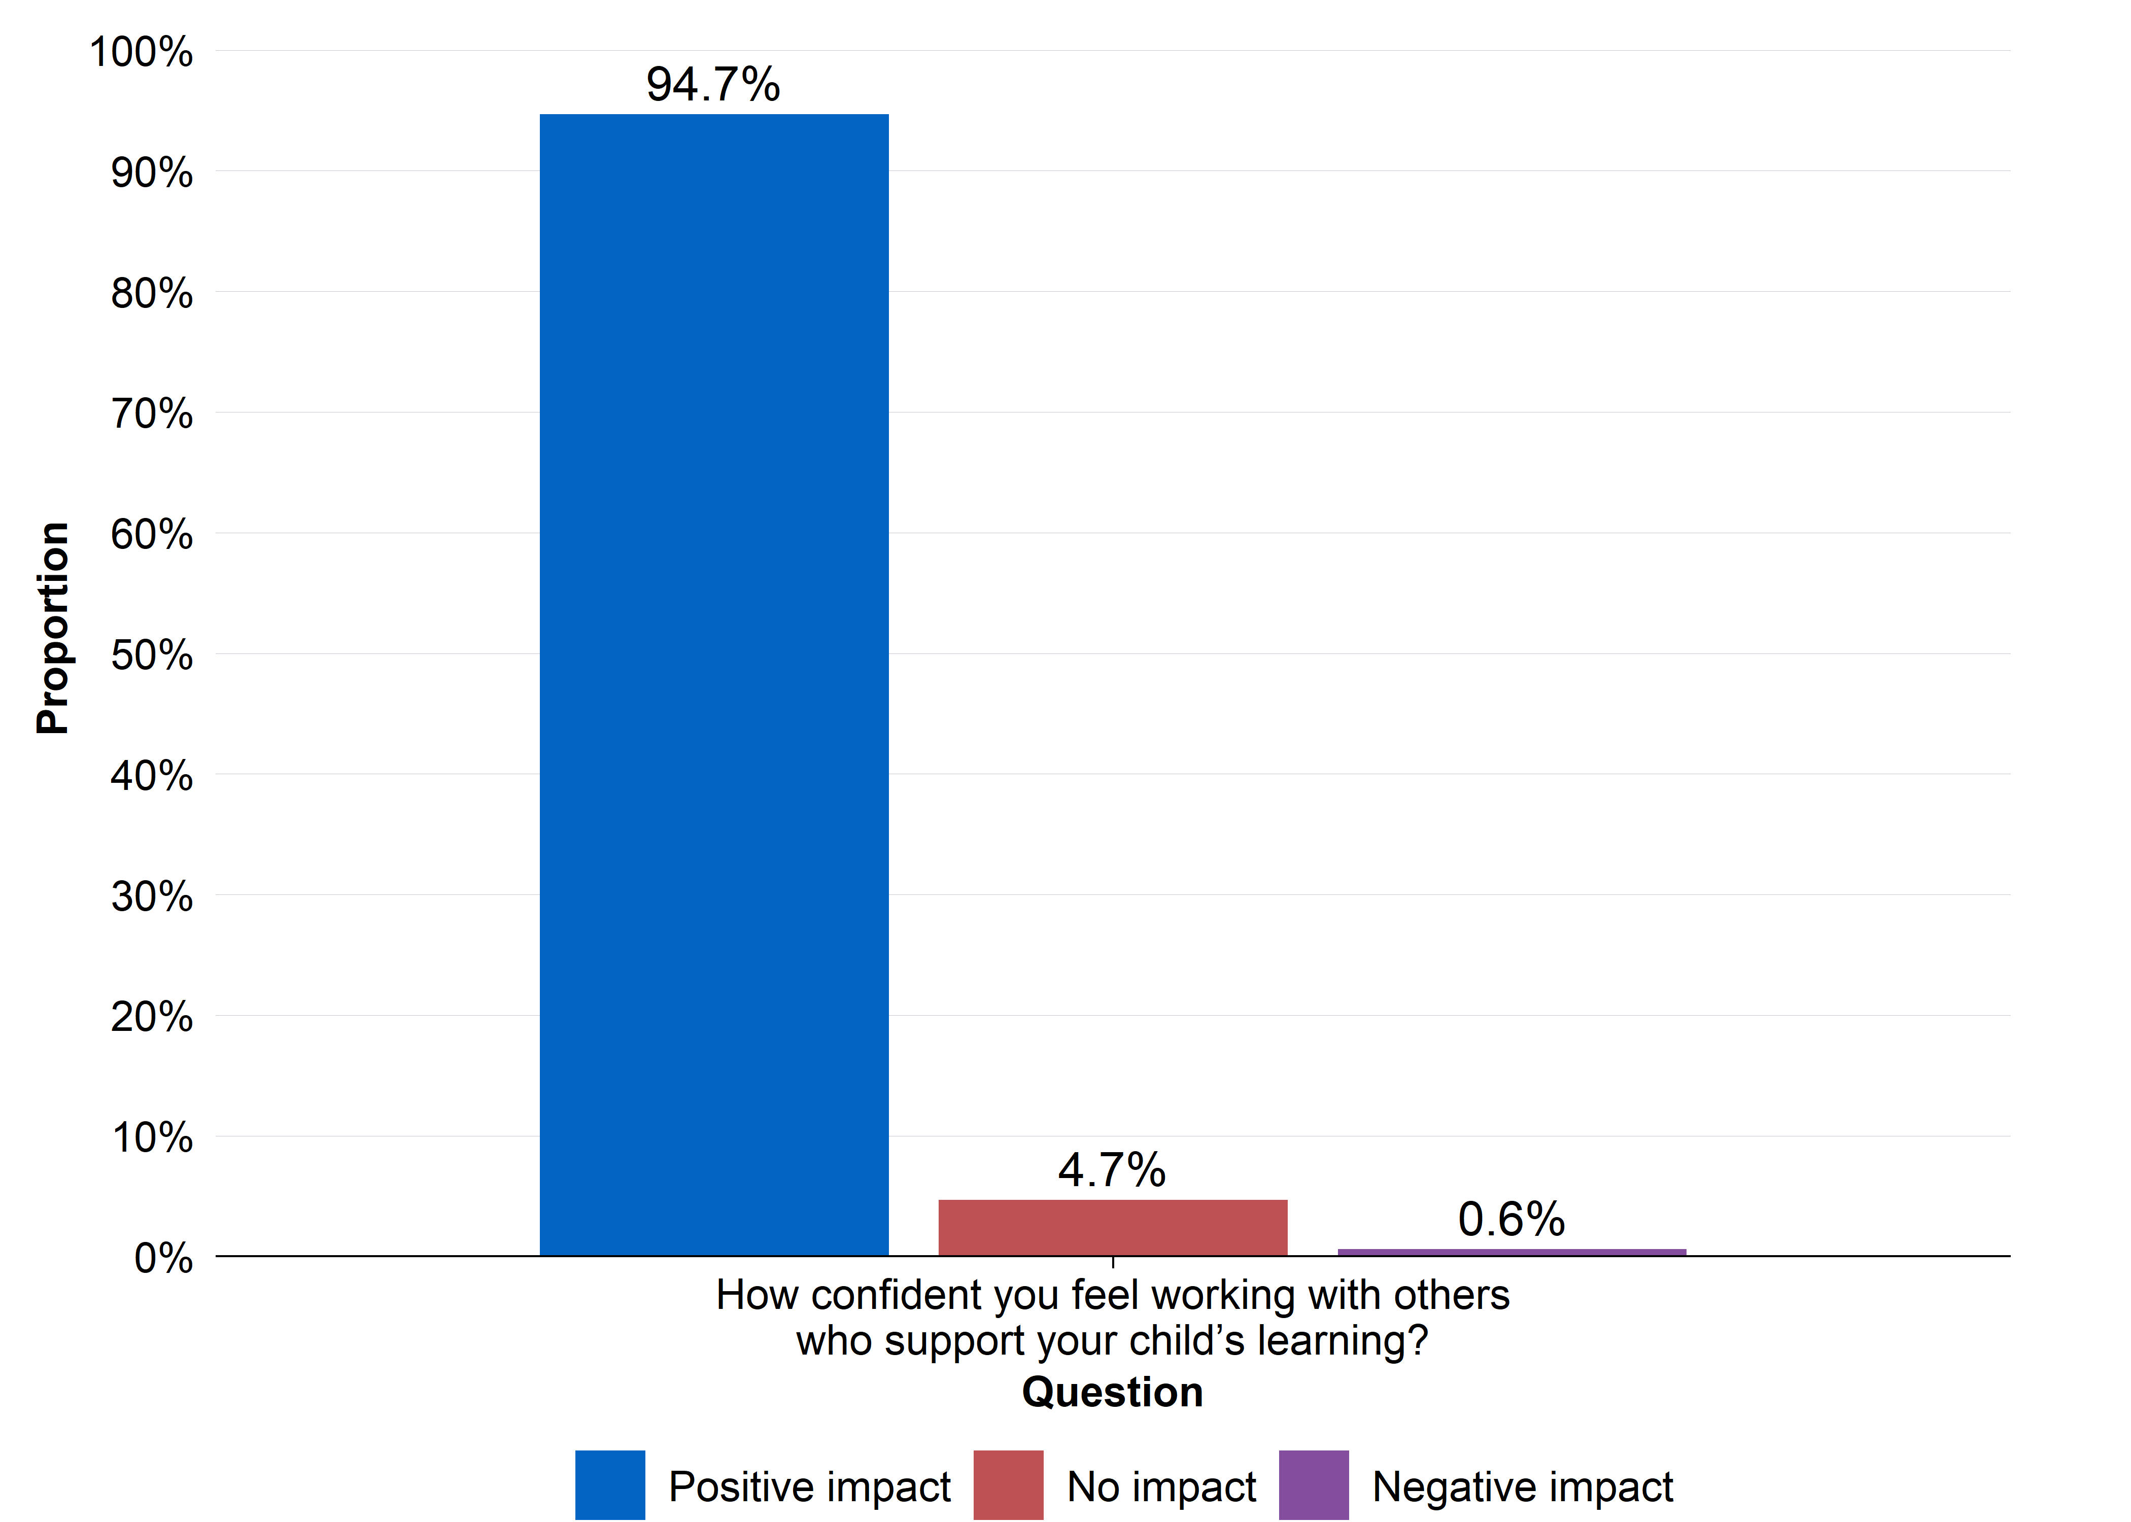
Source: Parent survey
N = 319. Question: How has HIPPY influenced: How confident you feel working with others who support your child’s learning? (for example, teachers, HIPPY staff)? Response options: HIPPY has had a very positive impact on this; HIPPY has had a positive impact on this; HIPPY has not had any impact on this; HIPPY has had a negative impact on this; HIPPY has had a very negative impact on this.

PRC parent survey questions relevant to ACE
There were two versions of the survey with the ordering of the question blocks counterbalanced due to the inclusion of questions relevant to ACE’s evaluation, and questions relevant to PRC’s evaluation. Both surveys commenced with a consent and eligibility check block (when parents had participated in HIPPY, and how many times). In one version of the survey, participants completed the ‘implementation’ question block for PRC’s evaluation prior to ACE’s ‘outcome’ question block; in the other survey, participants completed ACE’s ‘outcome’ question block prior to completing the ‘implementation’ question block. All surveys finished with a demographics and family characteristics question block.

Eligibility and pre-amble
- What year did you first enrol in HIPPY?
[Response options: before 2015;2015; 2016; 2017; 2018; 2019; 2020; 2021; 2022; 2023; 2024; 2025]
- How many times have you started HIPPY?
[Response options: 1; 2; 3; more than 3]
- Are you currently attending HIPPY?
[Response options: Yes – I am currently doing HIPPY with a child; No – I have already graduated from HIPPY; No – I stopped attending HIPPY before graduating]
- What month and year did you graduate from HIPPY?
[Response options: month; year]

Parent’s behaviours and engagement in HIPPY activities (and other educational activities)
- How has HIPPY influenced:
  - How often you do learning activities with your child in a week? (for example, reading, drawing, play-based learning, everywhere learning)
  - The range of learning activities you do with your child?
  - How long you spend doing a learning activity with your child?
  - The range of methods you use to show your support to your child?
  - [Response options: HIPPY has significantly increased this; HIPPY has increased this; HIPPY has not had any impact on this; HIPPY has decreased this; HIPPY has significantly decreased this]

Whether and how parents learn about child development and how their child learns
- How has HIPPY influenced your understanding of how your child likes to learn?
[Response options: I have a lot more knowledge of how my child likes to learn; I have more knowledge of how my child likes to learn; I have about the same knowledge of how my child likes to learn; I have less knowledge of how my child likes to learn; I have a lot less knowledge of how my child likes to learn]
- How has HIPPY influenced your knowledge of how your child learns through everyday activities?
[Response options: HIPPY has not influenced this at all; HIPPY has influenced this a little bit; HIPPY has influenced this somewhat; HIPPY has influenced this a large amount]

Parent’s provision of a positive home-learning environment
- Since joining HIPPY, how often do you:
  - Demonstrate warmth to your child during a learning activity?
  - Listen to the child and respect the child’s opinion during a learning activity?
  - Encourage the child to explore and ask questions?
  - Encourage the child to keep up with an activity, even when they find it difficult?
  - Find yourself getting upset or angry with your child during a learning activity?
  - Get upset and raise your voice when the child does not meet your expectations in an activity?
[Response options: Never; Rarely; Sometimes; Often; Most of the time; Always]
- To what extent do you think HIPPY has influenced:
  - How you interact with your child during learning activities?
  - How you show your support to your child during a learning activity?
  - How you encourage the child during a learning activity?
  - How you manage your own reactions to your child’s behaviour during a learning activity?
  - How you show love or warmth to your child?
[Response options: HIPPY has had a very positive impact on this; HIPPY has had a positive impact on this; HIPPY has not had any impact on this; HIPPY has had a negative impact on this; HIPPY has had a very negative impact on this]

Parent’s confidence in being their child’s first teacher and engaging with learning opportunities
- How confident did you feel doing learning activities with your child at the beginning of HIPPY?
- How confident do you currently feel doing learning activities with your child?
[Response options: Not confident at all; Slightly confident; Somewhat confident; Fairly confident; Very confident; Highly confident]
- How strongly do you agree with the following statement: I am my child’s first teacher
[Response options: Strongly disagree; Disagree; Neither agree nor disagree; Agree, Strongly agree]
- How has HIPPY influenced:
  - How confident you feel being your child’s first teacher?
  - How confident you feel supporting your child’s learning?
  - How confident you feel working with others who support your child’s learning? (for example, teachers, HIPPY staff)
  - How comfortable you are using learning activities to teach your child?
[Response options: HIPPY has had a very positive impact on this; HIPPY has had a positive impact on this; HIPPY has not had any impact on this; HIPPY has had a negative impact on this; HIPPY has had a very negative impact on this]

Improved parent-child relationships
- How often do you:
  - Enjoy listening to your child and doing things with him/her?
  - Feel close to your child when he/she is happy?
  - Feel close to your child when he/she is upset?
[Response options: Never; Rarely; Sometimes; Often; Most of the time; Always]
- How has HIPPY changed your relationship with your child?
[Response options: Extremely positive change; Very positive change; Positive change; No change; Negative change; Very negative change; Extremely negative change]
- Why do you think this?

Improved child school readiness, including cognitive, social and emotional development
- Please rate your level of agreement with the following statements:
  - My child is ready for school
[Response options: Strongly disagree; Disagree; Neither agree nor disagree; Agree, Strongly agree]
- How has HIPPY changed how ready your child is for school?
[Response options: HIPPY has had a very positive impact on this; HIPPY has had a positive impact on this; HIPPY has not had any impact on this; HIPPY has had a negative impact on this; HIPPY has had a very negative impact on this]
  - Why did you answer this way?

Parent/family characteristics
- What postcode did you live in while attending HIPPY?
- What is your current age?
- How many children do you have in your care (including grandchildren and nieces and nephews if you care for them)?
- What was your sex recorded at birth?
- What is your gender?
- What is your relationship with the child you did or are doing HIPPY with?
- Do you identify as being of Aboriginal and/or Torres Strait Islander descent?
- What is the main language you speak at home?
- How do you describe your sexual orientation?
- In general, how would you rate your physical health?

Interview guide
Table 15: Suggested interview questions
Element of theory of change/program logic | Suggested interview questions
Demographics and opening | Could you please describe what made you sign up for HIPPY?  How was your experience of HIPPY over the past two years?  Demographics [as appropriate]:  What is your relationship to the child who took part in HIPPY?  Is this your first child?  How many children do you have in your home?  What parts of HIPPY did you take part in? Which activities and how frequently?
Parent’s behaviours and engagement in HIPPY activities (and other educational activities) | Can you tell us about how you spend time with your child - what does this look like on a day-to-day basis?  [Follow-up prompt]: What kinds of learning activities or everyday learning do you do with your child?  Compared to your upbringing / before HIPPY / bring up previous children, how has HIPPY changed the way you spend time with your child?  [Follow-up prompt]: Were there changes in your activities because of HIPPY?  [Follow-up prompt]: What was it about HIPPY that taught you this?
Whether and how parents learn about child development and how their child learns | What have you learnt about child development since being a part of HIPPY?  [Follow-up prompt]: How has HIPPY taught you about how your child learns through play?  Imagine you didn’t take part in HIPPY; how would you have learnt about child development? / Thinking about other parents who aren’t involved in HIPPY: How do they learn about child development?  [Follow-up prompt]: How might other parents get the kind of information you’re learning in HIPPY?  [Follow-up prompt]: What have you learnt from other places about child development?
Parent’s provision of a positive home-learning environment | How do you make learning a positive experience for your child?  [Follow-up prompt]: Encouraging questions, resilience in the face of setbacks, using humour.  How much has the HIPPY approach influenced this?  How much has HIPPY taught you a new way of creating a positive space at home for learning?  Follow-up prompts: Which parts of HIPPY taught you this?
continued on next page

Table 15: Suggested interview questions (continued)
Element of theory of change/program logic | Suggested interview questions
Parent’s confidence in being their child’s first teacher and engaging with learning opportunities (school, teachers, community) | Now, we want to start thinking a little bit more about what has happened for you: What impact has HIPPY had on your confidence to teach your child?  [Follow-up prompt]: Why did you answer like this?  [Follow-up prompt]: What parts of HIPPY influenced this?  Other prompts: What level of confidence did you have before HIPPY? What is it now?  Can you describe what other things have been happening over the last couple of years that could have affected your confidence?  [Follow-up prompt]: Maybe you’ve learnt something from preschool, or from other parents or playgroups?
Improved parent-child relationships | How has your relationship with your child changed since you started participating in HIPPY?  [Follow-up prompt]: In what way has your relationship changed?  [Follow-up prompt]: Before HIPPY, what was your relationship with your child like?  [Follow-up prompt]: Thinking about your connection with your child, how has this changed since participating in HIPPY?  [Follow-up prompt]: How has HIPPY influenced the closeness of your relationship with your child or the strength of your relationship?  Have there been any significant events in the last two years that might have impacted on your relationship with your child? / What other things have been going on in the last two years that could have impacted your relationship with your child?  [If time / appropriate]: What aspects of HIPPY do you think you will carry forward to help continue to build your connection with your child?
Overall impact of HIPPY, including Improved child school readiness | Overall, how has taking part in HIPPY impacted your life?  [Follow-up prompt]: Why? How?  How has HIPPY impacted your child’s life?  [Follow-up prompt]: How does your child feel about starting school?  [Follow-up prompt]: What role do you think HIPPY has played in that?  What do you think would have happened if you hadn’t taken part in HIPPY?  If you didn’t take part in HIPPY, how many of these things might have changed anyway?

Participant Information/Consent Sheet

Parent interview/discussion group Participant Information Statement

Interview/group discussion: Parents and carers

Project Title: Home Interaction Program for Parents and Youngsters (HIPPY) 2024–25 Evaluation
You are invited to take part in an evaluation looking at the Home Interaction Program for Parents and Youngsters (HIPPY). The evaluation aims to learn more about your experiences with HIPPY. They are interested in whether the program has helped you and your child and how easy it is to access. An ethics committee has checked the evaluation processes and approved it.
You have been invited into the evaluation because you are or have been involved with the HIPPY program.
The evaluation is being conducted by the Parenting Research Centre (PRC), IPS Management Consultants and Curijo. IPS is an independent certified majority First Nations-owned consultancy firm and Curijo is an Aboriginal-owned and female-led consultancy firm. We are collaborating on some of the questions with the Australian Centre for Evaluation (ACE) The researchers/consultants involved in the evaluation are:

From the PRC: | From Curijo: | From IPS: | From ACE:
Dr Gina-Maree Sartore  Dr Catherine Wade  Ms Zvezdana Petrovic  Dr Victoria Hamilton | Belinda Kendall  Natasja Witbreuk  Stanley Jarrett  Bill Pritchard  Terri Bird  Zane Kendall | Dr James Butterworth  Dr Lillian De Bortoli  Kay Esensoy  Hannah Burgess  Shaquille McKenzie | Dr Vera Newman  Dr Ramethaa Pirathiban

You can contact Dr Gina-Maree Sartore for more information about the evaluation: gsartore@parentingrc.org.au
The evaluation is being funded by The Department of Social Services (DSS).
This Participant Information Sheet will tell you what is involved in the evaluation and help you decide whether or not you wish to take part. Please read this information carefully. If there is anything you do not understand or if you feel you need more information about anything, please ask.

What will I be asked to do?

Take part in an interview/group discussion
If you do decide to take part, you will be invited to do an interview or participate in a group discussion. In the interview or group discussion, you will be asked about if the program has helped you and your child and how easy it is to access. You will also be asked some questions about your background, how appropriate HIPPY is for families like yours, and how it could be improved. The interview/group discussion will go for about 40–60 minutes and may be done over the phone, by video-conference or in person.
If you agree to participate, you will be asked to give verbal consent before participating in the audio-recorded interview or group discussion. This audio recording will then be transcribed and will not contain any details that will identify you. If you wish not to be recorded, you can choose to do an interview (instead of a group discussion) where the interviewer will take notes during your interview, instead of recording and transcribing later. All group discussions will be audio-recorded as it won’t be possible to record only some participants and not others. You may choose to use a made-up name during the interview or group discussion. You can pause or stop the interview at any time. You can choose not to answer specific questions.

What are the possible benefits?
Your information will be of great benefit for understanding the HIPPY program, but it is unlikely there will be a personal or direct benefit to you from participating in this evaluation. Your contribution will help us determine if the HIPPY program is working well for families like yours and it may mean that it can be improved to suit other families in the future.
As a thank you for your time in the interview/group discussion, the evaluation team will give you a $50 gift card.

What are the possible risks?
Although it is not very likely, it is possible that talking about your experiences with HIPPY may make you feel upset or uncomfortable. If this happens, please let your Consultant know. You can also take a break from the interview at any time, skip questions, or ask for advice from your Tutor or the evaluation team. You could also call our PRC psychologist, Dr Catherine Wade on 0407 941 056. Or you could contact Lifeline at www.lifeline.org.au and on 13 11 14 or for Aboriginal and Torres Strait Islander people you could contact 13YARN.

Confidentiality
Any information you provide us through interviews/group discussions (interview recordings, transcripts, and notes) will be kept confidential and stored carefully by the evaluation team. Any information that could tell people who you are will be removed (for example, we will blank out any names in transcriptions of audio-recordings). Only the Curijo and IPS evaluation teams will have access to the audio-recordings and the transcripts. If you would like us to send you a $50 gift card as a thank you for your participation, we’ll ask for your email or postal address. Please know that this information will be kept separate from your interview or group discussion comments, ensuring that your feedback remains confidential and anonymous. The list of contact details will be permanently deleted at the end of the evaluation in December 2025.
Findings from interviews and group discussions will be summarised and reported as group findings to further protect your identity.
Audio files will be securely transferred from Curijo to IPS, so that responses can be transcribed and analysed by IPS and written up in a report. The audio files and transcripts will be retained securely for seven years from the day the evaluation is completed. All audio files and transcripts will be permanently deleted after seven years.
The evaluation results will be presented in a report and may be discussed publicly or presented at a conference or in a scientific publication, but individual participants will not be able to be identified.

Limits to Confidentiality
All information collected for this evaluation will be confidential, however, there are some important exceptions to confidentiality. If we are worried that you or your children are at significant risk of harm, we may have to let your HIPPY provider, or the Police know about this to ensure your safety and the safety of your children. However, if this was needed, we would speak with you about it first.

Do I have to take part?
No, you do not have to participate in the evaluation. You can still be part of the HIPPY program even without doing the evaluation. You can also stop participating in this evaluation at any stage and still do the HIPPY program as usual.
If you would like a copy of what you said in the focus group/interview, you can have it emailed to you so you can check it to make sure it is correct.
If you have already taken part in an interview or focus group, we can take your information out of our evaluation if we haven’t already started analysing it. But if we have started analysing it, we can’t identify your individual responses as your name has been removed from your responses.
When we report the results, we will make sure that you will not be able to tell who has said what comment, so no one will ever know that a comment is yours.

Will I hear about the results of this evaluation?
The results of this evaluation will be captured in a report, with interview and group responses presented as non-identifiable, group information. It will be up to the Australian Government if the report is available to the public.

Contact us
If you have any questions about the program, you can speak to your Tutor.
If you have any questions about the evaluation, you can call Dr Gina-Maree Sartore on 0458 898 280 or emailgsartore@parentingrc.org.au. Gina works at the Parenting Research Centre.

For complaints about the evaluation project
If you have any complaints or feedback about the evaluation, please contact the Chair of the PRC’s Human Research Ethics Committee on (03) 8660 3500.

Verbal consent checklist
Project Title: Home Interaction Program for Parents and Youngsters (HIPPY) 2024 Evaluation
Consent:
- I have read or it has been explained to me what the evaluation is about and what I will be asked to do.
- I know that I can take part in an interview or group discussion, and I can stop at any time.
- I know that the interview/group discussion will be audio-recorded and transcribed.
- I know that the interview/group discussion may be via telephone, video-conference or in-person
- I have had the chance to ask questions about the evaluation.
- I know I do not have to do the evaluation.
- I know if I do not do the evaluation, I can still do the HIPPY program.
Do you agree to take part in this evaluation? [Consultant to ask for verbal consent at the beginning of interview/group discussion] Yes No

Signatures

Participant to complete:
- I am 18 years or over.
- I have read the Participant Information Sheet and Informed Consent Form (or someone has read it to me in language I understand) and I agree to participate.
Name: __________________________________________
Signature: _______________________________________
Date: / /
Email (to send a copy of this form): _____________________________

Researcher to complete:
- I have described the nature of the research to the participant, and I believe that they understood and agreed to it.
Name: __________________________________________
Signature: _______________________________________

Where literacy in English is a factor affecting informed consent:
- I have described the research in detail to the participant, and I believe that they understood and agreed to it.
Name: __________________________________________
Signature: _______________________________________
Date: / /

For more information about HIPPY, see the HIPPY Australia web site: https://hippyaustralia.bsl.org.au/
For more details on HIPPY’s operations, see the Home Interaction Program for Parents and Youngsters Operational Guidelines (2022–2027): https://www.dss.gov.au/early-childhood/resource/home-interaction-program-parents-and-youngsters-hippy-operational-guidelines-2022-2027.
The AEDC is conducted every three years. The 2024 wave was not suitable because the change from the original HIPPY curriculum to HIPPY Age 3, which took effect in early 2023, meant that there were very few HIPPY children in the 2024 AEDC. The 2018 AEDC was also not used for two reasons. First, sufficiently reliable indicators of HIPPY program participation were not available for this cohort, as the program participation period 2015–2017 likely represents the early years of HIPPY data collection in DEX. Second, the required control variables for this cohort would have needed to be sourced from the 2016 Census of population and housing (Census) whereas the 2021 Census was required for the later cohort. However legislative restrictions only permit access to one year of Census data in PLIDA. Consequently, the 2021 AEDC was the most current available. For details on the AEDC and the five early childhood development domains, see: https://www.aedc.gov.au/
AvEDI questions are the individual questions that the teachers are asked to answer for each domain when filling out the AEDC for each child.
For details on how the ABS keeps integrated data safe, see: https://www.abs.gov.au/about/data-services/data-integration/keeping-integrated-data-safe. In addition, details on the ABS’ privacy-by-design approach to privacy protection in PLIDA are available here: https://www.abs.gov.au/about/data-services/data-integration/integrated-data/person-level-integrated-data-asset-plida/privacy-plida
Following consultation with BSL, the ACE understands that this discrepancy in the number of children versus families is likely due to multiple children being enrolled with a single parent/family.
The term ‘likely’ is used as a caveat to acknowledge that the evidence from the observational study had several limitations, including the potential for selection bias.
A standardised effect size of 0.07 is very small compared with typical effects reported in the literature for early childhood or parenting programs targeting school readiness ((see Appendix B: Observational study technical appendix for details).
In contrast to the AEDC domain scores, adapting to school was based on a single question, as stated above.
For each domain, an AEDC domain score is calculated for the child by combining teacher responses to multiple domain specific questions (subdomains). The Australian Government has licenced the domain score calculation methodologies from the Offord Centre of Child Studies at www.offordcentre.com operating through McMaster University in Canada.
A standardised effect size of 0.14 is within the lower range of effects typically reported in the literature for early childhood and parenting interventions (see Appendix B: Observational study technical appendix for details).
The pandemic may also have affected the AEDC collection process as several lockdowns took effect during the period it was undertaken (May to August 2021). The 2021 AEDC national report noted that a fall in results across all domains between 2018 and 2021, and most notably for the ‘language and cognitive skills’ domain (Australian Early Development Census, 2021). However, any pandemic‑related impacts would have affected both the treated and comparison groups and therefore do not necessarily invalidate the findings of the observational study.
‘Australian norms’ refers to the children in the general Australian population, based on data from either the 2015 Household, Income and Labour Dynamics in Australia (HILDA) survey or the 2006–07 ABS Family Characteristics and Transitions Survey (FCTS). Characteristics of these children may be systematically different from HIPPY children and are likely less disadvantaged compared to HIPPY children.
For example, interest in reading books, imaginary play and turn-taking are in the AEDC as Australian version of the Early Development Instrument (AvEDI) questions of ‘language and cognitive skills’ or ‘social competence’. Even if these had been included in the program logic, they may not have been included in the analysis due to the risk of inflating the ‘false-positive error rate’.
NAs in the table represent that these numbers are less than 10 and therefore suppressed to meet ABS DataLab output clearance rule.
The number of 7-year-old children in the treated group was fewer than 10, so they were combined with the 6-year-olds to meet ABS DataLab output clearance rules.
Year 1 of HIPPY completion dates were estimated for some children because this information was missing for most children who had completed year 2. This is due to the corresponding service types (service review and core component completed) being introduced in 2020 Program Specific Guidance. Intake (enrolment) dates were estimated for some children where records indicated completion of year 1 or year 2 of HIPPY, but intake dates were missing.
Standardised effect sizes for language and cognitive skills are estimated using Cohen’s d. For parent engagement with the school, the effect size is standardised by the outcome variability of the binary measure and is interpreted as analogous to Cohen’s d.
The misclassification percentage is calculated as a proportion of treated children as the analysis focused on the Average Treatment Effect on the Treated (ATT), which is defined relative to the treated group. As a result, any bias is driven by the extent to which treated individuals are misclassified and included in the comparison group.
N and % in bold font represents that there were a lot of missing values present for this variable. Summaries were based on available information only. Comparable data was not available for unlinked children.
N and % in bold font represents that there were a lot of missing values present for this variable. Summaries were based on available information only.
For children excluded from observational study this information came from the household composition recorded in DEX. Any children from families or groups were coded as not single-parent families.
This information was obtained from the income source recorded in DEX for children excluded from the observational study. For children where income source was recorded as government, other or nil, the major source of income was coded as government benefits.
Tutors’ outcomes are not discussed since there were no questions on these in either data source. However, the ACE received some tutor-level data from BSL in mid-August 2025, and has included this analysis in the descriptive analysis report provided separately.

