

State of Evaluation in the Australian Government 2026
April 2026

Contents
Foreword 1
Executive summary 2
How information was collected 2
Key findings 2
Introduction 5
Survey and stocktake overview 5
Stocktake of evaluations 7
How many evaluations? 7
Who delivered the evaluations? 8
Evaluation type and methods 8
Evaluation network, leadership and governance 9
Growth in the network of evaluation units 9
Size of evaluation units 10
Role and function of evaluation units 10
Senior leadership and enterprise-level strategies 11
Use of evaluation evidence 12
Evaluation evidence sharing, use and motivations 12
Embedding evaluation into everyday practice 13
Capability building and culturally appropriate and ethical evaluation 14
Evaluation capability building 14
Culturally appropriate evaluation 15
Ethical evaluation 16
Future priorities and next steps 17
Enablers and barriers to embedding a culture of evaluation 17
Next steps 19
Appendix 1: Evaluation reforms in the Australian Government 20
Appendix 2: Method and analytic approach 21
Appendix 3: Responding agencies 22
Appendix 4: Stocktake results 24
Appendix 5: Survey results (table format) 25

Foreword
The State of Evaluation in the Australian Government 2026 report gives a picture of how evaluation is used across the Australian Public Service (APS). It looks at how well evaluations are planned, carried out, and used, and how evaluation culture is developing across government. It builds on the first report, released in February 2025, and helps track progress against the Strengthening Evaluation in the Australian Government Action Plan 2026–2030.
The report is produced by the Australian Centre for Evaluation (ACE). ACE was set up to increase the amount, quality, and use of evaluation evidence, so government can design better policies and programs that improve the lives of Australians. The report takes a whole-of-government view. It goes beyond counting the number of evaluations. It also looks at the systems, processes, and supports needed to make sure evaluations are strong, ethical, and culturally appropriate.
The findings show that while evaluation activity is growing across government, more work is needed to achieve consistent, high-quality practice and a strong culture of evaluation. We must keep working together to ensure all departments and agencies can deliver evaluations that are rigorous, fit for purpose, used and shared. There is also strong demand for centralised support for planning, delivering, and using evaluations. To meet this need, ACE is promoting high-quality impact evaluation across the APS, while also helping agencies choose approaches that suit their purpose and context.
Collaboration, knowledge sharing, and professional development are essential for building evaluation capability across the system. In-house evaluation units are playing a key role in strengthening practice. ACE is working with these units to provide more centralised supports, including improved guidance, new training resources, online tools for collaboration, and tailored advice for conducting rigorous impact evaluations.
Thank you to all agencies that contributed to this year’s State of Evaluation. We look forward to continuing this work together as we build a stronger culture of evaluation and learning across the APS.

Eleanor Williams
Managing Director, Australian Centre for Evaluation

Executive summary
Building a strong culture of evaluation across the Australian Public Service (APS) is an essential foundation for evidence-informed decision-making. Good evaluation helps make sure government policies and programs are built on good evidence, continually improved and deliver an effective use of public money.
Since the Independent Review of the APS in 2019, the Australian Government has been rolling out reforms to strengthen evaluation skills, practices, and culture. A key part of this was the establishment of the Australian Centre for Evaluation (ACE) in Treasury. ACE’s role is to put evaluation evidence at the heart of government decision-making and to embed a culture of continuous learning across the APS.
As part of its leadership role, ACE provides regular updates to the Secretaries Board on the State of Evaluation in the Australian Government. These reports aim to:
- understand and track evaluation practices and capabilities across government
- measure change over time
- assess the impact of APS-wide evaluation reforms and guide future efforts
- identify areas where ACE can provide more support to help entities apply the Commonwealth Evaluation Policy.

How information was collected
ACE invited all Commonwealth entities covered by the Public Governance, Performance and Accountability Act 2013 (PGPA Act) to take part in:
- a Survey on evaluation design, planning, support from in-house units, and broader evaluation practices and culture
- a Stocktake of evaluations underway or completed for 2024–25.
Of the 195 entities invited, 77 completed the Survey, and 41 contributed to the Stocktake.

Key findings

Growing foundations for stronger evaluation
There has been clear progress in building a culture of evaluation across government. The number of in-house evaluation units has grown from 18 in 2021 to 34 units in 2025. Cross-agency and cross-jurisdiction engagement on evaluation is also strong. The APS Evaluation Profession, launched in February 2025, now has almost 5,000 members from more than 100 APS entities (as well as from State and Territory governments).
Furthermore, early signs of change in comparison to the previous report show progress in the developing APS evaluation culture. For example:
- 43% of agencies had a senior leader responsible for evaluation, up from 35% in 2024.
- 34% of agencies had an enterprise-level strategy or framework to guide evaluation planning, up from 25% in 2024.
In other areas, however, there remains room for improvement. Only 32% of agencies routinely released evaluation findings publicly, similar to the previous year. Agencies also identified gaps in ethical review processes, with only 24% having a process in place.

Stocktake of evaluation activity
The Stocktake provides data on the number of evaluations being undertaken, who is undertaking those evaluations, and what evaluation type was used (such as process, outcome, impact, or economic evaluation).
The Stocktake identified 847 evaluations at different stages of implementation, though this number is likely an underestimate since non-responding agencies may have also undertaken evaluation activities. Of the evaluations identified, 305 evaluations had been completed, including 222 completed in 2024–25. There were 217 evaluations completed in 2023-24.
Around half (52%) of evaluations in the stocktake were delivered by external providers (either in full or partially). Hybrid models, where internal and external staff work together, were used in 13% of evaluations in the stocktake.

Evaluation network, leadership and governance
The network of in-house evaluation units continues to grow. In 2025, 34 agencies had a dedicated unit (up from 18 in 2021), and another 5 plan to establish one by 2028. Evaluation units are more likely to be in place within large agencies, making up 21 out of the 34 units.
One-third of entities use enterprise-level strategies or frameworks to plan and prioritise evaluations, and another 16% are considering developing a strategy or framework.

Use of evaluation evidence
Agencies reported a range of motivations for undertaking evaluation. The most common was improving program implementation (84%), followed by enhancing accountability (77%), and building knowledge (77%).
Most agencies used evaluation to inform policy and program design and decision-making (71%) and outcome or impact evaluation to inform whether policies or programs achieved their objectives (70%). However, only a third (32%) of agencies reported routine public dissemination of evaluation findings or reports.

Capability building and culturally appropriate and ethical evaluation
Most agencies (71%) took part in evaluation capability building activities in 2024–25. Knowledge sharing across agencies was the most common activity (80%). Other common approaches included using guidance materials (71%), hands-on learning (69%), and attending community of practice events (64%). Only 28% engaged in capability building activities specifically focused on impact evaluation.
The most common activities of in-house evaluation units were advisory and support services (91%), capability building activities (88%), support for commissioning evaluations (71%) and directly delivering evaluations (71%). The types of capability support that agencies would most like from ACE are online training (76%), and provision of training resources (65%).
There were modest improvements in cultural capability: 39% of agencies (55% of large agencies) had processes to ensure evaluations are culturally appropriate for Aboriginal and Torres Strait Islander peoples and communities. This is a shift from 35% reported in 2025 but still remains an area requiring significant focus for the APS.

Future priorities and next steps
The most commonly reported enabler for embedding a culture of evaluation was support from agency leadership (75%), while the most common barrier was limited staff time (59%).
The Strengthening Evaluation in the Australian Government Action Plan 2026–2030, sets out a vision for building system-wide supports for high-quality evaluation while enabling agencies to tailor approaches to their individual contexts.
The Commonwealth Evaluation Reference Group will play a central leadership role in guiding and supporting the implementation of the Action Plan across the APS. ACE will work in close partnership with this group, drawing on its expertise, networks and advice to drive system stewardship and coordinated action. ACE will also continue to work with the APS Evaluation Profession to progress the Evaluation Profession Strategy, launched in February 2026.

Introduction
The Commonwealth Evaluation Policy aims to build a strong culture of evaluation and learning across the Australian Government. Introduced in December 2021, it applies to all Commonwealth agencies and companies covered by the PGPA Act. Its goal is to make sure government decisions and services are based on solid evidence.
In July 2023, ACE was created within Treasury to help put evaluation evidence at the centre of government decision-making. ACE has a broad and ambitious agenda. It aims to improve the volume, quality and use of evaluation evidence, lead best practice across the APS, support agencies with planning and using evaluations, and build evaluation skills across the service.
ACE delivered the first State of Evaluation in the Australian Government report to the Secretaries Board in February 2025. After this, ACE worked with the Commonwealth Evaluation Reference Group to develop the Strengthening Evaluation in the Australian Government – Action Plan 2026–2030. The Action Plan provides a long-term roadmap for embedding and using high-quality evaluation across government. Ongoing State of Evaluation reporting will be essential for tracking progress and supporting the Action Plan’s implementation.
The State of Evaluation report aims to track evaluation practices across the APS over time, measure progress of the Action Plan, and help prioritise future evaluation reforms.

Survey and stocktake overview
ACE invited all Commonwealth agencies and companies covered by the PGPA Act (195 in total) to take part in both a Survey and a Stocktake of evaluation activity for the 2024–25 period. The design and methods were similar to the approach used in the first State of Evaluation report.
The Survey collected agency-level information about:
- support and processes for evaluation planning, design, and use
- evaluation capability-building activities
- areas where ACE could offer further support to help agencies embed the Commonwealth Evaluation Policy.
The Stocktake collected information on evaluations that were planned, underway or completed. It also gathered details on evaluation design, delivery models, analytical methods, publication practices, evidence use, and alignment with Portfolio Budget Statement outcomes and their agency’s Corporate Plan.
Together, the Survey and Stocktake give a clear picture of evaluation activity, capability, and culture across the APS. All information was provided on the basis that only aggregate results would be reported.
Of the 195 invited agencies:
- 77 completed the Survey (39.5% of all agencies)
- 41 contributed to the Stocktake (21% of all agencies)
All portfolio departments participated, showing a strong whole-of-government commitment to building evaluation capability. Survey participation was somewhat lower than the inaugural year (47%), while Stocktake participation was slightly higher (20% previously). ACE will aim to improve survey response rate in the future through survey simplification, longer lead times, and improved guidance.
Large agencies (those with over 1,000 employees) comprised 40% (n=31) of Survey respondents and 61% (n=25) of Stocktake respondents: see Figure 1 and Figure 2, respectively.

Figure 1: Survey sample, by agency size
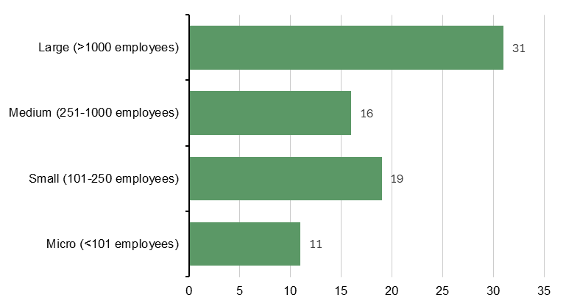

Figure 2: Stocktake sample, by agency size
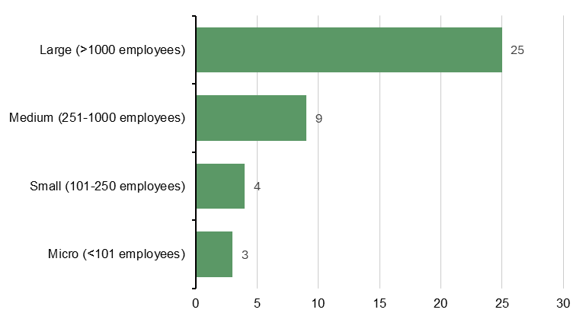

Stocktake of evaluations
The Stocktake provides a measure of volume and characteristics of evaluation activity across the Australian government. Agencies reported the number and types of evaluations underway in 2024–25, including their status, delivery approach, and evaluation type.
Main findings of the State of Evaluation 2026 Stocktake
- 847 evaluations were identified by 41 responding agencies, including evaluations that were planned, underway, or completed.
- 305 evaluations had been completed (of these, 222 were completed in 2024–25, the remainder were completed in other years).
- 52% of evaluations were delivered partly or fully by external providers.

How many evaluations?
The Stocktake identified 847 evaluations underway at different stages, from 41 responding agencies. This likely represents an underestimate since non-responding agencies may also have undertaken evaluation activities. Of those identified, 305 evaluations had been completed, including 222 that were completed in 2024–25. This was a similar number to the 217 evaluations completed in 2023-24. The identified evaluations were evenly spread across different stages of activity—planning, in progress, or completion (see Figure 3):
- 30% of evaluations (n=254) were planned.
- 32% of evaluations (n=275) were in progress.
- 36% of evaluations (n=305) were completed (with 222 completed in 2024–25).
- 2% of evaluations in the sample (n=13) did not specify status.

Figure 3: State of Evaluation 2026 Stocktake summary of evaluations by status
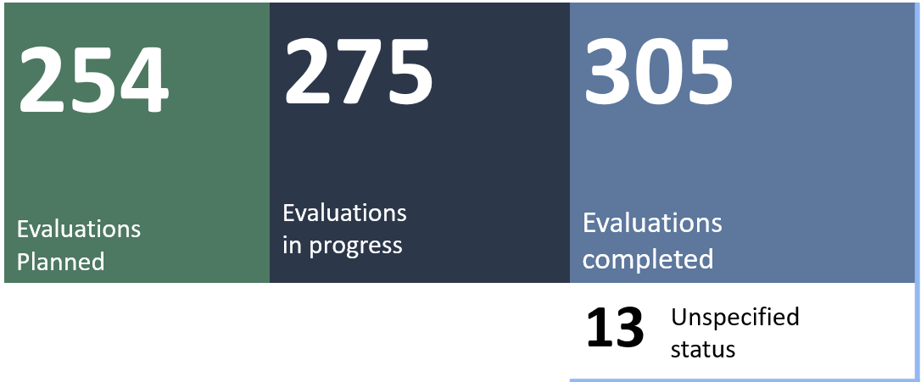

Who delivered the evaluations?
A least half (52%, n=438) of the evaluations in the stocktake were partly or fully delivered by external providers. Hybrid models, where internal and external staff work together, were used in 13% (n=107) of evaluations in the stocktake (Figure 4). A hybrid approach can help build internal skills.

Figure 4: Evaluation delivery approach
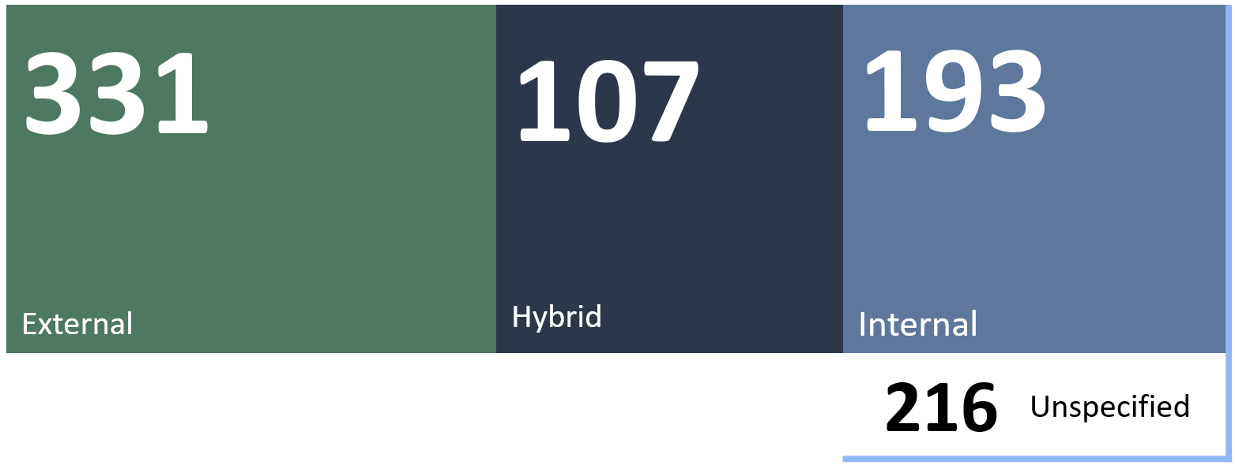
Guidance on who should conduct an evaluation is available in the Commonwealth Evaluation Toolkit. Ultimately, agencies’ decisions regarding evaluation delivery should be underpinned by the Commonwealth Evaluation Policy principle that evaluations should be credible. This means:
- Evaluations should be conducted by people who are technically and culturally capable.
- The collection and analysis of evidence should be undertaken in an impartial and systematic way, having regard to the perspectives of all relevant stakeholders.
- Evaluations should adhere to appropriate standards of integrity and independence.

Evaluation type and methods
Agencies were also asked to report the type of evaluation for each activity listed. Of the 847 evaluations recorded, 638 specified an evaluation type, while 210 did not. Agencies could select one or more evaluation type, depending on what applied. Among the 638 evaluations that did specify a type, most used a combination (502 multifocal evaluations), with the remaining 136 evaluations using a single type (for example, impact, process, economic evaluation). There were 219 impact evaluations (either a single type, or in combination with other types); of these there were 14 randomised trials that have commenced or been completed in recent years, across 8 different agencies.

Evaluation network, leadership and governance
Main findings
- 44% of agencies (34 of 77 responses) have a dedicated evaluation unit, with another 5 planning to create one by 2028.
- The median staffing level in evaluation units was 6 ASL (range: 0.1–45 ASL).
- 43% of agencies (33 of 77 responses) have an SES Band 1 leader responsible for evaluation.
- 55% of agencies (42 of 77 responses) centrally monitor evaluation activities.
- 34% of agencies (26 of 77 responses) have an evaluation strategy or framework.

Growth in the network of evaluation units
There has been clear progress in building evaluation capability across government. The number of in-house evaluation units has grown from around 18 units in 2021, when the Commonwealth Evaluation Policy was introduced, to 34 units in 2025 (Figure 5). Another 5 agencies plan to establish an evaluation unit by 2028.

Figure 5: Reported number of central evaluation units, 2021 to 2025
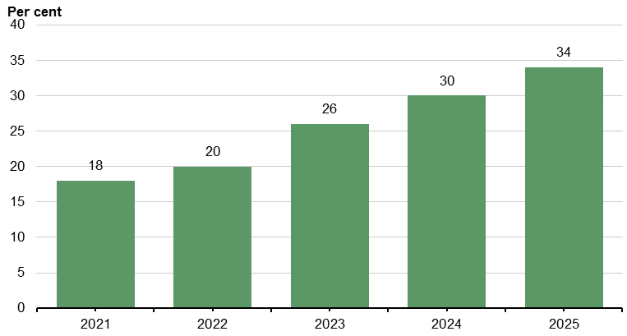
Note: Figures for previous years reflect backward-looking estimates and so may be inaccurate. The number of units identified for 2024 is different from the number cited in the previous State of Evaluation report. This is due to variation in responding agencies in the 2 reporting periods. An earlier stocktake in 2019, conducted by the Productivity Commission, identified 18 central evaluation units (Productivity Commission 2020, Indigenous Evaluation Strategy: Background Paper, Appendix B, pp. 414-415).

Size of evaluation units
Staffing levels within evaluation units ranged from an Average Staffing Level (ASL) of 0.1 to a 45 ASL. More than half of the 33 responding units had between 4 to 9 ASL (Figure 6). Of the evaluation units that responded to the survey, the overall average (mean) was 7.2 ASL, and median was 6 ASL.

Figure 6: Evaluation unit size across the Australian Government
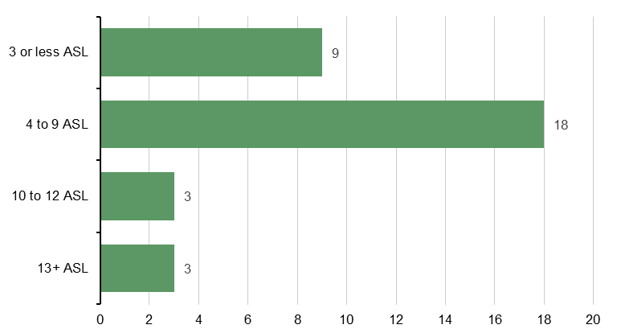

Role and function of evaluation units
The most common services provided by evaluation units were advisory and support services (91%), capability building (88%), evaluation delivery (71%), and commissioning evaluations (71%) (Figure 7). Units also develop tools and templates, support governance, run workshops, and share findings across and beyond their department.

Figure 7: Types of services provided by evaluation units
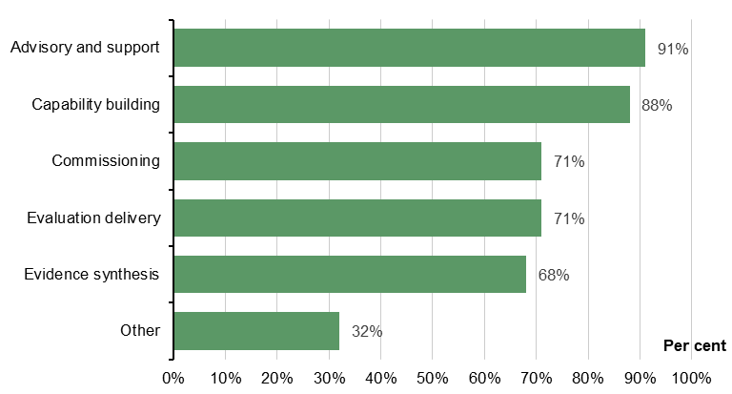
Note: Graphic represents the types of services that evaluation units most commonly provide for their agency, and agencies could select multiple options (n=34).
Common types of support delivered by evaluation units include evaluation planning and design (88%), reporting findings and knowledge translation (88%), outcomes identification through program logic modelling and/or theory of change (82%), and performance measurement/monitoring support (82%).

Senior leadership and enterprise-level strategies
Of the responding agencies, 43% (33 of 77 responses) had a Senior Executive Service (SES) leader responsible for evaluation. Figure 8 shows that SES leadership is most common in large agencies (65%). In contrast, only 38% of medium agencies, 21% of small agencies and 27% of micro agencies had an SES leader providing oversight of evaluation.

Figure 8: Senior leadership oversight of evaluation by agency size
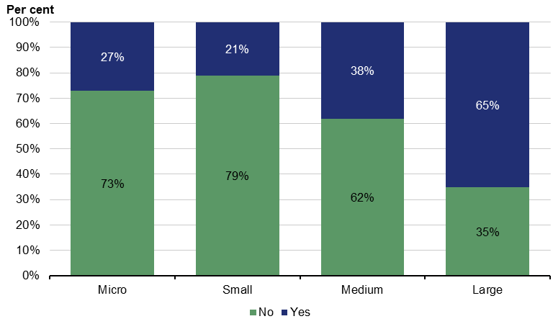
Growth in the number of agencies supported by an enterprise-level evaluation strategy or framework is a priority of the Strengthening Evaluation in the Australian Government Action Plan 2026–30. This calls for robust evaluation prioritisation within entity-level strategies.
- 34% of agencies (26 of 77 responses) had an enterprise-level evaluation strategy or framework
- 16% of agencies (n=12) were planning a strategy or framework
- 51% of agencies (n=39) did not have an enterprise-level evaluation strategy.
Agencies without strategies cited reasons of small size, limited resources, existing corporate planning or Enterprise Performance frameworks, or frameworks at a program level.
Less than half (49%) of agencies had a centrally managed forward work plan for conducting evaluations. Agencies commonly prioritise and schedule evaluation activities through direction from senior leadership (62%) or evaluation activities are managed by individual line areas (60%). Only a third (33%) of evaluation scheduling is based on commitments made through Cabinet and Budget processes.

Use of evaluation evidence
Main findings
- Only a third of agencies (32% of 71 responses) reported routine public dissemination of evaluation findings or reports.
- 71% (of 73 responses) used evaluation evidence to inform design and decision-making.
- Common motivations to undertake evaluation were to improve implementation (84% of 75 responses), build knowledge (77%), enhance accountability (77%), and to promote transparency (72%).

Evaluation evidence sharing, use and motivations
Only 32% of agencies (23 of 71 responses) routinely publish evaluation findings. This suggests that two-thirds (68%) of agencies had not yet adopted the Commonwealth Evaluation Policy principle that evaluations should be ‘Transparent where appropriate’.
Use of evaluation evidence is a priority of the Strengthening Evaluation in the Australian Government Action Plan 2026–2030. A key action is publication of evaluations, by routinely sharing evaluation findings to support program and policy design, and to publicly disseminate evaluation findings and reports where appropriate. The ACE Evaluation Library, launched in 2025, aims to make published evaluation evidence easier to access.
Evaluation evidence is most commonly used for design and decision-making (71%), to assess outcomes against policy or program objectives (70%), to inform the development of performance measures (63%); and to assess whether a policy or program is on track (60%). Agencies also indicated that they also used evaluation evidence less formally, often through stakeholder feedback, performance measurement, and post-project reviews.
The Survey asked ‘what are the motivations for evaluation within your agency’. The most common responses were to improve implementation (84% of 75 responses), build greater knowledge (77%), enhance accountability (77%), to promote transparency (72%), and to meet legislative requirements (63%) (Figure 9).

Figure 9: Motivations for evaluation within agencies
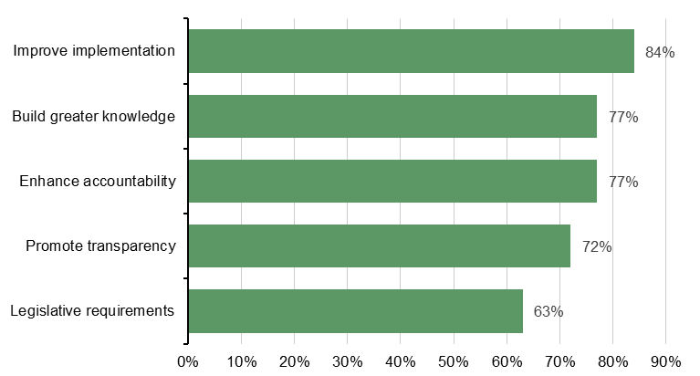

Embedding evaluation into everyday practice
Common uses of evaluation evidence in enterprise-level business planning processes are corporate performance reporting (88% of 72 responses) and program management (78%). There is room to improve the use of evaluations in Budget prioritisation processes: only 57% of agencies said they did so, although this is proportion is higher among large agencies (68% of 31 responses). The Commonwealth Evaluation Toolkit provides information to support good practice in planning for new policy proposals.

Figure 10: Evaluation consideration in everyday practice
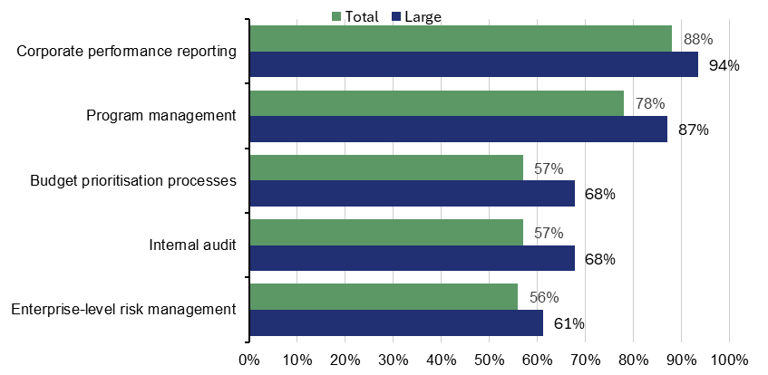

Capability building and culturally appropriate and ethical evaluation
Main findings
- 71% of agencies (55 of 77 responses) engaged in capability-building activities
- 28% of agencies (21 of 74 responses) engaged in impact-evaluation capability building
- 39% of agencies (29 of 75 responses) have processes in place to ensure evaluations are culturally appropriate with respect to Aboriginal and Torres Strait Islander people and communities. Larger agencies are more likely to have processes in place (59%).
- 24% of agencies (18 of 75 responses) have ethics review processes

Evaluation capability building
In-house evaluation units commonly provide advisory services (91%), evaluation capability building (88%), support for commissioning evaluations (71%), internal delivery of evaluations (71%) and evidence synthesis (68%).
Evaluation capability building activities include inter-agency knowledge sharing (80%), written guidance materials (71%), practical learning (69%) and Commonwealth Evaluation Community of Practice (CoP) and Evaluation Profession events (64%) and internal training (53%) (Figure 11).

Figure 11: Key evaluation capability building activities
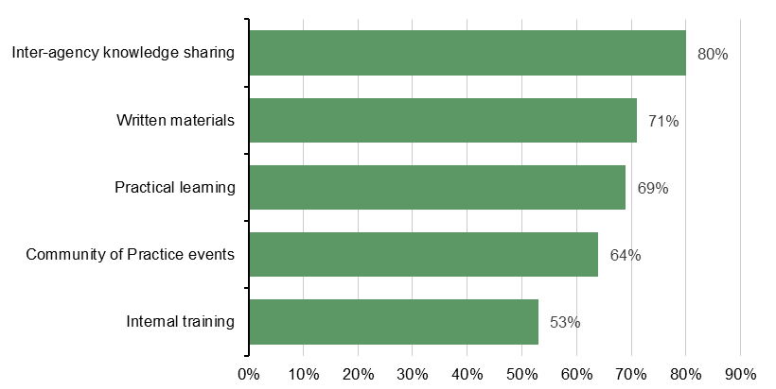

Culturally appropriate evaluation
The Commonwealth Evaluation Policy states that: ‘Ethical and culturally appropriate approaches should be considered in all evaluation activities, including for the collection, assessment and use of information’. Cultural safety is the positive recognition and celebration of cultures. It is more than just the absence of racism or discrimination and more than ‘cultural awareness’ and ‘cultural sensitivity’. It empowers people and enables them to contribute and feel safe to be themselves when involved in evaluation activities. Developing and implementing processes to ensure that evaluations are culturally safe is a priority in the Strengthening Evaluation in the Australian Government Action Plan 2026–2030.
39% of agencies (29 of 75 responses) had processes in place to ensure evaluations are culturally appropriate with respect to Aboriginal and Torres Strait Islander peoples and communities. 55% of large agencies have such processes in place and are more likely than smaller agencies to have these processes established, as shown in Figure 13.
The most common practices to support culturally appropriate evaluation were to provide opportunities for staff to strengthen their cultural capability (67% of 73 responses) and to undertake data collection for evaluation in a culturally safe manner (52%).

Figure 12: Agencies with processes to ensure culturally appropriate evaluations with respect to Aboriginal and Torres Strait Islander people and communities
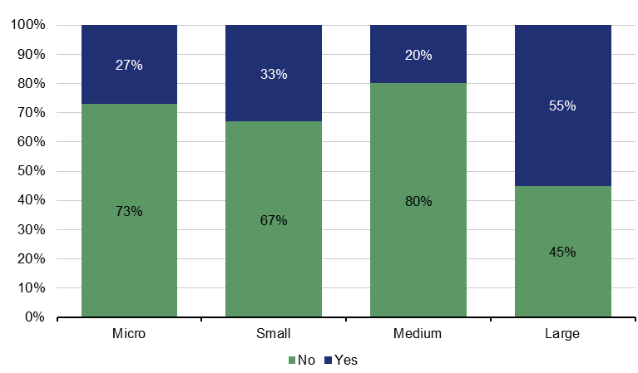

Ethical evaluation
Evaluations should be conducted ethically, as outlined in the Commonwealth Evaluation Policy. While there are many considerations to assure that each stage of an evaluation has been planned and executed ethically, a touchstone document is the National Statement on Ethical Conduct in Human Research. Developing and implementing processes to ensure that evaluations are subject to appropriate ethical review, consistent with the National Statement, is a priority in the Strengthening Evaluation in the Australian Government Action Plan 2026-2030.
Only 24% of agencies (18 of 75 responses) had an established ethics review process. Of the remainder without formal ethics processes, 44% (23 of 52 responses) relied on internal evaluation strategies for guidance, 23% are considering new processes, and 33% are unsure. These results do not necessarily mean that agencies do not use ethical approaches to evaluation, just that they do not have formal processes in place. Consequently, further research is needed to understand what this result means in practice.

Figure 13: Agencies with established ethics review processes for evaluations
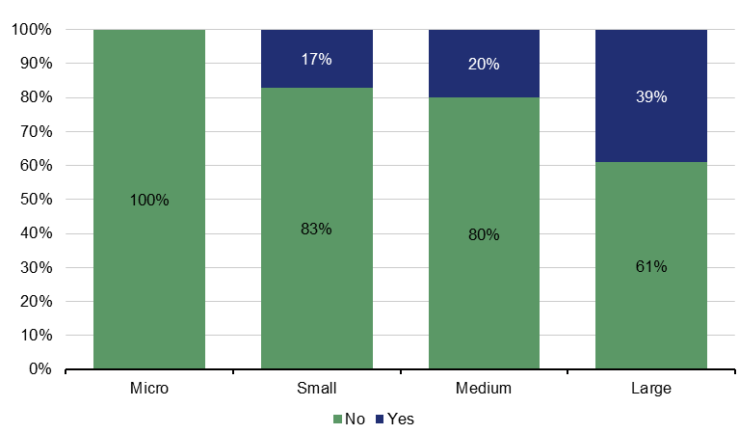

Future priorities and next steps
Main findings
- 75% of agencies (from 68 responses) reported support from agency leadership as an enabler for embedding a culture of evaluation.
- 59% of agencies (from 66 responses) reported limited staff time as a barrier
- Most agencies said they would value central support with enhanced guidance and tools (72% of 60 responses) and tailored information sessions (72%) to deliver on the intent of the Commonwealth Evaluation Policy.

Enablers and barriers to embedding a culture of evaluation
The Survey asked agencies to identify supports and barriers to embedding a culture of evaluation since the introduction of the Commonwealth Evaluation Policy in December 2021. These were non-mandatory questions, so some agencies did not respond.
The top enablers were support from agency leadership (75% of 68 responses) and support for evaluation among decision-makers (72%) (Figure 14). In large agencies, having staff dedicated to evaluation tasks was also identified as critical (70%).
The top barriers were limited staff time (59% of 66 responses), staff knowledge and skills (53%), and insufficient financial resources (50%) (Figure 15). Other challenges identified by agencies included poor quality or inaccessible data, long timeframes for measurable outcomes, reliance on external providers, and difficulties evaluating complex or sensitive programs. Additional issues identified were the need for more guidance for policy evaluation, high staff turnover, privacy constraints, and the complexity of multi-jurisdictional or infrastructure initiatives.
Agencies were asked to select centralised supports that would help them deliver on the intent of the Commonwealth Evaluation Policy. Most said they would value enhanced guidance and tools (72% of 60 responses), tailored information sessions (72%), and an evaluation maturity model (61%).
A Commonwealth Evaluation Maturity Model was published by ACE after the Survey was administered. It includes an assessment tool for agencies to self-assess evaluation skills, practices and resources, along with an action bank providing examples and templates. Agencies said they would value ACE providing capability support via online training through APS Learn (76% of 62 responses), and training delivered by ACE (65%).

Figure 14: Key enablers to embedding a culture of evaluation
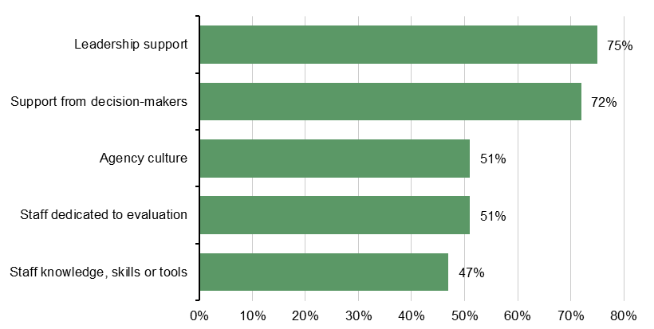

Figure 15: Key barriers to embedding a culture of evaluation
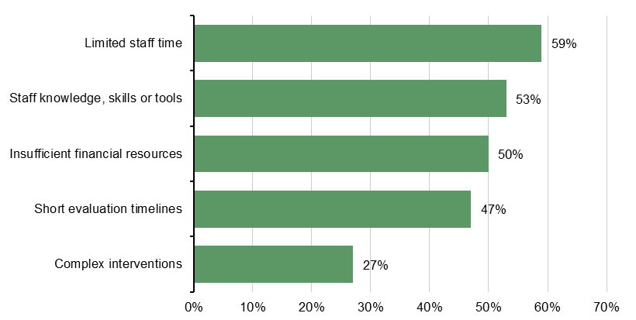

Figure 16: Central support to implement the Commonwealth Evaluation Policy
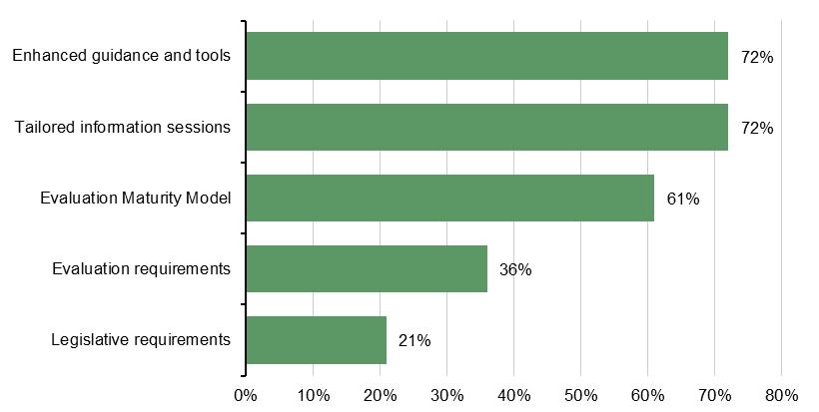

Next steps
The Strengthening Evaluation in the Australian Government Action Plan 2026–2030, recently endorsed by the Secretaries Board, sets out a vision for building system-wide supports for high-quality evaluation while enabling agencies to tailor approaches to their individual contexts.
The Commonwealth Evaluation Reference Group will play a central leadership role in guiding and supporting the implementation of the Action Plan across the APS. ACE will work in close partnership with this group, drawing on its expertise, networks and advice to drive system stewardship and coordinated action. ACE will also continue to work with the APS Evaluation Profession to progress the Evaluation Profession Strategy, launched in February 2026.

Appendix 1: Evaluation reforms in the Australian Government
The Australian Government has a long-term plan to build a strong and lasting culture of evaluation across the APS and beyond. This priority comes from the 2019 Independent Review of the APS, which found that evaluation across government had declined over many years. The Review recommended rebuilding strong evaluation practice.
A key part of this reform was the creation of a well-resourced central evaluation function: the Australian Centre for Evaluation (ACE), established in Treasury in July 2023. Strengthening in-house evaluation units across government is also central to creating lasting cultural change.
Since 2020, the Government has worked with agencies to design and roll out staged reforms to improve evaluation skills, practice, and culture. Major milestones include:
- 2021: Introduction of the Commonwealth Evaluation Policy and Toolkit
- 2022: New evaluation requirements in the Budget Process Operational Rules
- 2023: Establishment of the Australian Centre for Evaluation (ACE)
- 2024: Evaluation embedded in the APS Commissioner’s Direction on Stewardship
- 2025: Development of the Strengthening Evaluation in the Australian Government – Action Plan 2026–2030
Alongside these system-wide reforms, many Commonwealth agencies have taken their own steps to improve evaluation. These include creating evaluation units, developing enterprise-level strategies or work plans, and establishing evaluation oversight committees. Figure 18 provides a timeline of the major reform initiatives.

Figure 18: Evaluation reform timeline
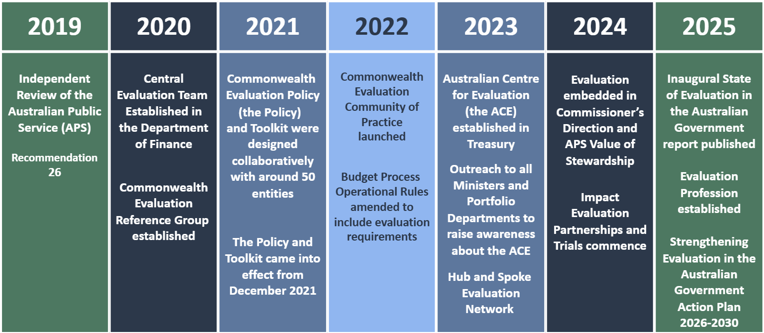

Appendix 2: Method and analytic approach

Survey and Stocktake design
The State of Evaluation Survey and Stocktake were co-designed by ACE and the Commonwealth Evaluation Reference Group. Detailed guidance was provided to help agencies complete the data collection. To support agencies of all sizes and types, ACE ran information sessions for clearance managers and held one-on-one discussions with many agencies during the planning and data collection period. The Secretary of the Treasury wrote to the Accountable Authorities of all PGPA Act agencies, encouraging them to take part. This resulted in a 39.5% response rate for the Survey and 21% response rate for the Stocktake.

Analysis considerations
The Survey was designed for a wide range of agencies with different sizes, roles, and governance arrangements. Because no questions were mandatory, some questions have different numbers of responses. The report notes these differences where relevant. In this report, ‘system-level’ refers to APS-wide settings, structures, and supports for evaluation, not program-specific arrangements.
The Stocktake used a template that asked agencies to list evaluations planned, underway, or completed during 2024–25. It focused on formal evaluations that include evaluation questions, plans, and reports. Some responses included evaluative activities not meeting this definition but still useful for performance monitoring. All submissions were included in the analysis.
The level of detail and consistency of the information provided in the Stocktake varied, reflecting differences in how agencies define and manage evaluation. Some evaluation activities (n=25) were removed from the final analysis because they did not meet the inclusion criteria (for example, internal audits). ACE will continue to work with agencies to improve data consistency and accuracy for future reports.

Table 1: Overview of Survey and Stocktake characteristics
 | Survey | Stocktake
Purpose | Collect information on agency-level evaluation practices, governance, capability building, and culture. | Capture evaluations planned, underway, or completed.
Areas of focus | Formal Evaluation (that is, commissioned evaluations); and Informal evaluation and monitoring (that is, the routine use of evaluation planning, tools, and approaches as part of everyday business) | Formal evaluations delivered internally, externally, or through hybrid models
Structure | Agency information; evaluation design and planning; evaluation use; evaluation capability | For each evaluation: design and delivery; methods; status and timing; evidence use; publication; alignment with frameworks
Response format | One survey response per agency | Itemised list of evaluations for 2024–25

Appendix 3: Responding agencies
Agency Name | Survey | Stocktake
AAF Company | Y | N
Administrative Review Tribunal (previously Administrative Appeals Tribunal) | Y | N
Army and Air Force Canteen Service (Frontline Defence Services) | Y | N
Attorney-General's Department | Y | Y
Australian Broadcasting Corporation | Y | N
Australian Bureau of Statistics | Y | Y
Australian Communications and Media Authority | Y | N
Australian Digital Health Agency | Y | Y
Australian Electoral Commission | Y | Y
Australian Federal Police | Y | N
Australian Financial Security Authority | Y | N
Australian Institute of Health and Welfare | Y | N
Australian Maritime Safety Authority | Y | Y
Australian National Maritime Museum | Y | N
Australian Pesticides and Veterinary Medicines Authority | Y | N
Australian Prudential Regulation Authority | Y | N
Australian Regional Investment Corporation | Y | Y
Australian Security Intelligence Organisation | Y | N
Australian Signals Directorate | Y | Y
Australian Taxation Office | Y | Y
Australian Trade and Investment Commission (Austrade) | Y | Y
Bureau of Meteorology | Y | Y
Bundanon Trust | Y | N
Clean Energy Regulator | Y | Y
Climate Change Authority | Y | N
Comcare | Y | Y
Commonwealth Scientific and Industrial Research Organisation | Y | Y
Commonwealth Superannuation Corporation | Y | N
Defence and Veterans' Services Commission | Y | N
Department of Agriculture, Fisheries and Forestry | Y | Y
Department of Climate Change, Energy, the Environment and Water | Y | Y
Department of Defence | Y | Y
Department of Education | Y | Y
Department of Employment and Workplace Relations | Y | Y
Department of Finance | Y | N
Department of Foreign Affairs and Trade | Y | Y
Department of Health, Disability and Aging | Y | Y
Department of Home Affairs | Y | Y
Department of Industry, Science and Resources | Y | Y
Department of Infrastructure, Transport, Regional Development, Communications, Sport, and the Arts | Y | Y
Agency Name | Survey | Stocktake
Department of Social Services | Y | Y
Department of the House of Representatives | Y | N
Department of the Prime Minister and Cabinet | Y | Y
Department of the Senate | Y | N
Department of the Treasury | Y | Y
Department of Veterans' Affairs | Y | Y
Director of National Parks | Y | Y
Digital Transformation Agency | Y | N
eSafety Commissioner | Y | Y
Export Finance Australia (formerly Export Finance and Insurance Corporation (EFIC) | Y | N
Fisheries Research and Development Corporation | Y | N
Food Standards Australia New Zealand | Y | N
Geoscience Australia | Y | N
Grains Research and Development Corporation | Y | Y
Housing Australia | Y | N
Independent Parliamentary Expenses Authority | Y | Y
Indigenous Business Australia | Y | Y
Infrastructure Australia | Y | Y
Inspector-General of Taxation | Y | N
IP Australia | Y | N
National Disability Insurance Agency | Y | Y
National Emergency Management Agency | Y | Y
National Health and Medical Research Council | Y | Y
National Indigenous Australians Agency | Y | Y
NDIS Quality and Safeguards Commission | Y | Y
Net Zero Economy Authority | Y | N
Northern Australia Infrastructure Facility | Y | N
Office of Parliamentary Counsel | Y | N
Office of the Australian Information Commissioner | Y | N
Office of the Fair Work Ombudsman | Y | Y
Outback Stores Pty Ltd | Y | N
Productivity Commission | Y | N
Professional Services Review | Y | N
Safe Work Australia | Y | Y
Services Australia | Y | Y
Sport Integrity Australia | Y | N
Tourism Australia | Y | N

Appendix 4: Stocktake results

Table 2: State of Evaluation Stocktake summary
Evaluation attributes | Large (number of evaluations=733) | Total (number of evaluations =847)
Evaluation stage
Planned | 250 | 254
Commenced | 242 | 275
Completed | 230 | 305
Unspecified status | 11 | 13
Assessment of effects on specific cohorts
First Nations | 181 | 202
Gender | 154 | 167
Culturally and Linguistically Diverse groups | 133 | 145
Geography (regional/remote) | 196 | 253
Age-groups | 123 | 135
Evaluation delivery
Internal | 155 | 193
External | 273 | 331
Hybrid | 89 | 107
Unspecified delivery approach | 216 | 216
Evaluation Type
Multifocal | 412 | 502
Process | 32 | 47
Outcomes | 49 | 54
Impact evaluation | 18 | 19
Economic | 4 | 4
Other | 10 | 12
Publication of findings
Decision taken to publish in full | 87 | 111
Decision taken to publish in part | 16 | 21
Decision taken not to publish | 90 | 114
Under consideration | 165 | 201
Evaluation evidence use
Findings and/or recommendations actioned in full | 51 | 60
Findings and/or recommendations actioned in part | 56 | 72
Findings and/or recommendations considered but not actioned | 9 | 11
Findings and/or recommendations under consideration | 149 | 200

Appendix 5: Survey results (table format)
For questions marked with an asterisk (*) sign in the table below, agencies were able to select multiple choices. Proportions here reflect the number of agencies selecting a choice from the total number of respondents and will not add up to 100.
Questions were not mandatory, and thus the total proportions may not add up to 100% due to missing data. Percentages are derived from total responses unless specified otherwise. The number of responses is noted as ‘n’ against each question in the table below (for large agencies and all agencies).
For certain questions, analysis is presented only in aggregate (without large agency breakdown).

Table 3: Survey results table
Survey question | Large agencies  (n = 31 unless specified otherwise) | Overall  (n = 77 unless specified otherwise)
Agency and governance characteristics
Does your agency have a senior officer (SES or equivalent) with oversight responsibility for evaluation at an -enterprise level? (Q. 5) | 65% | 43%
Does your agency have a dedicated evaluation unit or function? (serving part or all of your agency) (Q. 6) | 68% | 44%
What was the Average Staffing Level (ASL) for the unit or function in 2023-24? (Q 6.3, average) | 9 ASL | 7.2 ASL
Has there been any decision to substantially change the level of ASL in the evaluation unit or function since 2022-23? (Q. 6.4) | n=21 | n=34
Increase | 24% | 29%
Decrease | 19% | 18%
No change | 57% | 53%
What type of services does the evaluation unit or function provide? (please select all that apply) (Q6.5)*
Advisory and support | - | 91%
Capability building | - | 88%
Delivery | - | 71%
Commissioning | - | 71%
Evidence synthesis and translation | - | 68%
Other | - | 32%
What specific support activities or support does the evaluation function or unit provide to other areas of the agency? (please select all that apply) (Q. 6.6)* |  | n=34
Evaluation evidence appraisal and synthesis to inform policy design | - | 53%
Evaluation scoping and costing input into New Policy Proposals and policy development | - | 53%
Evaluation planning and design | - | 88%
Outcomes identification through program logic modelling and/or theory of change | - | 82%
Performance measurement/monitoring support | - | 82%
Procurement and contracting support for evaluation services | - | 68%
Supporting ethics review processes | - | 32%
Data collection design (e.g. Survey design and management, consultation tool design and consultations) | - | 76%
Evaluation data analysis and synthesis (qualitative and quantitative) | - | 85%
Reporting findings and knowledge translation | - | 88%
Managing evidence portals and clearinghouses | - | 32%
Evaluation capability building | - | 88%

Table 3: Survey results table (continued)
Survey question | Large agencies  (n = 31 unless specified otherwise) | Overall  (n = 77 unless specified otherwise)
Reporting findings and knowledge translation | - | 88%
Managing evidence portals and clearinghouses | - | 32%
Evaluation capability building | - | 88%
Other (please specify) | - | 18%
Are there plans to establish a dedicated evaluation unit or function within your agency? (Q. 6.7) | n=11 | n=44
We have a unit or function which performs a similar role as an evaluation unit | 18% | 14%
No plans exist | 64% | 75%
Planned | 9% | 11%
How many dedicated evaluation staff (ASL) work in your agency (outside of a dedicated evaluation unit or function)? (Q. 8, average) | 14.4 ASL | 9.5 ASL
Is evaluation considered in the context of -enterprise level business planning processes, such as (please select all that apply): (Q. 9) * | n=31 | n=72
Corporate performance reporting | 94% | 88%
Program management | 87% | 78%
Enterprise level risk management | 61% | 56%
Budget prioritisation processes | 68% | 57%
Internal audit | 68% | 57%
Prioritisation and evaluation planning
Does your agency have an -enterprise level evaluation strategy or framework? (Q. 10)
Yes, framework and/or strategy | 48% | 34%
Planned | 19% | 16%
No | 32% | 51%
Does your agency centrally monitor the status and use of evaluations?  (please select all that apply) (Q. 11) | n=16 | n=42
Completed evaluations | 100% | 95%
Evaluations in progress | 75% | 76%
Planned evaluations | 81% | 79%
Management responses to completed evaluations | 50% | 60%
Evaluation evidence use | 50% | 48%
Does your agency have a centrally managed forward work plan for conducting evaluations? (Q. 12) (n=91) | 48% | 49%
How does your agency currently identify, prioritise, and schedule evaluation activities? (please select all that apply) (Q. 13)* |  | n=73
Evaluation activities are managed by individual line areas | 77% | 60%
Driven by senior leadership | 77% | 62%
Based on commitments made through Cabinet and Budget processes | 52% | 33%
By exception, based on issues identified through routine risk, performance, or audit activities | 52% | 33%
Few evaluations are undertaken so no formal prioritisation or scheduling is required | 16% | 23%
Based on an enterprise level evaluation strategy and/or framework | 45% | 34%
How does your agency use evaluation (please select all that apply)? (Q. 14)* |  | n=73
Evaluation informs policy/program design or -decision making | 90% | 71%
Outcome or impact evaluation is undertaken to inform whether policies or programs achieve their objectives | 84% | 70%

Table 3: Survey results table (continued)
Survey question | Large agencies  (n = 31 unless specified otherwise) | Overall  (n = 77 unless specified otherwise)
Evaluation tools and approaches inform the development of performance measures | 74% | 63%
Evaluations support reporting on performance under the Commonwealth Performance Framework | 61% | 49%
Evaluation informs the direction of the agency | 42% | 34%
Evaluations are undertaken but generally do not inform the development of agency performance measures | 35% | 23%
Evaluation is conducted during development or implementation of policies or programs to help assess whether they are on track | 81% | 60%
Evaluation delivery
Does your agency use any defined processes to assure the quality of its evaluations? (Q. 15) | 65% | 43%
What proportion of evaluation work commences early in the policy/program cycle? (Q. 16) |  | n=76
Almost all evaluations (>75%) | 6% | 3%
Most evaluations (51%-74%) | 23% | 16%
Some evaluations (26%-50%) | 23% | 22%
Very few evaluations (<25%) | 23% | 17%
N/A or unsure | 26% | 42%
Does your agency use external evaluation services? (Q. 17) |  | n=75
External service providers | 74% | 56%
Evaluation is conducted in-house | 10% | 8%
Performance monitoring/reporting are used rather than evaluation | 10% | 19%
Other arrangements | 13% | 15%
Evaluation is not undertaken at all | 0% | 5%
What proportion of evaluations are conducted by evaluators from outside your agency? (Q. 18) |  | n=75
Almost all evaluations (>75%) | 23% | 17%
Most evaluations (51%-74%) | 13% | 7%
Some evaluations (26%-50%) | 13% | 15%
Very few evaluations (<25%) | 19% | 24%
N/A or unsure | 32% | 37%
What are the motivations for evaluation within your agency? (please select all that apply) (Q. 19) * |  | n=75
To improve implementation | 97% | 84%
To enhance accountability | 97% | 77%
To promote transparency | 81% | 72%
To build greater knowledge | 90% | 77%
To understand the impact of an intervention | 84% | 61%
To give stakeholders a voice | 81% | 56%
To help plan future interventions | 84% | 56%
To meet legislative requirements | 81% | 63%
To assess whether a program is needed | 77% | 44%
To identify innovative solutions | 77% | 48%
To seek funding renewal | 68% | 41%
To consider service expansion | 71% | 40%
To reduce waste | 68% | 32%
Other | 29% | 21%

Table 3: Survey results table (continued)
Survey question | Large agencies  (n = 31 unless specified otherwise) | Overall  (n = 77 unless specified otherwise)
Enablers and barriers
Within your agency, what supports have helped to embed a culture of evaluation since the introduction of the Commonwealth Evaluation Policy in December 2021? (please select all that apply) (Q. 20)* | n=30 | n=68
Support from agency leadership | 80% | 75%
Sufficient staff knowledge, skills, and/or tools | 60% | 47%
Agency culture in support of evaluation | 63% | 51%
Staff dedicated to evaluation tasks | 70% | 51%
In-house evaluation units | 60% | 41%
Support for evaluation amongst decision-makers | 90% | 72%
Sufficient funding | 47% | 38%
Working with an external evaluator | 47% | 37%
Within your agency, what have been the major barriers (if any) to embedding a culture of evaluation since the introduction of the Commonwealth Evaluation Policy in December 2021 (that is, the reasons why evaluation may NOT occur)? (please select all that apply) (Q. 21)* | n=30 | n=66
Limited staff knowledge, skills, and/or tools | 80% | 53%
Limited staff time | 67% | 59%
Insufficient financial resources | 70% | 50%
Shortage of time to complete evaluation | 73% | 47%
Challenging or complex interventions | 40% | 27%
Challenging stakeholder relationships | 37% | 24%
Staff attitudes towards evaluation | 27% | 14%
Poor past evaluations | 27% | 12%
Insufficient agency leadership support | 17% | 8%
Not linked to agency performance measures | 17% | 9%
Access to external evaluators | 3% | 2%
Indigenous evaluations and ethical practice
Does your agency have processes established to ensure evaluations are culturally appropriate with respect to Aboriginal and Torres Strait Islander people and communities? (Q. 22) | 55%  n=31 | 39%  n=75
Please indicate the extent to which processes below are applied consistently (Q. 22.1, proportion reflects the aggregate proportion of “used for all evaluations”) | Aggregate responses only (small n)
Centring Aboriginal and Torres Strait Islander people, perspectives, priorities, and knowledges in all stages of evaluation | - | 3%
Working in partnership with Aboriginal and Torres Strait Islander people and stakeholders on evaluation | - | 3%
Aboriginal and Torres Strait Islander leadership, oversight, and/or governance on evaluation activities | - | 1%
Disseminating, synthesising, and translating evaluation findings in accessible forms that can be used by Aboriginal and Torres Strait Islander people | - | 1%
Strengthening and supporting the capability of Aboriginal and Torres Strait Islander people, entities, and communities to engage in and use evaluation | - | 1%
Engaging with Aboriginal and Torres Strait Islander staff within your agency | - | 4%
To what extent does your agency draw on the following resources to support evaluations to be culturally appropriate with respect to Aboriginal and Torres Strait Islander people and communities? (please select all that apply) (Q. 24, proportion reflects the aggregate proportion of “used for all evaluations”)* | Aggregate responses only (small n)

Table 3: Survey results table (continued)
Survey question | Large agencies  (n = 31 unless specified otherwise) | Overall  (n = 77 unless specified otherwise)
National Agreement on Closing the Gap Priority Reforms | - | 4%
Productivity Commission’s Indigenous Evaluation Strategy | - | 4%
Framework for the Governance of Indigenous Data | - | 3%
AIATSIS Code of Ethics for Aboriginal and Torres Strait Islander Research | - | 5%
AES First Nations Cultural Safety Framework | - | 4%
Does your agency’s evaluation practice adopt any of following approaches to support culturally appropriate evaluation? (please select all that apply) (Q. 25)* |  | n=73
The agency routinely considers evaluating the impacts of its mainstream policies and programs on Aboriginal and Torres Strait Islander people | 48% | 34%
Evaluations include an examination of how entities are working with Aboriginal and Torres Strait Islander people to develop and deliver policies and programs | 39% | 26%
Data used for evaluation are collected in a culturally safe manner. | 65% | 52%
The agency provides opportunities for staff to strengthen their cultural capability | 77% | 67%
The agency allocates sufficient time and resources for meaningful engagement with Aboriginal and Torres Strait Islander people during evaluations | 32% | 25%
Does your agency have an evaluation ethics review process? (Q. 26) | 39% | 24% (n=75)
If no formal process is established, please specify if any of the following apply:  (Q. 26.2) | n=19 | n=52
Agency evaluation strategy and/or policy provides ethical practice guidance | 53% | 44%
Under consideration | 26% | 23%
Unsure | 21% | 33%
Evaluation evidence use
To what extent does your agency use evaluation evidence to (responses indicating “always” and “often”) (please select all that apply) (Q.28)*
Plan/revise general strategies | 35% | 35%
Plan/revise program initiatives | 48% | 40%
Plan/revise grant initiatives | 32% | 19%
Report to Board of Directors | 23% | 29%
Report to Government | 52% | 42%
Report to stakeholders | 39% | 34%
Advocate for a cause | 3% | 5%
Share findings with peers | 32% | 25%
Make funding allocation decisions | 26% | 18%
Does your agency routinely disseminate evaluation findings or reports publicly? (Q.30) | 32% | 32% (n=71)
Did your agency include any evaluation findings in the 2023 Annual Report? (Q. 31) | 45% | 44% (n=73)
Evaluation capability and ACE support
In the 2023-24 financial year, did your agency engage in evaluation capability building activities? (please select all that apply) (Q. 32)* |  | n=55
Written materials (for example, published guidance) | 81% | 71%
Exchanged knowledge with other government agencies | 84% | 80%
Participated in the Commonwealth Evaluation Community of Practice events | 74% | 64%
External training | 55% | 45%
Internal training | 61% | 53%
Opportunities to learn by being involved in an evaluation design or implementation | 77% | 69%

Table 3: Survey results table (continued)
Survey question | Large agencies  (n = 31 unless specified otherwise) | Overall  (n = 77 unless specified otherwise)
Internal -agency level evaluation Community of Practice events | 35% | 27%
Built capability by working with external evaluation providers (as an explicit part of the contract) | 32% | 33%
Evaluation coaching/mentoring | 35% | 33%
In the 2023-24 financial year, did your agency engage in any capability building specific to impact evaluation using experimental or quasi -experimental designs? (Q. 33) | 55% | 28% (n=74)
What additional activities or actions could be taken centrally that would help to support your agency to deliver on the policy intent of the Commonwealth Evaluation Policy? (Please select all that apply) (Q. 34)* |  | n=60
Develop a Commonwealth Evaluation Maturity Model and supporting tools | 68% | 61%
Tailored information session | 77% | 72%
Stronger legislative requirements | 29% | 21%
Mandatory requirements to evaluate interventions that meet certain criteria | 45% | 36%
Enhanced guidance and tools | 81% | 72%
Are there specific areas where additional support from the Australian Centre of Evaluation would help your agency to build evaluation capability and embed an enduring culture of evaluation across the Australian Government? (please select all that apply) (Q. 38)* | Aggregate responses only | n=62
Online training through APS Learn | 71% | 76%
Provision of training resources | 68% | 65%
More guidance/resources on the Commonwealth Evaluation Toolkit | 45% | 44%
Commonwealth Evaluation Community of Practice Events | 65% | 58%
Evaluation coaching/mentoring | 55% | 55%
Train -the -trainer support | 55% | 52%
Enhanced coordinated evaluation procurement arrangements to access evaluation service providers | 45% | 39%
Dedicated centrally held funds to support high quality evaluation (similar to UK’s Evaluation Accelerator Fund) | 58% | 58%
Centrally supported ethics review arrangements | 55% | 45%
Technical support for impact evaluations | 74% | 58%
External training provider panel | 29% | 29%

Commonwealth Evaluation Policy | evaluation.treasury.gov.au
Commonwealth Evaluation Reference Group | evaluation.treasury.gov.au
The Stocktake asked: whether the evaluation related to a cross-portfolio activity; what Budget outcome(s) and Program/s the evaluation related to (referring to Portfolio Budget Statements), and what key activity or priority the evaluation linked to in the agency’s corporate plan.
Portfolios in the Australian Government are established through the Administrative Arrangements Order. A portfolio may encompass more than one Department. See Portfolio | Department of Finance
Variation in how agencies defined ‘completion’ affected the timeframes reported in this Stocktake.
See Appendix 5, Question 6.6
Sample size by agency size (large, medium, small and micro). Percentages may not sum to 100% due to rounding.
ACE Evaluation Library | APO
For further detail of results see Appendix 5, Question 14.
The survey an option for free-text responses at Question 14.
Evaluation planning for new policy proposals | evaluation.treasury.gov.au
In February 2025, the Commonwealth Evaluation Community of Practice transitioned into the APS Evaluation Profession.
Indigenous evaluation | evaluation.treasury.gov.au
National Statement on Ethical Conduct in Human Research 2025 | NHMRC
Other challenges were identified in free-text comments in the Survey.
Commonwealth Evaluation Maturity Model | evaluation.treasury.gov.au
Not all data fields in the Stocktake were mandatory, which is reflected in the reporting.

