Commonwealth Evaluation Maturity Model: User Guide
Contents
About this User Guide 2
What is the Commonwealth Evaluation Maturity Model? 3
Background 3
The Maturity Model explained 3
Who should use the Maturity Model 5
The three stages to using the Maturity Model 6
Stage 1: Initiate and plan for the assessment 6
Stage 2: Undertake the assessment 8
Stage 3: Analyse assessment results and develop an action plan 9
Appendix A: What does good look like? 12
Evaluation culture and leadership 12
Evaluation capability 12
Evaluation design planning and delivery 13
Evaluation use 14
Appendix B: Evaluation Maturity results logbook 15
Appendix C: Example approaches to action planning 17

About this User Guide
The Commonwealth Evaluation Maturity Model (the Maturity Model) is a tool to assist Commonwealth agencies to assess and strengthen evaluation capability. The use of the model is designed to strengthen the leadership, skills and culture of evaluation and encourage routine use of evaluation evidence to inform policy decisions.
Senior leadership support is crucial to creating an authorising environment for the successful use and implementation of this model. A senior leaders brief about the Maturity Model has been developed to assist engage senior leadership in your agency.
The Maturity Model is designed to be flexible to adapt to different organisational contexts. Whether you choose to conduct a maturity assessment at a branch, divisional, group or agency level, it is important to take the approach that best suits your needs.
The Australian Centre for Evaluation recommends the Maturity Model is conducted by:
- agency-level evaluation units (or equivalent units for groups, divisions or branches, if they exist); or
- coordination areas that have evaluation expertise or knowledge with agency-wide responsibilities (for agencies without evaluation units).
Use of the Maturity Model is not a mandatory requirement for agencies. The tool is optional and designed to offer practical ways to uplift organisational evaluation capability.
This User Guide is designed to assist evaluation units and coordinating areas on how to:
- Initiate and conduct a maturity assessment
- Interpret sections of the framework
- Complete the assessment tool and analyse assessment results
- Use results to develop an action plan to uplift your agency’s evaluation maturity.
If you have any questions about how to undertake the Commonwealth Evaluation Maturity Model, please contact:
- Your agency’s evaluation unit (if you have one); or
- The Australian Centre for Evaluation at evaluation@treasury.gov.au.

What is the Commonwealth Evaluation Maturity Model?

Background
The Australian Centre for Evaluation (ACE) co-designed and piloted the Commonwealth Evaluation Maturity Model (the Maturity Model) with a group of agencies from across the Australian Public Service (APS).
The Maturity Model is designed to uphold the APS value of Stewardship and to support the APS Reform initiative of embedding a culture of evaluation to improve the capability of the APS. It is complemented by the Commonwealth Evaluation Policy, the Evaluation Profession, the ACE Evaluation Library, and the report on State of Evaluation in the Australian Government.

The Maturity Model explained
The Maturity Model is a tool that provides a simple pathway to strengthen evaluation capability. It is not a mandatory requirement for agencies to complete. Use of the model is intended to:
- Strengthen the leadership and culture of evaluation
- Strengthen evaluation skills and use by encouraging routine use of evaluation evidence to inform policy decisions.
The Maturity Model includes an online assessment tool based on a ‘maturity framework’. The framework has 4 domains: evaluation culture and leadership; evaluation capability; evaluation design, planning and delivery; and evaluation use. Within each domain there are dimensions and descriptors to assess the level of evaluation maturity (see Table 1 for an overview). Appendix A provides a description of what best practice evaluation looks like under each of these 4 domains.
There are 3 maturity levels for each descriptor: ‘emerging’, ‘maturing’ and ‘embedded’ (see Table 2 for an explanation of each maturity level). The online tool provides an overview of evaluation maturity, indicating areas to develop action planning to strengthen evaluation capability.
Senior leadership support is crucial to creating an authorising environment for the successful use and implementation of this model. The ‘senior leaders brief’ can be used to engage senior leadership about the Maturity Model.

Table 1: Evaluation Maturity Model domains
Domains | Dimensions | Descriptors
Evaluation culture and leadership | Senior leadership engagement  Strategy and governance  Integrated planning | Promoting learning and improvement  Leadership promotes evaluation  Evaluation in strategic planning  Evaluation policy or governance  Linking program outcomes to performance planning/corporate reporting  Evaluation evidence used to manage risks
Evaluation capability | Organisational capacity  Data systems  Ethics and cultural safety | Technical evaluation skills  Evaluation training/professional development  Evaluation knowledge/understanding  Relationships with data areas  Data knowledge, skills champions  Linked data access  Culturally safe practices  Knowledge of ethical research protocols
Evaluation design, planning and delivery | Prioritisation  Evaluation methods  Resourcing | Evaluation as a business priority  Using evaluation to govern the effectiveness of policies, programs and services  Evaluation planning  Evaluation delivery  Evaluation technical expertise and evaluation methods  Evaluation resources  Evaluation funding/budget  Hiring for evaluation skills
Evaluation use | Design  Decision making  Evidence translation | Program logic/theory of change are built into design processes  Use of evaluation results for design  Use of evaluation evidence for decision-making  Availability of evidence for decision-making  Engagement and partnerships with research stakeholders

The evaluation maturity levels are defined in Table 2, describing what maturity looks like.
Table 1: Definition of the maturity levels in the Evaluation Maturity Model
Emerging | Maturing | Embedded
Evaluation is still in its infancy, but pockets of knowledge, skills and good practice are developing.  Leadership is becoming aware of the value of evaluation. | Evaluation processes, skills and forums are being established throughout the organisation.  Leadership is supporting, funding and using evaluation evidence. | Evaluation is embedded into all processes; evaluation resources are prioritised, and evaluation evidence is consistently used for program design and decision-making.  Leadership is actively acknowledging the value of evaluation in the work of the public service.

Who should use the Maturity Model
The Maturity Model is designed to be flexible to adapt to different organisational contexts. Whether you choose to conduct a maturity assessment at a branch, divisional, group or agency level, it is important to take the approach that best suits your needs.
The Maturity Model assessment and action planning process could be led and conducted by:
- agency-level evaluation units (or equivalent units for groups, divisions or branches, if they exist); or
- coordination areas that have evaluation expertise or knowledge with agency-wide responsibilities (for agencies without evaluation units).
Engaging senior leadership early to oversee and support the process is strongly encouraged, as this provides the authorising environment for using the Maturity Model, including gathering data across the agency and implementing an action plan. This may also promote buy-in across the agency (or group, division or branch) and support for prioritising evaluation resourcing and approving action plans.

The three stages to using the Maturity Model
Figure 1: Commonwealth Evaluation Maturity Model assessment and action planning process summary
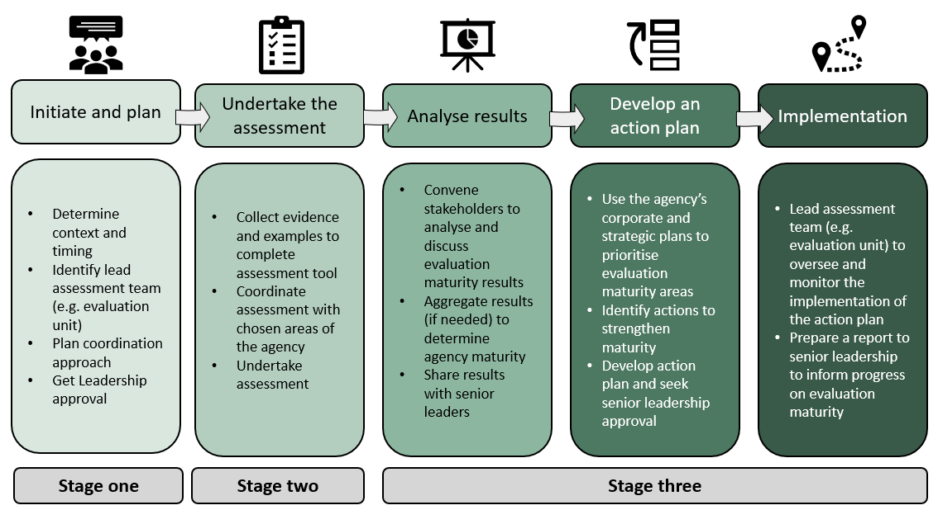

Stage 1: Initiate and plan for the assessment

Assess the right timing and senior leadership buy-in
Before undertaking the assessment, identify the optimal timing and context for your agency (or group, division or branch). The context could be determined by whether resources are available to implement an action plan, and what an agency’s corporate and strategic priorities are for the year. For example, the timing for commencing this maturity assessment could be determined by corporate and annual plan cycles, for which an evaluation maturity assessment could contribute to these agency-level plans. Figure 2 illustrates the cyclical process agencies could take to implement the maturity assessment and how assessment activities can be sequenced around an agency’s strategic and corporate planning cycles.
Senior leadership support will be critical to ensuring the process is successfully implemented within an agency. A seniors leaders brief is available to support areas to engage with key senior leadership sponsors.
The following considerations may be helpful to engage senior leadership:
- The APS value of Stewardship states that all APS agencies have a responsibility to use evidence and evaluation in their work (requirement D)
- The Budget Process Operational Rules set out evaluation requirements for New Policy Proposals
- The Commonwealth Evaluation Policy is a principles-based policy on evaluation that applies to all Commonwealth entities
Figure 2: Commonwealth Evaluation Maturity Model cycle
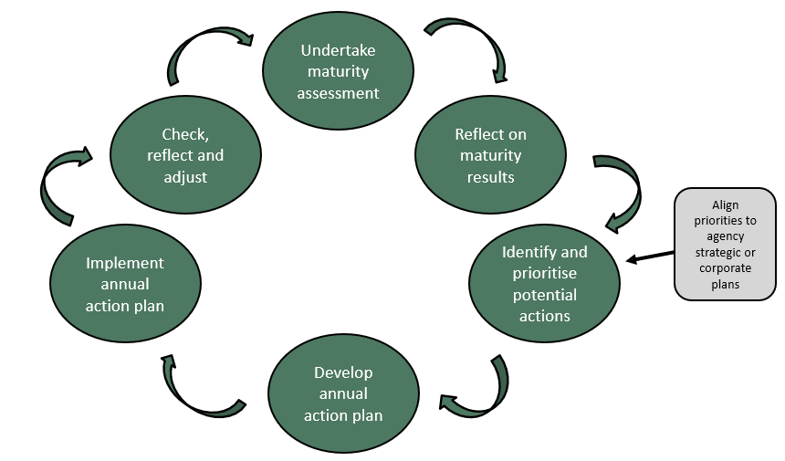

Plan the process
It is important to factor in sufficient time to implement and undertake the Maturity Model assessment and action plan. Based on the Maturity Model pilot, the process could take between 1-4 months depending on how many teams are involved in the assessment.
It is at the discretion of each agency (or group, division or branch) how the assessment and action planning process is undertaken. Table 3 outlines three different approaches to the assessment and action plan, which can be adapted as needed.
Table 3: Optional approaches to undertake the Evaluation Maturity Model assessment
Option one  (low resourcing) | Option two  (moderate resourcing) | Option three  (higher resourcing)
Evaluation unit/coordination team undertakes the maturity model assessment and action plan solo. | Evaluation unit/coordination team invites up to 3-4 divisions or teams to undertake the maturity model assessment and action plan together. | Evaluation unit/coordination team invites at least 5 divisions or teams to undertake the assessment within their division.
Before undertaking the assessment, it is important to document evidence of input from areas to inform of the overall evaluation maturity rating. Evaluation units or coordination teams undertaking moderate or higher resourcing approaches may wish to use the results logbook template at Appendix B. This resource helps collect individual divisions or teams’ assessments for each dimension and descriptor to inform the agency-wide maturity level.

To confirm the best approach in your context:
- Ensure senior leadership are engaged and supportive of the process
- Identify the best-placed coordination team, ideally an evaluation unit, to coordinate the full process
- Identify resourcing capacity to determine the level of resourcing approach is feasible
- Identify relevant stakeholders/teams to engage to input into the assessment.

Stage 2: Undertake the assessment

Collecting evidence for the assessment tool
A range of a methods can be used to inform the maturity assessment results, including:
- Collecting information across the teams to inform assessment ratings using Appendix A
- Using the Delphi Technique or Nominal Group Technique
- Using existing information and evidence across teams to inform the assessment ratings
- Organising a meeting with stakeholders to discuss your rating against each descriptor
- Requesting individual teams undertake their own assessment and share/aggregate results with the broader group
- Undertaking interviews with key stakeholders and senior leaders to gather their perspectives and experiences to inform the assessment ratings.

Complete the online maturity assessment tool
The online assessment tool is designed to be undertaken collaboratively rather than individually to encourage discussion and reflection on evaluation skills, practices and resources.
The tool has a total of 4 domains, 12 dimensions and 30 descriptors to rate your agency’s maturity. Within each domain, there are dimensions and descriptors to assess the level of evaluation maturity. There are three maturity levels for each descriptor: ‘emerging’, ‘maturing’ and ‘embedded’. The online tool provides an overview of evaluation maturity, indicating areas to develop action planning to strengthen evaluation capability.
The user will be asked to select the statement that best describes their agency’s evaluation maturity level under each descriptor. These responses will inform the final assessment results.
While there is no prescribed approach to undertake the online assessment tool, it is recommended an agency’s evaluation unit or a coordination team engages across the agency to capture inputs to ensure results are representative of the agency’s overall evaluation mature.

Stage 3: Analyse assessment results and develop an action plan

Analyse and share results
The online tool provides options for downloading results in a PDF format, making it easy to analyse and share results. The results provide a breakdown of maturity level overall and by domain, dimension and descriptor. This assists evaluation units or coordination teams with understanding where the agency performed well and where further improvement is recommended.
The assessment tool results identify an aggregate maturity level for each domain and dimension, which can be used by the coordinating teams and can be shared with senior leadership. The results produced by the maturity assessment are owned by the specific agency undertaking the assessment and should be used as a reflective tool for continuous improvement. These results are not a benchmark in comparison to other agencies.

Prioritise and design an action plan
The action plan process aims to assist in prioritising evaluation capability building practices within an agency.
This process can be done in a variety of ways, and it is up to each agency to decide which approach fits best in their context. The Action Bank resource provides an optional template for agencies to develop action plans based on their maturity assessment results.
Agencies can use a variety of methods to facilitate action planning.
- Figure 4 outlines examples of possible options agencies can take to complete the action planning process.
- Appendix C maps out 3 different approaches agencies undertaken during the Maturity Model pilot process to analyse results and identify actions to strengthen evaluation maturity.

Figure 1: Optional steps to undertake the action planning process
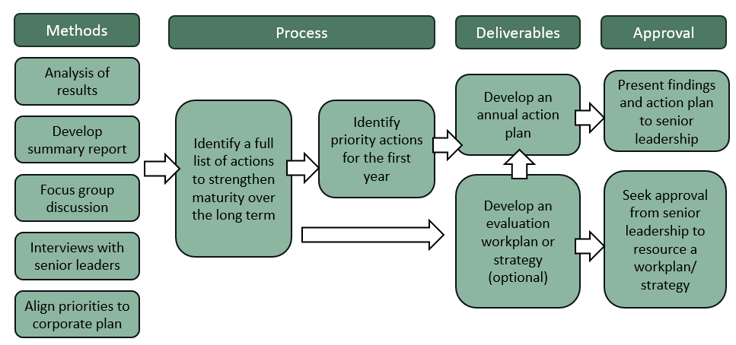
Agencies are encouraged to use the maturity level descriptors in the report to guide their actions. For example, if an agency rates itself as ‘emerging’ under a specific descriptor, it could look at what is described in the ‘maturing’ descriptor to guide what actions they choose.
To develop specific actions, the Action Bank resource provides options agencies can choose to strengthen evaluation maturity in their context. It may also be useful to align actions to organisational strategies and corporate plans, as well as recommendations from audits or reviews such as those from the Australian National Audit Office and the Australian Public Service Commission’s Capability Review Program.

Tips for action plan design
- Summarise and analyse results: Develop a concise summary of results to inform your team’s key priorities.
- Action Bank: Draw on the Action Bank resource which provides examples that can be used to develop an action plan in your context.
- Implementation: Include information on who is responsible, how actions will be resourced and specific timeframes to support effective implementation (see ‘Appendix A’ in the Action Bank resource)).
- Annual Frequency: Design annual action plans to ensure practical and achievable actions are identified. This will enable agencies to report frequent progress to senior leadership.
- Do not over commit: Identify and select the highest priority actions for the year. Ensure all actions can be resourced and achieved within timeframes.
- Evaluation plan or strategy: Some agencies might also want to identify a full list of actions to achieve full evaluation maturity over a longer timeframe. This could form the basis of an evaluation strategy or workplan.

Implementation
The final stage is to implement and monitor progress of the action plan with relevant teams across the branch, division, group or agency. This includes supporting teams to take responsibility for various activities and to understand their role in strengthening evaluation. This may require the evaluation unit or coordination team to hold a workshop or training session, to support areas to better understand their role in evaluation strengthening to build maturity in a common way.
The action plan can be used as a communication and monitoring tool, to ensure all areas are on the same page about what needs to be achieved within specific timeframes. Undertaking routine check-ins to determine progress, barriers and whether any approaches require adapting will be important to maintain momentum and progress. Importantly, bringing senior leadership along the journey will be crucial to successful implementation of action plans.

Additional questions?
If you have any questions about how to undertake the Maturity Model, please contact:
- Your agency’s evaluation unit (if you have one); or
- The Australian Centre for Evaluation at evaluation@treasury.gov.au.

Appendix A: What does good look like?

Evaluation culture and leadership
An optimised level of evaluation maturity in relation to evaluation culture and leadership would likely include the following elements:
- Senior leadership organises routine sessions such as division-wide learning presentations or action learning processes to share evaluation, promoting a culture of evaluative thinking and continuous improvement
- At least one senior leader within the agency has a designated role to oversight evaluation at an agency level
- Senior leadership has endorsed an evaluation strategy or workplan
- Evaluation is included as a standing item on existing governance forums for senior leaders to oversee evaluation activities
- Leaders ensure that all program outcomes align or are linked to agency level outcomes in performance planning and reporting
- Evaluation findings are consistently used to manage program risks and support performance improvements during the life of a program or policy cycle.

Evaluation capability
An optimised level of evaluation maturity in relation to evaluation capability would likely include the following elements:
- There are sufficient staff with technical evaluation skills to support the planning and delivery of evaluation across a team, division or agency (for example, hiring of evaluation champions or an evaluation unit)
- There are requirements for policy, program and service staff to undertake basic evaluation training and professional development (for example, it is included in staff performance agreements)
- There are sufficient staff designing and delivering policies, programs and services who understand evaluation concepts
- There are strong relationships with data areas, supporting staff to access and use administrative data for monitoring and evaluation
- There are sufficient staff with technical skills to use administrative data for evaluation purposes (for example, these could exist through hiring data champions or data teams that support skill uplift)
- Sufficient staff have access to linked data, which can be used for evaluative purposes (for example, staff may have access to Data Lab to analyse BLADE and PLIDA, which requires a specific technical skillset)
- There are sufficient staff trained in cultural safety practices for evaluation design (for example, undertaking the AIATSIS training on APS Learn and being familiar with principles of data sovereignty)
- Evaluation design and delivery is undertaken by staff who are trained in ethical research protocols.

Evaluation design planning and delivery
An optimised level of evaluation maturity in relation to evaluation design planning and delivery would likely include the following elements:
- Evaluation is seen as a core aspect of the team, division or agency’s business
- Monitoring and evaluation is built into the governance of all policies, programs and services to manage risk
- Evaluation planning is a standard component of the policy, program and service design process
- Evaluation delivery has become standard practice to understand whether policies, programs and services are reaching outcomes
- Sufficient staff have the expertise to design high-quality evaluation methodologies to deliver robust evaluation findings
- Sufficient staff have expertise in a wide variety of data collection methods for evaluation
- Evaluation findings are consistently credible, supported by a mixed methods (quantitative and qualitative data sources) approach, with sound triangulation and analysis
- Sufficient dedicated evaluation resources exist (for example, evaluation unit and/or champions) to support evaluation planning and delivery
- Senior leadership embed evaluation funding requirements, that is, into new policy, program and service designs
- Hiring for evaluation skills is embedded in graduate recruitment and general policy, program and service provider roles.

Evaluation use
An optimised level of evaluation maturity in relation to evaluation use would likely include the following elements:
- Program logic and/or theories of change are endorsed as requirements to accompany design and implementation of policies, programs and services
- Formal requirements are in place to ensure staff use evaluation evidence to inform the development of New Policy Proposals
- Leaders establish processes to ensure evaluation evidence is frequently used to inform decision making
- Evaluation findings are frequently used to deliver timely feedback through interim reporting to inform decision making
- Leaders have formalised partnerships with external research institutes and academics to support the production of evidence to inform policy making
- Senior leadership is committed to publicly publishing evaluation evidence by default
- A knowledge management system has been established to store all types of evidence documents, including evaluation and research.

Appendix B: Evaluation Maturity results logbook
This results logbook assists evaluation units and coordination areas with documenting notes taken from coordinating responses with divisions and teams within the agency. The purpose of this logbook is to help summarise each division or teams’ maturity levels under the domains and dimensions to assist with completing the online assessment tool.
Division or team:
Domain and dimension | Maturity level | Summary
 | (emerging/maturing/embedded) | Summarise relevant evaluation maturity model assessment results. Highlight key points from the evidence/rationale for the assessment.
Evaluation leadership and culture | Rating:
Senior leadership engagement | Rating:
Strategy and governance | Rating:
Integrated planning | Rating:
Evaluation capability | Rating:
Organisational capacity | Rating:
Systems and technology | Rating:
Ethics and cultural safety | Rating:
 | (emerging/maturing/embedded) | Summarise relevant evaluation maturity model assessment results. Highlight key points from the evidence/rationale for the assessment.
Evaluation design and delivery | Rating:
Prioritisation | Rating:
Evaluation methods | Rating:
Resourcing | Rating:
Evaluation use | Rating:
Design | Rating:
Decision making | Rating:
Evidence translation | Rating:

Appendix C: Example approaches to action planning
From February to June 2025, ten agencies piloted the Evaluation Maturity Model and came up with different approaches to develop action plans. These approaches are outlined below and demonstrate how action planning can be undertaken in different ways depending on your context.
Figure 2: Different approaches to action planning
