Commonwealth Evaluation Maturity Model – Action Bank

Introduction
The Action Bank provides examples of actions that users of the Commonwealth Evaluation Maturity Model (the Maturity Model) can select to develop an action plan.
This document also includes a template to assist with developing an action plan and provides several sample approaches to action planning.
These resources serve as a guide only. The Australian Centre for Evaluation (ACE) acknowledges each agency has a different context and recommends agencies adopt the approach that works best for you.

How to use the Action Bank
The Action Bank is organised by domains and dimensions, providing examples of how teams can strengthen evaluation maturity within specific areas. It is split between strategic and operational actions, and encourages teams to consider actions to influence culture change with senior leaders, and with operational staff.
Strategic actions are long-term, high-level initiatives that align with an agency’s overall priorities and vision. They focus on achieving overarching goals and shaping the future direction of the agency. Operational actions are shorter term activities that support the implementation of an agency’s strategy priorities in practice. Strategic actions set the direction, whereas operational actions execute the plan.
To develop an action plan, draw on the maturity assessment results from the online assessment tool and align actions to strategic and corporate plans. For further information on developing an Action Plan, please refer to the User Guide.
Appendix A is a template to assist agencies’ evaluation units or coordination teams with selecting priority actions and developing an action plan in a structured format.
Appendix B provides several sample approaches to action planning. These sample approaches are based on the Maturity Model pilot undertaking by selected agencies from February to June 2025. These approaches demonstrate how action planning can be undertaken in different ways depending on the agency’s size, resourcing and context.

Domain 1: Evaluation leadership and culture
Dimensions | Strategic actions
Senior leadership engagement  Strategy and governance  Integrated planning | Develop an agency-wide evaluation strategy and, where appropriate, align the strategy to agency-wide strategic goals/outcomes  The Secretary or the head of the agency to send a message across the department/agency to set evaluation expectations  Senior executive leadership champion the whole-of-APS expectations for evaluation, including the Commonwealth Evaluation Policy, APS Value of Stewardship and Budget Process Operational Rules (BPORs)  Identify senior executive evaluation champions and develop their capability to promote and use evaluation  Agree expectations for evaluation to be integrated into corporate and operational planning, program governance structures and risk management  Establish requirements for robust problem and needs analysis and the development and testing of program logic for new programs or policies

Dimension | Operational actions
Senior leadership engagement | Integrate evaluative thinking and reflective practice into the way corporate and operational planning, program design, implementation and delivery is managed  Communicate the Commonwealth Evaluation Policy, the APS Value of ‘Stewardship’ and Budget Process Operational Rules (BPORs) to motivate leadership use of evidence and evaluation  Include evaluation in senior leadership strategy updates, identifying key evaluation outcomes and internal capability uplift  Document and share the journey to staff, to include what worked well, what was learned and how it influenced decisions  Engage evaluation champions to promote to executive levels and to teams the value and use of evaluation
Strategy and governance | Develop a forward work plan to implement the evaluation strategy, and report progress to the executive  Include evaluation as a standing item on a relevant agency-wide governance forum  Embed evaluation into policy design and program management processes, to ensure evaluation becomes part of business-as-usual  Convene a high-level board to oversee major evaluations and ensure alignment with agency priorities.
Integrated planning | Establish a formal process to integrate evaluation into corporate planning processes  Include evaluation activity and results in agency annual reports  Use monitoring data and evaluation findings to manage program risks and support performance improvement  Integrate evaluation into risk management systems and processes  Align all program outcomes to agency corporate reporting

Domain 2: Evaluation capability
Dimensions | Strategic actions
Organisational capacity  Data systems  Ethics and cultural safety | Dedicate resources to evaluation staff (such as an evaluation unit or champions) to build evaluation capability across the agency  Embed evaluation skills into business-as-usual recruitment, including graduate recruitment  Identify evaluation skills as a priority in organisational capability planning  Plan and allocate resources to build evaluation capability  Allocate resources to ensure systems and technology are available to plan and conduct evaluation  Include data and evaluation in the same area within an agency  Demonstrate a clear commitment to ethical and culturally safe evaluation practices  Determine appropriate evaluation ethics review arrangements and accountabilities

Dimension | Operational actions
Organisational capacity | Coordinate an evaluation community of practice to build capability and knowledge  Develop evaluation guidance and tools that fit within the agency’s context including providing practical templates, checklists, and case studies to support staff in integrating evaluation into their work.  Build foundational skills and knowledge in evaluation across all staff, including specific methods and terminology  Develop short, accessible training on evaluation fundamentals tailored to different roles (for example, policy officers, program managers, analysts).  Provide evaluation support and advice to program, policy and service areas  Support staff/teams to join the Evaluation Profession  Support staff working in policy and program teams to undertake secondments in evaluation teams  Integrate evaluation skills into staff performance agreements  Establish an intranet page with relevant links, guidance and resources for all staff  Establish a baseline of evaluation literacy across the agency
Data systems | Improve administrative data access and use for evaluation through providing training and supporting staff to access and navigate resources  Strengthen staff skills in analysing and using linked data sets such as PLIDA and BLADE  Develop a language model to understand data from a large program or grantees more efficiently  Establish relationships with data teams to improve access and use of data for monitoring and evaluation  Hire data champions to support better use of existing data, such as administrative and linked data across the agency  Develop a process to ensure all grants data is available for use in evaluation  Establish routine engagement with data branches and data governance committees to learn how existing data can be utilised for your agency’s evaluations  Provide guidance and support for staff on the use of systems and technology to conduct evaluation
Ethics and cultural safety | Establish a low-risk ethics process to fast-track review of low-risk evaluation  Provide resources and training for cultural safety and ethical design in evaluation design and delivery  Promote online training models such as Ethics and Cultural Safety (AIATSIS), which is freely available through APS Learn  Design specific training for cultural safety in evaluation in partnership with First Nations and Culturally and Linguistically Diverse people

Domain 3: Design, planning and delivery
Dimensions | Strategic actions
Prioritisation  Evaluation methods  Resourcing | Identify evaluation as a core business priority  Evaluation planning and delivery is required for all policies, programs and services  Develop principles for the use of fit-for-purpose methods  Allocate resources with evaluation skills to plan and conduct evaluation  Establish requirements for evaluation planning and resourcing in the development of New Policy Proposals (NPPs)  Establish criteria for where investment in evaluation is most valuable for learning, accountability and decision-making
Dimension | Operational actions
Prioritisation | Build evaluation into the governance of policies, programs and services  Establish program logic and/or theory of change as requirements to accompany program design and implementation  Define minimum expectations for program logic and evaluation inclusion in programs, policies and services  Undertake routine monitoring and evaluation of programs to inform progress towards outcomes  Use high-visibility, strategically important projects to model best practice evaluation (to inspire broader adoption)  Evaluation is included in annual business planning processes  Establish monitoring and evaluation plans for existing programs in scope for future evaluation activities  Develop a standard operating procedure outlining how to undertake evaluation in-house  Create compelling case studies to demonstrate how evaluation improves outcomes, informs decisions and builds trust  Prioritise evaluations based on strategic risk, investment size, and public impact

Dimension | Operational actions
Evaluation methods | Provide resources and training for staff to plan, commission and use evidence from a variety of evaluation methods, especially impact evaluation  Resource evaluation hardware/software to support data management, monitoring and reporting  Develop partnerships with evaluation and data units, which supports them to meet regularly  Hire staff with evaluation expertise in a variety of methods, including impact evaluation  Use external experts to advise on evaluation methodologies, especially impact evaluation methods  Embed short, structured reflection sessions after major initiatives or evaluations.
Resourcing | Recruit evaluation staff/champions to strengthen evaluation design, planning and delivery  Develop a system to prioritise program evaluation funding  Develop clear guidance to embed evaluation into New Policy Proposals drafted by the agency  Dedicate specific budget to evaluation  Allocate a percentage of funding to evaluation activities for projects over a threshold

Domain 4: Evaluation use
Dimensions | Strategic actions
Design  Decision making  Evaluation translation | Communicate the need for evaluation evidence to be used to inform program design and decision making  Determine appropriate policy or governance requirements that support sharing and using evaluation evidence with relevant internal and external stakeholders  Identify knowledge brokering approaches that build relationships with the research community outside of government

Dimension | Operational actions
Design | Establish requirements for all staff to use evaluation evidence (where possible) to inform program design  Deliver training to policy and program staff to demonstrate how evaluation evidence can be used to inform design, and to help staff assess the quality and relevance of evaluation evidence for their policy problem  Share insights internally (and externally where appropriate) to build a culture of transparency and improvement.
Decision making | Consistently share evaluations with decision makers  Communicate evaluation findings to leaders, including ministerial offices  Establish an internal evaluation portal where staff and leaders can access evaluation evidence to support decision making  Engage leaders in evaluation from the beginning, providing progress updates on key findings and recommendations
Evidence translation | Build strong partnerships with external stakeholders including research institutes and academics to share and utilise relevant evidence  Contribute to the Australian Policy Online (APO) evaluation library by making evaluation reports publicly available  Establish governance or advisory groups with policy and research stakeholders to ensure the utilisation and translation of evidence  Identify requirements to publish evaluation online as a default  Work with key stakeholders to frequently share evaluation findings  Regularly update agency evaluation homepage and/or newsletters with recent reports

Appendix A: Evaluation Maturity Action Plan template
Use the action plan template to identify what the top three priorities are for your evaluation maturity action plan. Use your evaluation maturity results, your agency’s corporate, annual and strategic plans and other relevant information to identify the three highest priorities.

Table 1: Action plan template example
 | Priority action | Justification | Activities | Resources | Whom | Timeframe | Approval
Guidance questions | What is the key action? | Why is it a priority? | What activities will be undertaken to achieve this? | What resources are required? | Who is responsible for coordinating this action? | When will this action be achieved? | Which senior leader needs to approve this?
Priority 1
Priority 2
Priority 3

Appendix B: Example approaches to action planning
From February to June 2025, ten agencies piloted the Evaluation Maturity Model and came up with different approaches to develop action plans.
These approaches are outlined below and demonstrate how action planning can be undertaken in different ways depending on your context.

Figure 1: Different approaches to action planning
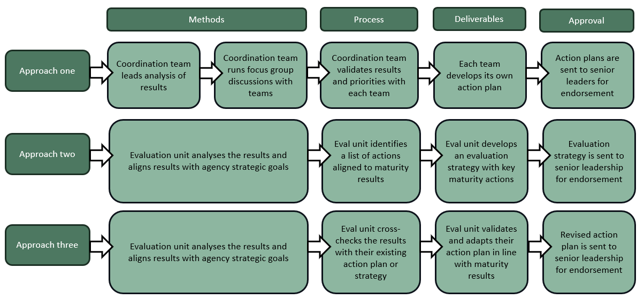

The term program is used throughout this document as a generic term. It could refer to any type of program, project, policy, strategy, intervention etc.

