Improving on‑time submission rates for charity Annual Information Statements: a randomised trial

Summary report

September 2025

# Background

The Australian Charities and Not‑for‑profits Commission (ACNC) is the national charity regulator.

Most registered charities in Australia must submit an Annual Information Statement (AIS) each year to the ACNC. The AIS captures key operational and financial information and keeps the public Charity Register up to date. Timely submission is important for maintaining transparency, supporting public trust, and reducing regulatory burden. The ACNC aims for an on‑time submission rate of 75%. Despite regular reminder emails from the ACNC, the rate was between 68% and 73% in recent years.

This evaluation tested whether sending an additional reminder email to a charity’s Responsible Person could improve the timely submission of an AIS. A charity’s Responsible Person is a person who is responsible for governing a charity. Generally, a charity’s Responsible People are its board or committee members, or trustees (including insolvency trustees or administrators). The additional reminder emails were sent in batches from 7 to 17 January 2025, ahead of the 31 January deadline.

# Evaluation approach

This evaluation used a randomised controlled trial (RCT) involving 15,000 charities that had an AIS due by 31 January 2025 but had not yet submitted their AIS by 3 January 2025. All of these charities had already received a first reminder email from the ACNC.

Charities were randomised into 2 groups, such that half the charities received a second, standard reminder email sent directly to a charity’s usual email address only (control group), while the other half also received an additional email reminder sent directly to a Responsible Person (treatment group). The trial was conducted in partnership between the ACNC, the Australian Centre for Evaluation (ACE) and Behavioural Economics Team of the Australian Government (BETA). The trial was subject to independent ethics review, and the trial design was pre‑registered with a pre‑analysis plan.

Although the additional second reminder email would appear to be a relatively simple intervention, it did involve some implementation costs and had the potential to create a minor burden for the Responsible Person. This might also have created flow‑on costs for the ACNC through additional support requests from charities. It was not clear that the intervention would be sufficiently effective to justify these costs, if they eventuated, making it important to evaluate.

# Summary of findings

**An additional reminder to a charity’s Responsible Person substantially improved on‑time AIS submission rates.** Charities that received the additional reminder to a Responsible Person were 5.6 percentage points more likely to submit their AIS on time (by 31 January 2025) compared to those who received only the standard business as usual reminder (62.0% versus 56.4%, see Figure 1). These submission rates appear lower than previous years, but this is because they only include charities that had not already submitted by 3 January 2025.

**Charities submitted earlier when they received the additional reminder to a Responsible Person.** In addition to improving on‑time AIS submission rates, the second reminder prompted charities to submit their AIS sooner. Charities that received the additional email reminder to a Responsible Person typically submitted their AIS around 3 days earlier than those in the control group.

**The effect of the additional reminder to a Responsible Person was consistent across different groups of charities.** The intervention demonstrated consistent impacts across all major groups, including small, medium and large charities, volunteer‑based organisations, incorporated associations, and Basic Religious Charities. While the size of the treatment effect varied slightly between groups, there were no statistically significant differences, suggesting the additional reminder to a Responsible Person is broadly effective in prompting on‑time AIS submissions.

Figure 1. On-time AIS submission rates for the treatment and control groups

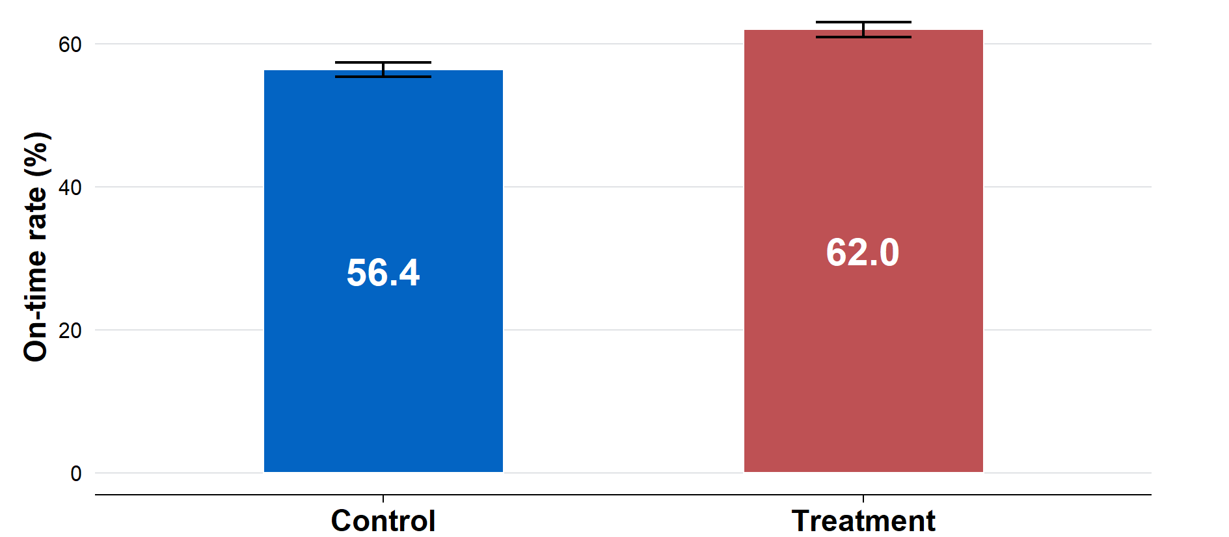

# Lessons learnt and recommendations

An extra email reminder to a charity’s Responsible Person boosted on‑time AIS submissions by 5.6 percentage points and led to submissions a median of 3 days earlier. The reminder worked across all types of charities, with no evidence of differences between charity types. While on‑time AIS submission supports greater transparency and public trust through more accurate and timely information, there are also operational costs associated with sending the additional reminder email. This is especially the case if the ACNC is unable to assist charities to comply with their obligations due to increased demand for assistance.

**The ACNC should examine ways to minimise the implementation costs associated with the additional reminder to assess whether it can become part of as business‑as‑usual practice.** The additional reminder to a Responsible Person improved on‑time submissions rates. However, there were various implementation costs associated with the additional reminder. The ACNC should seek to minimise these costs where possible (for example, through automation, streamlined processes, or more targeted reminders), and then assess whether the benefits of the additional reminder outweigh the remaining costs.

**The ACNC should explore alternative uses of reminders, within operational constraints.** The ACNC should also consider other potential uses for the additional reminder to a Responsible Person. For instance, the reminder could be targeted towards charities with overdue AIS submissions. Alternatively, the ACNC consider testing the additional reminder to a Responsible Personas as the *first* reminder to targeted groups of charities, such as those with historically lower submission rates or lower engagement levels.

**The ACNC should consider more trials to strengthen regulatory outcomes.** This randomised trial demonstrates how such trials can provide clear evidence about what works and by how much, particularly when the outcome is uncertain. The ACNC should consider using rigorous evaluation strategies, including randomised trials, in the future where opportunity, resourcing, and timelines allow. Specifically, the ACNC should consider trials when testing new approaches or processes.