

Improving on-time submission rates for charity Annual Information Statements: a randomised trial

September 2025

© Commonwealth of Australia 2025

ISBN: 978‑1‑923278‑26‑4

This publication is available for your use under a [Creative Commons Attribution 4.0 International](https://creativecommons.org/licenses/by/4.0/) licence, with the exception of the Commonwealth Coat of Arms, the Treasury logo, photographs, images, third party materials, materials protected by a trademark, signatures and where otherwise stated. The full licence terms are available from [creativecommons.org/licenses/by/4.0/legalcode](https://creativecommons.org/licenses/by/4.0/legalcode).



Use of Treasury material under a [Creative Commons Attribution 4.0 International](https://creativecommons.org/licenses/by/4.0/) licence requires you to attribute the work (but not in any way that suggests that the Treasury endorses you or your use of the work).

**Treasury material used ‘as supplied’**

Provided you have not modified or transformed Treasury material in any way including, for example, by changing the Treasury text; calculating percentage changes; graphing or charting data; or deriving new statistics from published Treasury statistics – then Treasury prefers the following attribution:

Source: Nguyen V, Newman VE, Copley S, Greenwell H and Williams E (2025) *Improving on‑time submission rates for charity Annual Information Statements: a randomised trial*, the Australian Centre for Evaluation, the Australian Treasury.

**Derivative** **material**

If you have modified or transformed Treasury material, or derived new material from those of the Treasury in any way, then Treasury prefers the following attribution: *Based on Treasury data*

**Use of the Coat of Arms**

The terms under which the Coat of Arms can be used are set out on the Department of the Prime Minister and Cabinet website (see [https://www.pmc.gov.au/honours‑and‑symbols/commonwealth‑coat‑arms](https://www.pmc.gov.au/honours-and-symbols/commonwealth-coat-arms)).

**Other uses**

Enquiries regarding this licence and any other use of this document are welcome at:

Manager  
Media Unit  
The Treasury  
Langton Crescent   
Parkes ACT 2600  
Email: [media@treasury.gov.au](http://creativecommons.org/licenses/by/3.0/au/deed.en)

**Acknowledgements**

The evaluation was undertaken in collaboration with the Australian Charities and Not‑for‑profits Commission (ACNC). The authors would like to thank Tim Liu, Alexandra Lara, and Robert Mulderry from the ACNC for their valuable feedback and support throughout the project. The authors also acknowledge the contribution of the Behavioural Economics Team of the Australian Government (BETA) in the design of the intervention.

# Contents

Executive Summary 4

Evaluation approach 4

Key findings 4

Conclusions and recommendations 5

1. Introduction and policy context 7

2. Evaluation design and implementation 8

Summary of design 8

Implementation 8

3. Results 10

The additional reminder to Responsible Person substantially increased on‑time AIS submission 10

The second email reminder to an RP accelerated median AIS submissions by 3 days 11

On‑time submission rates increased across all charity characteristics 12

Operational considerations 15

4. Conclusions and recommendations 16

Appendix A: Reminder sent to Responsible Person 18

Time is running out to submit the 2024 Annual Information Statement 19

Appendix B: Determination of a charity’s Responsible Person 20

Appendix C: Technical appendix 21

Pre‑registration and ethics 21

Deviations from the pre‑analysis plan (PAP) 21

Data processing and randomisation 21

Summary of sample 23

Primary analysis 23

Secondary analysis 25

Subgroup analyses 26

Risk of bias 28

# Executive Summary

The Australian Charities and Not‑for‑profits Commission (ACNC) is the national charity regulator.

Most registered charities in Australia must submit an Annual Information Statement (AIS) each year to the ACNC. The AIS captures key operational and financial information and keeps the public Charity Register up to date. Timely submission is important for maintaining transparency, supporting public trust, and reducing regulatory burden. The ACNC aims for an on‑time submission rate of 75%. Despite regular reminder emails from the ACNC, the rate was between 68% and 73% in recent years.

This evaluation tested whether sending an additional reminder email to a charity’s Responsible Person could improve the timely submission of an AIS. A charity’s Responsible Person is a person who is responsible for governing a charity. Generally, a charity’s Responsible People are its board or committee members, or trustees (including insolvency trustees or administrators). The additional reminder emails were sent in batches from 7 to 17 January 2025, ahead of the 31 January deadline.

## Evaluation approach

This evaluation used a randomised controlled trial (RCT) involving 15,000 charities that had an AIS due by 31 January 2025 but had not yet submitted their AIS by 3 January 2025. All of these charities had already received a first reminder email from the ACNC.

Charities were randomised into 2 groups, such that half the charities received a second, standard reminder email sent directly to a charity’s usual email address only (control group), while the other half also received an additional email reminder sent directly to a Responsible Person (treatment group). The trial was conducted in partnership between the ACNC, the Australian Centre for Evaluation (ACE) and Behavioural Economics Team of the Australian Government (BETA). The trial was subject to independent ethics review, and the trial design was pre‑registered with a pre‑analysis plan.

Although the additional second reminder email would appear to be a relatively simple intervention, it did involve some implementation costs and had the potential to create a minor burden for the Responsible Person. This might also have created flow‑on costs for the ACNC through additional support requests from charities. It was not clear that the intervention would be sufficiently effective to justify these costs, if they eventuated, making it important to evaluate.

## Key findings

**An additional reminder to a charity’s Responsible Person substantially improved on‑time AIS submission rates.** Charities that received the additional reminder to a Responsible Person were 5.6 percentage points more likely to submit their AIS on time (by 31 January 2025) compared to those who received only the standard business as usual reminder (62.0% versus 56.4%, see Figure 1). These submission rates appear lower than previous years, but this is because they only include charities that had not already submitted by 3 January 2025.

**Charities submitted earlier when they received the additional reminder to a Responsible Person.** In addition to improving on‑time AIS submission rates, the second reminder prompted charities to submit their AIS sooner. Charities that received the additional email reminder to a Responsible Person typically submitted their AIS around 3 days earlier than those in the control group.

**The effect of the additional reminder to a Responsible Person was consistent across different groups of charities.** The intervention demonstrated consistent impacts across all major groups, including small, medium and large charities, volunteer‑based organisations, incorporated associations, and Basic Religious Charities. While the size of the treatment effect varied slightly between groups, there were no statistically significant differences, suggesting the additional reminder to a Responsible Person is broadly effective in prompting on‑time AIS submissions.

Figure 1. On-time AIS submission rates for the treatment and control groups

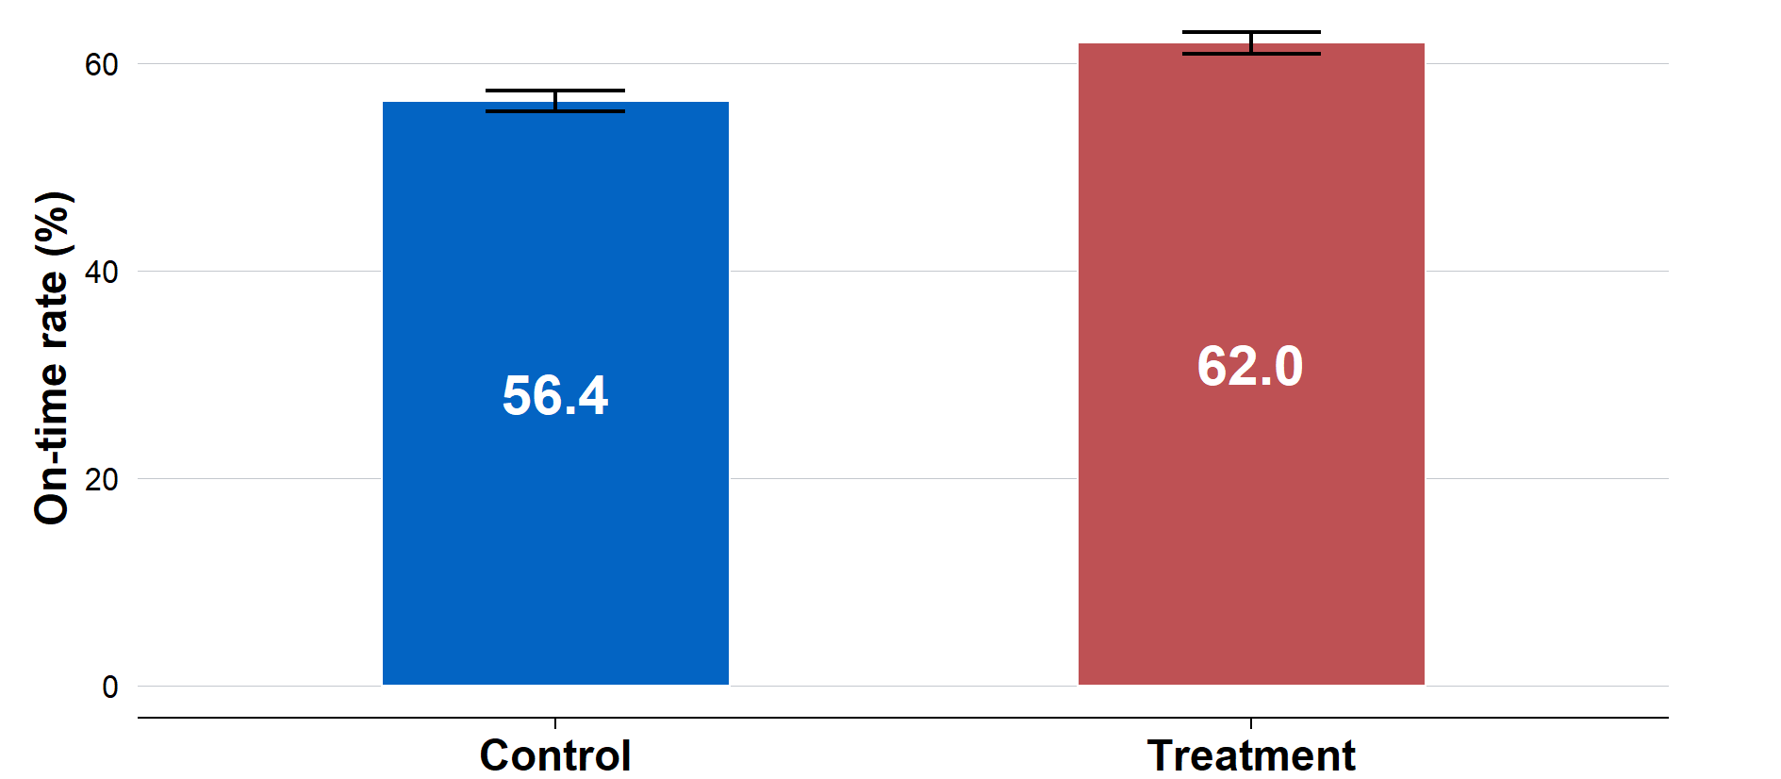

## Conclusions and recommendations

An extra email reminder to a charity’s Responsible Person boosted on‑time AIS submissions by 5.6 percentage points and led to submissions a median of 3 days earlier. The reminder worked across all types of charities, with no evidence of differences between charity types. While on‑time AIS submission supports greater transparency and public trust through more accurate and timely information, there are also operational costs associated with sending the additional reminder email. This is especially the case if the ACNC is unable to assist charities to comply with their obligations due to increased demand for assistance.

**The ACNC should examine ways to minimise the implementation costs associated with the additional reminder to assess whether it can become part of as business‑as‑usual practice.** The additional reminder to a Responsible Person improved on‑time submissions rates. However, there were various implementation costs associated with the additional reminder. The ACNC should seek to minimise these costs where possible (for example, through automation, streamlined processes, or more targeted reminders), and then assess whether the benefits of the additional reminder outweigh the remaining costs.

**The ACNC should explore alternative uses of reminders, within operational constraints.** The ACNC should also consider other potential uses for the additional reminder to a Responsible Person. For instance, the reminder could be targeted towards charities with overdue AIS submissions. Alternatively, the ACNC consider testing the additional reminder to a Responsible Personas as the *first* reminder to targeted groups of charities, such as those with historically lower submission rates or lower engagement levels.

**The ACNC should consider more trials to strengthen regulatory outcomes.** This randomised trial demonstrates how such trials can provide clear evidence about what works and by how much, particularly when the outcome is uncertain. The ACNC should consider using rigorous evaluation strategies, including randomised trials, in the future where opportunity, resourcing, and timelines allow. Specifically, the ACNC should consider trials when testing new approaches or processes.

1. Introduction and policy context

Most registered charities in Australia are required to submit an Annual Information Statement (AIS) to the Australian Charities and Not‑for‑profits Commission (ACNC) each year. The AIS collects key information about a charity’s operations, finances and activities. This information is used to update the ACNC Charity Register, a public database that helps donors, funders, charities and the public to access accurate and up‑to‑date information about registered charities.

The AIS plays a central role in upholding transparency and maintaining public trust in charities. It also reduces the regulatory burden on charities, as the ACNC shares information from the AIS with a range of other regulators (this reduces the need for charities to report separately to other regulators, reducing costs). The information charities provide in their AIS is also published online, helping to ensure transparency. For these reasons, providing the ACNC with an AIS is an important process for charities to adhere to, and timely reporting supports the efficiency of this process, and the accuracy and usefulness of the Charity Register.

Charities must submit their AIS to the ACNC by a deadline, which differs depending on each charity’s reporting period. Charities have 6 months to submit their AIS after the end of the reporting period. For charities that report to the ACNC by financial year, the charity must submit their AIS to the ACNC by 31 December. However, it is standard practice for the ACNC Commissioner to provide these charities with an extension due to the New Year period. Approximately 65% of registered charities have the AIS submission deadline of 31 January and 28% have the deadline of 30 June annually. A small proportion of charities have other due dates due to their reporting period.

Despite the benefits of on‑time submission, a proportion of charities fail to submit their AIS on‑time. The ACNC aims to have 75% of AIS submitted by the due date. The on‑time submission rate by 31 January was 73% in 2023–2024 and 68% in 2022–2023. There are penalties for submitting an AIS late, including administrative penalties, loss of registration, and reputational damage, which may affect a charity’s ability to operate and secure funding.

To support compliance, the ACNC typically sends reminder emails to the charity’s ‘address for service’ email address. A charity’s Address for Service is the primary address where the ACNC sends all correspondence. However, this email address may not be regularly monitored, and the email may not reach individuals in the charity responsible for submitting the AIS.

This evaluation was designed to test whether an additional email reminder – sent directly to a Responsible Person – could improve on‑time submission rates of a charity’s AIS. The ACNC selected the Responsible Person based on a set order of position titles, prioritising the role most likely to submit the AIS, starting with Treasurer, then Secretary, Director, and so on (see Appendix B for details).

1. Evaluation design and implementation

This section outlines how the trial was designed and implemented, including the randomisation process, timing of the intervention, and key operational considerations.

## Summary of design

This evaluation used a randomised trial to test the effectiveness of an additional email reminder, sent to a designated Responsible Person (RP), in improving the timely submission of a charity’s AIS.

Charities that had not submitted their Annual Information Statement (AIS) by the date the email reminder was sent – and did not meet any other exclusion criteria – were included in the trial. All charities in the trial were sent a second email reminder ahead of the 31 January 2025 deadline (all charities receive the first reminder 2‑3 months before the due date), per business‑as‑usual processes. If the charity was randomised to the treatment group, the charity also received an additional email as part of the second reminder regarding the AIS submission deadline, sent to a RP for the charity, in addition to the reminder email sent to the main contact email address.

|  |
| --- |
| ***Key evaluation question: Does sending an additional email reminder to a charity’s Responsible Person increase the likelihood that a charity submits its AIS on‑time?*** |

## Implementation

A total of 15,000 charities that had not submitted their AIS as of 3 January 2025 were included in this RCT.[1] On this date, the full number of charities was finalised and randomly assigned into 2 groups:

* Treatment group (7,500 charities): Received both the standard reminder email to the charity’s main contact and an additional email to the RP
* Control group (7,500 charities): Received only the standard reminder email sent to the charity’s main contact, as per usual practice of the ACNC.

Charities that met at least one of the following exclusion criteria were excluded from the trial: charities with an invalid/blank Responsible Person contact email; charities that were exempt from submission; charities that submitted paper, bulk or group versions of the AIS; charities that reported by calendar year; and charities that still had outstanding AIS submissions from previous years.

The ACE conducted the randomisation on 3 January using a stratified approach, with a randomly generated ‘batch number’ for each charity serving as the stratification variable. A batch number was used due to the ACNC’s operational requirement to send the reminder emails in smaller daily batches. Thus, the batch number corresponded to the date each charity was scheduled to receive their additional reminder emails. This method ensured even allocation across the treatment and control groups on each send date.

The ACNC sent reminder emails from 7 to 17 January 2025, typically sending 2 batches of 1,000 charities each per business day.[2]

This batching approach was necessary to accommodate the ACNC’s system capacity, ensure reliable delivery of the emails, and enable support services to cater to charity enquiries.

The RP was selected based on hierarchical criteria developed by the ACNC reflecting how likely the individual was to be involved in submitting the AIS. The exact criteria can be found in Appendix B. The business‑as‑usual email was sent to each charity’s Address for Service email.

The primary outcome of interest was a binary variable for whether a charity submitted its AIS on‑time, defined as submission on or before 31 January 2025. The primary analysis used a linear probability model, with robustness checks for different model specifications and data settings.

The evaluation also explored how quickly charities submitted their AIS after the additional second reminder emails were sent. A Kaplan‑Meier survival analysis was used to understand how long it takes charities to submit their AIS, and to compare whether the treatment group submitted their AIS earlier than the control group. Time to submission was defined as the number of days between when a charity received the reminder email and when the charity submitted its AIS. The calculation included weekends, as some charities chose to submit over weekends. This outcome was calculated for each individual charity, as the date that each charity received the reminder emails differs across charities (due to the ‘batching’ of email sends).

All outcome definitions and statistical models were pre‑specified in the pre‑analysis plan to ensure transparency.[3] All outcomes were extracted from the ACNC systems on 17 February 2025. The ACNC de‑identified the data and provided outcome data to ACE in csv format. For full details of the pre‑analysis plan, see Technical Appendix C.

The randomised trial was reviewed and approved by Macquarie University’s human research ethics service (Project ID: 18222). It was assessed as ‘low risk’ and so was not subject to further review by one of Macquarie’s Human Research Ethics Committees.

1. Results

This section presents the results of the trial, including the impact of the additional reminder email on on‑time AIS submission rates, overall timing of submissions and how the effect varied across different types of charities. It also covers the operational costs and potential savings associated with implementing the intervention.

## The additional reminder to Responsible Person substantially increased on-time AIS submission

The primary outcome of interest in this randomised trial was whether a charity submitted its AIS on‑time, defined as submission on or before 31 January 2025. Sending an additional reminder email to a charity’s Responsible Person increased the overall on‑time submission rate by 5.6 percentage points compared to the control group who received business‑as‑usual communications (an increase from 56.4% to 62.0%, see Figure 2).

Had this additional reminder been sent to all 15,000 charities in the trial, an estimated 840 charities would have submitted on time, with a likely reduction in workload for the ACNC.[4]

The result was also consistent across different model specifications and data settings; see Technical Appendix C for details.[5]

Figure 2. Change in on-time AIS submission rates



Note: Results from linear probability model of on‑time submission, by treatment status. The difference of 5.6 percentage points was statistically significant (p<0.001). N=15,000.

Figure 3 shows the cumulative number of AIS submissions over time for both treatment and control charities. Submissions began to increase steadily after 7 January 2025, when the first batch of reminder emails were sent, and continued to rise throughout the month. By the end of the submission period, the treatment group recorded a higher number of cumulative submissions compared to the control group. The gap between the 2 lines reflects the higher rate of on‑time reporting amongst charities that received the additional email reminder to the Responsible Person.

Figure 3. Cumulative AIS 2024 submission count by day, January 2025

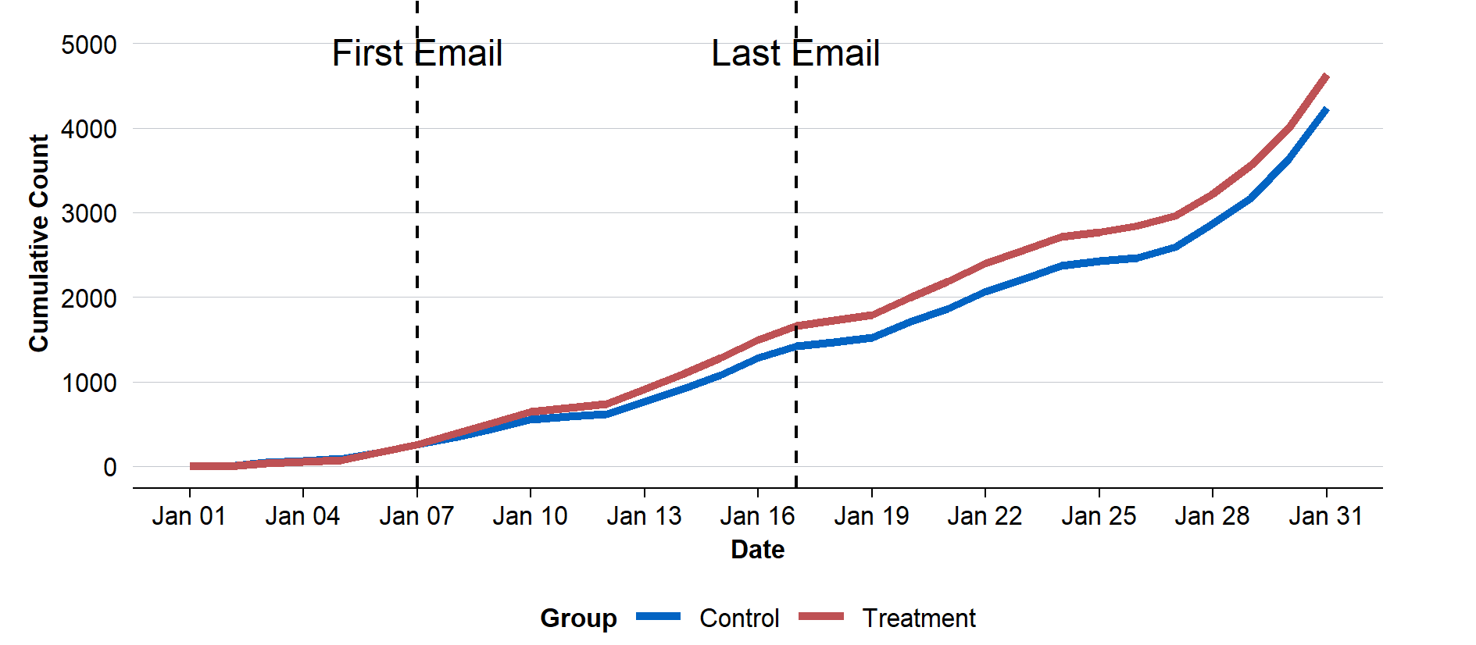

Note: ‘First email’ refers to emails sent to the first batch of charities on 7 January. ‘Last email’ refers to emails sent on 17 January to the final batch of charities.

|  |
| --- |
| ***The 5.6 percentage point increase in on time submission rate provides clear evidence that direct communication with a charity’s governance contact (the Responsible Person) can materially influence on time AIS submissions.*** |

## The second email reminder to an RP accelerated median AIS submissions by 3 days

The evaluation also explored how quickly charities submitted their AIS after the additional second reminder emails to a Responsible Person were sent. This ‘survival analysis’ showed that charities that received the extra email reminder to their RP submitted their AIS around 3 days earlier than charities that only received the usual reminder. That is, the median time to submission was:

* 18 days for charities in the treatment group (who received the additional email to an RP).
* 21 days for charities in the control group (who only received the standard email reminder).

Figure 4. Total number of AIS submissions by day, January 2025

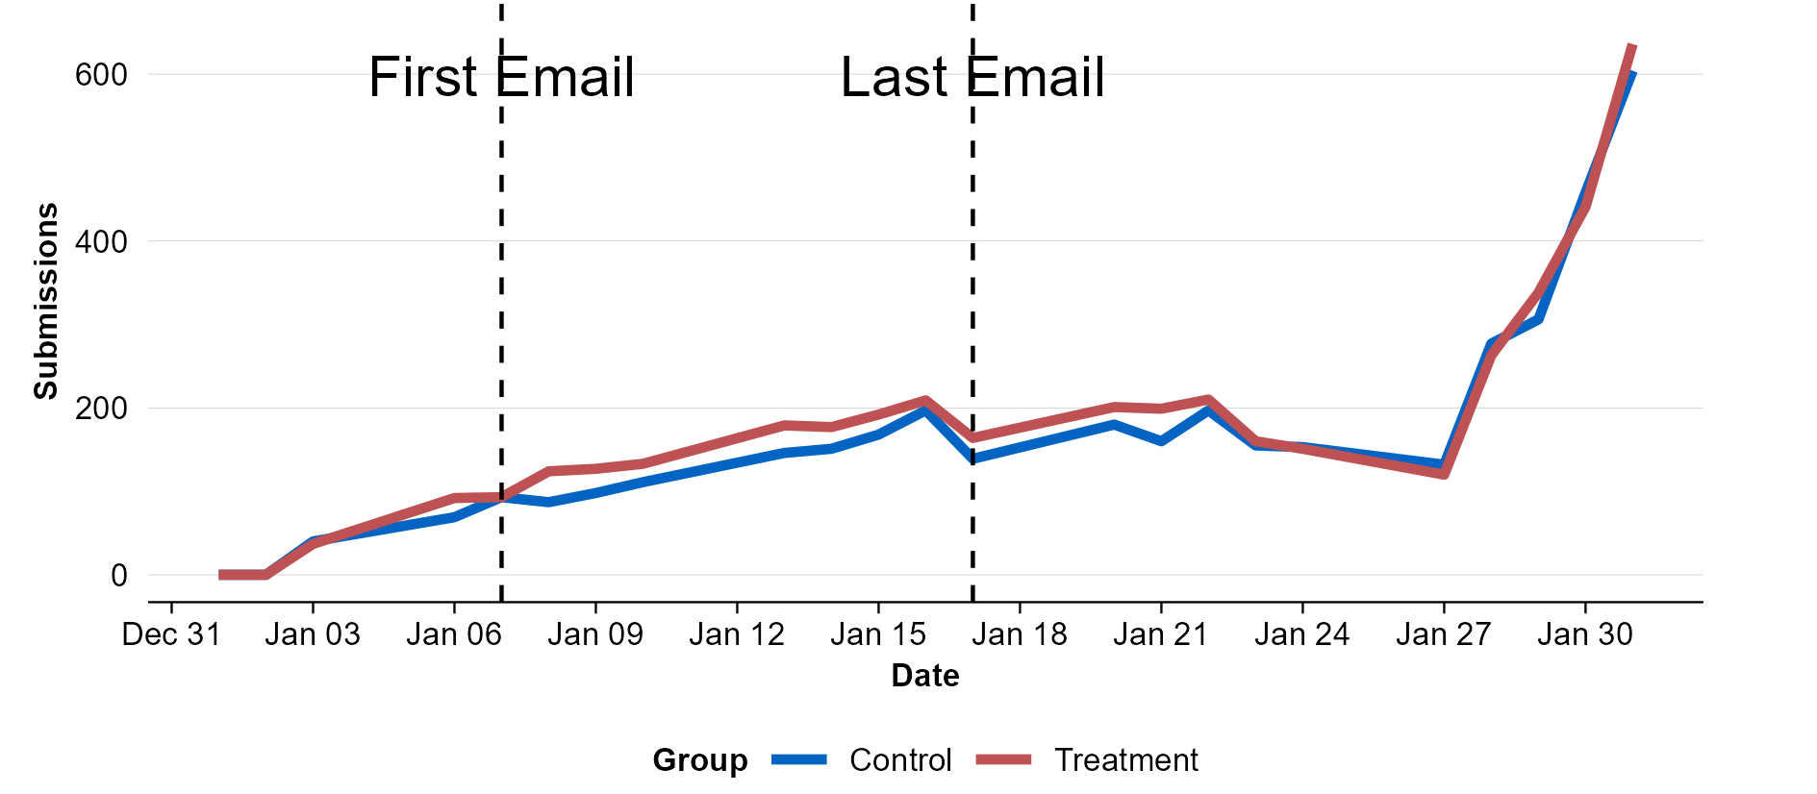

Note: Daily submission rate on weekdays only (N = 7,856).

Figure 4 shows the total number of AIS submissions by day, comparing the treatment and control groups. Submissions steadily increased throughout January, with a notable spike in the final days leading up to the 31 January 2025 deadline. Both groups followed a similar trend, but the treatment group consistently submitted slightly earlier, resulting in a small but visible gap between the 2 lines. This suggests that the additional reminder email had a modest but consistent effect on encouraging earlier submissions, consistent with the ‘survival analysis’ reported above.

|  |
| --- |
| ***This trial provides evidence that charities that received an additional email reminder to their RP were not only more likely to submit their AIS on time, but also submit it sooner.*** |

## On-time submission rates increased across all charity characteristics

The evaluation also included subgroup analysis to examine whether the treatment had different effects across specific types of charities. This subgroup analysis used standardised ACNC criteria, which were:

* **Charity size**: A charity’s size was classified based on its annual revenue, following the ACNC legislative criteria: small (revenue under $500,000), medium ($500,000 to $3 million), or large ($3 million or more).
* **Incorporated association status**: Charities report whether they are an incorporated association in the AIS.
* **Volunteer‑based status**: Charities are classified as volunteer‑based if they had no employees but had at least one unpaid volunteer. Otherwise, they were classified as non‑volunteer based.
* **Basic Religious Charity status**: Charities can classify themselves as a Basic Religious Charity if they meet specific criteria set by the ACNC’s legislation.[6]
* **First AIS**: The ACNC categorised charities according to whether this was the charity’s first time submitting an AIS.

The primary analysis was run separately for each subgroup of interest. For example, the ACE examined the treatment effect (difference between the treatment and control on‑time AIS submission rates) for volunteer‑based charities, then just for non‑volunteer‑based charities, and so on.

Across all subgroups, the treatment improved on‑time submission rates. That is, there was no evidence that the treatment did not improve submission rates, or backfired, for any specific type of charity.

Figure 5 shows that large charities had the highest on‑time submission rates, regardless of treatment status. Among large charities, 80.9% in the treatment group submitted on time compared to 77.3% in the control group, indicating a 3.6 percentage point improvement due to the treatment. Medium and small charities experienced larger effects, with treatment leading to a 5.1 percentage point increase for medium charities and a 5.8 percentage point increase for small charities.

Figure 5. On-time AIS submission rate for charities by size

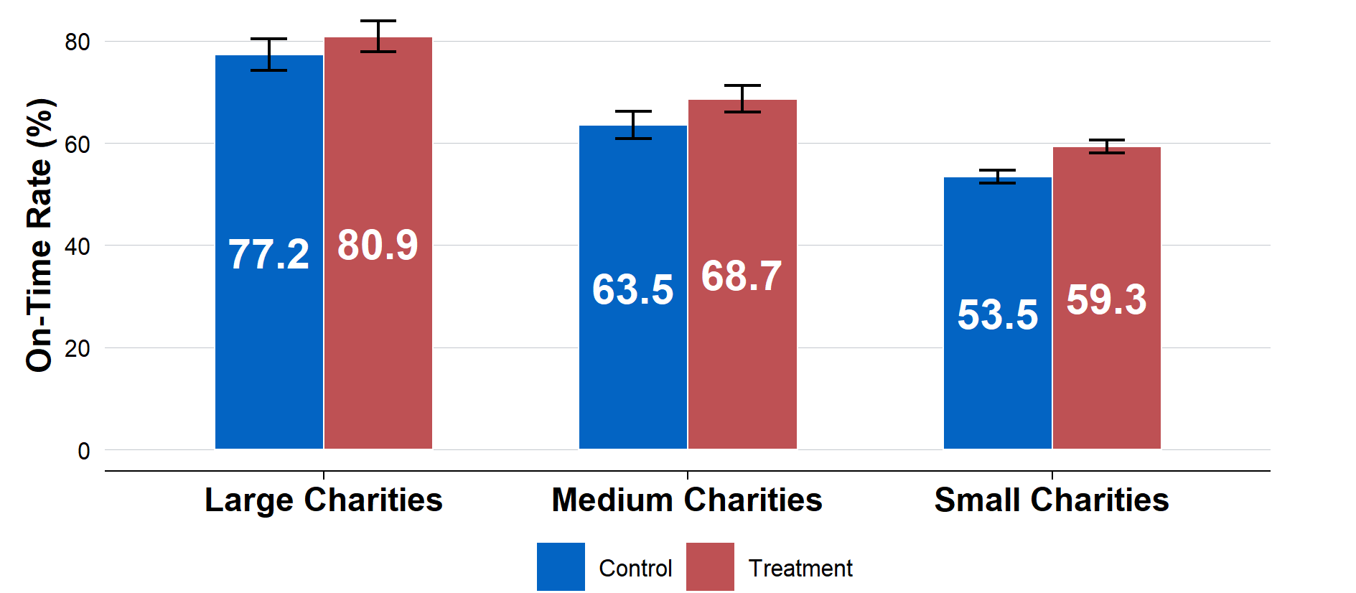

Note: N=1,228 for Large Charities, N= 2,231 for Medium Charities, N=10,347 for Small Charities. The sample sizes do not add up to the full sample of 15,000 due to missing data. See the Technical Appendix C for more details.

The results for the remaining 4 subgroup analyses are shown in Figure 6.

Although there were some differences in the magnitude of the treatment effect when comparing it across different subgroups, none of these differences were statistically significant. This could mean that the treatment effect is similar across groups, or it could be because there was insufficient sample size to detect small differences in the treatment effect.

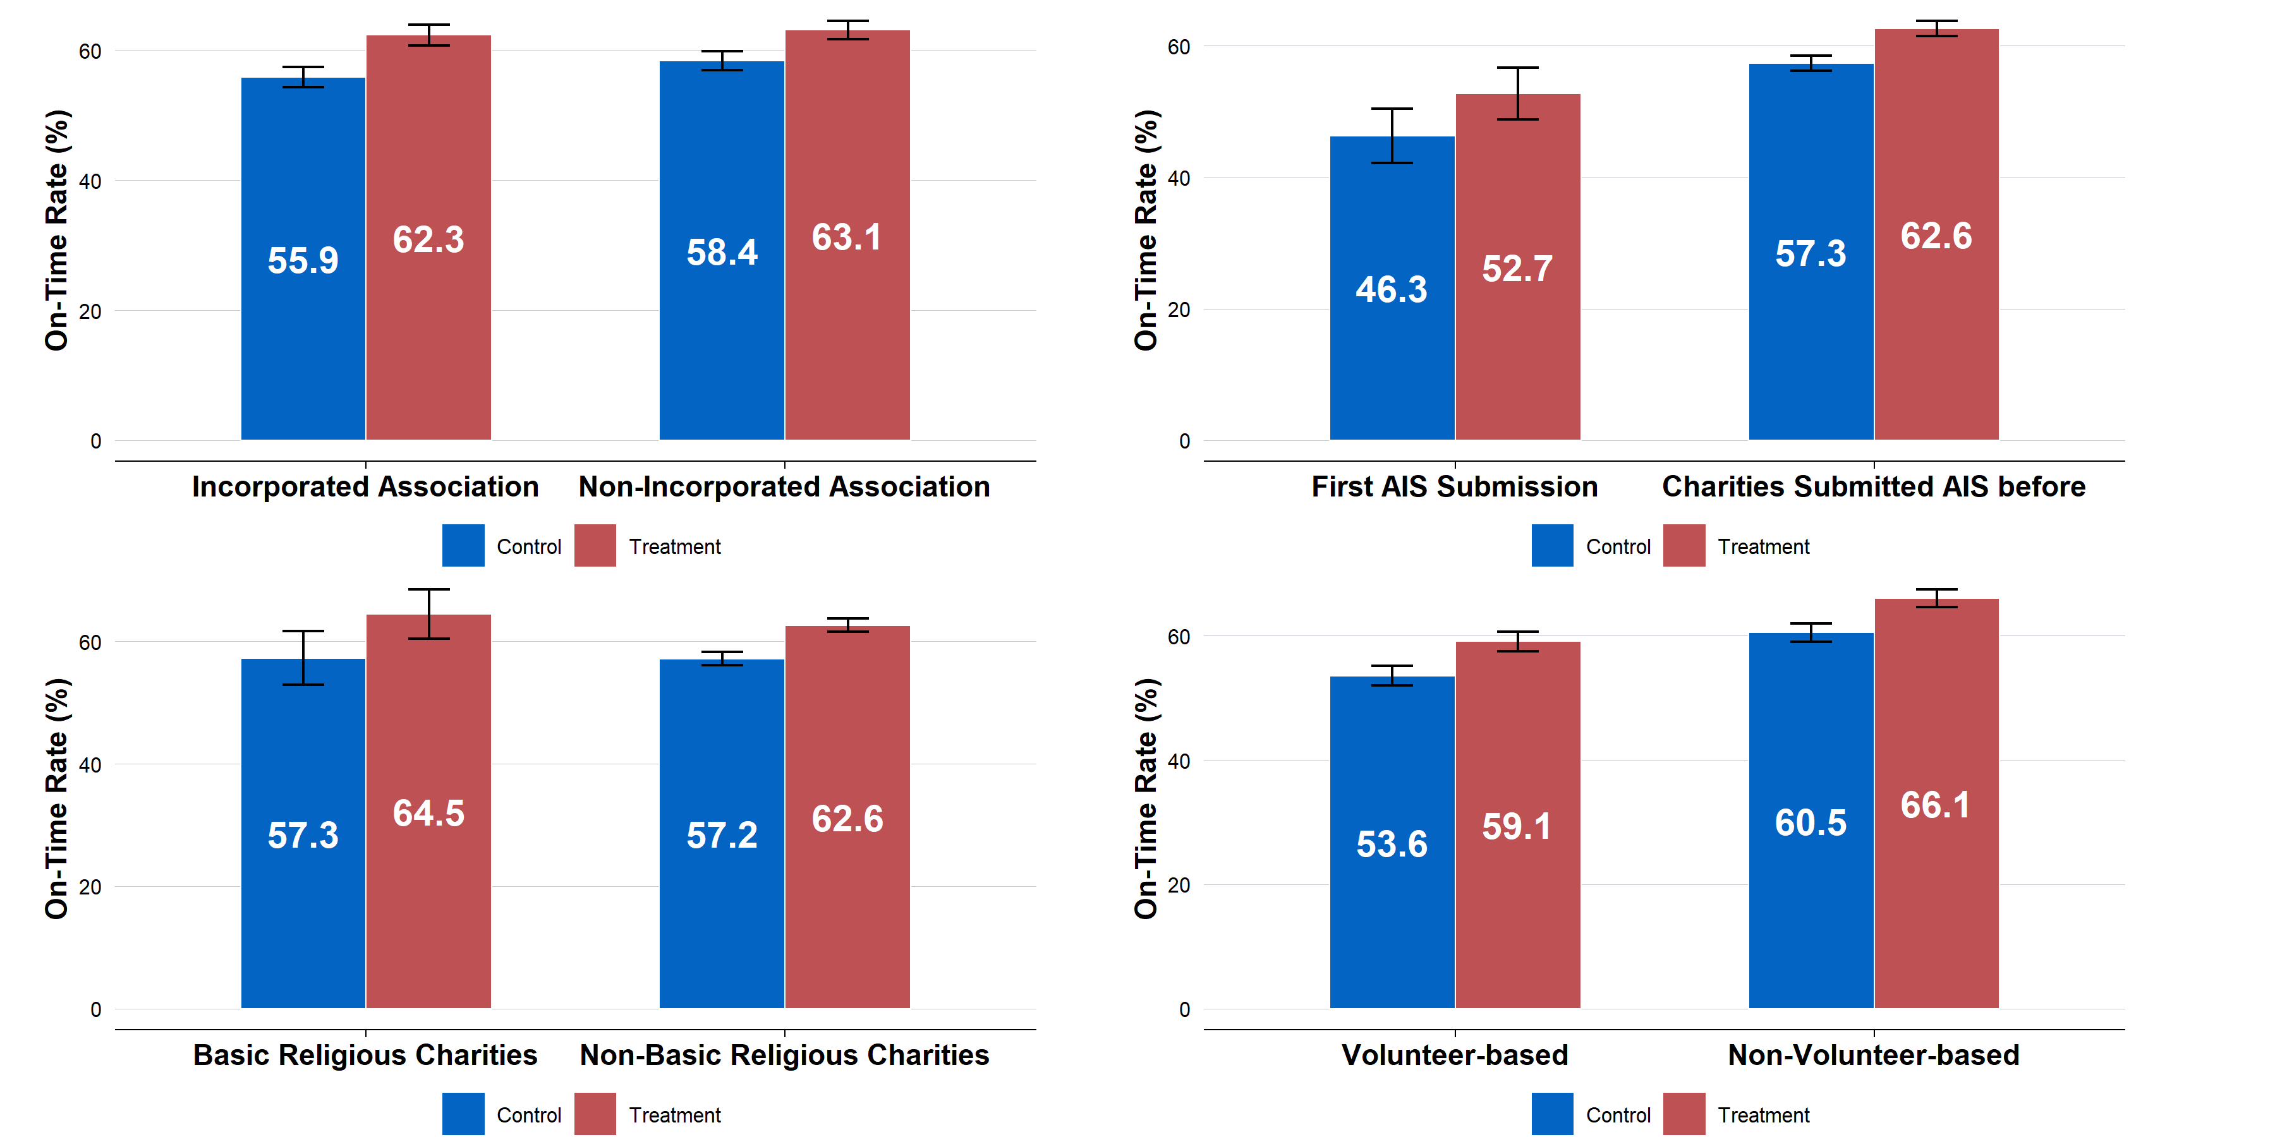Figure 6. On-time AIS submission rate for charities by charity characteristic

Note: First row: N=6,481 for Incorporated Association, N=7,325 for Non‑Incorporated Association. N=1,192 for Submitted AIS for the first time, N= 13,808 for Submitted AIS before. Second row: N=896 for Basic religious charities and N= 12,910 for Non‑basic religious charities. N=6,561 for Volunteer‑based, N=7,245 for Non‑volunteer‑based. For most of these subgroup analyses, the sample sizes do not sum to 15,000 due to missing data in the subgroups. See Technical Appendix C for more details.

## Operational considerations

Although an explicit assessment of the operational costs and operational savings was not included in the original Pre‑Analysis Plan, evaluating the practical costs and operational trade‑offs associated with the intervention provides important context for interpreting the trial’s outcomes and informing future implementation decisions. This section discusses these considerations.

### Operational costs of the intervention

While the additional reminder email to the Responsible Person had clear benefits, described in Chapter 3, it also involved various implementation costs.

First, it was not possible to fully automate message delivery. Instead, for each batch of emails, the ACNC undertook manual data cleaning to ensure they were using the most accurate email address for the Responsible Person. This involved removing duplicate email addresses and updating the Responsible Person’s email address if it had changed. This dataset was then uploaded to the mailout provider. Cumulatively, these tasks took about one full day of work over the trial period to complete.

Second, the additional reminder email generated an increase in enquiries to the ACNC’s call centre. During the period, the ACNC received an extra 77 calls (8.8%) from charities receiving the additional reminder (872 calls from the control group versus 949 from treatment). This required increased involvement from call centre managers to handle these extra calls, and reprioritisation of tasks.[7]

It is possible some of these costs could be reduced over time. For example, enquiries from charities may decline as the organisation, rather than just a single Responsible Person, becomes more familiar with the reminder or AIS submission process.

Similarly, it is possible the ACNC can find a simpler, or more targeted, way to implement the message delivery process that reduces the amount of manual data cleaning required, meaning the resourcing costs for email delivery can be minimised.

Any changes also need to be balanced against the growing number of charities being regulated by the ACNC.

### Operational savings of the intervention

Although there were some costs of the intervention, these need to be considered against the additional benefits the trial delivered. The trial found that charities that received the additional reminder email to a Responsible Person submitted their AIS around three days earlier than those who did not.

This pattern of earlier submission can bring about some operational savings. It may reduce the amount of follow‑up ACNC must undertake with individual charities, lowering administrative costs. It may also reduce last‑minute extension requests, easing pressure on staff. Finally, by increasing charities’ awareness of their AIS obligations, the reminders may help foster more consistent reporting in future cycles. Over time, this could reduce the need for follow‑up and enhance the ACNC’s overall regulatory efficiency beyond a single reporting period.

1. Conclusions and recommendations

This randomised trial provides strong evidence that sending an extra email reminder to a charity’s RP improves on‑time AIS submission rates. Charities in the trial that received the additional email reminder were 5.6 percentage points more likely to submit their AIS on time compared to charities that did not receive an additional email reminder to an RP. Charities that received the additional email reminder to their RP also submitted their AIS earlier—a median of 3 days sooner than charities that did not receive the extra email.

These effects were consistent across all types of charities, including volunteer‑based, Basic Religious Charities, incorporated associations, and small, medium or large charities. The additional email reminder increased on‑time AIS submission across all subgroups, and there was no statistically significant difference in the additional email reminder’s impact between groups. This suggests that the reminder works broadly across different types of charities.

This result was based on a comparison between 2 *randomly allocated* groups: one group of charities that received the extra email (the treatment group) and one group of charities that did not (the control group). Because the 2 groups of charities were randomly selected, and then treated the same in every other way, any general changes that might have influenced submission behaviour this year—such as improvements in the ACNC messaging, sector‑wide communication, or changes in reporting habits—would have affected both groups equally. This means the difference in submission rates can be attributed to the additional reminder email sent to the RP, rather than other contextual factors.

The intervention delivered several benefits aligned with ACNC’s regulatory objectives. First, improved on‑time AIS submissions contribute to a more accurate and up‑to‑date Charity Register, which supports transparency and potentially strengthens public trust. Second, higher on‑time AIS reporting reduces ACNC’s workload by lowering the volume of reminder emails, extension requests, and follow‑up communications. This frees staff capacity and allows resources to be redirected to other regulatory priorities (noting the operational costs listed below). Third, the additional reminder to an RP likely increased charities’ awareness of their reporting obligations, which may have longer‑term benefits if it encourages more consistent compliance in future reporting periods.

However, the additional reminder was associated with some resourcing costs. Manual data cleaning was necessary to ensure the accuracy of RP email addresses, and to ensure that the email was sent to the most appropriate individual. In addition, the extra reminder email generated an increase in enquiries to the ACNC’s call centre, which required a reallocation of tasks. Although costs may reduce over time, the ACNC will need to weigh all costs against the benefits of the additional reminder.

**Recommendation 1 – The ACNC should examine ways to minimise the implementation costs associated with the additional reminder so that it can become part of as business‑as‑usual practice.** The trial showed that the reminder led to a substantial increase in on‑time submissions across all charity types. This has benefits for charities themselves, for public trust in the Charity Register, and for the ACNC. However, there were implementation costs associated with the additional reminder related to manual data cleaning, and additional enquiries arising from the reminders. The ACNC should seek to minimise these costs—for example, through automation, streamlined processes, or more targeted reminders. The ACNC should then assess whether the benefits of the additional reminder outweigh the remaining costs.

**Recommendation 2 – The ACNC should explore the alternative use of reminders, within operational constraints.** Given the effectiveness of the reminder, the ACNC should explore other potential uses for this approach, if the associated implementation costs can be kept manageable. For instance, ACNC could test sending reminders specifically to charities with overdue AIS submissions or extend the reminder strategy to charities with a 30 June deadline. Alternatively, the ACNC could consider trialling the additional reminder to RPs as the *initial* reminder regarding the AIS process, particularly for charities with historically lower submission rates or engagement levels. Such alternative uses of the reminder to RPs could enable the ACNC to enhance compliance outcomes, particularly for charities who may be more likely to submit their AIS late, while managing the associated implementation costs.

**Recommendation 3 – The ACNC should consider more randomised trials to strengthen regulatory outcomes within operational constraints.** This trial demonstrates the value of randomised trials in testing policy ideas or regulatory processes before rolling them out more broadly. Randomised trials are especially helpful when there is uncertainty about the likely impact of an intervention, or when several options are being considered. In this case, the trial helped assess whether an extra reminder could make a meaningful difference in on‑time AIS submission, as well as identifying associated implementation costs.

The ACNC could consider rigorous impact evaluation approaches within operational constraints, including randomised trials, to add more robust evidence to ongoing operational processes. In situations where the expected outcome is relatively clear (for example, using reminders to increase engagement), simpler approaches may be more appropriate. But in situations such as when the size of the effect is uncertain, the potential costs and benefits need to be weighed up, the mechanisms are unclear, or past evidence is mixed, a randomised trial can help provide greater clarity and reduce the risk of investing in less effective regulatory strategies.

Appendix A: Reminder sent to Responsible Person

The image below shows the email reminder that was sent to the Responsible Person. The text of that reminder is provided below.

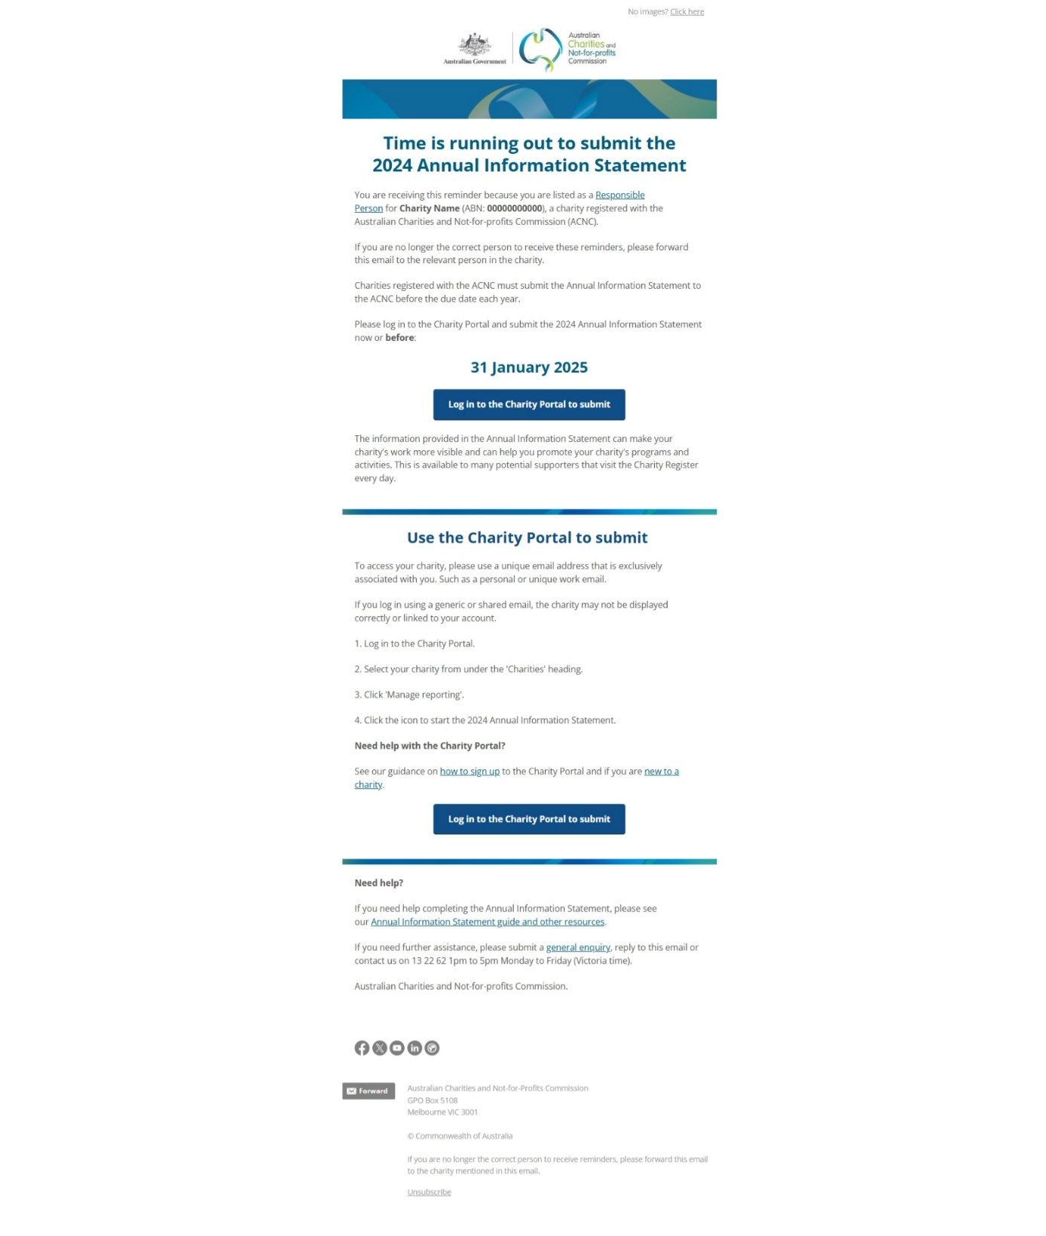

## Time is running out to submit the 2024 Annual Information Statement

You are receiving this reminder because your email address is listed as a Responsible Person for **Charity Name** (ABN: **00000000000**), a charity registered with the Australian Charities and Not‑for‑profit Commission (ACNC).

If you are no longer the correct person to receive these reminders, please forward this email to the relevant person in the charity.

Charities registered with the ACNC must submit the Annual Information Statement to the ACNC before the due date each year.

Please log in to the Charity Portal and submit the 2024 Annual Information Statement now or before:

**31 January 2025**

Log in to the Charity Portal to submit

The information provided in the Annual Information Statement can make your charity’s work more visible and can help you promote your charity’s programs and activities. This is available to many potential supporters that visit the Charity Register every day.

Use the Charity Portal to submit

To access your charity, please use a unique email address that is exclusively associated with you. Such as a personal or unique work email.

If you log in using a generic or shared email, the charity may not be displayed correctly or linked to your account.

1. Log in to the Charity Portal
2. Select your charity from under the ‘Charities’ heading.
3. Click ‘Manage reporting’.
4. Click the icon to start the 2023 Annual Information Statement.

### Need help with the Charity Portal?

* See our guidance on how to sign up to the Charity Portal and if you are new to a charity.
* Log in to the Charity Portal to submit

### Need help?

If you need help completing the Annual Information Statement, please see our Annual Information Statement guide and other resources.

If you need further assistance, please submit a general inquiry, reply to this email or contact us on 13 22 62 1pm to 5pm Monday to Friday (Victoria time).

Appendix B: Determination of a charity’s Responsible Person

The ACNC used the criteria below to determine which Responsible Person would receive the treatment intervention.

The preference order by position title were as follows:

1. Treasurer
   1. If the Treasurer email is blank or their email matches the charity address for service email, then preference is given to the next position title listed below and follows the same criteria as specified in this point.
   2. Additionally, if there are 2 Responsible People with the same position title that meet the criteria above (i.e. 2 treasurers with unique emails), preference will be given to the Responsible Person with the more recent start date on their RP relationship.
2. Secretary
3. Director
4. President
5. Public Officer
6. Chairperson
7. Committee Member
8. Trustee
9. Board Member
10. Vice‑president
11. Deputy Chairperson
12. Other

Appendix C: Technical appendix

This appendix provides further detail on how the randomised trial was conducted and analysed, in accordance with the pre‑analysis plan. It details:

* pre‑registration and ethics
* deviations from the pre‑analysis plan
* data processing and randomisation
* the study population
* primary analysis
* secondary analysis
* sub‑group analyses
* risk of bias

## Pre-registration and ethics

The randomised trial was reviewed and approved by Macquarie University’s human research ethics service (Project ID: 18222) on 3 December 2024. It was assessed as ‘low risk’ and so was not subject to further review by one of Macquarie’s Human Research Ethics Committees.

The trial was publicly pre‑registered with the American Economic Association’s Social Science Registry ([AEARCTR‑0015006](https://www.socialscienceregistry.org/trials/15006)) on 17 December 2024. The pre‑analysis plan (PAP) and registration were completed prior to the start of data collection and analysis.

## Deviations from the pre-analysis plan (PAP)

Randomisation, data processing, and analysis followed the procedures outlined in the pre‑analysis plan, with the following 2 exceptions. These deviations are also noted in the relevant sections of this Appendix.

* The ACE did not pre‑specify that it would mean centre covariates in the PAP. The ACE mean‑centred the covariates to improve interpretability and reduce multicollinearity. This deviation did not change the results.
* For the subgroup analysis, the ACE did not specify a fully saturated model in the PAP. The ACE used a fully saturated model to make interpretation of subgroup effects and interactions clearer. This change did not alter the underlying results or conclusions.

## Data processing and randomisation

### Randomisation

As outlined in the PAP, the ACNC sent the ACE a de‑identified csv file for randomisation. The data file contained a charity identifier, and information on each charity’s characteristics: charity size, basic religious status, incorporated association, volunteer‑based status, and whether it was the charity’s first AIS submission.

The ACE then conducted the stratified randomisation process through the following steps:

1. Organise the data: The ACE ensured that all relevant fields were completed and coded accurately. The ACE did not find any inconsistency, nor that any changes to the data were required.
2. Randomly assign charities to ‘batches’: The ACE randomly assigned each charity to a batch of 1,000. The batch order corresponded to the order in which the email reminders were to be sent by ACNC during January 2025.
3. Randomise charities to treatment and control: The ACE randomised all charities to treatment and control, stratifying by ‘batch’. This ensured even allocation of send dates across treatment and control groups.

The ACE did not deviate from the PAP for this process.

### Cleaning of outcome data

The ACE received de‑identified outcome data from the ACNC on 17 February 2025. In preparing the data, the ACNC noted several discrepancies in the raw data. These were identified and discussed prior to any analyses taking place and included instances of missing data (one charity with missing covariate data) and 4 charities with incorrect information due to internal system errors.

During the data cleaning and verification process, the ACE took the following action for each instance of incorrect or missing data.

* *Charities granted an extension in 2025 and charities that de‑registered between randomisation and data extraction*: Although some charities were granted an AIS extension, the ACE applied a consistent rule that considered 31 January 2025 as the fixed deadline for all submissions. This meant that even if a charity received an extension to their AIS submission deadline, the AIS submission was still coded as “Not on time” if the charity submitted their AIS after 31 January. The same rule applied to charities that deregistered. This decision was made to avoid introducing a separate timeline for compliance and to maintain comparability across the sample.
* *Charities that had already submitted before the email was sent*: Several charities had already submitted their AIS before the rollout of email reminders began (7 January 2025). These were identified in the data by the label “Not sent (already submitted)”. For these cases, the ‘date email sent’ was set to missing (NA) to reflect the fact that they were not exposed to the treatment. These charities were still included in the Intention‑to‑Treat for the primary analysis, but not in the survival analysis.
* *Corrections to ‘First AIS’ status*: ACE corrected the First AIS status to ‘Y’ for 2 charities after the ACNC identified the issue and confirmed that AIS24 was their first AIS, following an error identified in the original data query. Two other charities were marked as NA for on‑time submission as they were not required to submit an AIS in 2023.
* *Missing covariate data*: One charity had missing data for the covariate regarding on‑time submission for the 2023 AIS. The ACE did not make any adjustment for this charity, and the missing covariate was treated in line with the pre‑specification (see details on page 26).

## Summary of sample

The sample included 15,000 charities, which were evenly split between treatment and control groups. As expected, the sample was well balanced between treatment and control on available characteristics (Table 1): for example, volunteer‑based (47.4% in treatment versus 47.7% in control) and basic religious charity (6.7% in treatment versus 6.3%). Of course, there was a difference in the proportion of charities that submitted their 2024 AIS on time, since that was the purpose of the trial: the rate for the treatment group was 61.8%, compared to 56.5% for the control group.

The total sample was smaller for the following 4 subgroups: whether a charity is volunteer‑based, a basic religious charity, an incorporated association, and whether the charity submitted on time in 2023. This was because this subgroup information was only available for the 13,806 charities that had already submitted at least one AIS to the ACNC prior to the trial. Although subgroup data was available in the 2024 AIS submission (the subject of the current trial), this information could not be used as it was linked to the treatment effect (that is, only charities that submitted their AIS on time would have this information available for the ACNC).

Table 1. Trial sample composition

|  |  |  |  |  |  |  |  |  |  |  |  |
| --- | --- | --- | --- | --- | --- | --- | --- | --- | --- | --- | --- |
| Summary Statistics by Treatment Group | | | | | | | | | | | |
| Variable | Total Sample | | | Control | | | | | Treatment | | |
| N | Mean | SD | | N | Mean | SD | N | | Mean | SD |
| On‑time submission 2024 (trial result) | 15,000 | 0.592 | 0.492 | | 7,500 | 0.565 | 0.496 | 7,500 | | 0.618 | 0.486 |
| Volunteer‑based (2023) | 13,806 | 0.475 | 0.499 | | 6,933 | 0.474 | 0.499 | 6,873 | | 0.477 | 0.499 |
| Basic religious charity (2023) | 13,806 | 0.065 | 0.246 | | 6,933 | 0.063 | 0.243 | 6,873 | | 0.067 | 0.250 |
| Incorporated association (from 2023 AIS) | 13,806 | 0.469 | 0.499 | | 6,933 | 0.474 | 0.499 | 6,873 | | 0.465 | 0.499 |
| On‑time submission 2023 | 13,808 | 0.699 | 0.459 | | 6,934 | 0.700 | 0.458 | 6,874 | | 0.697 | 0.460 |
| First AIS submission | 15,000 | 0.079 | 0.270 | | 7,500 | 0.075 | 0.264 | 7,500 | | 0.084 | 0.277 |

## Primary analysis

### Model specification

The ACE estimated a model where the outcome variable indicated whether a charity submitted its AIS on time (1 = Yes, 0 = No). The main variable of interest was a treatment indicator, coded as 1 if the charity received the additional email reminder to a Responsible Person, and 0 otherwise. The coefficient on this variable captured the average treatment effect. The full specification for the models was:

$$Y_{i}=β_{0}+ β_{1}{Treatment}_{i}+ β_{2}Covariates+ β_{3}Treatment x Covariates+β_{4}Missingness+∈_{i}$$

The model included 3 sets of covariates: Charity size (based on 2023 AIS data) (Small, Medium and Large), batch number and whether the charity submitted on time in 2023 (Yes/No). These covariates were mean‑centred. When data on a covariate was missing, the missing value was set to 0, and a separate missingness indicator was added to capture the effect of missing data on the outcome. The ACE also included interaction terms between the treatment and the covariates (but not the missingness indicator) to explore whether the treatment effect varied across charity characteristics. Standard errors were calculated using a HC2 heteroskedasticity‑consistent estimator. Further information on the model is provided in the PAP on pages 8‑9.

As outlined in the ‘Summary of sample’ section above, the ACE excluded charity size data submitted in the 2024 AIS from the model, as this information became available only after treatment assignment and was therefore potentially influenced by the intervention. For newly registered charities that were not required to submit an AIS in 2023, 2023‑related covariates were naturally missing and handled accordingly within the model.

|  |
| --- |
| Deviation from PAP |
| The ACE did not pre‑specify that it would mean‑centre covariates in the PAP. The ACE mean‑centred the covariates to improve interpretability and reduce multicollinearity. This deviation did not change the results. |

### Hypothesis and regression outputs

The main hypothesis was that the on‑time submission rate would be higher in the treatment group (who received an additional email reminder to the Responsible Person) compared to the control group. Figure 5 shows the estimated effect of treatment and each of the covariates on the likelihood that a charity submitted its AIS on time.

The coefficients from the primary regression model (as seen in Figure 7) show:

* **Past behaviour was the strongest predictor of on‑time AIS submissions**: Charities that submitted on time in 2023 were significantly more likely to submit on time in 2024. This variable has the largest positive effect in the model.
* **Treatment had a positive impact**: Receiving the additional email reminder was associated with a higher rate of on‑time submission, even after accounting for other factors.
* **Charity size matters**: Small and medium charities were slightly less likely to submit on time than large charities (the reference group), as shown by the negative coefficients. However, their interaction with treatment was not statistically significant, suggesting the treatment effect was similar across different charity sizes.
* **Batch effects were minimal**: The batch number (which reflects when charities received the email) had a small influence on outcomes, and the interaction between treatment and batch was also small, suggesting the timing of when charities received the reminder within the rollout period did not strongly affect the results.
* **No strong moderation effects**: Interaction terms between treatment and other variables (charity size, past submission status, batch) show no large or statistically significant shifts, suggesting the treatment effect was relatively stable across different subgroups.

Figure 7. Coefficient plots for primary analysis

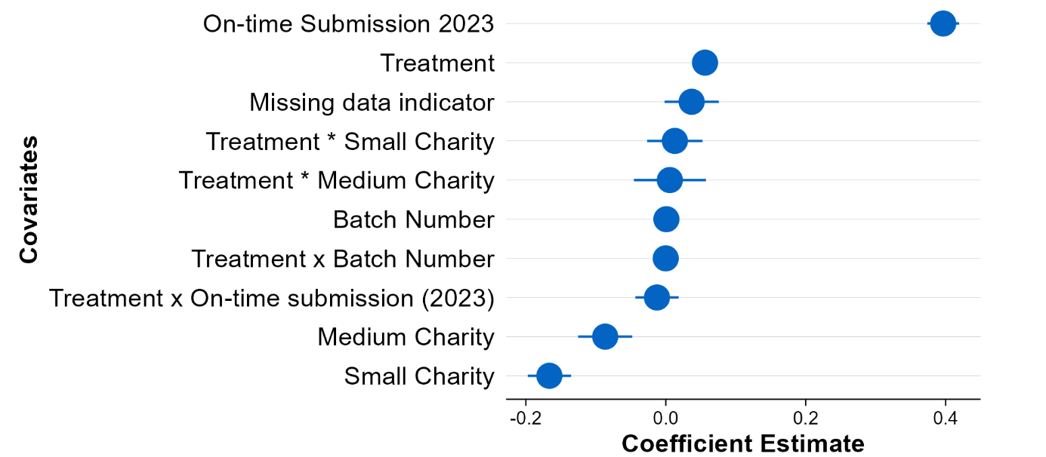

Source: Primary regression of on‑time submission on treatment status of charities submitting 2024 AIS. N=15,000

### Robustness checks

To ensure the robustness of the findings, the ACE tested several alternative modelling choices.

* Estimation of the main specification using a logistic regression model, instead of a linear probability model (see PAP page 13 for further details). The evaluation findings were unaffected, with statistically significant results in the same direction and with very similar effect sizes, indicating that the findings reported here are not sensitive to the choice of regression framework.
* Reclassification of charities with extended AIS deadlines as ‘on‑time’ rather than ‘late’. This reflected the potential adjusted reporting behaviour in response to the additional email reminder (that is, it is plausible that some charities requested a deadline shift in response to the additional reminder, rather than submitting the AIS). This change also did not materially affect the estimated impact of the additional email reminder to a Responsible Person.

## Secondary analysis

### Model specification

To analyse the timing of AIS submissions, the ACE used Kaplan‑Meier survival analysis. This method estimates the probability that a charity had not yet submitted its AIS by each day following the reminder email. It accounted for differences in when charities received the email, as well as the fact that some charities may not have submitted at all by the end of the observation period.

The analysis compares the cumulative submission patterns of the treatment and control groups over time, allowing an examination of not just whether charities submitted, but when they submitted. Median time to submission was also calculated for each group. All survival curves were estimated using the *survfit*() function in R, and differences between groups were tested using log‑rank tests.

For more information on the model, refer to the PAP, page 9.

### Regression outputs

Figure 8. Kaplan-Meier curve showing time to 2024 AIS submission by treatment groups

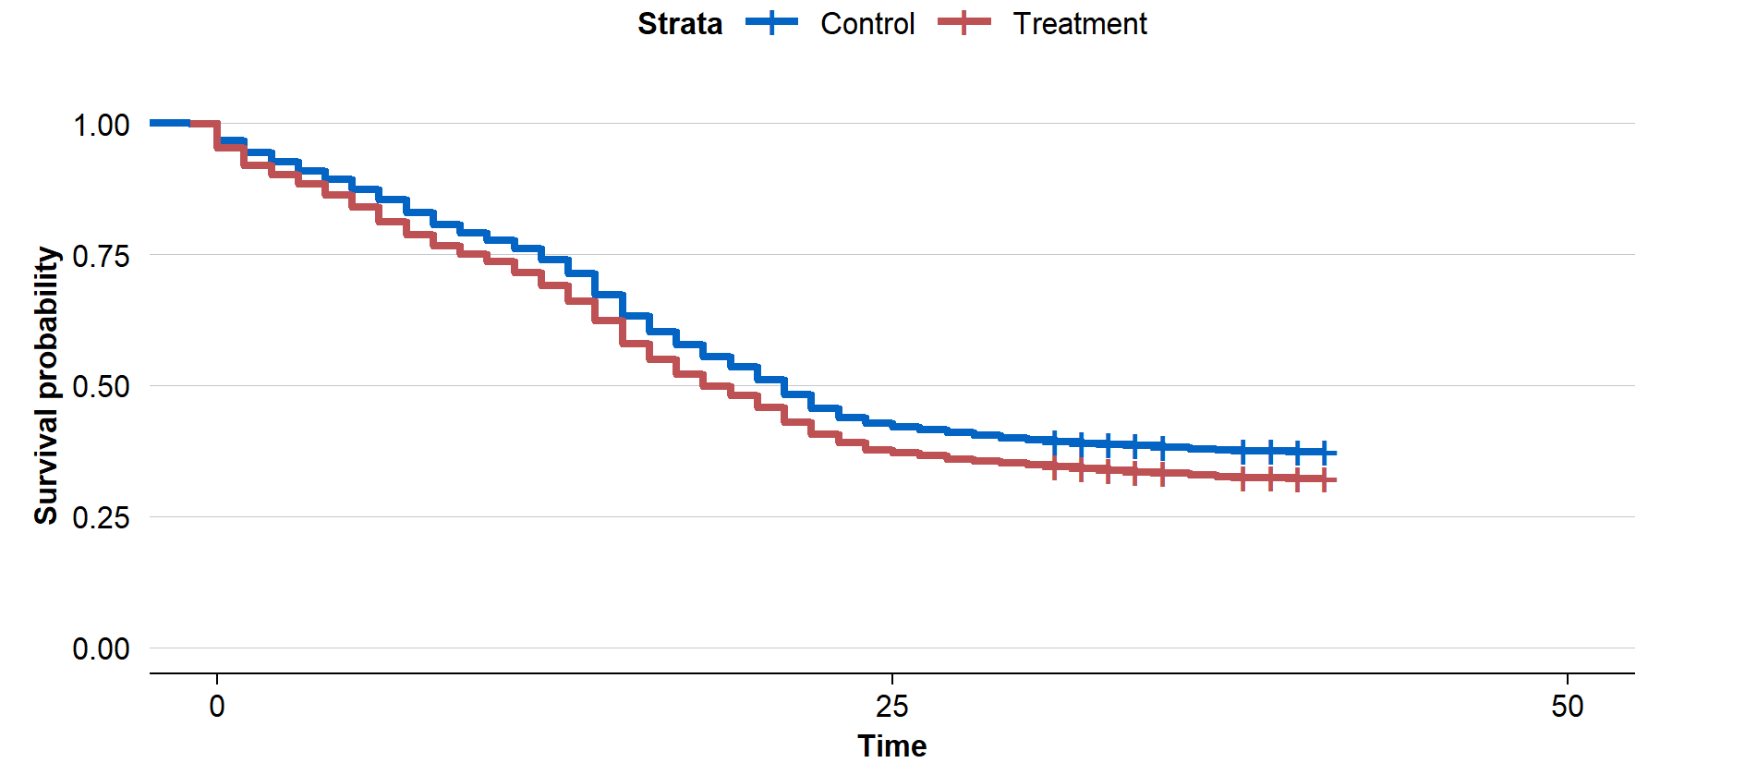

Source: Kaplan Meier survival analysis.

In survival analysis, a lower curve means the event (submission) is happening faster. In Figure 8, the treatment curve dropped more quickly and stays below the control curve. This demonstrates that a higher proportion of treated charities had already submitted at each day compared to control charities.

|  |
| --- |
| Deviation from PAP: |
| The ACE did not deviate from the pre‑analysis plan for the secondary analysis. |

## Subgroup analyses

### Model specification

The subgroup analysis was conducted in 2 steps. First, the ACE added an interaction term between the treatment and the subgroup of interest to the main regression model, outlined in the Primary analysis section. This allowed the ACE to formally test whether the treatment effect varied across subgroups. The interaction coefficient showed whether—and by how much—the treatment effect differed between levels of the subgroup.

Second, the ACE ran separate regressions within each level of the subgroup of interest to directly estimate the treatment effect for that specific subgroup. These models followed the same structure as the primary analysis, with missing values for covariates set to zero, and a missing data indicator included for each covariate to retain all observations in the model. However, the ACE excluded the subgroup variables and any interaction terms related to it as covariates (where relevant), meaning that 2 subgroup models differed from the primary analysis model:

* In the charity size subgroup, the ACE excluded charity size as a covariate and treatment and covariate interaction, as the analysis was conducted separately within each size category
* For the subgroup effects for charities submitting their AIS for the first time (versus not the first time), all covariates were removed from the models. This is because covariates for the ‘first AIS’ subgroup were generated after treatment assignment, and the ‘first AIS’ versus ‘non‑first AIS’ subgroups would not be directly comparable.

All models used a fully saturated specification that included the main effects of each covariate, treatment status, and their interaction terms. Specifically, the ACE included mean‑centred baseline covariates such as 2023 on‑time submission status, charity size, and batch number, along with their interactions with treatment. This approach allows the treatment effect to vary flexibly across different levels of these variables.

Refer to PAP pages 10‑12 for further information on these models.

|  |
| --- |
| Deviation from PAP: |
| The ACE did not specify a fully saturated model in the PAP. The ACE used a fully saturated model to make interpretation of subgroup effects and interactions clearer, while noting that this deviation did not alter the underlying results or conclusions. |

### Regression outputs

Table 2 shows that the reminder email led to higher on‑time AIS submission rates across all subgroups. The largest improvements were seen among basic religious charities (7.3 percentage points), incorporated associations (6.4 percentage points), and first‑time submitters (6.4 percentage points).[8] Gains were also observed across charity size, with small charities improving by 5.8 percentage points, and across volunteer‑based and non‑volunteer‑based charities, both increasing by around 5.5 percentage points. These results suggest the reminder was effective across a wide range of charity types.

Table 2. Summary of the predicted AIS 2024 on-time submission for each subgroup

| **Subgroup** | **Subgroup** | **Treatment mean on‑time AIS submission** | **Control mean on‑time AIS submission** | **Treatment effect** |
| --- | --- | --- | --- | --- |
| Charity size | Small charities | 59.3% | 53.5% | 5.8ppt |
|  | Medium charities | 63.5% | 68.7% | 5.2ppt |
|  | Large charities | 80.9% | 77.3% | 3.6ppt |
| Incorporated associations | Incorporated associations | 62.3% | 55.9% | 6.4ppt |
|  | Non‑incorporated associations | 63.1% | 58.4% | 4.7ppt |
| Volunteer‑based charities | Volunteer‑based charities | 59.1% | 53.6% | 5.5ppt |
|  | Non‑volunteer based charities | 66.1% | 60.5% | 5.6ppt |
| Basic religious charities | Basic Religious Charities | 64.5% | 57.3% | 7.3ppt |
|  | Non‑based Basic Religious Charities | 62.7% | 57.2% | 5.6ppt |
| First AIS | Charities submitting AIS for first time | 52.7% | 46.3% | 6.4ppt |
|  | Charities not submitting AIS for first time | 62.6% | 56.3% | 6.3ppt |

## Risk of bias

While the aim of randomisation is to eliminate the risk of bias in estimated outcomes, bias may re‑emerge in various ways. This section discusses 3 potential threats to internal validity: missing outcome data, spillovers, or evaluation‑driven effects.

### Missing data

As discussed above, there was no missing outcome data in this trial. There was some missing covariate data however this was handled consistently with the pre‑analysis plan. That is, the missing covariate value was imputed as 0, and an additional missingness indicator was included in the model.

### Spillovers

It was possible that some charities had a shared Responsible Person or other shared management. In this case, a charity assigned to the control group may benefit from the extra reminder message that was sent to the Responsible Person. To the extent that such ‘spillovers’ occurred, this would have meant that the trial marginally *underestimated* the effect of the extra reminder. However, this spillover effect was likely to be limited: internal ACNC estimates suggested that less than 5% of charities are likely to have an overlap of Responsible Person.

### Blinding and evaluation-driven effects

Participants were unaware they were involved in a trial however it was not possible to blind the participants to their treatment status. Nonetheless, it is unlikely there were substantial evaluation‑driven effects due to awareness of treatment status.

1. There were slightly more than 15,000 charities that had not submitted their AIS by 3 January, but due to batch rounding, the ACNC randomly excluded approximately 600 charities before providing the final sample to ACE.
2. On January 7, 8, and 17, a single batch of 1,000 reminders was sent each day to balance other operational needs (for example, sending reminders for charities with overdue AIS’ and other cohorts not in the trial, whilst ensuring enquiries fielded by ACNC’s Advice Services could still be managed within service standards). On all other business days during the trial, 2 batches of 1,000 reminders were sent. Some batches contained fewer than 1,000 charities because charities that had already submitted their AIS or had been deregistered were removed before the reminder emails were sent. However, these charities were still included in the analysis. See Technical Appendix C for more details.
3. The pre‑registration and pre‑analysis plan can be found at [AEARCTR‑0015006](https://www.socialscienceregistry.org/trials/15006).
4. To test the sensitivity of the results to a later definition of ‘on‑time’ submission, the ACE also ran the analysis based on a 14 February deadline. The treatment effect remained positive but was slightly smaller, at 5.1 percentage points, equivalent to approximately 765 additional charities submitting by that time.
5. Additional results can be found at [Improving on‑time submission rates for charity Annual Information Statements: a randomised trial](https://evaluation.treasury.gov.au/publications/charity-on-time-submission-trial)
6. The 6 criteria are: charity subtype, incorporated under certain legislation, reporting to ACNC as part of a group, deductible gift recipient endorsement, government grants, and participation in National Redress Scheme.
7. This difference was not pre‑specified in the pre‑analysis plan for this trial. However, it seems clear that the extra calls were due to the additional reminder because of the nature of the calls, which often related specifically to queries from the Responsible Person.
8. The regression output for each subgroup can also be viewed using the charts in the subgroup section of the main report.